现在学习各具体指令的功能相关，至于其机器码格式非主要，但可继续添加至Diasm中进行完善。

ADD
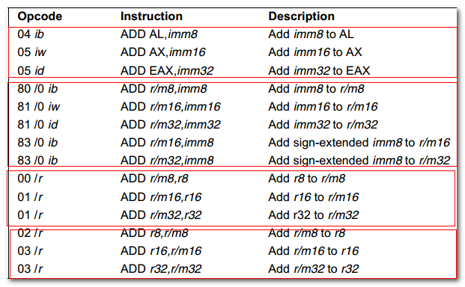
When an immediate value is used as an operand, it is sign-extended to the length of the destination operand format.
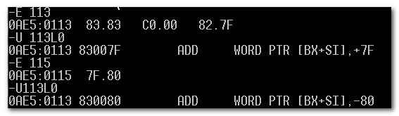

It evaluates the result for both signed and unsigned integer operands and set OF and CF flags to indicate a carry(overflow) in the signed or unsigned result, respectively. The SF flag indicates the sign of the signed result.

OF | DF | IF | SF | ZF | AF | PF | CF
OF=0, NV  OF=1,OV | DF=0,DN  DF=1,UP | IF=0,DI  IF=1,EI | SF=0, PL  SF=1, NG | ZF=0,NZ  ZF=1,ZR | AF=0,NA  AF=1,AC | PF=0, PE  PF=1, PO | CF=0,NC  CF=1, CY
OF=1，有符号数，溢出 | DF=1,地址减小 | IF=1，允许中断 | SF=1,有符号数，最高有效位为1 | ZF=1,计算所得结果为0 | AF=1, D3低半字节有进位或者借位 | PF=1，最低1字节中1的个数为奇数 | CF=1, 无符号数，最高有效位有进位或者借位

The instruction can used with a LOCK prefix to allow the instruction to be executed atomically.

1.1标志寄存器的影响
It evaluates the result for both signed and unsigned integer operands and set the OF and CF flags to indicate a carry in the signed or unsigned result.
The SF flag indicates the sign of the signed result.

OF, SF, ZF, AF, CF, PF
OF | DF | IF | SF | ZF | AF | PF | CF
OF=0, NV  OF=1,OV | DF=0,DN  DF=1,UP | IF=0,DI  IF=1,EI | SF=0, PL  SF=1, NG | ZF=0,NZ  ZF=1,ZR | AF=0,NA  AF=1,AC | PF=0, PE  PF=1, PO | CF=0,NC  CF=1, CY
OF=1，有符号数，溢出 | DF=1,地址减小 | IF=1，允许中断 | SF=1,有符号数，最高有效位为1 | ZF=1,计算所得结果为0 | AF=1, D3低半字节有进位或者借位 | PF=1，最低1字节中1的个数为奇数 | CF=1, 无符号数，最高有效位有进位或者借位
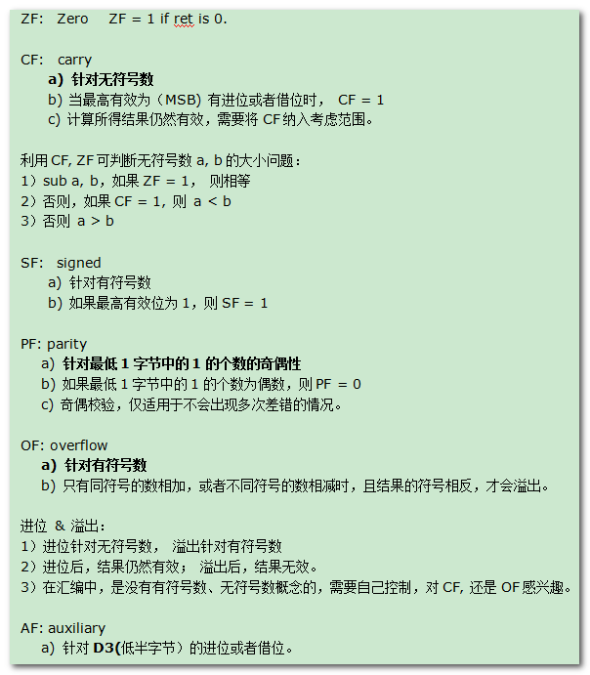

ADC
常用下面方法，获取CF
Xor cx, cx
进行算术运算
Adc cx, 0

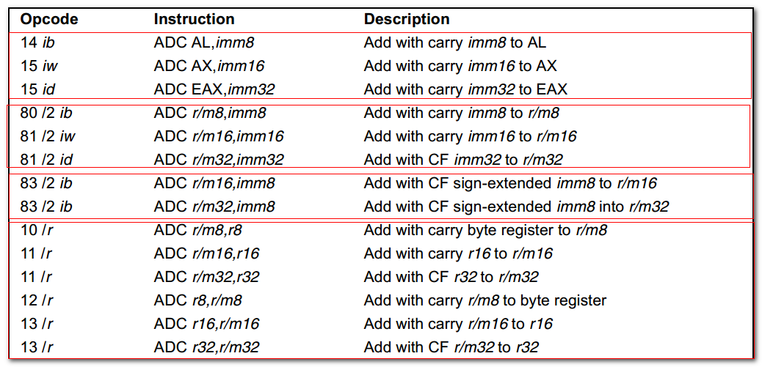
Adds the dst operand, the source operand, and the CF flag, and stores the result in the dst operand.

DEST <---- DEST + SRC + CF;

The state of the CF flag represents a carry from a previous addition.
When an immediate value is used as an operand, it is sign-extended to the length of the dst operand format.
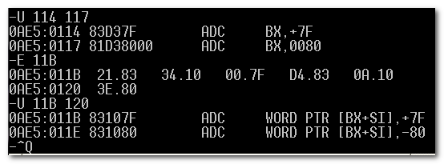
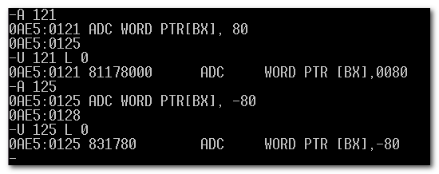

The ADC instruction does not distinguish between signed or unsigned operands. Instead, the processor evaluates the results for both data types and sets the OF and CF flags to indicate a carry in the signed or unsigned result.

The ADC instruction is usually executed as part of a multibtye or multiword addition in which an ADD instruction is followed by an ADC instruction.
(大数加法）。

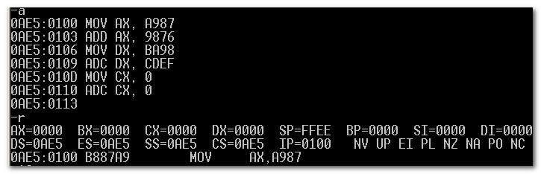
BA98 A987 + CDEF 9876 的结果为CX.DX.AX
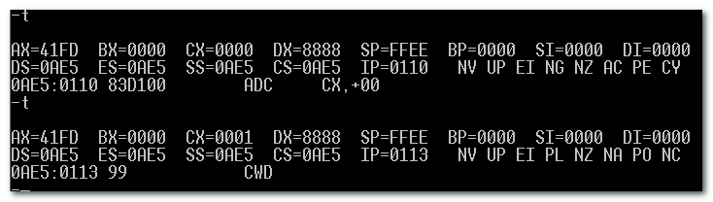

2.1 标志寄存器的影响
同ADD

INC
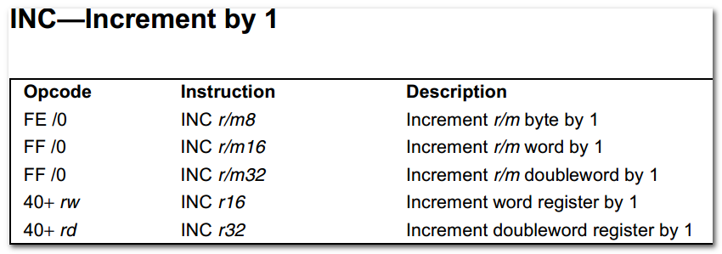
This instruction allows a loop counter to be updated without disturbing the CF flag.

3.1标志寄存器的影响
The CF flag is not affected.
The OF, SF, ZF, AF and PF flags are set according to the result.

SUB
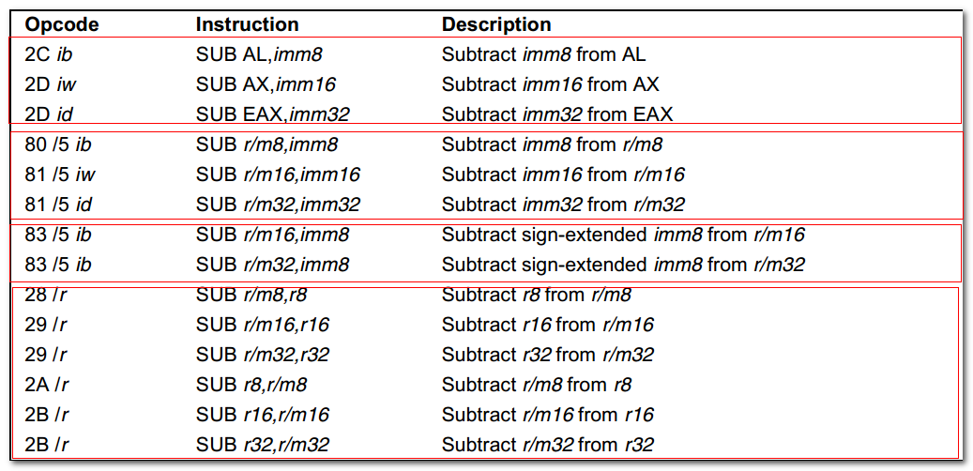\When an immediate value is used as an operand, it is sign-extended to the length of the destination operand format.

标志寄存器的影响同ADD

4.1 补码
Neg(X) , 对CF的影响：
- 若X = 0, 则CF = 0
- 若X != 0, 则CF = 1
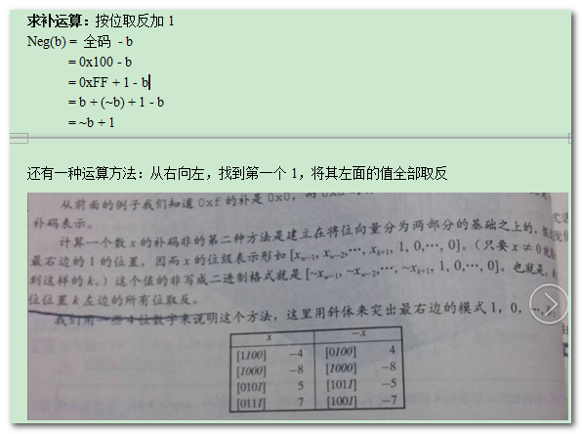
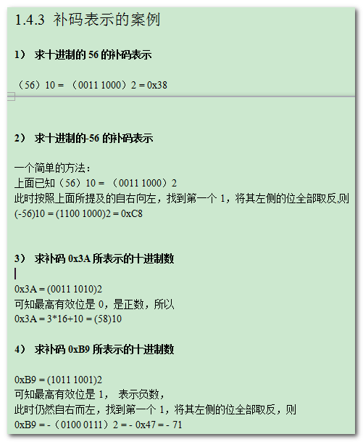

4.2 NEG
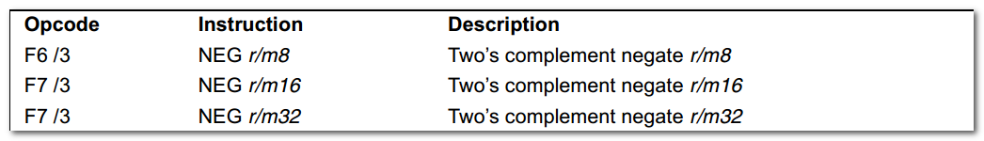

Replaces the value of operand(the destination operand) with its two’s complement. (This operation is equivalent to subtracting the operand from 0).

IF DEST = 0
THEN CF = 0
ELSE CF = 1
FI;
DEST = -(DEST)

充分借助SBB和NEG，可解决一些定式问题。
如 x == 0 ? 0 : -1
MOV REG, X
NEG REG ; CF=0 if X=0; ELSE CF=1
SBB REG, REG ; REG = REG-REG-CF = 0 if X= 0; ELSE = -1;

可推广
X == 0 ? Y : Y-1

SBB
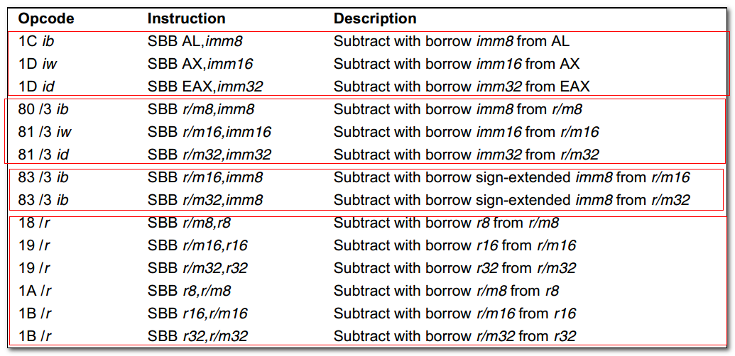
Adds the source operand and the carry flag, and subtracts the result from the destination operand. The state of the CF flag represents a borrow from a previous subtraction.

DEST = DEST - (SRC + CF)

同ADC类似， the SBB instruction is usually executed as part of a multibyte or multiword subtraction in which a SUB instruction is followed by a SBB instruction.

DEC
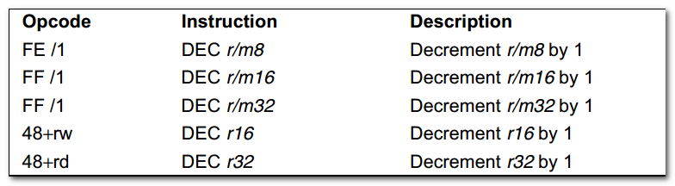
同INC 一样，不会影响CF.

CMP
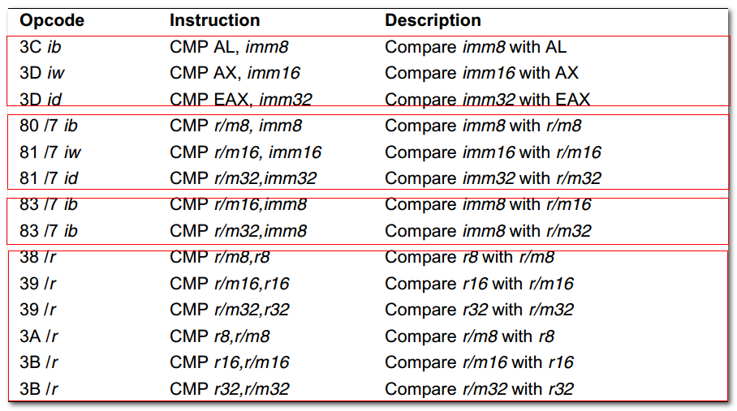

Temp = SRC1 - SignExtend(SRC2);
ModifyStatusFlags //同SUB

MUL
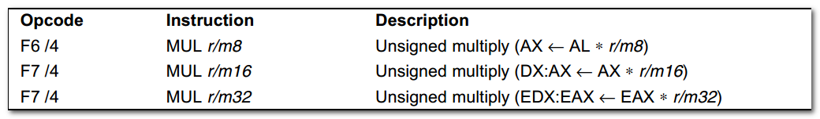

Unsigned multiply

AX <---- AL * r/m8
DX. AX <---- AX * r/m16

AL, AX, EAX作为隐含参数。
The destination operand is an implied operand located in register AL, AX, or EAX.
The source operand is located in a general-purpose register or a memory location.

The high-order bits of the product contained in register AH, DX, or EDX.
If the high-order bits of the products are 0, the CF and OF flags are cleared; otherwise, the flags are set.

8.1 标志寄存器的影响
The OF and CF flags are set to 0 if the upper half of the result is 0;
Otherwise, they are set to 1.

The SF, ZF, AF, PF flags are undefined.

IMUL
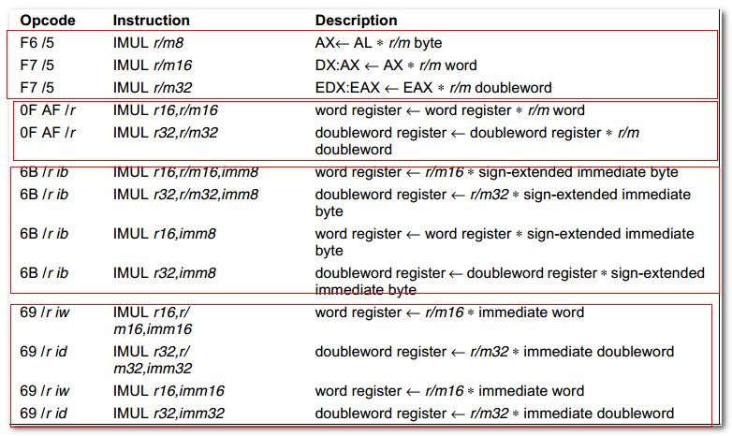

Signed multiplication of two operands.
- One-operand form. 与MUL 类似。r/m8/16 * AL/AX/EAX -->AX, DX.AX, EDX.EAX

- Two-operand form. The destination operand (the first operand) is multiplied by the source operand(second operand). The destination operand is a general-purpose register and the source operand is an immediate value, a general-purpose register, or a memory location.

- Three-operand form.
  - This form requires a destination operand (the first operand) and two source operands( the 2nd and 3rd operands).
  - The first source operand(which can be a general-purpose register or a memory location) is multiplied by the second source operand( an immediate value).
  - The product is then stored in the destination operand ( a general-purpose register).

When an immediate value is used as an operand, it is sign-extended to the length of the destination operand format.

The CF and OF flags are set when significant bit (including the sign bit) are carried into the upper half of the result.
The CF and OF flags are cleared when the result(including the sign bit) fits exactly in the lower half of the result.

The three forms of the IMUL instruction are similar in that the length of the product is calculated to twice the length of the operands.
- with the one-operand form, the product is stored exactly in the destination.
- With the two- and three- operand forms, however, result is truncated to the length of the destination b4 it is stored in the destination register.

- Because of this truncation, the CF or OF flag should be tested to ensure that no significant bits are lost.

The two- and three-operand forms may also be used with unsigned operands because the lower half of the product is the same regardless if the operands are signed or unsigned.
The CF and OF flags, however, cannot be used to determine if the upper half of the result is non-zero.

IF one-operand form
THEN IF (OperandSize = 8)
THEN
AX = AL * SRC // signed multi
IF AL == AX
THEN CF=0; OF=0
ELSE CF=1; OF=1
FI;
ELSE IF OperandSize=16
THEN
DX.AX = AX * SRC //signed multi
IF sign_extend_to_32(AX) = DX.AX
THEN CF=0; OF=0;
ELSE CF=1; OF=1;
FI;
ELSE //OperandSize = 32
EDX:EAX=EAX*SRC //signed multi
IF EAX=EDX.EAX
THEN CF=0; OF=0
ELSE CF=1;OF=1
FI
FI
ELSE IF two-operand form
THEN
Tmp = DST * SRC //signed multi, tmp is double DST size
DST=DST *SRC //sign multi
IF tmp !=DEST
THEN CF=1;OF=1
ELSE CF=0; OF=1
FI
ELSE //three-operand
DST = SRC1*SRC2 //signed multi
Tmp = SRC1*SRC2 //signed multi, tmp is double SRC1 size
IF tmp != DST
THEN CF=1; OF=1;
ELSE CF=0;OF=0
FI
FI
FI

9.1标志寄存器的影响
- For the one-operand form of the instruction, the CF and OF flags are set when significant bits are carried into the upper half of the result.
  - AL != AX
  - Sign_extend_to_32(AX) != DX.AX
  - EAX != EDX.EAX
- And cleared when the result fits exactly in the lower half of the result.
  - AL==AX
  - Sign_extend_to_32(AX) == DX.AX
  - EAX == EDX.EAX
- For the two- and three-operand forms of the instruction, the CF and OF flags are set when the result must be truncated to fit in the destination operand size
- And cleared when the result fit exactly in the destination operand size.
- The SF, ZF, ZF, and PF flags are undefined.

Div
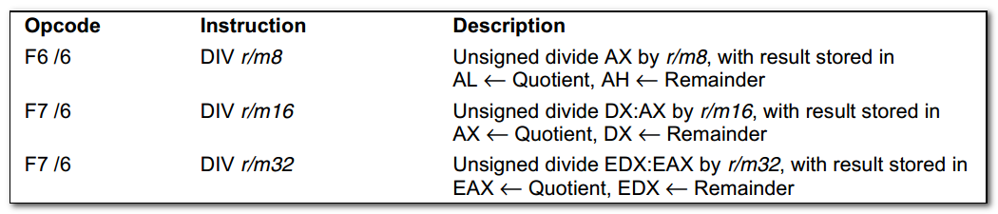
Divides (unsigned) the value in the AX, DX:AX, or EDX:EAX registers (dividend) by the source operand(divisor) and stores the result in the AX(AH:AL), DX:AX, or EDX:EAX registers.
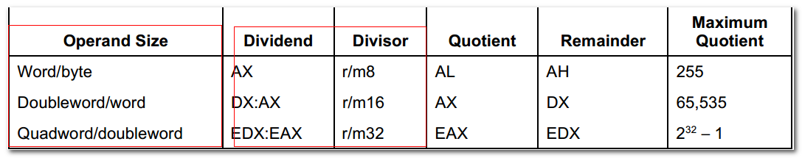
The operand size (dividend/divisor).

Non-integral results are truncated(chopped) towards 0.
The remainder is always less than the divisor in magnitude.
Overflow is indicated with the #DE(divide error) exception rather than with the CF flag.

IF SRC = 0
THEN #DE
FI
IF OperandSize = 8 // word/byte operation
THEN
Tmp = AX/SRC
If tmp > FF
THEN #DE
ELSE
AL=tmp
AH=AX mod SRC
FI
ELSE
IF OperandSize=16 //doubleword/word operation
THEN
Tmp=DX.AX/SRC
If tmp>FFFF
THEN #DE
ELSE
AX=tmp
DX=DX.AX mod SRC
FI
ELSE //quadword/doubleword
Tmp = EDX.EAX/SRC;
IF tmp>FFFFFFFF
THEN #DE
ELSE
EAX=tmp
EDX=EDX.EAX mod SRC
FI
FI
FI

10.1标志寄存器的影响
The CF, OF, SF, ZF, AF and PF flags are undefined.

#DE if the source operand(divisior) is 0
If the quotient is too large for the destination register.

IDIV
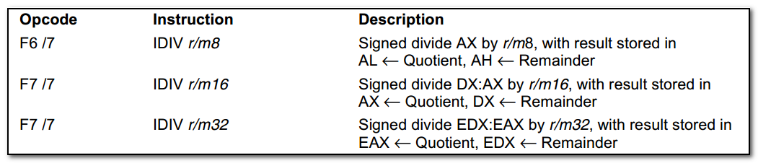
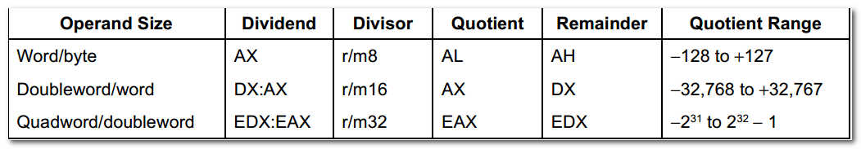
Non-integral results are truncated (chopped) towards 0.
The sign of the remainder is always the same as the sign of the dividend.
The absolute value of the remainder is always less than the absolute value of the divisor.
Overflow is indicated with the #DE exception rather than with the OF flag.

IF SRC=0
THEN #DE
FI;
IF OperandSize = 8 //word/byte operation
THEN
Tmp= AX/SRC
If tmp>7F or tmp < 80
THEN #DE
ELSE
AL=tmp
AH=AX signedmod SRC
FI
ELSE
IF OperandSize=16 //doubleword/word operation
THEN
Tmp=DX.AX/SRC //signed division
If tmp >7FFF or tmp < 8000
THEN #DE
ELSE
AX=tmp
DX=DX.AX SignedMod SRC
FI
ELSE //quadword/doubleword operation
Tmp = EDX.EAX/SRC //signed division
IF tmp>7FFFFFFF or tmp <80000000
THEN #DE
ELSE
EAX=tmp
EDX=EDX.EAX SignedMod SRC
FI
FI
FI

对标志寄存器的影响
The CF, OF, SF, ZF, AF, and PF flags are undefined.

符号扩展
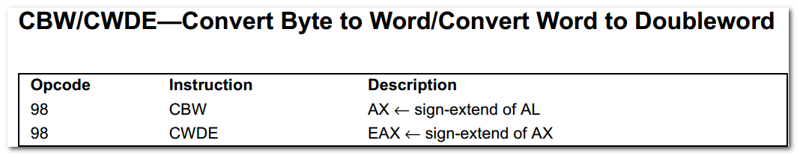
The CWDE instruction is different from the CWD(convert word to double) instruction.
The CWD instruction uses the DX.AX register pair as the destination operand.
The CWDE uses the EAX as destination.

CBW: AH = 00 or FF

对标志寄存器没有影响。

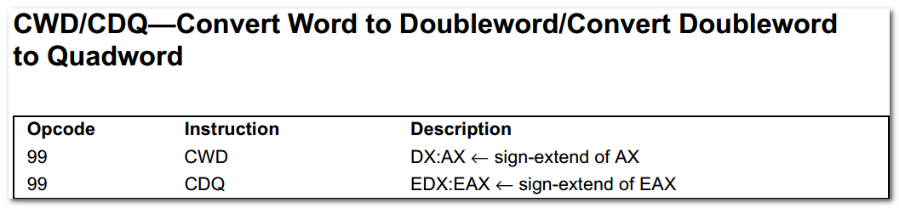
The CWD instruction can be used to produce a doubleword dividend from a word b4 a word division.

Cwd ; DX.AX <---AX
Idiv bx;

The CDQ instruction can be used to produce a quadword dividend from a doubleword b4 doubleword division.

对于无符号数除法应该采用直接将高8或者16位清0的方法，获得倍长的被除数。

十进制调整指令
TBD

习题
