Logical Operation

1.1 AND (logical and)
X AND 0 = 0
X AND 1 = 1
编译器对这些恒等式不产生代码。

对标志寄存器的影响：
The OF and CF flags are cleared;
The state of the AF flag is undefined.

X % 2^n 可用 X AND (2^n - 1)优化

1.2 OR (Logical Inclusive OR)
X OR 0 = X
X OR 1 = 1

同AND

1.3 XOR (Logical Exclusive OR)
X XOR X = 0
X XOR 0 = X
X XOR 1 = ~X

针对位操作，进行灵活运用。
比如求abs(X), 可用位操作实现无分支的解法。
- X >= 0 , abs(X) = X
- X < 0, abx(X) = neg(X) 按位取反加1

MOV AX, X
CWD ; X>=0则DX=0; 否则DX=FFFF
XOR AX, DX; X>=0 则AX=X; 否则AX=~X
SUB AX, DX; X>=0 则AX=X; 否则AX=~X+1

1.4 TEST (Logical Compare)
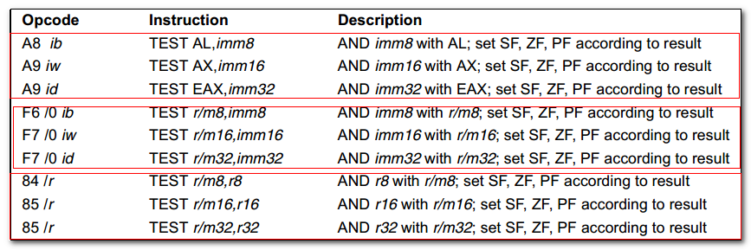
Computes the bit-wise logical AND of first operand (source 1 operand) and the second operand(source 2 operand) and sets the SF, ZF and PF status flags according to the result. The result is then discarded.

对标志寄存器的影响：
The OF and CF flags are set to 0.
The state of the AF is undefined.

TMP = SRC1 AND SRC2
SF = MSB(TMP)
IF TMP = 0
THEN ZF = 1
ELSE ZF = 0
FI
PF = BitwiseXNOR(TEMP[0:7])
CF=0
OF=0
(AF is Undefined)

Shift Instructions
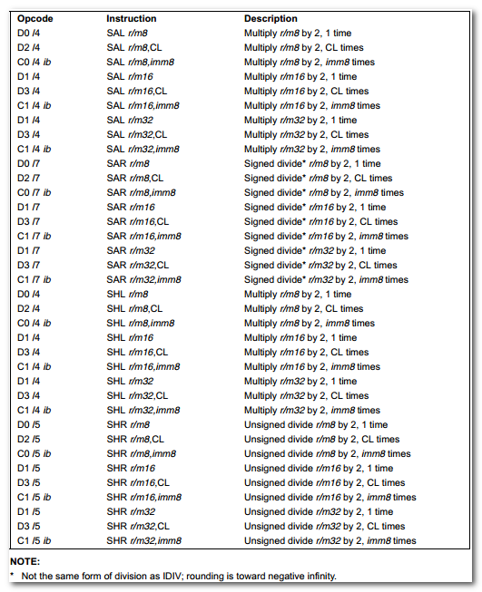
Bits shift beyond the destination operand boundary are first shifted into the CF flag, then discarded.
At the end of the shift operation, the CF flag contains the last bit shifted out of the destination operand.

在8086下，当移位次数大于1时，需要借助CL进行指定。
The count is masked to 5 bits, which limits the count range to 0 to 31.

SAL (Shift arithmetic left) SHL(shift logical left)
SAR (Shift arithmetic right) SHR(shift logical right)

Using the SAR instruction to perform a division operation does not produce the same result as the IDIV instruction.
The quotient from the IDIV instruction is rounded toward zero, whereas the “quotient” of the SAR instruction is rounded toward negative infinity. This difference is apparent only for negative numbers.

The OF flag is affected only on 1-bit shifts.
(更多关于OF, CF的设置）

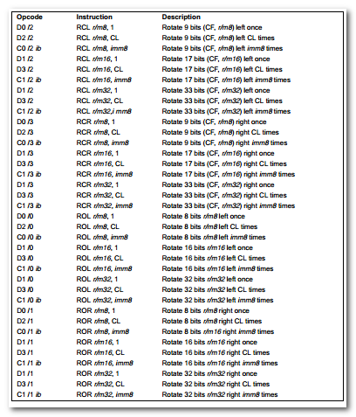
ROL (rotate left) RCL(rotate through carry left)
ROR(rotate right) RCR(rotate through carry right)

For the ROL and ROR instructions, the original value of the CF flag is not a part of the result, but the CF flag receives a copy of the bit that was shifted from one end to the other.

循环移位的可逆性。

串操作

3.1 MOVS (Move Data from String to String)
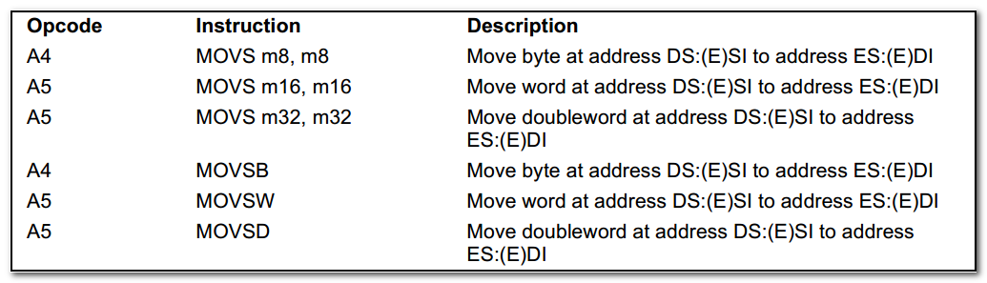

DS:(E)SI ES:(E)DI
The DS segment may be overridden with a segment override prefix, but the ES segment cannot be overridden.

确保利用CLD, STD来调整(E)SI, (E)DI的变化方向。

The MOVS, MOVSB, MOVSW and MOVSD instructions can be preceded by the REP prefix for block moves.

相当于C 库中的memcpy.

3.2 STOS (Store String)
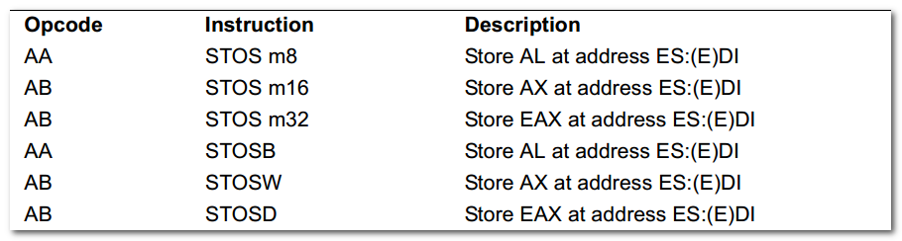

Stores a byte, word, or doubleword from the AL, AX or EAX register, respectively, into the destination operand.
The destination operand is a memory location, the address of which is read from ES:(E)DI registers.

The STOS, STOSB, STOSW and STOSD instructions can be preceded by the REP prefix for block loads of ECX bytes, words, or doublewords.
More often, however, these instructions are used within a LOOP construct because data needs to be moved into the AL, AX, or EAX register before it can be stored.

3.3 LODS (Load String)
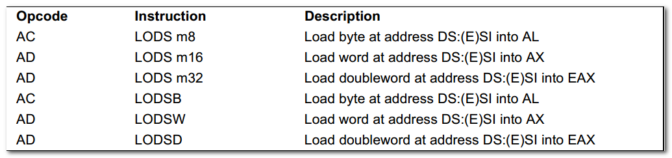
Loads a byte, word, or doubleword from the source operand into the AL, AX, or EAX register respectively.
The source operand is a memory location, the address of which is read from the DS:(E)DI registers. The DS segment may be overridden with a segment override prefix.

3.4 CMPS (Compare String Operands)
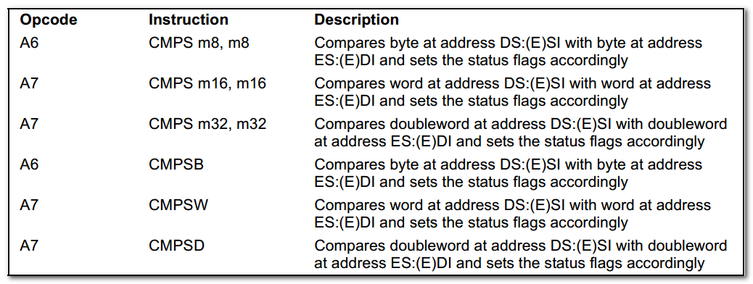
Compares the byte, word, or double word specified with the first source operand with the byte, word, or double word specified with the second source operand and sets the status flags in the EFLAGS register according to the results.

DS:(E)SI ES:(E)DI

The CF, OF, SF, ZF, AF, and PF flags are set according to the temporary result of the comparison.

3.5 SCAS (Scan String)
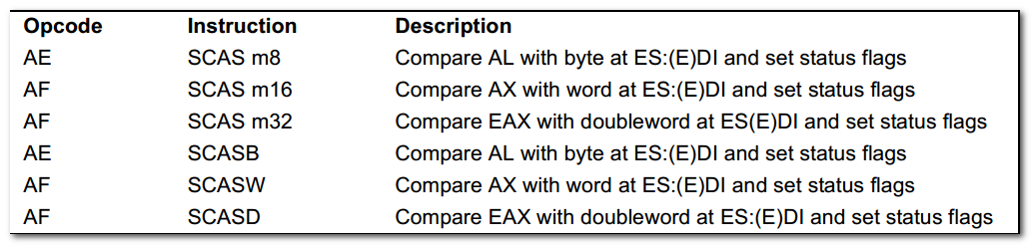

Compares the byte, word, or double word specified with the memory operand with the value in the AL, AX or EAX register, and sets the status flags in the EFLAGS.
The memory operand address is read from the ES:(E)DI

ES:(E)DI

AL-SRC
AX-SRC
EAX-SRC

3.6 REP (Repeat String Operation Prefix)
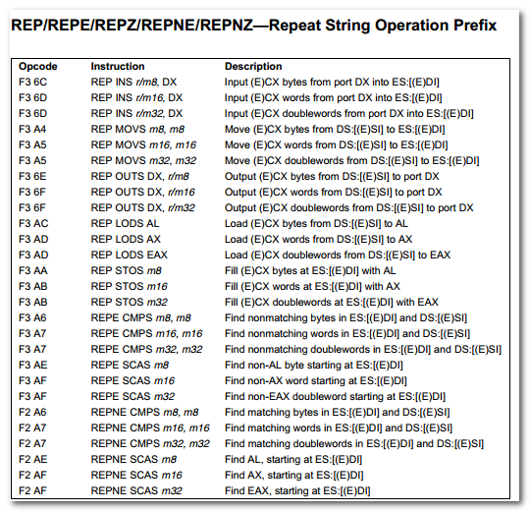

Repeats a string instruction the number of times specified in the count register( (E)CX) or until the indicated condition of the ZF flag is no longer met.

REP(repeat)
REPE(repeat while equal)
REPNE(repeat while not equal)
REPZ(repeat while zero).
REPNZ(repeat while not zero)

The REP prefixes apply only to one string instruction at a time.
To repeat a block of instructions, use the LOOP instruction or another looping construct.

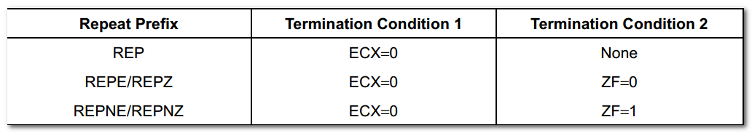

A REP STOS instruction is the fastest way to initialize a large block of memory.

When both termination conditions are tested, the cause of a repeat termination can be determined either by testing the (E)CX register with a JECXZ instruction or by testing the ZF flag with a JZ, JNZ, and JNE instruction.

The REPE/REPZ and REPNE/REPNZ prefixes are used only with the CMPS and SCAS instructions.

The LAHF (load AH from flags) and SAHF(store AH into flags) instructions operate on five of the EFLAGS status flags(SF, ZF, AF, PF, and CF).
The LAHF instruction copies the status flags to bits 7, 6, 4, 2, and 0 of the AH register, respectively.
The contents of the remaining bits in the register(bits 5, 3, and 1) are undefined.

The SAHF instruction copies bits 7,6,4,2, and 0 from the AH register into the SF, ZF, AF, PF, and CF flags, respectively in the EFLAGS register.

