CALL
CALL NEXT
NEXT:
POP REG

该段指令的作用是获取NEXT的地址，并保存到REG中。
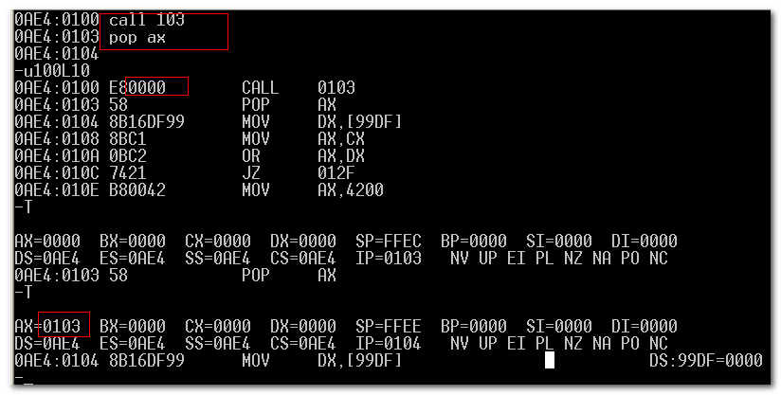

$ 当前地址

利用$, 可对上面获取指令地址的CALL进行改写：
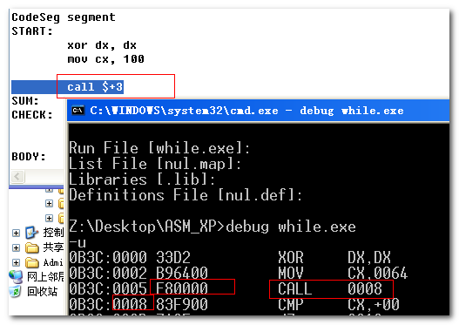

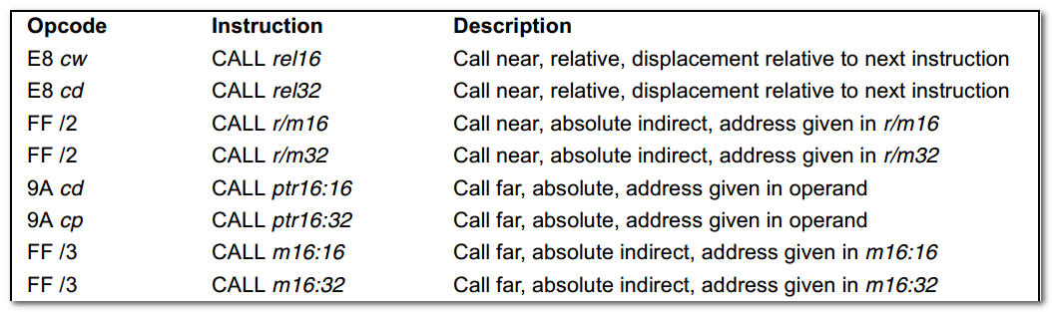
(push cs)
Push ip
Jmp label

同jmp类似，可进行段内、段间的call，有near、far之分 （在32位下，已无far, 其32位的寻址能力可满足要求）。

Near Call:
1)When executing a near call, the processor pushes the value of the (E)IP (which contains the offset of the instruction following the CALL instruction) onto the stack( for later as a return-instruction pointer).
2) then the processor branches to the address in the current code segment specified with the target operand.
3) the target operand specifies either an absolute offset in the code segment( that is an offset from the base of the code segment)
4 ) or a relative offset ( a signed displacement relative to the current value of the instruction pointer in the EIP register, which points to the instruction following the CALL instructions).
- The CS register is not changed on near calls.

An absolute offset is specified indirectly in a general-purpose register or a memory location(r/m16, r/m32). Absolute offsets are loaded directly into the EIP register.

A relative offset (rel16, rel32) is generally specified as a label in assembly code, but at the machine code level, it is encoded as a signed, 16- or 32- bit immediate value. This is value is added to the value in the EIP register.

When executing a far call in real address or virtual-8086 mode, the processor pushes the current value of both the CS and EIP register on the stack for use as a return-instruction pointer.

A program or operating system/executive can set up many stacks. The number of stacks in a system is limited by the maximum number of segments and the available physical memory.

When a system sets up many stacks, only one stack---the current stack----is available at a time.

Setting Up a Stack
To set a stack and establish it as the current stack, the program or operating system/executive must do the following:
- establish a stack segment
- Load the segment selector for the stack segment into the SS register using a MOV, POP, or LSS instruction.
- Load the stack pointer for the stack into the ESP register using a MOV, POP, or LSS instruction. (The LSS instruction can be used to load the SS and ESP registers in one operation)

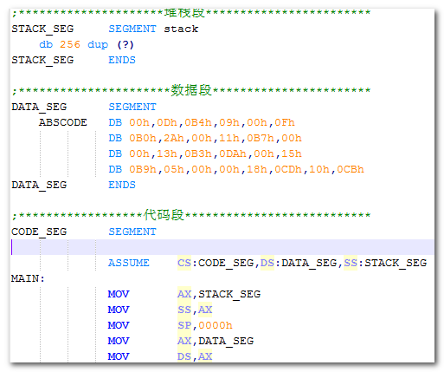

Pushing a 16-bit value onto a 32-bit wide stack can result in stack misaligned (that is, the stack pointer is not aligned on a doubleword boundary).
Mov word ptr[01], 1234

One exception to this rule is when the contents of a segment register(a 16-bit segment selector) are pushed onto a 32-bit wide stack. Here, the processor automatically aligns the stack pointer to the next 32-bit boundary.

The processor provides two pointers for linking of procedures:
- the stack-frame base pointer
- The return instruction pointer

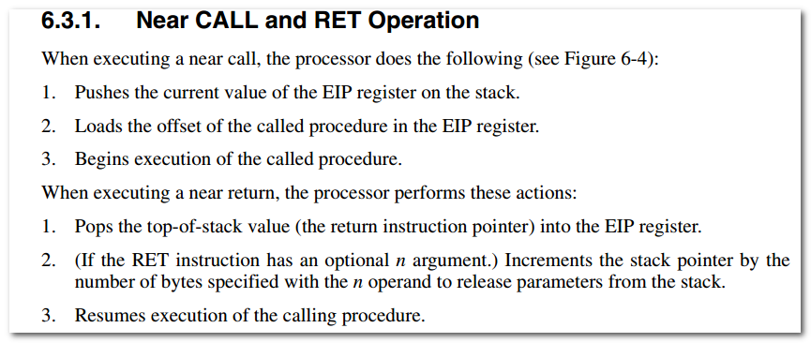
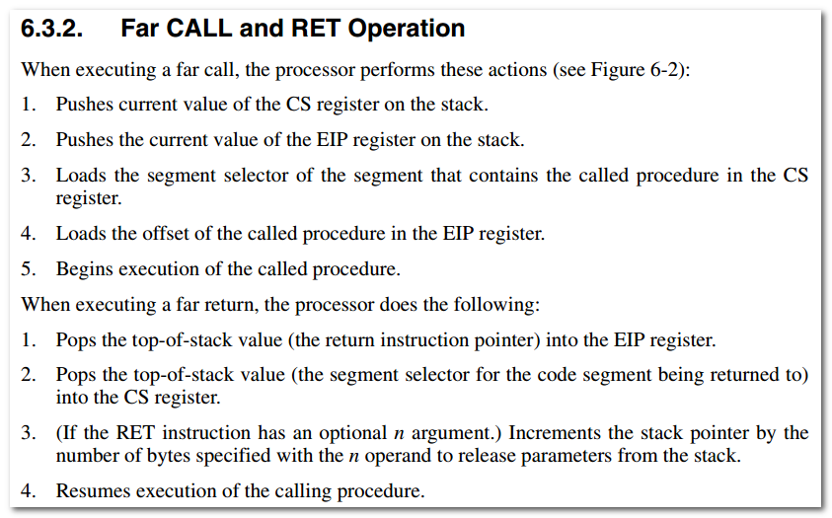
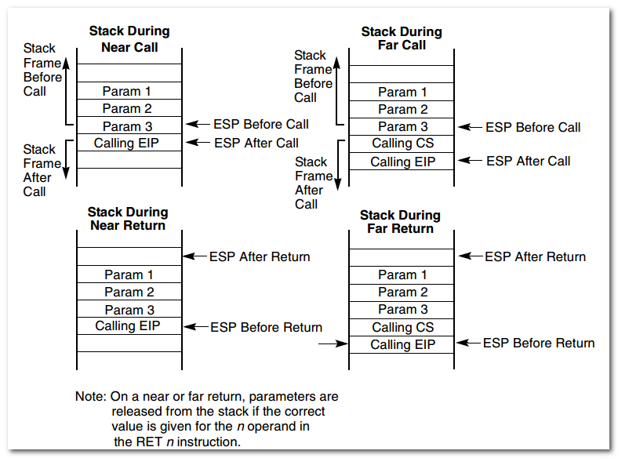

An alternate method of passing a larger number of parameters(or a data structure) to the called procedure is to place the parameters in an argument list in one of the data segments in memory. A pointer to the argument list can be then passed to the called procedure through a general purpose reg or the stack.

PUSHA pushes the values in all general-purpose registers on the stack in the following order:
EAX, ECX, EDX, EBX, ESP, EBP, ESI, EDI (ACDB SBSD)

Skill
带有常量或者与常量等价的三目运算，可以用无条件分支等价替换。
如 AX > 39 ? 7:0
====>
Cmp ax, 39
SBB CX, CX
Not cx
And cx, 7

AX > 39 ? Y + 7 : Y <===> Y + (AX>39 ? 7 :0)

中断向量表
Debug.exe 下用d 0:0 ， 每ip, cs进行组织。

其他
Int 21h 的0Ah调用，需要注意缓冲区格式
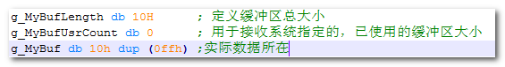

Assume ds:DataSeg 用于指示编译器。
但实际的关联，还需要自己指定。
MOV AX, DataSeg
Mov ds, ax

分析报告

5.1 结论
Code.asm利用栈、结合retf 来模拟段间调用，执行DataSeg中的代码，完成对控制台的背景色设置。
效果如下图所示：
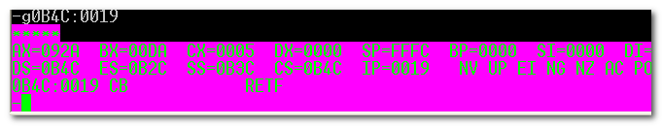

具体分析情况如下：

5.2 Entry Point
该程序的入口点，直接进行far call, 会依次将cs, ip压栈。
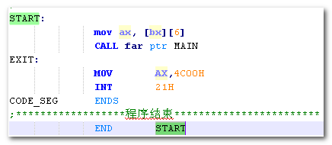
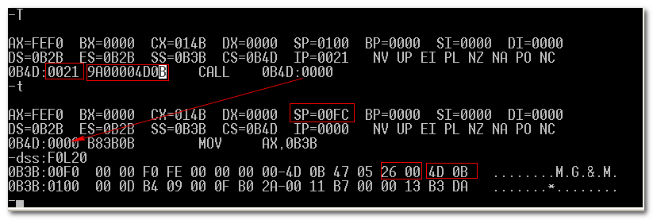
（然而，这里保存的cp, ip, 后续会随着栈的变化而变得无效。当然了，后续有新的操作来解决该问题）

各段的大致情况如下：
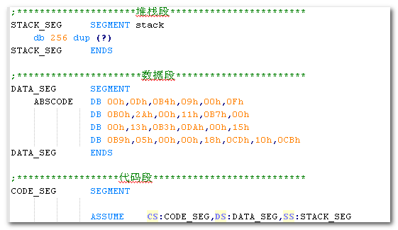

5.3 Main
该部分主要是对各段进行调整，同时将相关数据压入栈内，进行准备性操作。
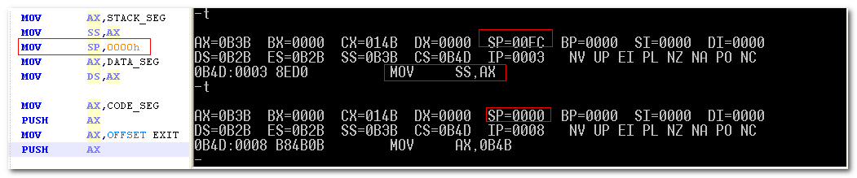
（SS段的变化，默认会对sp进行清空? 此前的栈内数据变得无效)

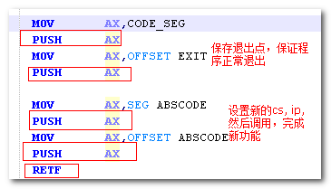
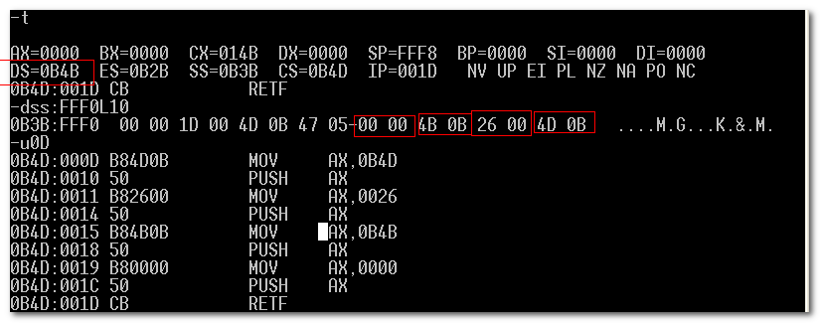
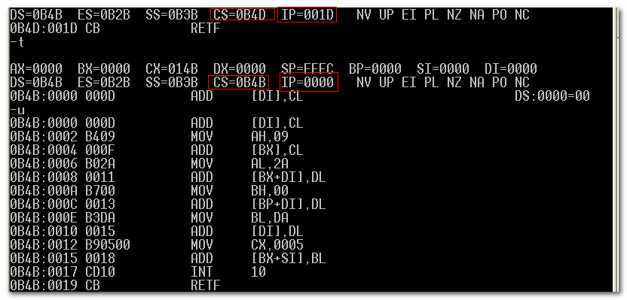
这样，就把数据段中的数据，当作代码来执行。

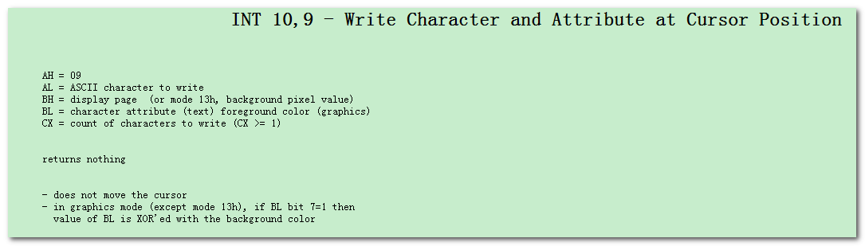
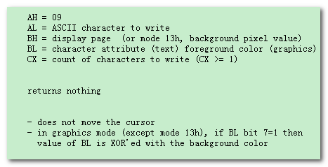
仅需关注AH, AL, BH, BL, CX即可，其他为干扰代码
等价转换为如下代码
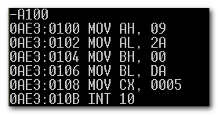
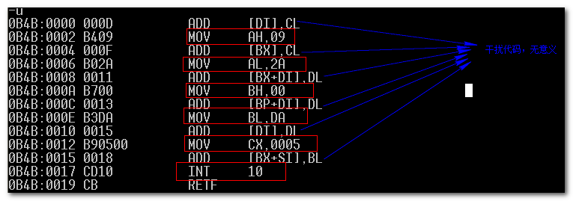
MOV AH,09 ; 在光标位置写上字符，并设置属性
MOV AL,2A ; *
MOV BH,00 ; display page ??
MOV BL,DA ; foreground color
MOV CX,0005 ; 个数
INT 10

5.4 效果
效果如下
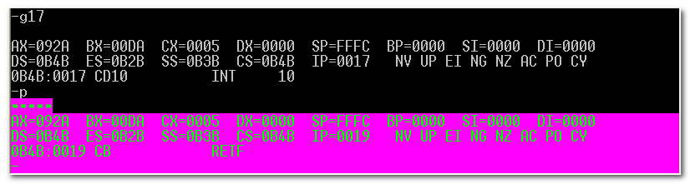

5.6退出
利用栈内保存的cs, ip，安全的退出程序。
