NSG : Simulation File Generation Software
NSG Introduction and Installation
NSG is a script generator designed for ns2 , the latest version of the second version ( NSG2 ), the biggest difference compared with the previous version ( NSG1 ) NSG2 in addition to the originally supported wireless network also supports wired network script, the following items listed species NSG2 main functions and support of ns2 :
- Produce wired and wireless network script (currently not supported wireless and wired mixed script)
- Node types supported : WirelessNode and WiredNode
- Support WirelessNode mobile settings
- Link types supported : Duplex-link and Simplex-lin k
- Agent Support ( TCP , TCP / Tahoe , TCP / Reno , TCP / Newreno , TCP / Vegas , TCPSink , UDP and NULL )
- Support of Application kind: CBR and FTP
- Routing protocol support the kind ︰ DSDV, DSR, AODV and TORA
- Queue types supported : DropTail , RED , FQ , DRR , SFQ and CBQ
- Wireless network related settings
- 802.11 parameter setting ( NSG provides a set of 802.11b default parameters)
Since the NSG 2 is written Java, so you can perform (such as Windows, Linux, Mac OS ...) on any Java-supported platforms, in addition NSG2 in the form of J ava J ar archives to release itself is not so NSG2 Need to install, just download NSG2 and saved to your computer can be started through Java . Its download URL is as follows:
NSG2 Download URL: http://wushoupong.googlepages.com/nsg
In addition, must be determined prior to performing NSG2 computer equipped with J ava Runtime Environment (JRE) or Java SE Development Kit (JDK), to Window operating system, for example, to determine whether the computer has Java installed, you can command in DOS Column enter " java-version " If the computer has Java installed, the installed Java version is displayed (refer to Figure 1 ).
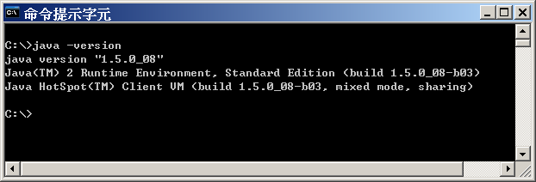
Figure 1. Confirm the Java version on your computer
If you have not already installed JRE or JDK in your computer , you can also download the latest version of JRE or JDK from Sun Java website. Please refer to the instructions on the website for installation steps.
Sun's JAVA official website: http://java.sun.com/javase/downloads/index.jsp
To start NSG2 in the DOS command line to switch to the NSG2 program storage directory (in this case NSG2 is stored in the C: \ nsg2 \ directory) Type " java -jar nsg2.jar " (please refer to Figure 2 ).
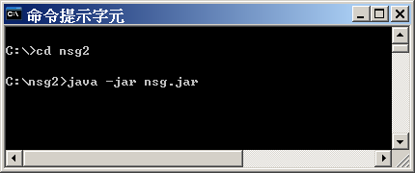
Figure 2. Execute NSG2
NSG 2 basic concepts
Using NSG 2 to generate the script file is very simple. In the design of NSG 2 , we wanted to allow users to create ns2 script files in the most natural and intuitive way , so try to design them with WYSIWYG That is to say most of the users can directly see the location of Node and other related information (coordinates, connections, etc ... ) directly on the screen. After the script is generated, the user can make his own needs for the appropriate Modify, archive the script file (. Tcl ) and then by ns2 to perform, so the use of very simple, if you can seize a few key points, you can easily operate NSG2 .
The following will be for several NSG2 basic concepts for a simple explanation, in NSG 2 , the most convenient place is to generate Node coordinates in the wireless network , in my experience, writing ns2 wireless network script file must be The coordinates (including x, y, z ) of each Node are provided . In order to produce a large number of regular Node , the writing of the script file becomes very complicated. This is also when the author wants to write a tool to assist The reason why the script file is generated, NSG 2 to generate Node coordinates is a fairly easy task.
When using NSG 2 , it is mainly divided into five modes. Most of these modes are designed according to several major objects in ns2 . For the relationship among the objects, refer to Figure 3 . To switch between modes, just press the toggle button at the top of the screen. The NSG 2 contains the following five modes:
- Hand mode
- Node mode
- Link mode (only for wired internet scripts)
- Agent mode
- Application mode

Figure 3. The main object relationship in NSG2
Hand mode
In Hand mode mode is the most simple function , mainly to allow users to adjust the range to watch. When building a large script, it may contain a large number of Node , the screen may not accommodate all the objects, this time can be used to adjust the Hand mode to watch the range, just hold down the left mouse button, and then drag that can.
Node mode
In Node mode mode, the user can configure the location of the Node . In the case of a wired network script, the coordinates of the Node are not important, mainly because of their relative positions. However, the NSG still determines the Node- related position To configure the location of the Node in NAM .
When designing a wireless network scenario, Node coordinates becomes very important, because each coordinate Node will affect transmission range and signal strength, etc. Routing protocol, so when a wireless network build script, NSG 2 will The bottom of the screen shows the coordinates of the information as a reference. NSG and assumes the transmission distance is 250m wireless network Node (actual effective transmission distance of an analog wireless networks is determined according to the set parameters), when the transmission distance is within 250m of the two Node, will NSG 2 Draw a connection between the two, users can click on the Node and drag to adjust the position of the Node to be placed . In addition, Node mode also provides a way to generate multiple Node , which includes: Chain vertical and horizontal, Grid ( n × n ) and Random , users only need to set the distance between Node and Node , You can easily generate a large number of regular network topology.
Link mode
Link mode is only applicable to the script of the wired network. This setting is not needed in the wireless network. In Link mode , it can be used to set the link between Node and Node , such as Simplex-link or Duplex-link , and set related parameters (Transmission speed, queue type, etc.). When using the first property set, and then use the mouse to select two Node to link, after set up, can also be used to modify the parameters of right-link or delete links.
Agent mode
In Agent mode , the user can set up a communication protocol to be attached to the Node ( referred to as Agent in ns2 ). At present, NSG 2 mainly supports TCP (including multiple variants) and UDP protocol. The setting method is as simple as Click on the left mouse button to attach the Node , and then click to place A gent can be placed , the Agent 's focus is attached to a Node instead of its location, the location is set to display the screen Fills, so the user can place the position in a clearly identifiable position can be.
In addition to setting the Node Ag ent mode Agent belongs, you can also set the information about the transmitter and receiver, by selecting two Agent can use to be paired, in general, TCP A gent ns2 must correspond to TCP-Sink A gent , while UDP A gent corresponds to Null A gent where TCP A gent and UDP A gent are senders , and TCP-Sink A gent and Null A gent are TCP A gent and UDP A respectively gent receiver. Matching issues such as pairing two TCP Agents or pairing a TCP A gent with a UDP A gent is not meaningful when setting the sender and the receiver .
After setting the Agent , you can also use the right mouse button to modify or modify the parameters of the Agent or delete Agent , some of the details of the parameters in the generation of Agent can not be set directly, we must first establish A gent , and then use the right mouse button pop-up menu is set, for example, the TCP congestion window and packet size, and other related settings.
Application mode
Under the Application mode mode can be used to set the top of the application, such as CBR and FTP, just click on the Agent to be added when setting the left mouse button, and then click to the placement of Application can also The focus of the Application is on the additional Agent rather than its location, so the location is set as long as it is clearly identifiable.
And set the same agent , when set Application , you can use the right mouse button to modify the Application parameters or delete Application , some of the parameters in the Application can not be set directly, you must first create a good Application , then use the right mouse button the pop-up menu is set, for example, the CBR packet si ze Transmission rate and other related settings.
Parameters
When addition to the above five modes, in addition to the function of parameter setting, the wired network script, set the parameter name contains the simulation time profile and Trace (Trace file containing the NAM), in establishing a wireless network script is another more Wi-Fi (wireless) and channel characteristics (channel) related settings. It is worth mentioning that, NSG 2 provides a set of analog 802.11b reference values in the related settings of channel characteristics , but it will not be enabled by default. If users want to enable these settings, select The box on the left of the screen can be, of course, you can set the new value according to the simulation needs.
When everything is set up, press the TCL button to generate TCL script file, the user can also make some adjustments in the script file at this time, after the adjustment is completed, the file can be stored and use ns2 to execute.
Finally, a few things to note:
- When setting the parameters, if necessary parameters then the user must be provided, otherwise the NSG will pop up a warning message; if non-essential parameters, you can enter -1 if the parameter is set to -1 when it is generated TCL script file will be ignored NSG This parameter. In addition, the NSG will not check the correctness of the parameters. For example, if you enter a queue size of -50 , the NSG will "faithfully" write the value into the script file.
- When deleting an object, the object associated object belongs, and also a deletion, such as deleting a Node, all connected to the Link to Node and the Node all attached to the Agent will be deleted, and when the Agent is deleted, All attached to the Agent's Application will also delete.
- If you set the Agent , the transmitter (or receiver) is not set, then the Agent will be ignored when generating the TCL script file , because even if the Agent settings are added to the script file simulation will not be effective.
Use NSG to generate wired web scripts
Then I will be a simple example to introduce how to generate a NSS in a wired network scenario file, the simulation environment as shown in Figure 4 .

Figure 4. Wired network topology
Put a total of six Node in this simulation environment , the following conditions:
- Create a CBR connection (labeled as cbr 0 ) with the protocol UD P as a communication protocol between n 0 and n 4 .
- Create a CBR connection (labeled cbr 1 ) with UDP as the protocol between n 1 and n 5 .
- The bandwidth between n0 - n2 , n1 - n2 , n3 - n4 , n3 - n5 is 2M bps , and the delay time is set to 1 0ms .
- n2 - n is 3 to bandwidth 1M bps, the delay time is set to 20m s.
- All links are Duplex-link , queue management mechanism is to use DropTail , and the queue length ( Queue limit ) are set to 10 packet length.
In the application settings:
- cbr 0 packet size is set to 1500bytes , and to 1M bps transmission speed to send data, the simulation time of 1 second to start sending data, the end of the first 4 seconds to send.
- cbr 1 packet size is also set to 1500bytes , and to 1M bps transmission speed to send data, and simulation time of 2 seconds to start sending data, the end of the first 3 seconds to send.
- The entire simulation time is set to 5 seconds.
Note: Due to the UDP protocol ns2 default packet size is 1000bytes, that is, when the packet size exceeds 1000bytes when UDP packets will be cut into smaller pieces to convey (Segmentation), so to be specified when setting UDP packet size 1500bytes to avoid the upper application packet is cut by UDP .
In this experiment, we can see that both cbr connections pass n2 - n3 and the bandwidth of this link is 1M bps . However, cbr 0 is transmitted at 1M bps , which makes the entire n2 - n3 Bandwidth is cbr 0 packets are filled, so when cbr 1 also began to transmit, you will find n2 - n3 traffic began to become crowded, after a period of time, when the n3 queue is full when Some packets will begin to be discarded at n3 , which continues until cbr 1 finishes the transfer.
Actual operation
Step1: Add a script of a wired network, a user may be established via ario → New wired scenario SCEN (or press the shortcut Ctrl + W), after the establishment shown in Figure 5, in the case of the NSG will default Switch to Node mode ( Node button turns gray), which means the user can set up Node right away .
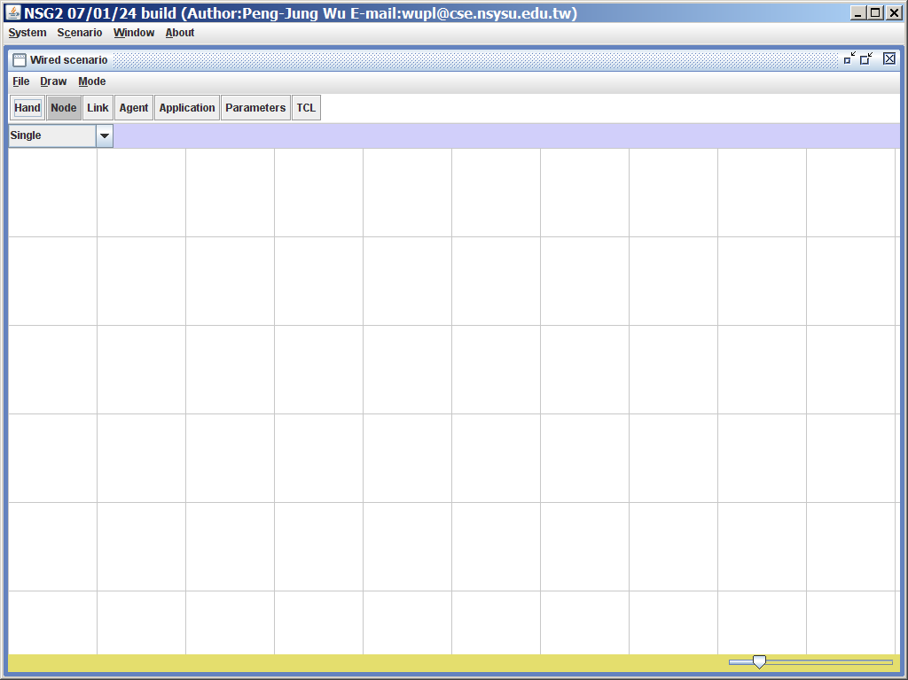
Figure 5. Add a cable network of the script
Step2 : Start the script needed to start the Node , use the mouse to click directly to the position you want to put the Node to establish Node , in this example the relative position of the six Node established in Figure 6 , by adjusting the lower right of the screen The bars show different proportions.
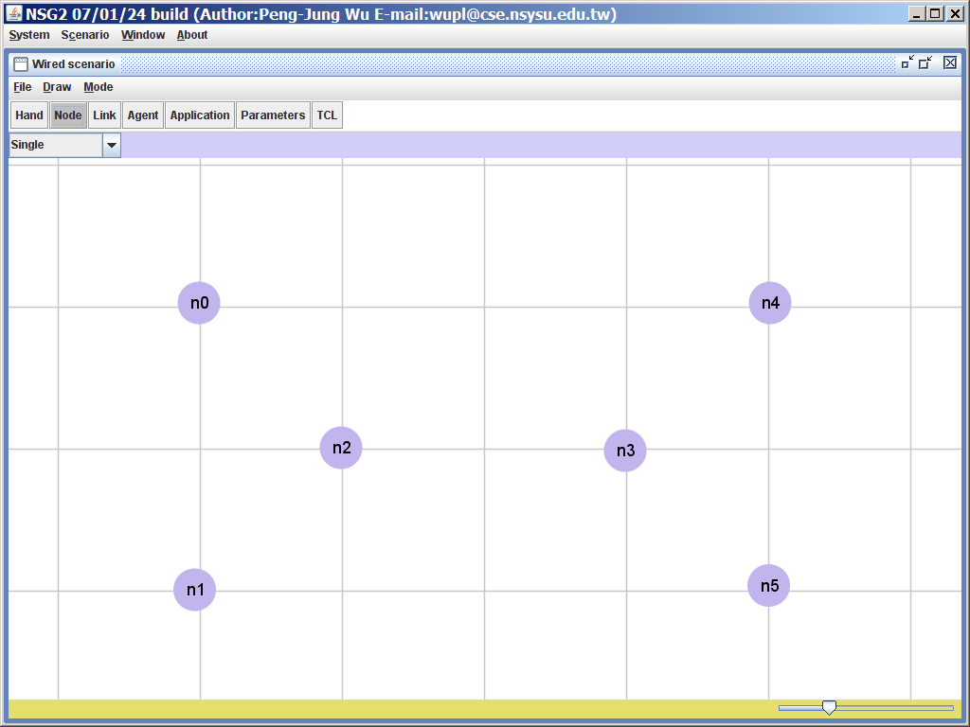
Figure 6: set the location of the six nodes
Step3 : Set the link between Node , first switch to Link mode ( press the Link button or shortcut key Ctrl + 3 ), and then set the following parameters in order.
- Link-type : duplex-link
- Queue type : DropTail
- Capacity : 2Mbps
- Propagation delay : 10ms
- Queue size : 10
Step4 : Set up the link between n0 - n2 , n1 - n2 , n3 - n4 and n3 - n5 by mouse clicking , then set Capacity to 1M bps , Propagation delay to 20m s , and then Establish the link between n2 and n3 . After the establishment is completed, as shown in Figure 7 , if there is no parameter set during the establishment process, you can also right-click the link and modify it.
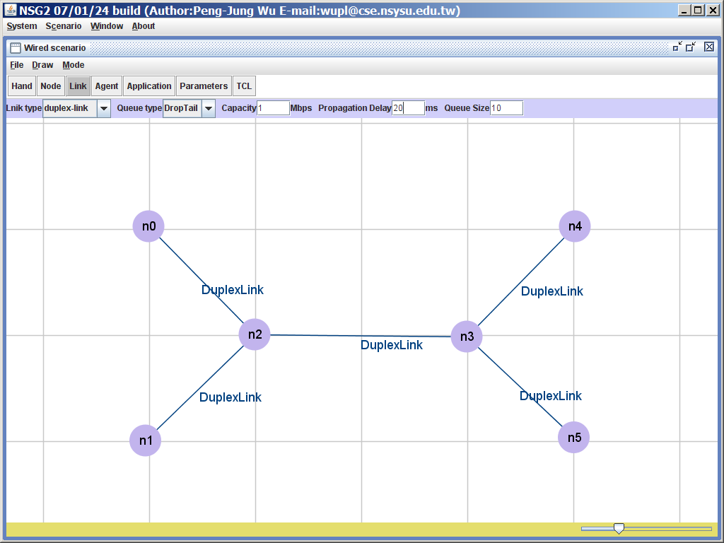
Figure 7: Set the link between the six nodes
Step5 : Then switch to the Agent mode ( press the Agent button or shortcut Ctrl + 4 ) to carry out the communication protocol settings . Agent type first select set of packet size and UD P (Packet size) is 1500 bytes, and each of a build Agent on n0 and n1, then select Agent type is NULL, and each establishing a NULL Agent on n4, n5. Once you have created will continue to set connection between Agent Agent, which embodiment is set to establish a connection of the mouse to select two Agent, here respectively (udp0, null2) and (udp1, n ull 3) Establish a connection between the established as shown in Figure 8 .
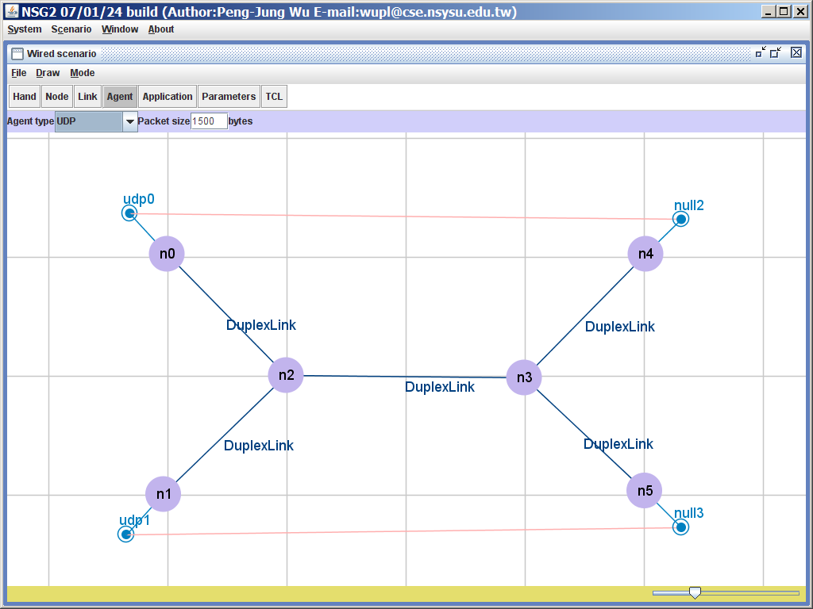
Figure 8: Establishing Agents
Step6: switch to MODE Application (Application button or pressing shortcut Ctrl + 5) to the upper application settings, set to the Application type CBR and set the start time (Start time) is 1 second, the end time (Stop time) 4 seconds, the packet size is 1500 bytes, the transmission speed of 1Mbps, then build a CBR Application on n0, then start time (start time) to 2 seconds, the end time (Stop time) is 3 seconds, and the n 1 Then create a CBR Application , as shown in Figure 9 .
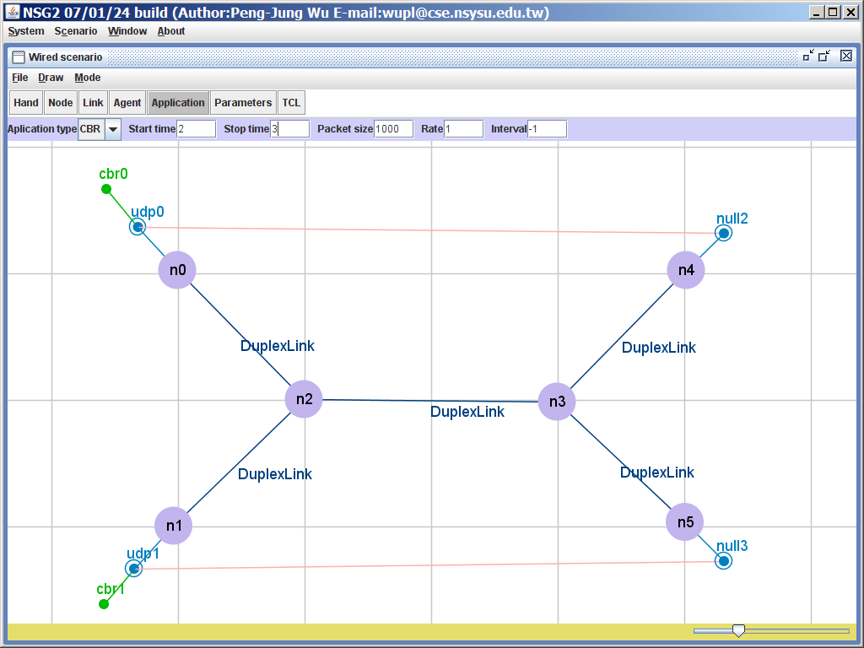
Figure 9: Establishing Application
Step7: Finally, the simulation parameter setting (or pressing Parameters button shortcut to Ctrl + 6), in this example, since the script is to establish a wired network, it only need to the analog part of the time parameter (Simulation time ) Is set to 5.0 , and specify the Trace file name can be generated , as shown in Figure 10 .
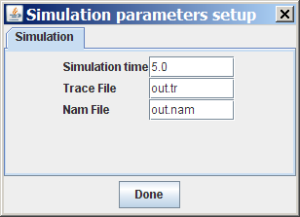
Figure 10: Set simulation parameters
Step8 : When everything is set, press the TCL button ( Ctrl + 7 ) can produce the script file, the script file generated each time will be based on a separate window, the user at this time can also be based on their own Needs to be amended, as shown in Figure 11 .
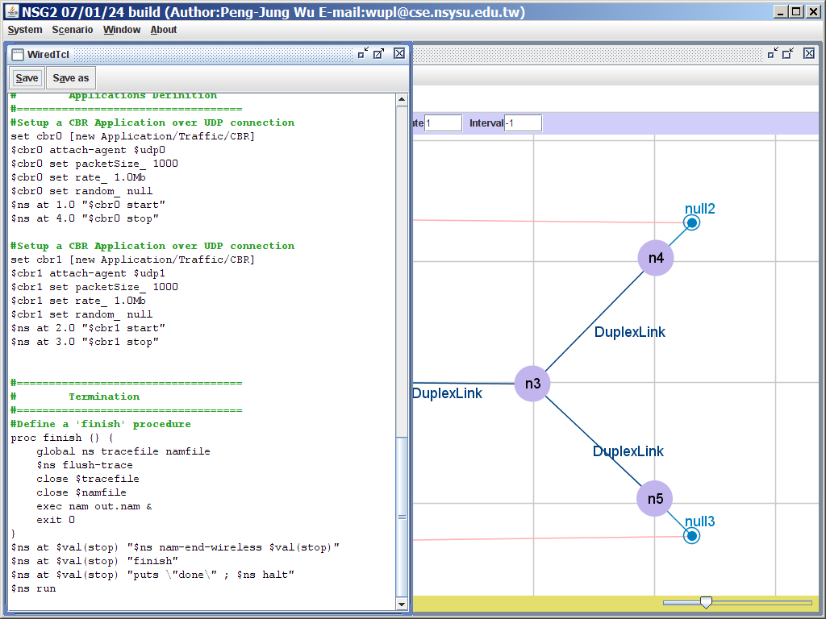
Figure 11. Produce the script file
Step9 : Press the Save button (shortcut key Alt + S ) TCL file generated will be stored up, you can go to ns2 start simulation, the script file generated as follows .

# This script is created by NSG2 beta1
# <http://wushoupong.googlepages.com/nsg>

# ===================================
# Simulation parameters setup
# ===================================
set val (stop) 5.0; # time of simulation end

# ===================================
# Initialization
# ===================================
#Create a ns simulator
set ns [new Simulator]

#Open the NS trace file
set tracefile [open out.tr w]
$ ns trace-all $ tracefile

#Open the NAM trace file
set namfile [open out.nam w]
$ ns namtrace-all $ namfile

# ===================================
# Nodes Definition
# ===================================
#Create 6 nodes
set n0 [$ ns node]
set n1 [$ ns node]
set n2 [$ ns node]
set n3 [$ ns node]
set n4 [$ ns node]
set n5 [$ ns node]

# ===================================
# Links Definition
# ===================================
#Createlinks between nodes
$ ns duplex-link $ n0 $ n2 2.0Mb 10ms DropTail
$ ns queue-limit $ n0 $ n2 10
$ ns duplex-link $ n2 $ n1 2.0Mb 10ms DropTail
$ ns queue-limit $ n2 $ n1 10
$ ns duplex-link $ n4 $ n3 2.0Mb 10ms DropTail
$ ns queue-limit $ n4 $ n3 10
$ ns duplex-link $ n3 $ n5 2.0Mb 10ms DropTail
$ ns queue-limit $ n3 $ n5 10
$ ns duplex-link $ n2 $ n3 1.0Mb 20ms DropTail
$ ns queue-limit $ n2 $ n3 10

#Give node position (for NAM )
$ ns duplex-link-op $ n0 $ n2 orient right-down
$ ns duplex-link-op $ n2 $ n1 orient left-down
$ ns duplex-link-op $ n4 $ n3 orient left-down
$ ns duplex-link-op $ n3 $ n5 orient right-down
$ ns duplex-link-op $ n2 $ n3 orient right

# ===================================
# Agents Definition
# ===================================
#Setup a UDP connection
set udp0 [new Agent / UDP]
$ ns attach-agent $ n0 $ udp0
set null2 [new Agent / Null]
$ ns attach-agent $ n4 $ null2
$ ns connect $ udp0 $ null2
$ udp0 set packetSize_ 1500

#Setup a UDP connection
set udp1 [new Agent / UDP]
$ ns attach-agent $ n1 $ udp1
set null3 [new Agent / Null]
$ ns attach-agent $ n5 $ null3
$ ns connect $ udp1 $ null3
$ udp1 set packetSize_ 1500

# ===================================
# Applications Definition
# ===================================
#Setup a CBR Application over UDP connection
set cbr0 [new Application / Traffic / CBR]
$ cbr0 attach-agent $ udp0
$ cbr0 set packetSize_ 1500
$ cbr0 set rate_ 1.0Mb
$ cbr0 set random_ null
$ ns at 1.0 "$ cbr0 start"
$ ns at 4.0 "$ cbr0 stop"

#Setup a CBR Application over UDP connection
set cbr1 [new Application / Traffic / CBR]
$ cbr1 attach-agent $ udp1
$ cbr1 set packetSize_ 1500
$ cbr1 set rate_ 1.0Mb
$ cbr1 set random_ null
$ ns at 2.0 "$ cbr1 start"
$ ns at 3.0 "$ cbr1 stop"

# ===================================
# Termination
# ===================================
#Define a 'finish' procedure
proc finish {} {
global ns tracefile namfile
$ ns flush-trace
close $ tracefile
close $ namfile
exec nam out.nam &
exit 0
}
$ ns at $ val (stop) "$ ns nam-end-wireless $ val (stop)"
$ ns at $ val (stop) "finish"
$ ns at $ val (stop) "puts \" done \ "; $ ns halt"
$ ns run

NSG arising out of the script file will automatically start to render NAM process simulation, and if you do not want to start NAM parameters can be set in the NSG, the NAM File option is set to -1, the NSG will not start to write instructions NAM Into the script file. FIG 12 is a NAM startup screen, it can be seen in the simulation time of 2.1 seconds, n2 packet is discarded due to the influx of too many packets phenomena occur simultaneously.
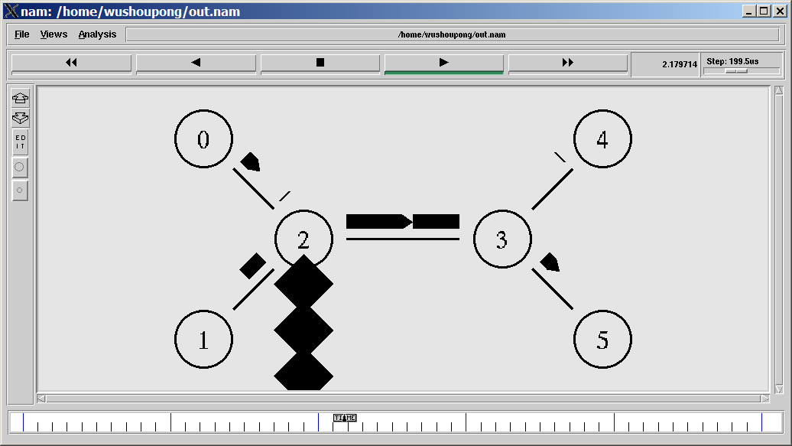
Figure 12
The following part of the interception of the Trace file, the contents of the Trace file can also be observed packet discarded phenomenon ( d on behalf of the drop ).
Before slightly
r 2.12 3 5 cbr 1500 ------- 0 1.0 5.0 2 88
r 2.12 0 2 cbr 1500 ------- 0 0.0 4.0 92 101
+ 2.12 2 3 cbr 1500 ------- 0 0.0 4.0 92 101
d 2.12 2 3 cbr 1500 ------- 0 0.0 4.0 92 101
- 2.12 2 3 cbr 1500 ------- 0 1.0 5.0 4 92
r 2.124 1 2 cbr 1500 ------- 0 1.0 5.0 9 102
+ 2.124 2 3 cbr 1500 ------- 0 1.0 5.0 9 102
r 2.128 2 3 cbr 1500 ------- 0 1.0 5.0 3 90
+ 2.128 3 5 cbr 1500 ------- 0 1.0 5.0 3 90
- 2.128 3 5 cbr 1500 ------- 0 1.0 5.0 3 90
+ 2.128 0 2 cbr 1500 ------- 0 0.0 4.0 94 105
- 2.128 0 2 cbr 1500 ------- 0 0.0 4.0 94 105
+ 2.132 1 2 cbr 1500 ------- 0 1.0 5.0 11 106
- 2.132 1 2 cbr 1500 ------- 0 1.0 5.0 11 106
r 2.132 3 4 cbr 1500 ------- 0 0.0 4.0 86 89
r 2.132 0 2 cbr 1500 ------- 0 0.0 4.0 93 103
+ 2.132 2 3 cbr 1500 ------- 0 0.0 4.0 93 103
d 2.132 2 3 cbr 1500 ------- 0 0.0 4.0 93 103
- 2.132 2 3 cbr 1500 ------- 0 0.0 4.0 88 93
r 2.136 1 2 cbr 1500 ------- 0 1.0 5.0 10 104
+ 2.136 2 3 cbr 1500 ------- 0 1.0 5.0 10 104
slightly

