电信计费系统
操作系统:linux
语种:Java
技术:Servlet/JSP
数据库:oracle
Jdk1.7
Apache7.60

- 新建项目netctoss Maven项目
中国电信运行支持系统-网络版
- 导包
- JAVAEE
- JSTL
- JDBC
- DBCP(技术)
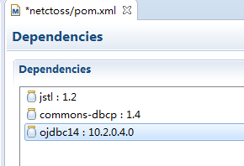

先做咨询功能fee_list.html 从何入手???

画图分析:
一个servlet处理所有请求

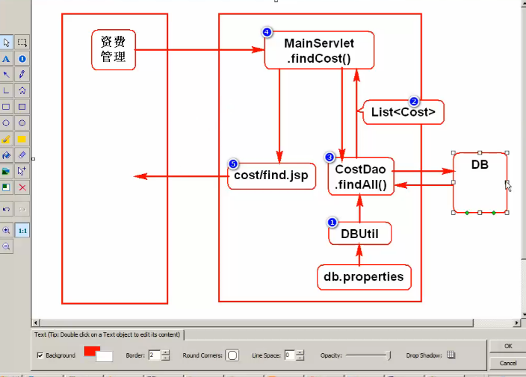
1.连接数据库:
Util->DButil.java

DButil.java
/** 声明连接池(导入commons-dbcp:1.4的jar包) */
private static BasicDataSource ds;

static{
//读取连接参数
Properties p = new Properties();
try {
/** 读取参数 */
p.load(DBUtil.class.getClassLoader().getResourceAsStream("db.properties"));
/** 数据库连接参数 */
String driver = p.getProperty("driver");
String url = p.getProperty("url");
String user = p.getProperty("user");
String pwd = p.getProperty("pwd");
/** 连接池参数 */
String initSize = p.getProperty("initSize");
String maxSize = p.getProperty("maxSize");
/** 创建连接池，并设置参数 */
ds = new BasicDataSource();
/* 设置连接数据库 */
ds.setDriverClassName(driver);
/* 设置连接地址，端口，sid*/
ds.setUrl(url);
/* 设置帐号 */
ds.setUsername(user);
/* 设置密码 */
ds.setPassword(pwd);
/* 设置初始连接数 */
ds.setInitialSize(Integer.parseInt(initSize));
/* 设置最大连接数 */
ds.setMaxActive(Integer.parseInt(maxSize));
} catch (IOException e) {
e.printStackTrace();
throw new RuntimeException("找不到文件",e);
}
}

public static Connection getConnection() throws SQLException{
return ds.getConnection();
}
/**
* 创建一个归还连接的方法
* 连接池创建的连接，其close方法不再是关闭连接，而是将连接归还给连接池
* 连接池会将此连接数据清空并标识为空闲
* @param conn
*/
public static void close(Connection conn){
if(conn != null){
try {
conn.close();
} catch (SQLException e) {
e.printStackTrace();
throw new RuntimeException("归还连接失败",e);
}
}
}

public static void main(String[] args) throws SQLException {
System.out.println(123);
Connection conn = DBUtil.getConnection();
System.out.println(conn);
}
}

resources->db.properties
Db.properties
# db params(no space)
driver=oracle.jdbc.driver.OracleDriver
url=jdbc:oracle:thin:@172.230.8.99:1523:oracle
user=system
pwd=123456789
# DateSource params
initSize=1
maxSize=3

2.包
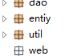
- entity 表里有什么字段写什么属性
Cost.java 实体类
private Integer costId; //资费ID
private String name; //资费名称
private Integer baseDuration; //基本时长
private Double baseCost; //基本费用
private Double unitCost; //单位费用
private Integer status; //状态 0 开通 1暂停
private String descr; //描述
private Timestamp creatime; //创建时间
private Timestamp startime; //开通时间
private String costType; //资费类型 1-包月 2-套餐 3-计时
- dao
CostDao.java
提取 Alt+Shift+M 封装一个方法,createCost

public class CostDao {
public List<Cost> findAll() {
Connection conn = null;
try {
conn = DBUtil.getConnection();
String sql = "select * from cost_wx order by cost_id";
Statement smt = conn.createStatement();
ResultSet rs = smt.executeQuery(sql);
List<Cost> list = new ArrayList<Cost>();
while(rs.next()){
//提取 Alt+Shift+M 封装一个方法,createCost
Cost c = createCost(rs);
list.add(c);
}
return list;
} catch (Exception e) {
e.printStackTrace();
throw new RuntimeException("查询资费失败",e);
}
}
//Alt+Shift+M
private Cost createCost(ResultSet rs) throws SQLException {
Cost c = new Cost();
c.setCostId(rs.getInt("cost_id"));
c.setName(rs.getString("name"));
c.setBaseDuration(rs.getInt("base_duration"));
c.setBaseCost(rs.getDouble("base_cost"));
c.setUnitCost(rs.getDouble("unit_cost"));
c.setStatus(rs.getString("status"));
c.setDescr(rs.getString("descr"));
c.setCreatime(rs.getTimestamp("creatime"));
c.setStartime(rs.getTimestamp("startime"));
c.setCostType(rs.getString("cost_type"));
return c;
}
//测试
/*public static void main(String[] args) {
CostDao cs = new CostDao();
List<Cost> list = cs.findAll();
for(Cost l:list){
System.out.println(l.getName());
}
}*/
}

- MainServlet -->重写servlet
提问: 1)是否需要接受参数? 2)如果获取路径 req.ervletpath
public class MainServlet extends HttpServlet {
protected void service(HttpServletRequest req, HttpServletResponse res) throws ServletException, IOException {
String path = req.getServletPath();
if ("/findCost.do".equals(path)) {
// 查询所有资费
findCost(req, res);
} else {
throw new RuntimeException("无效的访问路径.");
}
}
protected void findCost(HttpServletRequest req, HttpServletResponse res) throws ServletException, IOException {
//查询所有的资费
CostDao dao = new CostDao();
List<Cost> list = dao.findAll();
//转发到查询页面
//当前路径 /netctoss/findCost.do
//目标: /webapp/WEN-INF/cost/find.jsp
req.setAttribute("costs",list);
req.getRequestDispatcher("WEN-INF/cost/find.jsp").forward(req, res);

}
}

- web.xml配置servlet
<servlet>
<servlet-name> main </servlet-name>
<servlet-class>web.MainServlet</servlet-class>
</servlet>
<servlet-mapping>
<servlet-name>main</servlet-name>
<url-pattern>/find.do</url-pattern>
</servlet-mapping>
- 新建一个find.jsp
Uri->maven->jstl->META-INF->c.tld->12行
<%@ pageEncoding="utf-8"%>
<%@taglib uri="http://java.sun.com/jsp/jstl/core" prefix="c" %>
fee->fee_list.html 全选 粘贴
访问路径 http://localhost:8080/netctoss/findCost.do
复制图片样式 放到webapp下面和WEB-INF平级
图片依然不显示 路径不对 把../去掉
删掉一个模版 留下1 100删掉 使用 EL取值 cost错误
Find.jsp

<c:forEach items="${costs }" var="c">
<tr>
<td>${c.costId }</td>
<td><a href="fee_detail.html">${c.name }</a></td>
<td>${c.baseDuration }</td>
<td>${c.baseCost }</td>
<td>${c.unitCost }</td>
<td>${c.creatime }</td>
<td>${c.startime }</td>
<td>
<c:if test="${c.status=='0' }">开通</c:if>
<c:if test="${c.status=='1' }">暂停</c:if>
</td>
<td>
<input type="button" value="启用" class="btn_start" onclick="startFee();" />
<input type="button" value="修改" class="btn_modify" onclick="location.href='fee_modi.html';" />
<input type="button" value="删除" class="btn_delete" onclick="deleteFee();" />
</td>
</tr>
</c:forEach>

- 增加一条数据

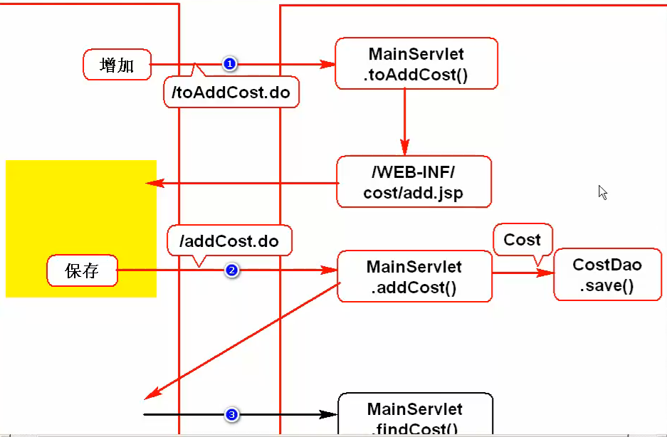

CostDao->save() 方法
public void save(Cost cost) {
Connection conn = null;
try {
conn = DBUtil.getConnection();
String sql = "insert into cost_wx values(cost_seq_wx.nextval,?,?,?,?,'1',?,sysdate,null,?)";
PreparedStatement ps = conn.prepareStatement(sql);
ps.setString(1, cost.getName());
ps.setInt(2, cost.getBaseDuration());
ps.setDouble(3, cost.getBaseCost());
ps.setDouble(4, cost.getUnitCost());
ps.setString(5, cost.getDescr());
ps.setString(6, cost.getCostType());
ps.executeUpdate();
} catch (Exception e) {
e.printStackTrace();
throw new RuntimeException("增加资费失败",e);
}finally{
DBUtil.close(conn);
}
}

//测试save
public static void main(String[] args) {
CostDao dao = new CostDao();
Cost c = new Cost();
c.setName("tarena套餐");
c.setBaseDuration(6000);
//c.setUnitCost(0.1);
//c.setBaseCost(60.0);
c.setDescr("tarena套餐不错");
c.setCostType("2");
dao.save(c);
}
}
问题:当前业务下,基本时长,基本费用.单位,费用有可能为null(包月的情况),字段也允许为空
但setInt/setDouble 方法不允许传入null 可以将这样的数据当作Object处理
ps.setDouble(4, cost.getUnitCost());->ps.setObject()

MainServlet.java
addCost()->
else if("/addCost.do".equals(path)){
addCost(req,res);
}
private void addCost(HttpServletRequest req, HttpServletResponse res) throws Exception {
req.setCharacterEncoding("utf-8");//解决乱码
//接受表单数据
String name = req.getParameter("name");
String baseDuration = req.getParameter("baseDuration");
String baseCost = req.getParameter("baseCost");
String unitCost = req.getParameter("unitCost");
String descr = req.getParameter("desc");
String costType = req.getParameter("costType");
Cost c = new Cost();
c.setName(name);
if(baseDuration != null && !baseDuration.equals("")){
c.setBaseDuration(new Integer(baseDuration));
}
if(baseCost != null && !baseCost.equals("")){
c.setBaseCost(new Double(baseCost));
}
if(unitCost != null && !unitCost.equals("")){
c.setUnitCost(new Double(unitCost));
}
c.setDescr(descr);
c.setCostType(costType);
CostDao dao = new CostDao();
dao.save(c);
//重定向到查询功能
res.sendRedirect("findCost.do");
}
修改add.jsp->input name
name="name"
name="costType" value="1" 2 3
name="baseDuration"
name="baseCost"
name="unitCost"
name="descr"
取消回到查询页面
onclick="history.back();" 内置对象
;
跳转
Mainservlet.java
else if("/toAddCost.do".equals(path)){
toAddCost(req, res);
}
private void toAddCost(HttpServletRequest req, HttpServletResponse res) throws ServletException, IOException {
req.getRequestDispatcher("WEB-INF/cost/add.jsp").forward(req, res);
}

创建add.jsp ->fee_add.html 粘贴进去
修改find.jsp 增加按钮 toAddCost.do
Web.xml 复制一遍

修改: 修改和插入一样 唯一的区别就是 修改页面需要有参数

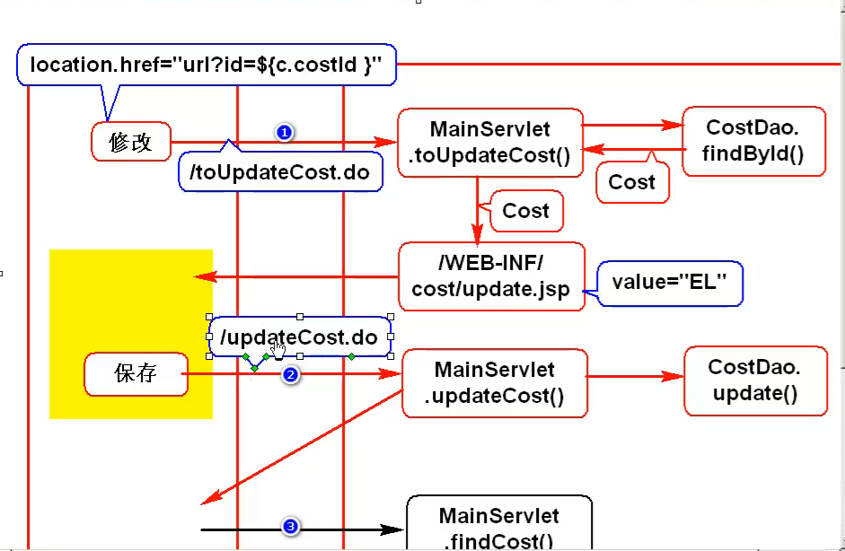

先查询->

//根据Id查询
public Cost findById(int id){
Connection conn = null;
try {
conn = DBUtil.getConnection();
String sql = "select * from emp_wx where cost_id=?";
PreparedStatement ps = conn.prepareStatement(sql);
ps.setInt(1, id);
ResultSet rs = ps.executeQuery();
if(rs.next()){
return createCost(rs);
}
} catch (SQLException e) {
e.printStackTrace();
throw new RuntimeException("查询资费失败",e);
}finally{
DBUtil.close(conn);
}
return null;
}
进行测;

MainSetvlet:
else if("/toUpdateCost.do".equals(path)){
//打开修改资费页
toUpdateCost(req,res);
}

private void toUpdateCost(HttpServletRequest req, HttpServletResponse res) throws ServletException, IOException {
//接受传入的参数
String id = req.getParameter("id");
//查询要修改的数据
CostDao dao=new CostDao();
Cost cost = dao.findById(new Integer(id));
//转发到修改页面
req.setAttribute("cost",cost);
req.getRequestDispatcher("WEB-INF/cost/update.jsp").forward(req, res);

}
新建update.jsp ->fee_modi.html 修改css image 去掉../
修改 find.jsp ->修改按钮连接 onclick="location.href='toUpdateCost.do?id=${c.costId}';"

修改update.jsp 里面的 value

value="${cost.costId} "
value="${cost.name }"
value="${cost.baseDuration }"
value="${cost.baseCost }"
value="${cost.unitCost }"
${cost.descr }
${cost.costType=='1'? 'checked':'' }
${cost.costType=='2'? 'checked':'' }
${cost.costType=='3'? 'checked':'' }

点击保存按钮->作业
CostDao-->update

public void update(Cost cost){
Connection conn = null;
try {
conn = DBUtil.getConnection();
String sql = "update cost_wx set name=?,base_duration=?,base_cost=?,unit_cost=?,status=0,descr=?,creatime=sysdate,startime=null,cost_type=? where cost_id=?";
PreparedStatement ps = conn.prepareStatement(sql);
ps.setString(1, cost.getName());
ps.setInt(2, cost.getBaseDuration());
ps.setDouble(3, cost.getBaseCost());
ps.setDouble(4, cost.getUnitCost());
ps.setString(5, cost.getDescr());
ps.setString(6, cost.getCostType());
ps.setInt(7, cost.getCostId());
ps.executeUpdate();
} catch (Exception e) {
e.printStackTrace();
throw new RuntimeException("增加资费失败",e);
}finally{
DBUtil.close(conn);
}
}
SetObject
测试:
//测试
public static void main(String[] args) {
CostDao dao = new CostDao();
Cost c = new Cost();
c.setCostId(100);
c.setName("wx爱编程");
c.setBaseDuration(100);
c.setBaseCost(20.0);
c.setUnitCost(0.6);
c.setDescr("爱编程丫爱变成");
c.setCostType("2");
dao.update(c);
}
mainServlet.java

//处理更新页面
private void updateCost(HttpServletRequest req, HttpServletResponse res) throws IOException {
req.setCharacterEncoding("UTF-8");
res.setCharacterEncoding("UTF-8");
String id = req.getParameter("costId");
String name = req.getParameter("name");
String baseDuration = req.getParameter("baseDuration");
String baseCost = req.getParameter("baseCost");
String unitCost = req.getParameter("unitCost");
String descr = req.getParameter("desc");
String costType = req.getParameter("costType");
Cost c = new Cost();
c.setName(name);
c.setCostId(new Integer(id));

if(baseDuration != null && !baseDuration.equals("")){
c.setBaseDuration(new Integer(baseDuration));
}
if(baseCost != null && !baseCost.equals("")){
c.setBaseCost(new Double(baseCost));
}
if(unitCost != null && !unitCost.equals("")){
c.setUnitCost(new Double(unitCost));
}
c.setDescr(descr);
c.setCostType(costType);
CostDao dao = new CostDao();
dao.update(c);
//重定向到查询功能
res.sendRedirect("findCost.do");

}

删除:
Find.jsp->href=”local”
CostDao ->delete()

public void delete(Cost cost){
Connection conn = null;
try {
conn = DBUtil.getConnection();
String sql = "delete from cost_wx where cost_id=?";
PreparedStatement ps = conn.prepareStatement(sql);
ps.setInt(1, cost.getCostId());
ps.executeUpdate();
} catch (SQLException e) {
e.printStackTrace();
}
}

测试:
public static void main(String[] args) {
CostDao dao = new CostDao();
Cost c = new Cost();
c.setCostId(100);
dao.delete(c);
}

MainServlet.java

else if("/delCost.do".equals(path)){
delete(res,req);
}

//执行删除
private void delete(HttpServletResponse res, HttpServletRequest req) throws IOException {
String id = req.getParameter("id");
Cost c = new Cost();
c.setCostId(new Integer(id));
CostDao dao = new CostDao();
dao.delete(c);
res.sendRedirect("findCost.do");
}

登录: 设置数据库 admin_info_XXX

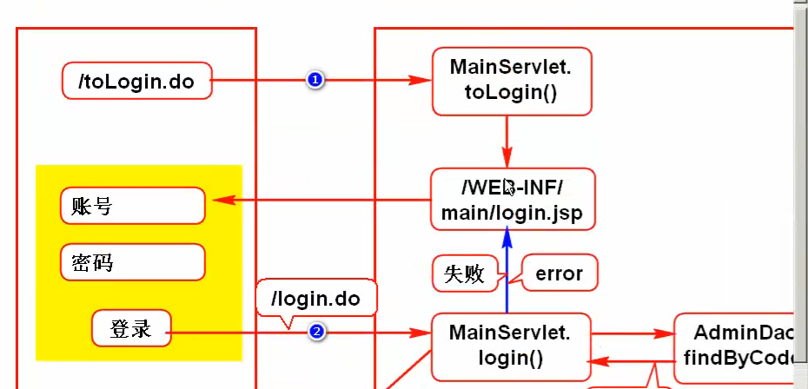
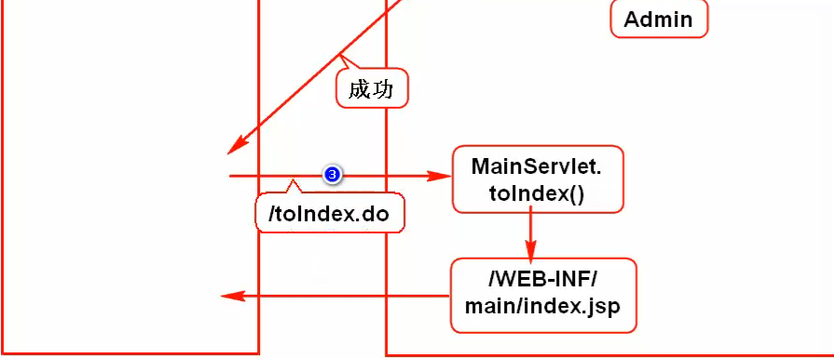
MainSetvlet.java
//登录判断
else if("/toLogin.do".equals(path)){
toLogin(req,res);
}
//跳转登录页面
private void toLogin(HttpServletRequest req, HttpServletResponse res) throws ServletException, IOException {
//转发
req.getRequestDispatcher("WEB-INF/main/login.jsp").forward(req, res);; }
//主页判断
else if("/toIndex.do".equals(path)){
toIndex(req,res);
}
//跳转主页
private void toIndex(HttpServletRequest req, HttpServletResponse res) throws ServletException, IOException {
req.getRequestDispatcher("WEB-INF/main/index.jsp").forward(req, res);
}

新建文件夹 main->login.jsp main->index.jsp 静态代码粘过来

在entity包下,新建Admin实体类

private Integer adminId; //管理员ID
private String adminCode; //管理员帐号
private String password; //密码
private String name; //名字
private String email; //邮箱
private String telephone; //电话
private Timestamp enrolldate; //时间
Get() set()

在dao包下,新建 AdminDao类
生成注释快捷键 Alt+Shift+j
public Admin findByCode(String code){
Connection conn = null;
try {
conn = DBUtil.getConnection();
String sql = "select * from admin_info_wx "
+ "where admin_code=?";
PreparedStatement ps = conn.prepareStatement(sql);
ps.setString(1, code);
ResultSet rs = ps.executeQuery();
if(rs.next()){
Admin a = new Admin();
a.setAdminId(rs.getInt("admin_id"));
a.setAdminCode(rs.getString("admin_code"));
a.setPassword(rs.getString("password"));
a.setName(rs.getString("name"));
a.setEmail(rs.getString("email"));
a.setTelephone(rs.getString("telephone"));
a.setEnrolldate(rs.getTimestamp("enrolldate"));

return a;

}
} catch (Exception e) {
e.printStackTrace();
throw new RuntimeException("查询用户失败",e);
}finally{
DBUtil.close(conn);
}
return null;

//测试
public static void main(String[] args) {
AdminDao dao = new AdminDao();
Admin a = dao.findByCode("admin");
System.out.println(a.getName());
}
Mainservlet.java
else if("/login.do".equals(path)){
//登录
login(req,res);
}
//登录
private void login(HttpServletRequest req, HttpServletResponse res) throws ServletException, IOException {
//接收表单数据
String adminCode = req.getParameter("adminCode");
String password = req.getParameter("password");
//验证帐号密码
AdminDao dao = new AdminDao();
Admin admin= dao.findByCode(adminCode);
if(admin == null){
//帐号错误,转发到登录页
req.setAttribute("error", "帐号错误");
req.getRequestDispatcher("WEB-INF/main/login.jsp").forward(req, res);
}else if(!admin.getPassword().equals(password)){
//密码错误,转发到登录页
req.setAttribute("error", "密码错误");
req.getRequestDispatcher("WEB-INF/main/login.jsp").forward(req, res);
}else{
//登陆成功重定向到主页
res.sendRedirect("toIndex.do");
}
}

Login.jsp
<form action="login.do" method="post"><form>
Name=>adminCode name=>password
超链接调用submit 使用js
Document.getElementsById....
<a href="javascript:document.forms[0].submit"></a>
错误提示
${error }
记住密码 value="${param.adminCode}" value="${param.password}"

使用引用 include
Shift+table 左移
菜单栏 web-inf/men.jsp
绝对路径 /项目名/路径
<ul id="menu">
<li><a href="/netctoss/toIndex.do" class="index_off"></a></li>
<li><a href="" class="role_off"></a></li>
<li><a href="" class="admin_off"></a></li>
<li><a href="/netctoss/findCost.do" class="fee_off"></a></li>
<li><a href="" class="account_off"></a></li>
<li><a href="" class="service_off"></a></li>
<li><a href="" class="bill_off"></a></li>
<li><a href="" class="report_off"></a></li>
<li><a href="" class="information_off"></a></li>
<li><a href="" class="password_off"></a></li>
</ul>

Index.jsp -->引用
<%@include file="../menu.jsp" %> 一开始
改成 el表达式
先引入 <%@taglib uri="http://java.sun.com/jsp/jstl/core" prefix="c" %>
<c:import url="../menu.jsp"></c:import>
修改各个 jsp

异常的统一处理
web.xml配置
<!--1.通过异常类型来判断了解 -->
<!--1.通过异常类型来判断了解 -->
<error-page>
<exception-type>java.long.Exception</exception-type>
<location>/WEB-INF/error.jsp</location>
</error-page>
<!--2.通过编号来判断 -->
<error-page>
<error-code>404</error-code>
<location>/WEB-INF/error.jsp</location>
</error-page>
<error-page>
<error-code>500</error-code>
<location>/WEB-INF/error.jsp</location>
</error-page>

新建error.jsp 粘贴过来
修改倒计时 24行 33
“/netctoss/toLogin.do”

登录会显示登录用户名 在退出的后面 使用
cookie来操作
Login->登陆成功之前 cookie写法
//将账号存入cookie
Cookie cookie = new Cookie("adminCode",adminCode);
//发送到浏览器
res.addCookie(cookie);

新建一个 logo.jsp find.jsp 32行
<img src="images/logo.png" alt="logo" class="left"/>
<!--格式固定不变 -->
<span>${cookie.adminCode.value }</span>
<a href="#">[退出]</a>
<c:import url="../logo.jsp"></c:import>

Session写法
//将账号存入session
HttpSession session = req.getSession();
session.setAttribute("adminCode",adminCode);
<span>${adminCode }</span>
<a href="/netctoss/logout.do">[退出]</a>
else if("/logout.do".equals(path)){
//登出
logout(req,res);
}
//登出
private void logout(HttpServletRequest req, HttpServletResponse res) throws IOException {
//销毁session
req.getSession().invalidate();
//重定向
res.sendRedirect("toLogin.do");
}

登录验证码
把imageUtil.java 粘贴过来
测试
else if("/createImage.do".equals(path)){
//生成验证码
createImage(req,res);
}
//生成验证码图片
private void createImage(HttpServletRequest req, HttpServletResponse res) throws IOException {
Object[] objs = ImageUtil.createImage();
//objs[0] 验证码 objs[1] 图片
//讲验证码存入session
HttpSession session = req.getSession();
session.setAttribute("imagecode", objs[0]);
//讲图片输出给浏览器
res.setContentType("image/png");
OutputStream os = res.getOutputStream();
ImageIO.write((BufferedImage)objs[1], "png", os);
os.close();
}

在login.jsp 27行 更换地址 src="createImage.do"

点击更换验证码
onclick="this.setAttribute('src','createImage.do?x='+Math.random());"
Logo.jsp 26行 name=”code”
MainServlet.jsp
Logo()

String code = req.getParameter("code");
HttpSession session = req.getSession();
String imageCode = (String) session.getAttribute("imagecode");
//验证验证码
if(code == null || code.equals("") || !code.equalsIgnoreCase(imageCode)){
req.setAttribute("error", "验证码错误");
req.getRequestDispatcher("WEB-INF/main/login.jsp").forward(req, res);
return;
}

没有登录 不让进去主页查询?

Filter在Tomcat启动时只创建并初始化一次. 所以他是单利
哪些不需要过滤 toLogin.do login.do createImage.do
哪些需要过滤 toIndex.do logout.do findCost.do toAdd.do toUpdate.do

Web->loginFilter->实现FIlter
public class LoginFilter implements Filter {

public void destroy() {}
public void doFilter(ServletRequest req,
ServletResponse res, FilterChain chain)
throws IOException, ServletException {
HttpServletRequest request = (HttpServletRequest) req;
HttpServletResponse response = (HttpServletResponse) res;
//判断当前请求是否为需要排除检查的请求,如果是则不对此进行检查

//尝试从session中获取帐号
HttpSession session = request.getSession();
String adminCode =(String) session.getAttribute("adminCode");

if(adminCode == null){
//未登录重定向到登录页面
//request.getContentType() 获取项目名 /netctoss
response.sendRedirect(request.getContextPath()+"/toLogin.do");
}else{
//已登录,请求继续执行
chain.doFilter(request, response);
}

}
public void init(FilterConfig arg0)
throws ServletException {}

}

配置FIlter
Web.xml 全部都过滤
<!-- 登录过滤器 -->
<filter>
<filter-name>login</filter-name>
<filter-class>web.LoginFilter</filter-class>
<!--声明不需要检查的路径 -->
</filter>
<filter-mapping>
<filter-name>login</filter-name>
<url-pattern>*.do</url-pattern>
</filter-mapping>
排除需要不过滤的
<!--声明不需要检查的路径 -->
<init-param>
<param-name>excludePath</param-name>
<param-value>
/toLogin.do,/login.do,/createImage.do
</param-value>
</init-param>

LoginFilter.java
//需要排除检查的请求路径
private String[] paths;
public void init(FilterConfig cfg)
throws ServletException {
//从配置文件里面读取出来
String excludePath =
cfg.getInitParameter("excludePath");
paths = excludePath.split(",");
}
在这之前
//判断当前请求是否为需要排除检查的请求,如果是则不对此进行检查
String p = request.getServletPath();
for(String path:paths){
if(p.equals(path)){
//当前请求不需要检查
//让请求继续执行
chain.doFilter(request, response);
return;
}
}

