1. 服务端采用Docker搭建，安装包下载地址: <https://github.com/Jonnyan404/zerotier-planet>

|  |
| --- |
| git clone https://github.com/Jonnyan404/zerotier-planet  OR  git clone https://gitee.com/Jonnyan404/zerotier-planet  cd zerotier-planet  docker-compose up -d  # 以下步骤为创建planet和moon  docker cp mkmoonworld-x86_64 ztncui:/tmp  docker cp patch.sh ztncui:/tmp  docker exec -it ztncui bash /tmp/patch.sh  docker restart ztncui |

下载planet文件: ./zerotier-planet/ztncui/etc/myfs/planet

1. Windows客户端（参照: <https://www.mrdoc.fun/doc/443/>）

下载地址: <https://www.zerotier.com/download/>

用第1步中planet文件替换在C盘: C:\ProgramData\ZeroTier\One 路径下的文件

重启ZeroTierOneService服务

Windows开启远程登录方法:

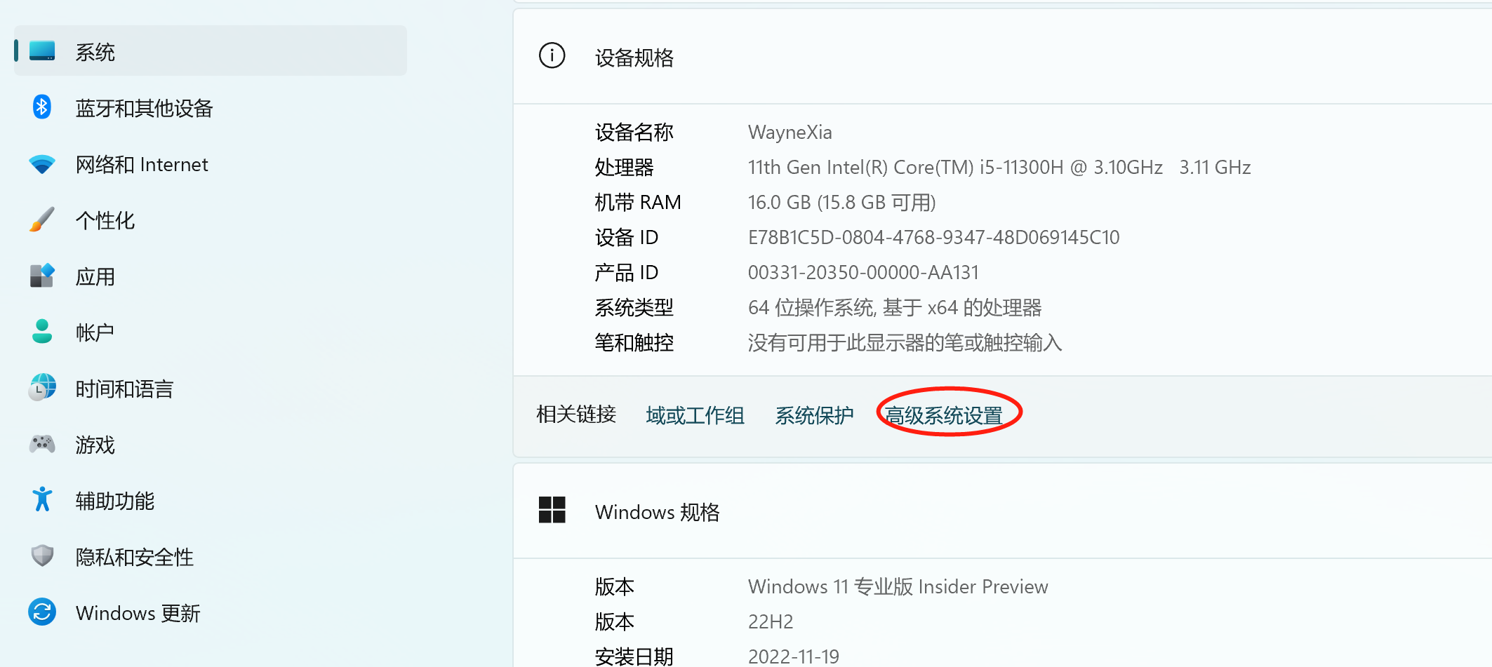

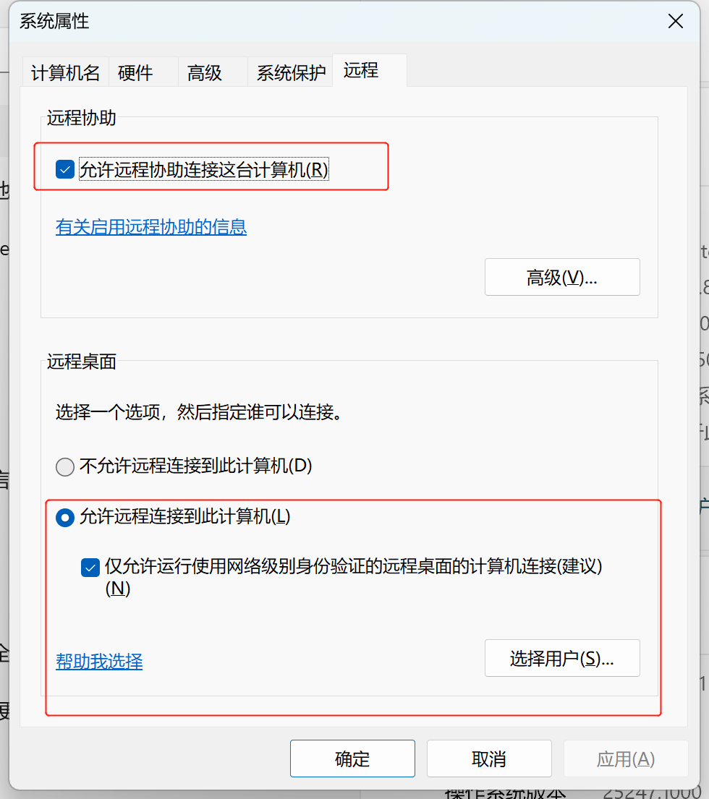

1. Openwrt客户端（参照: https://www.red-yellow.net/openwrt路由器安装zerotier并启用moon服务.html）

登录openwrt后台，对配置文件进行编辑: /etc/config/zerotier

|  |
| --- |
| config zerotier sample_config  option enabled 1  # persistent configuration folder (for ZT controller mode)  option config_path '/etc/zerotier'  option port '9993'  # path to the local.conf  #option local_conf '/etc/zerotier.conf'  # Generate secret on first start  option secret ''  # Join a public network called Earth  list join '1169545b648296ee'  #list join '<other_network>' |

修改完成后，执行正下命令:  
/etc/init.d/zerotier restart

/etc/init.d/zerotier enabled