Machine Learning for Covered Call Optimization
Strategy Selection Across Market Regimes

Christopher Mendoza, Swathi Pabbathi, Carlos Ortiz, Fatimat Atanda
Master of Science in Applied Artificial Intelligence
Shiley Marcos School of Engineering
University of San Diego
christophermendoza@sandiego.edu, spabbathi@sandiego.edu,
cortizmontesdeoca@sandiego.edu, fatanda@sandiego.edu

ABSTRACT
This study develops a machine learning framework to optimize covered call strategies by predicting the most effective combination of strike price and time to expiration for a given stock and market condition. Using data from equity prices, company fundamentals, and options markets, the problem is formulated as a multi-class classification task over predefined strategy buckets. Multiple models, including tree-based methods, recurrent neural networks, and a transformer-based architecture, are evaluated to assess the impact of nonlinear modeling and temporal structure on predictive performance.
Results show that all models outperform a random baseline, indicating the presence of meaningful predictive signal in the feature set. However, model performance is limited by significant overfitting and sensitivity to distribution shifts across market regimes, with accuracy concentrated in dominant strategy classes. These findings suggest that while machine learning can provide useful insights for covered call strategy selection, robust real-world application requires regime-aware modeling, periodic retraining, and validation through financial back testing.

KEYWORDS
Machine Learning; Covered Call Strategy; Options Trading; Financial Time Series; Classification Models; Implied Volatility; Regime Shift; Risk-Adjusted Return.

1 Introduction
Covered call strategies are widely used by institutional and retail investors as a method of enhancing portfolio income while modestly reducing downside volatility. The strategy involves holding an underlying equity position while selling call options against that position, thereby generating option premium income in exchange for limiting potential upside. Although conceptually straightforward, the selection of strike price and time to expiration introduces a complex trade-off between premium capture, capital appreciation, volatility exposure, and assignment risk. In practice, many investors rely on static heuristics such as consistently selling 30-day calls 10 percent out of the money, despite the likelihood that optimal contract selection depends on firm fundamentals, valuation context, and prevailing market conditions.
This project investigates whether machine learning models can improve covered call decision making by dynamically selecting the optimal strike and maturity bucket based on observable financial and market features. The problem is framed as a multi-class classification task in which the model selects among nine discrete covered call structures defined by combinations of moneyness, including at the money, 5 percent out of the money, and 10 percent out of the money, and maturity buckets of 30, 60, or 90 days to expiration. Rather than attempting to predict exact option prices or continuous return outcomes, the project discretizes the action space into a small set of realistic portfolio choices. The model then recommends the contract structure expected to maximize realized risk-adjusted return over the subsequent option cycle.
In addition to firm-level financial and market data, this study incorporates macroeconomic indicators to capture broader market regime dynamics that may influence option strategy performance. Financial statement data and historical equity prices are obtained through the Alpha Vantage financial data API, which provides programmatic access to corporate fundamentals, price history, and related financial metrics (Alpha Vantage, 2024). To complement these data, macroeconomic indicators are sourced from the Federal Reserve Economic Data (FRED) database maintained by the Federal Reserve Bank of St. Louis, which aggregates a wide range of economic and financial time series including interest rates, monetary policy indicators, and macroeconomic conditions (Federal Reserve Bank of St. Louis, 2024). Incorporating both firm-level and macroeconomic variables allows the model to capture interactions between company fundamentals and broader economic regimes that may affect volatility, option premiums, and assignment probabilities in covered call strategies.
The intended users of this system are institutional money managers seeking a systematic and data-driven enhancement to an existing covered call overlay strategy. In a production setting, such a system would operate at a monthly decision frequency, ingest updated financial statements, valuation metrics, and market regime indicators, and generate contract recommendations for each eligible security. Although this project represents a prototype, it is designed to simulate the structure and logic of a deployable decision-support tool.
The ultimate objective of this project is to evaluate whether a machine learning–based contract selection framework can generate economically significant improvements in risk-adjusted performance relative to a static rule-based covered call strategy. Rather than assuming that covered call optimization is primarily a function of implied volatility or option premium levels, this study investigates whether firm-level fundamentals, valuation metrics, and market regime indicators contain predictive information about the relative performance of alternative moneyness and maturity structures over the subsequent option cycle.
The central research hypothesis is that cross-sectional and time-varying financial features jointly influence the payoff distribution of covered call strategies, and that a supervised learning classifier, particularly one incorporating a neural network architecture capable of modeling nonlinear interactions, can identify structure-performance relationships that are not captured by simple heuristics. We test whether such a model produces higher out-of-sample Sharpe ratios, improved downside risk characteristics, and more favorable drawdown profiles than a baseline strategy that systematically sells 30-day calls 10 percent out of the money. Evidence in support of this hypothesis would suggest that contract selection in covered call overlays is not purely mechanical, but instead benefits from structured feature integration and nonlinear modeling.

2 Data Summary
The dataset used in this project integrates multiple sources of financial and market data obtained through the Alpha Vantage API. The dataset spans the period from 2015 through 2025 and includes information for ten publicly traded companies across multiple sectors. Four primary data sources were used to construct the modeling dataset: daily equity price data, quarterly financial statements, options chain data, and company overview metadata. The daily market dataset contains 47,350 observations and includes variables such as open, high, low, close, adjusted close prices, trading volume, dividend adjustments, and stock split adjustments. From these raw fields, several technical indicators were engineered including daily returns, rolling volatility measures, and normalized price series. Quarterly financial statement data contributed measures of corporate performance such as revenue, profit margins, debt levels, equity, and operating cash flows. From these variables, additional financial ratios were derived including gross margin (average approximately 54%), revenue growth (average approximately 23%), debt-to-equity ratio (average approximately 0.70), and return on equity (average approximately 9.6%). Options market data consisted of approximately 927,000 option contracts containing strike prices, expiration dates, bid and ask quotes, implied volatility (average approximately 42.5%), and option Greeks including delta, gamma, theta, and vega. A final company overview dataset provided static firm attributes such as sector classification, industry, shares outstanding, and equity beta. After feature engineering and aggregation to a monthly decision frequency, the final modeling dataset contained 28 engineered features including 15 technical indicators, 9 fundamental variables, and 4 valuation metrics.

Several data quality issues were encountered during preprocessing and were addressed through systematic cleaning procedures. Missing data were present in several financial statement fields, with missingness ranging between approximately 27% and 56% depending on the variable. Examination of the raw data indicated that most missing values corresponded to fields that were not applicable for certain companies rather than true data gaps. Among the engineered features used in the final dataset, only the debt-to-equity ratio contained a small number of missing observations (seven values, approximately 1% of the dataset). These values were imputed using the median of the available observations to preserve the distribution while minimizing sensitivity to outliers. The raw options dataset also contained duplicate observations due to repeated API responses. The dataset was reduced from approximately 1.85 million rows to 927,008 unique contracts through deduplication. Of these contracts, only approximately 16.2% (52,184 call options) fell within the strike and maturity ranges relevant to the strategy design. In addition, certain technical indicators required long historical windows for calculation. To ensure sufficient historical information for indicators such as 200-day moving averages, observations prior to January 2016 were removed to allow rolling window initialization. Some financial ratios also exhibited extreme values caused by temporary accounting distortions or near-zero denominators. These values were clipped to economically reasonable ranges, including restricting price-to-earnings ratios to [-100, 500] and free cash flow yield to [-1, 1]. Finally, because the datasets originate from sources with different temporal granularities—including daily prices, quarterly fundamentals, static company attributes, and options contracts with varying expiration dates—an as-of merge was implemented to align them. The merge used backward matching on fiscal reporting dates to attach the most recently available financial statement data to each daily market observation. This approach ensured that only information that would have been available at that time was used, preventing look-ahead bias in the modeling dataset.

Exploratory data analysis revealed substantial diversity in price behavior across the selected stocks. Figure 1 illustrates the adjusted closing price history for all tickers from 2015 through 2025. The chart shows that the selected securities exhibit distinct growth trajectories and volatility profiles over the sample period. Several stocks demonstrate strong long-term upward trends while others display more moderate or volatile price movements. Importantly, the dataset captures multiple major market regimes, including the market disruption during the 2020 global crisis and the subsequent recovery period. These variations confirm that the dataset includes a wide range of market conditions, which is essential for evaluating the robustness of covered call strategies across different economic environments.

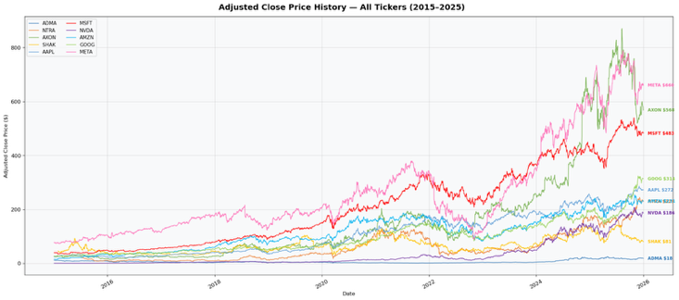
Figure 1

Trading activity across the selected stocks also varies significantly. Figure 2 presents a volume analysis including cumulative trading volume, median daily volume, and rolling volume trends. Large-cap securities such as Apple, NVIDIA, Microsoft, and Meta exhibit significantly higher trading volumes compared to smaller companies in the dataset. High trading volume generally indicates greater market liquidity and stronger investor participation, which typically translates into deeper options markets and tighter bid–ask spreads. In contrast, smaller stocks such as ADMA, SHAK, AXON, and NTRA exhibit substantially lower trading volumes, suggesting reduced liquidity and potentially higher transaction costs. The variation in trading volume across securities provides a realistic environment for evaluating covered call strategies across both highly liquid and moderately traded assets.

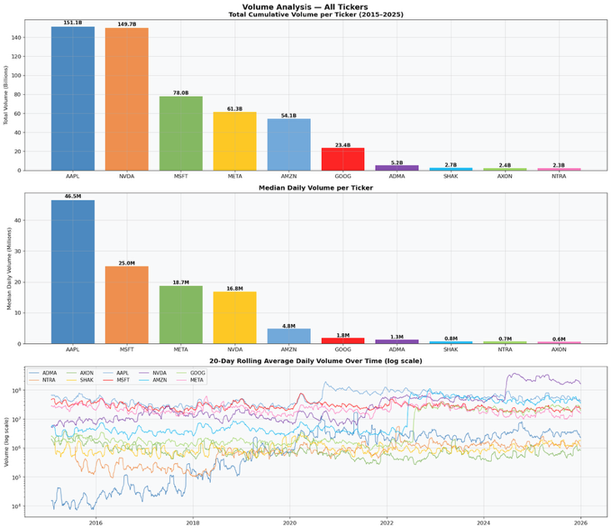
Figure 2

Volatility dynamics further highlight differences between securities and across time. Figure 3 displays rolling annualized volatility using both 20-day and 60-day windows. Volatility varies substantially across tickers and exhibits pronounced spikes during periods of market stress, particularly around early 2020. Elevated volatility levels are associated with increased option premiums, which can benefit option-selling strategies such as covered calls by generating higher income. The observed volatility patterns demonstrate that the dataset captures realistic market risk dynamics and provides a suitable environment for evaluating option-selling strategies under varying risk conditions.

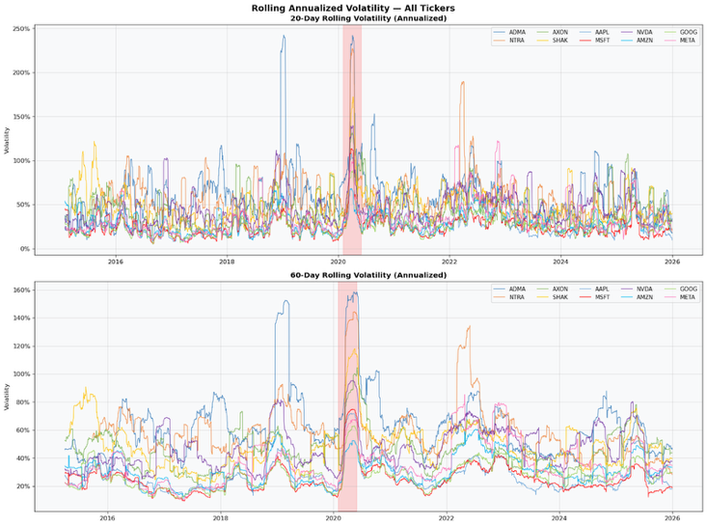
Figure 3

Additional analysis of the options dataset provides insight into the distribution of option characteristics relevant to covered call strategies. Figure 4 shows the distribution of call option delta values across tickers. Most contracts cluster around higher delta values between approximately 0.7 and 0.9, indicating a large number of near-the-money or in-the-money options. The chart also highlights typical covered call delta ranges between approximately 0.3 and 0.6, which balance premium income with assignment risk. The presence of a wide range of delta values confirms that the dataset contains a diverse set of option moneyness levels suitable for evaluating strike selection strategies.

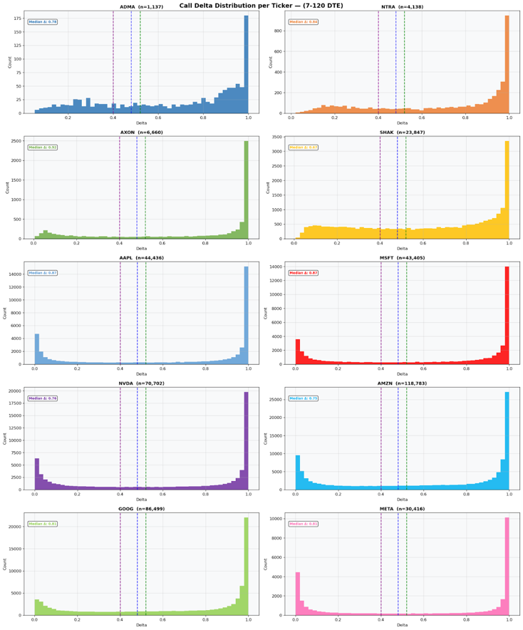
Figure 4

The distribution of option maturities is shown in Figure 5, which presents the distribution of days-to-expiration (DTE) for call options between 7 and 120 days. Most options fall within short-to-medium expiration windows of roughly 7 to 60 days. This range aligns with commonly used covered call strategies that seek to capture rapid time decay while maintaining flexibility in strike selection. A reference line around approximately 40 days highlights a typical expiration horizon used by many option sellers to balance premium generation and risk exposure.

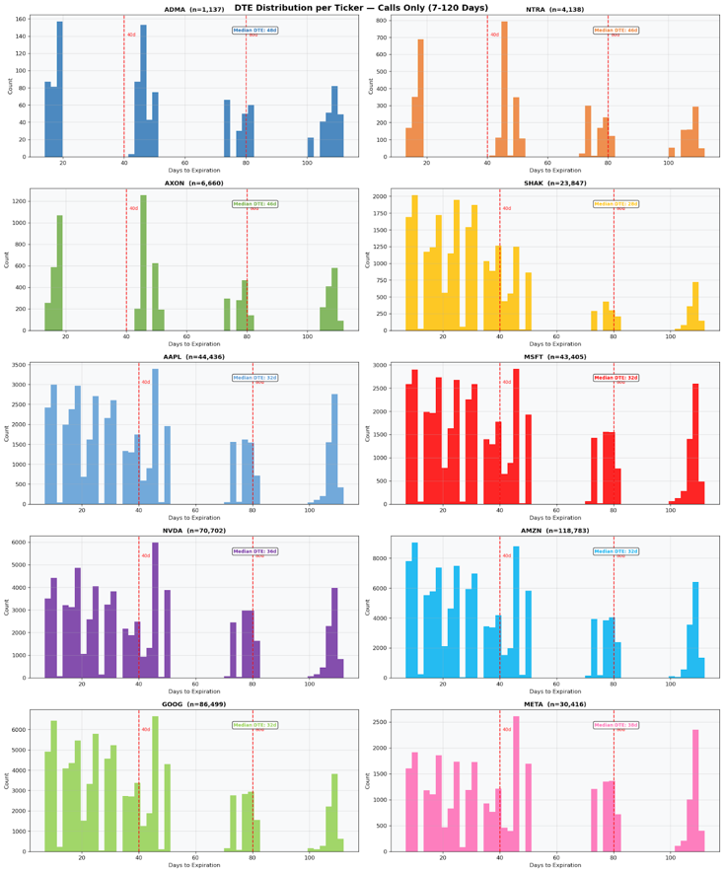
Figure 5

Options market liquidity also varies significantly across tickers. Figure 6 illustrates open interest and contract-level trading volume for call options within the 7–120 day expiration window. Large-cap stocks such as Apple, Microsoft, NVIDIA, and Amazon exhibit substantially higher open interest and trading activity compared to smaller securities. Higher options liquidity typically leads to tighter bid–ask spreads and improved execution efficiency, both of which are important considerations when implementing systematic option strategies.

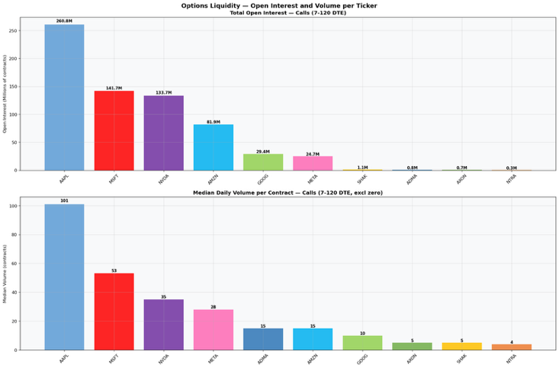
Figure 6

To evaluate potential strategy structures, option contracts were segmented into nine strategy buckets based on combinations of moneyness and time to expiration. Figure 7 illustrates the distribution of contracts across buckets defined by three moneyness levels (at-the-money, 5% out-of-the-money, and 10% out-of-the-money) and three maturity ranges (30, 60, and 90 days). The heatmap shows that most contracts are concentrated in shorter maturities and slightly out-of-the-money strikes, which aligns with common covered call implementations designed to maximize premium income while limiting assignment risk.
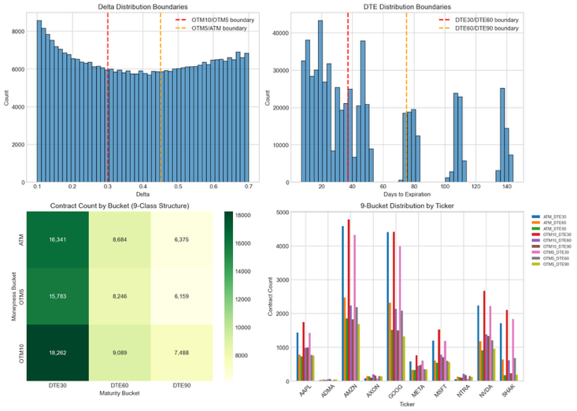

Figure 7

Figure 8 further illustrates the overall distribution of contracts across the nine buckets, where at-the-money 90-day contracts appear most frequently, while other strike-distance and maturity combinations also remain well represented. The presence of multiple strike and maturity combinations ensures that the dataset contains sufficient variation for the machine learning model to learn meaningful relationships between market conditions and optimal covered call structures.

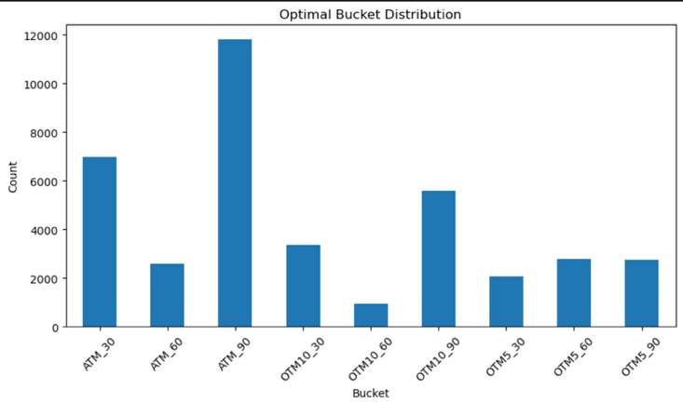
Figure 8

Finally, analysis of relationships between engineered variables revealed several highly correlated feature pairs. For example, operating margin and net margin exhibit a correlation of approximately 0.95, while 21-day momentum and the ratio of price to the 50-day moving average have a correlation of approximately 0.88. Similarly, short-term volatility measures such as 10-day and 21-day volatility exhibit a correlation of approximately 0.82. These relationships arise because many engineered features are derived from common underlying data sources such as historical price series or financial statements. While these correlations do not invalidate the usefulness of the features, they introduce redundancy that must be considered during model development. Highly correlated variables can increase the risk of multicollinearity and may require the use of regularization or feature selection techniques to ensure that the model learns stable and interpretable relationships.

3 Literature Review
Recent research demonstrates that machine learning methods are increasingly effective in predicting option returns and improving derivatives-based trading strategies. Bali et al. (2023) provide one of the most comprehensive studies in this area, showing that nonlinear machine learning models significantly outperform linear methods when predicting cross-sectional option returns using a large set of option-specific and stock-level features. Their findings highlight that option-based characteristics, such as moneyness, implied volatility, and contract-level features, are the strongest predictors, while stock-based features provide additional incremental predictive power. Importantly, their results suggest that option return predictability is driven by market frictions and mispricing, indicating that systematic strategies such as covered calls can benefit from data-driven optimization.
Research specific to covered call strategies further emphasizes the importance of strike and maturity selection. Diaz and Kwon (2017) frame covered call construction as a risk–return optimization problem and show that optimal strike selection depends on investor objectives. At-the-money (ATM) options provide greater premium income and downside protection, while out-of-the-money (OTM) options offer higher upside participation under certain market conditions. Additionally, empirical evidence consistently supports the use of short-dated options, typically around one month to expiration, due to more favorable risk premia. These findings support the structure of this project, which discretizes the action space into combinations of moneyness and time-to-expiration buckets to capture realistic strategy choices.
A key modeling consideration in the literature is whether to frame option prediction as a regression or classification problem. Most option return studies adopt a regression framework, predicting continuous returns and evaluating performance using ranking-based metrics such as quantile sorting and portfolio spreads. However, classification approaches have been shown to perform well in financial prediction tasks where directional accuracy is more important than precise magnitude estimation. For example, Khaidem et al. (2016) and Zhong and Enke (2019) demonstrate that classification-based models can outperform regression approaches in trading contexts due to their robustness to noise and volatility. As a result, the literature increasingly supports hybrid approaches that combine regression-based training with ranking or decision-based evaluation, aligning closely with the objective of selecting optimal covered call strategies.
Feature engineering plays a critical role in option return prediction and strategy performance. Prior research consistently highlights the importance of combining option-level features, such as implied volatility, moneyness, Greeks, time to expiration, and liquidity measures, with underlying equity features such as realized volatility, momentum, and firm characteristics. Additionally, several studies emphasize the importance of the implied volatility surface, where predictive power is linked to a contract’s position across strike and maturity dimensions. While some approaches model the full volatility surface using deep learning architectures, others demonstrate that carefully engineered summary features capturing skew, term structure, and volatility spreads can provide strong predictive performance in tabular models. Macroeconomic variables such as market volatility indices and interest rates further enhance model performance by capturing broader market regimes.
From a machine learning perspective, the literature suggests that no single model consistently dominates across all financial prediction tasks, making model comparison essential. Random Forest models are widely used as strong baseline models for tabular financial data due to their ability to capture nonlinear relationships and feature interactions with minimal preprocessing. However, studies such as Bali et al. (2023) indicate that more advanced tree-based methods and nonlinear models often outperform simple ensemble approaches. Feedforward neural networks (MLPs) provide greater flexibility in modeling complex nonlinear relationships and are commonly used in option return prediction tasks, particularly when working with large feature sets. More recent work highlights the potential of transformer-based models for tabular data, which use attention mechanisms to capture complex interactions across heterogeneous features. Although these models have demonstrated strong performance across a range of applications, their effectiveness depends on dataset size and feature complexity, and they often require more computational resources and tuning.
Evidence from applied studies further supports the use of machine learning in covered call and options-related strategies. Ngwaba (2025) finds that deep learning models, particularly recurrent neural networks, outperform traditional machine learning and time-series models when forecasting covered call exchange-traded funds, suggesting that nonlinear and temporal patterns play a significant role in strategy performance. While this study focuses on time-series forecasting rather than cross-sectional strategy selection, it reinforces the broader conclusion that flexible nonlinear models are well-suited to capturing the dynamics of option-based strategies.
Overall, the literature supports a machine learning framework that integrates rich feature engineering with nonlinear modeling approaches. Effective systems combine option-level, equity-level, and macroeconomic data, account for nonlinear interactions, and evaluate performance using economically meaningful metrics. These findings directly inform the design of this project, which applies Random Forest, neural network, and transformer-based models to predict optimal covered call strategies within a structured action space.

4 Methodology
This study formulates the covered call strategy selection task as a supervised multi-class classification problem. The objective is to predict the optimal option strategy bucket for a given stock on a given trading day based on historical market, firm, and option characteristics. Strategy buckets are defined by combinations of option moneyness of at-the-money (ATM), 5% out-of-the-money (OTM5), and 10% out-of-the-money (OTM10) and time-to-expiration (30, 60, and 90 days). To address sparsity in certain long-dated categories, selected buckets were consolidated, resulting in a final set of seven classes. This discretization reflects realistic decision-making in covered call strategies while ensuring sufficient observations per class for model training.

The model inputs consist of a set of engineered features designed to capture key dimensions of equity and options market behavior. These features fall into three primary categories: technical indicators derived from historical price data, fundamental indicators derived from company financial statements, and option-specific variables describing contract characteristics and market conditions.

Technical features capture short- and medium-term price dynamics, including momentum, moving average relationships, and rolling volatility measures. These variables are intended to reflect trend persistence and short-term price fluctuations that influence both option premiums and assignment risk. Fundamental features include measures of profitability, growth, and leverage, such as gross margin, revenue growth, return on equity, and debt-to-equity ratio. These variables provide information about firm quality and financial stability, which may affect long-term volatility and price behavior. Option-related features include implied volatility, option Greeks (delta, gamma, theta, and vega), liquidity measures such as trading volume and open interest, and time-to-expiration. These features directly describe option pricing dynamics and are central to modeling covered call performance.

To reduce dimensionality and prevent overfitting, feature selection was performed using a Random Forest classifier trained exclusively on the training dataset. Features were ranked by importance, and the top 35 features were retained for all subsequent models. This approach ensures that feature selection does not introduce information leakage from validation or test data.

All features were standardized using a StandardScaler fitted on the training set only, with the same transformation applied to validation and test datasets.

​​To evaluate different modeling approaches, this study implements both tree-based models and deep learning architectures. These models were selected to capture a range of nonlinear relationships and temporal dependencies present in financial data.

Tree-based ensemble models, including Random Forest, XGBoost, and LightGBM, were used as baseline approaches. These models are well-suited for tabular financial datasets due to their ability to model nonlinear feature interactions without requiring extensive preprocessing. Their robustness to feature scaling and ability to handle mixed data types make them a strong benchmark for comparison against more complex models.

A sequence-based deep learning model was implemented using a bidirectional Long Short-Term Memory (LSTM) architecture with a temporal attention mechanism. The model consists of two stacked bidirectional LSTM layers with a hidden size of 64, allowing it to capture temporal dependencies in both forward and backward directions. The temporal attention layer assigns weights to different timesteps within the input sequence, enabling the model to focus on the most informative periods within the historical window. The resulting representation is passed through a fully connected classification head with dropout regularization. This architecture was chosen to capture sequential patterns in financial time series, where recent and distant observations may have varying predictive importance.

The primary deep learning model used in this study is a Patch Time Series Transformer (PatchTST), which is designed to capture both local and long-range dependencies in multivariate time series data. The model processes input sequences of 50 trading days, which are divided into fixed-length patches to reduce the computational complexity of attention. Each patch is embedded into a low-dimensional representation and passed through a multi-layer Transformer encoder with multi-head self-attention. The use of patching allows the model to efficiently learn both short-term temporal patterns within patches and longer-term dependencies across patches. A relatively small embedding dimension and number of attention heads were selected to reduce overfitting given the size of the dataset. The encoded sequence is aggregated and passed to a linear classification head that outputs probabilities over the seven strategy classes.

Model training was conducted using a strictly chronological data split to prevent lookahead bias and ensure realistic evaluation. The dataset was divided into training, validation, and test sets based on time, with training data consisting of observations prior to 2022, validation data covering 2022–2023, and test data consisting of 2024 onward.

Input sequences were constructed using rolling windows of 50 trading days for each stock. For each prediction at time t, the model receives input data from the preceding 50 days (t-50 to t-1), ensuring that no future information is included in the input features. This design aligns with real-world deployment, where only past information is available at the time of decision-making.

Training for deep learning models was performed using mini-batch gradient descent with batch sizes of 32–64, depending on the model. Optimization was carried out using the AdamW optimizer, which incorporates weight decay for improved generalization. Early stopping was applied based on validation macro F1 score to prevent overfitting, and gradient clipping was used in sequence models to stabilize training.

The dataset exhibits significant class imbalance, with certain strategy buckets—particularly longer-dated at-the-money options—dominating the distribution. To address this issue, two complementary techniques were applied during training.

First, partial resampling was performed on the training set, where majority classes were undersampled and minority classes were oversampled to reduce extreme imbalances. Second, class-weighted loss functions were used, with weights computed from the training data to penalize misclassification of underrepresented classes more heavily. These approaches were applied exclusively to the training data to avoid introducing bias into validation and test evaluations.

Hyperparameter optimization was conducted using the Optuna framework with a Tree-structured Parzen Estimator (TPE) sampler. Separate search spaces were defined for each model, including parameters such as tree depth, number of estimators, and learning rate for tree-based models, as well as embedding dimension, number of attention heads, dropout rates, and patch configuration for the Transformer model.

The PatchTST model consists of 4 Transformer encoder layers with an embedding dimension of 64, 2 attention heads, and a feedforward dimension of 64. Dropout (0.107) and head dropout (0.340) were applied for regularization, with Batch Normalization used to stabilize training. The model was trained using a class-weighted cross-entropy loss function and optimized using AdamW with a learning rate of 4.2 x 10^{-4} and weight decay of 2.8 x 10^{-4}. Training was performed for a maximum of 12 epochs with a batch size of 32, using early stopping with a patience of 3 epochs based on validation macro F1 score.

Model performance during tuning was evaluated using time-series cross-validation, ensuring that validation splits preserved chronological order. This approach maintains the temporal integrity of the data while enabling systematic exploration of hyperparameter configurations.

In addition to standard hyperparameter tuning, a post-training calibration step was applied to improve classification performance on minority classes. Specifically, per-class decision thresholds were adjusted using validation data to rebalance prediction probabilities and improve macro-level performance without altering model structure.

Model performance was evaluated using accuracy, macro F1 score, weighted F1 score, and balanced accuracy. Macro F1 score was used as the primary evaluation metric, as it assigns equal importance to all classes and is therefore robust to class imbalance. These metrics provide a comprehensive assessment of both overall predictive performance and class-level behavior.

Based on architectural considerations and the need to capture long-range temporal dependencies in financial time series, the PatchTST Transformer model was selected as the primary model for this study. Tree-based and LSTM models were used as baseline comparisons to evaluate the relative performance of sequence-based deep learning approaches.

5 Results
This section evaluates the performance of the machine learning models in predicting the optimal covered call strategy bucket and assesses their ability to generalize across different market conditions.

All models in this study exhibited significant overfitting, as evidenced by large gaps between training and validation or test performance. The LSTM-CNN baseline provides the clearest example, achieving a training Macro F1 score of 0.819 while validation Macro F1 peaked at only 0.206, resulting in an overfitting gap of 0.613. Validation loss began diverging early in training, increasing sharply after epoch 7, which triggered early stopping. A similar pattern was observed in the XGBoost model, where training Macro F1 reached 0.830 but dropped to 0.142 on the test set, indicating poor generalization. Increasing architectural complexity did not resolve this issue. The LSTM-CNN Multi-Scale variant and other deep learning extensions achieved comparable training performance but failed to improve test results, suggesting that model capacity was not the limiting factor.

Despite these limitations, the models demonstrate that the feature set contains meaningful predictive signal. All models exceeded the random baseline accuracy of 14.3% for a 7-class classification problem. The best-performing model, a threshold-tuned LSTM-CNN, achieved a test accuracy of 34.0%, representing approximately a 2.4× improvement over random selection. This indicates that the combination of technical, fundamental, and option-based features provides useful information for predicting covered call strategy outcomes.

However, model performance varied significantly across classes. Four of the seven classes received F1 scores of zero across most models, indicating a failure to distinguish between several strategy buckets. This issue is primarily driven by a severe distribution shift between training and test data. In particular, the class representing OTM10_60_90 contracts increased from approximately 1.25% of the training dataset to 53.15% of the 2024 test dataset. This shift caused models to heavily favor the dominant class, limiting their ability to generalize across the full strategy space.

From an application perspective, the model provides partial utility. It performs relatively well in identifying the dominant strategy bucket in regimes where out-of-the-money, longer-dated options are optimal. For example, XGBoost achieved an F1 score of 0.48 for the dominant class in the test set. However, the model offers little to no predictive value for less frequent strategy buckets, which limits its usefulness in scenarios requiring more granular decision-making.

The results also highlight strong regime dependency in model performance. Walk-forward validation showed substantial variation in Macro F1 scores across time, with performance differing by more than 2.5× between years. This indicates that model effectiveness depends heavily on whether the current market environment resembles the training data distribution.

Finally, while a prototype system was deployed using a containerized architecture (Streamlit interface, FastAPI backend, and MLflow tracking), several limitations remain. The system requires a minimum 50-day feature history to generate predictions, lacks real-time data ingestion, and does not provide confidence estimates for predictions. Additionally, the model outputs only a strategy bucket rather than a specific executable contract, requiring additional post-processing for practical use.

Overall, the results demonstrate that while the models successfully learn patterns in the data, their ability to generalize across changing market regimes remains limited.

6 Conclusion
The primary objective of this project was to develop a machine learning framework capable of predicting the optimal covered call strategy bucket based on historical stock price, technical, and fundamental data. The results indicate that this objective is partially achieved.

All models were able to learn meaningful patterns from the feature set, as demonstrated by performance exceeding the random baseline. The best-performing model achieved a test accuracy of 34.0%, confirming that the selected features contain predictive signal relevant to covered call strategy selection. However, none of the models were able to reliably distinguish across all seven strategy classes, and significant overfitting was observed across all architectures.

The most significant finding of this study is that model performance is fundamentally constrained by distribution shift rather than model architecture. A substantial change in class distribution between training and test data, particularly the increase in the OTM10_60_90 class, undermined the ability of all models to generalize. This result suggests that the covered call optimization problem is highly regime-dependent, and that models trained on historical data may fail when market conditions change.

Several additional insights emerged from the modeling process. First, increasing model complexity did not improve performance, indicating that the primary limitation lies in the data rather than the model architecture. Second, transformer-based models underperformed relative to simpler tree-based methods, suggesting that data-hungry architectures may not be appropriate for moderately sized financial datasets. Third, macroeconomic features did not contribute meaningfully to predictive performance, while stock-level technical and fundamental features proved more informative.

These findings have important implications for the practical application of machine learning to options trading. In its current form, the model is not suitable for fully automated deployment, as it lacks robustness across market regimes and does not provide consistent performance across all strategy classes. However, it may serve as a decision-support tool in specific market conditions, particularly when dominant strategy regimes are present.

Future work should focus on addressing the limitations identified in this study. The most critical next step is the development of a financial backtesting framework to evaluate model predictions in terms of realized returns, risk-adjusted performance, and drawdowns. Additionally, implementing rolling retraining procedures and incorporating regime detection mechanisms may improve model adaptability to changing market conditions. Expanding the dataset to include a broader universe of securities and developing a real-time data pipeline would further enhance the robustness and applicability of the system. Finally, extending the model to predict specific option contracts rather than strategy buckets could bridge the gap between model output and executable trading decisions.

In summary, this project demonstrates that machine learning can extract meaningful signal for covered call strategy selection, but also highlights the critical importance of regime awareness and data distribution in financial modeling.

ACKNOWLEDGMENTS
Special thanks to Mark Scalzo of Validex Growth Investors for pushing us to explore a real-world problem in investment management and helping guide the direction of this project.
Works Cited

Alpha Vantage. (2024). Alpha Vantage financial data API. https://www.alphavantage.co/

Federal Reserve Bank of St. Louis. (2024). Federal Reserve Economic Data (FRED). https://fred.stlouisfed.org/

Diaz, Mauricio & Kwon, Roy. (2019). Portfolio optimization with covered calls. Journal of Asset Management. 20. 10.1057/s41260-018-00106-0.
Bali, T. G., Beckmeyer, H., Moerke, M., & Weigert, F. (2021). Option return predictability with machine learning and big data. SSRN Electronic Journal. https://ssrn.com/abstract=3895984
Khaidem, L., Saha, S., & Roy Dey, S. (2016). Predicting the direction of stock market prices using random forest. arXiv. https://arxiv.org/abs/1605.00003
Zhong, X., & Enke, D. (2019). Predicting the daily return direction of the stock market using hybrid machine learning algorithms. Financial Innovation, 5(1), 24. https://doi.org/10.1186/s40854-019-0138-0
Ngwaba, C. A. (2025). Forecasting covered call exchange-traded funds (ETFs) using time series, machine learning, and deep learning models. Journal of Risk and Financial Management, 18(3), 120. https://doi.org/10.3390/jrfm18030120

