CSYE7200 Assignment 1

Shuxian Wu

**In Class Exercise 1**

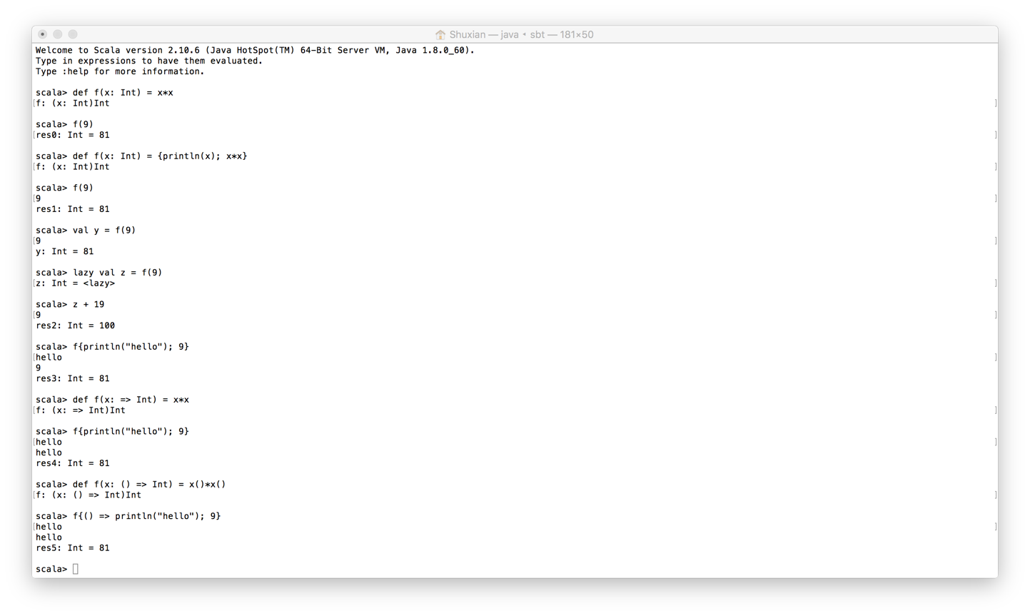

**In Class Exercise 2**

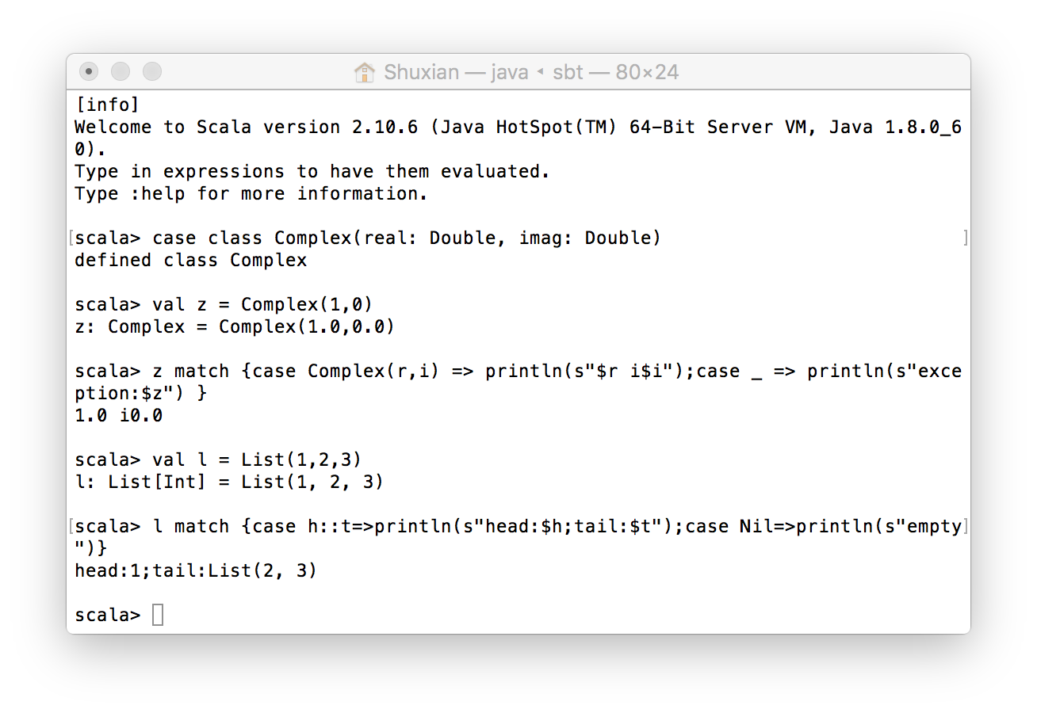

**Hello World**

HelloWorld.scala

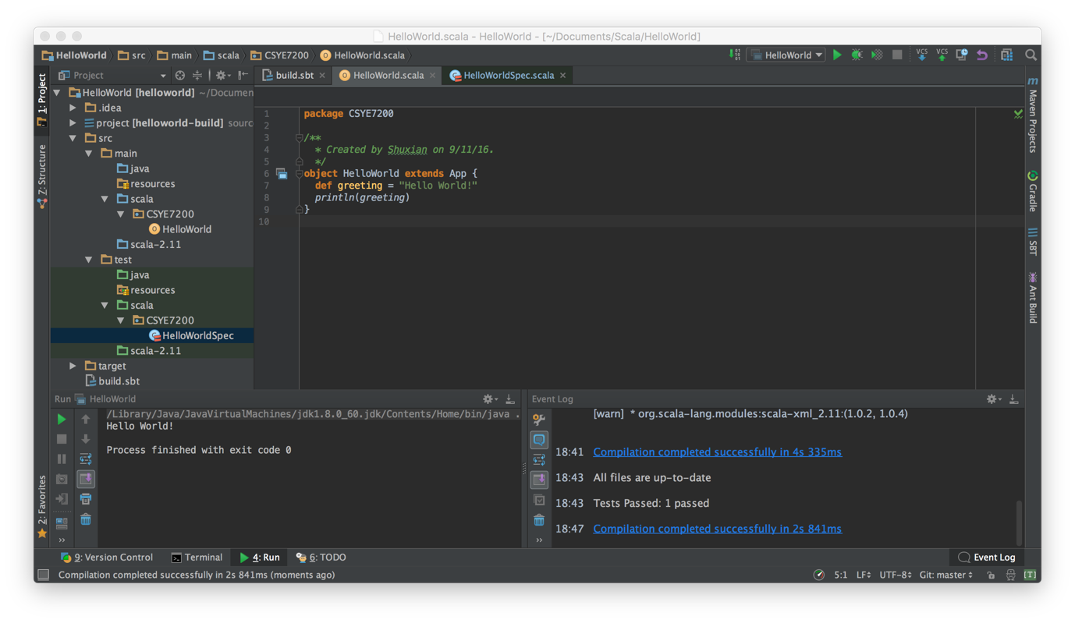

HelloWorldSpec.scala

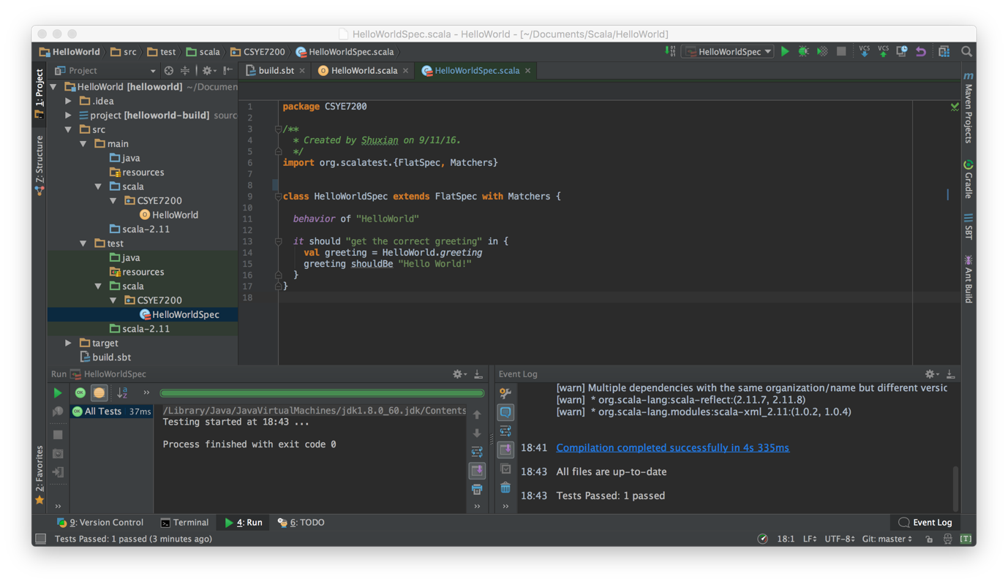

Ingest

