1、cmd 管理员运行

$ cnpm i -g windows-build-tools --vs2017

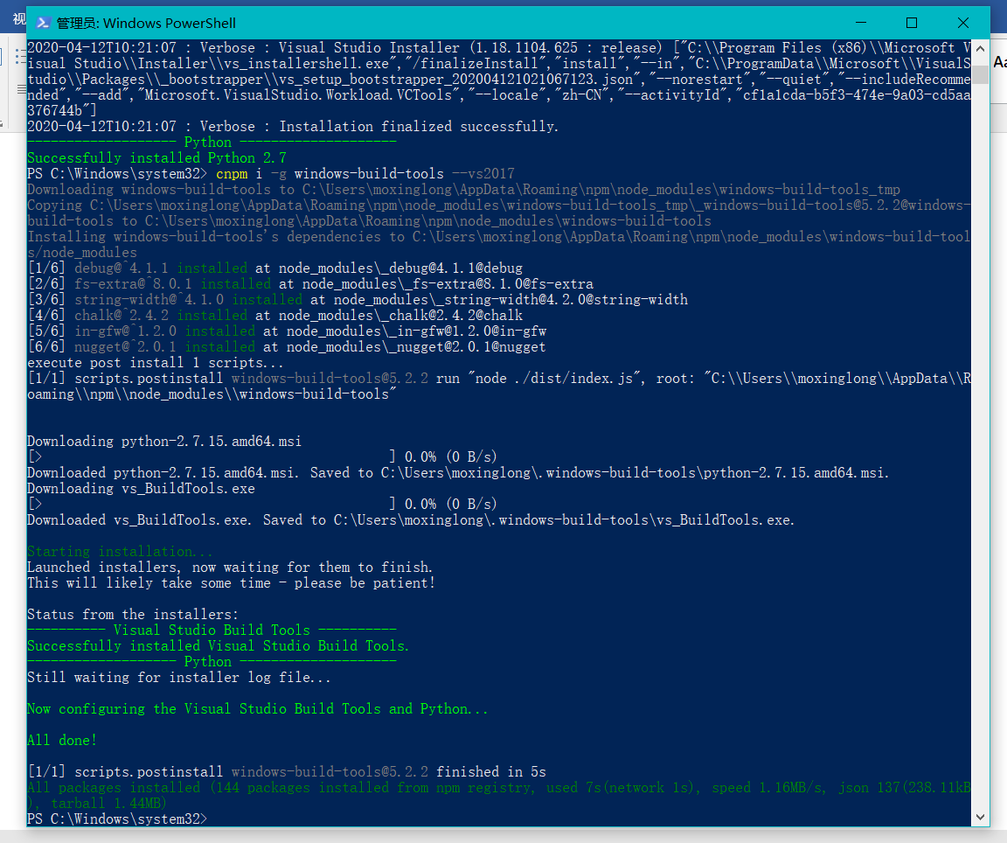

2、安装Cmake

<https://cmake.org/download/>

安装完之后，重启电脑，cmd中输入cmake

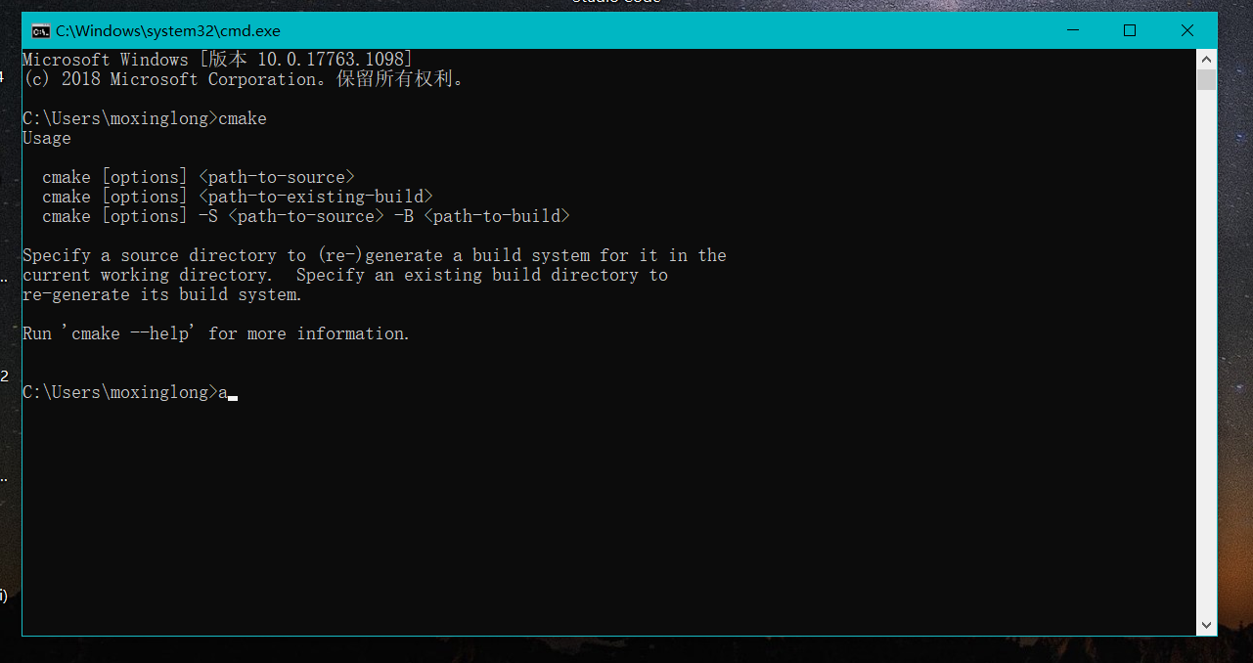

<https://blog.csdn.net/u011231598/article/details/80338941?depth_1-utm_source=distribute.pc_relevant.none-task-blog-BlogCommendFromBaidu-3&utm_source=distribute.pc_relevant.none-task-blog-BlogCommendFromBaidu-3>

3、安装 npm install --save opencv4nodejs