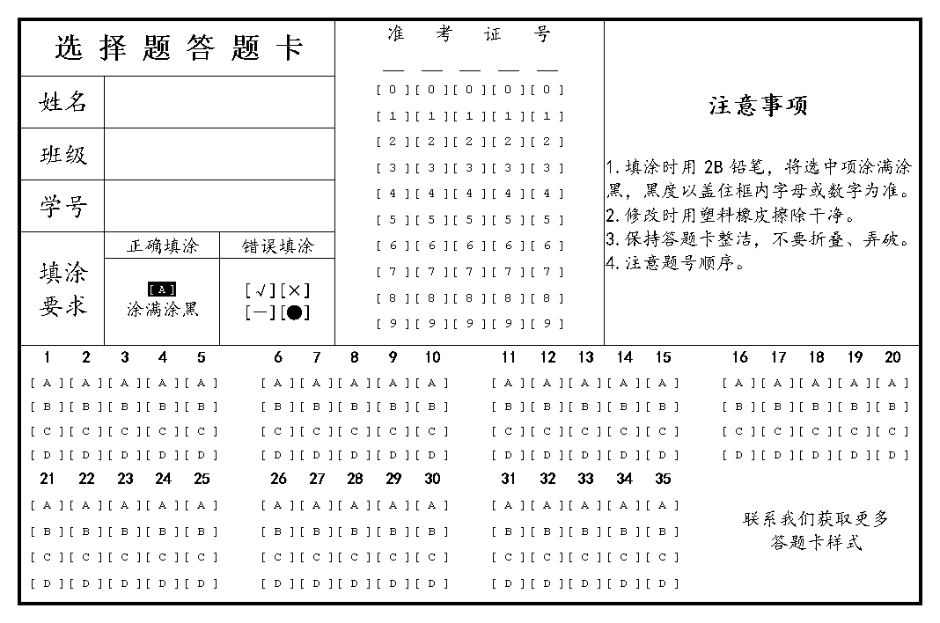





|  |  |  |  |  |  |  |  |
| --- | --- | --- | --- | --- | --- | --- | --- |
|  | 1 | ① | ② | ③ | ④ | ⑤ |  |
|  | 2 | ① | ② | ③ | ④ | ⑤ |  |
|  | 3 | ① | ② | ③ | ④ | ⑤ |  |
|  | 4 | ① | ② | ③ | ④ | ⑤ |  |
|  | 5 | ① | ② | ③ | ④ | ⑤ |  |
|  | 6 | ① | ② | ③ | ④ | ⑤ |  |
|  | 7 | ① | ② | ③ | ④ | ⑤ |  |
|  | 8 | ① | ② | ③ | ④ | ⑤ |  |

|  |  |  |  |  |  |  |  |
| --- | --- | --- | --- | --- | --- | --- | --- |
|  | 1 | ① | ② | ③ | ④ | ⑤ |  |
|  | 2 | ① | ② | ③ | ④ | ⑤ |  |
|  | 3 | ① | ② | ③ | ④ | ⑤ |  |
|  | 4 | ① | ② | ③ | ④ | ⑤ |  |
|  | 5 | ① | ② | ③ | ④ | ⑤ |  |
|  | 6 | ① | ② | ③ | ④ | ⑤ |  |
|  | 7 | ① | ② | ③ | ④ | ⑤ |  |
|  | 8 | ① | ② | ③ | ④ | ⑤ |  |

|  |  |  |  |  |  |  |  |
| --- | --- | --- | --- | --- | --- | --- | --- |
|  | 1 | ① | ② | ③ | ④ | ⑤ |  |
|  | 2 | ① | ② | ③ | ④ | ⑤ |  |
|  | 3 | ① | ② | ③ | ④ | ⑤ |  |
|  | 4 | ① | ② | ③ | ④ | ⑤ |  |
|  | 5 | ① | ② | ③ | ④ | ⑤ |  |
|  | 6 | ① | ② | ③ | ④ | ⑤ |  |
|  | 7 | ① | ② | ③ | ④ | ⑤ |  |
|  | 8 | ① | ② | ③ | ④ | ⑤ |  |

|  |  |  |  |  |  |  |  |
| --- | --- | --- | --- | --- | --- | --- | --- |
|  | 1 | ① | ② | ③ | ④ | ⑤ |  |
|  | 2 | ① | ② | ③ | ④ | ⑤ |  |
|  | 3 | ① | ② | ③ | ④ | ⑤ |  |
|  | 4 | ① | ② | ③ | ④ | ⑤ |  |
|  | 5 | ① | ② | ③ | ④ | ⑤ |  |
|  | 6 | ① | ② | ③ | ④ | ⑤ |  |
|  | 7 | ① | ② | ③ | ④ | ⑤ |  |
|  | 8 | ① | ② | ③ | ④ | ⑤ |  |