碳单质：

1.碳纤维<http://www.tanxw.com/news/hydt/196.html>

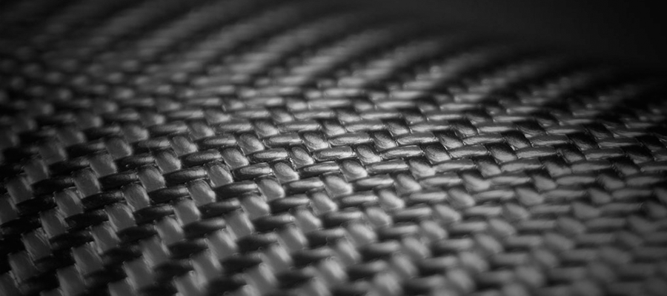

2.

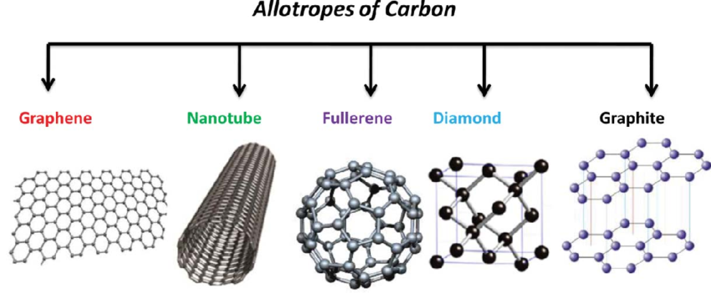

一氧化碳：

[https://en.wikipedia.org/wiki/Carbon_monoxide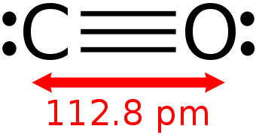](https://en.wikipedia.org/wiki/Carbon_monoxide#)

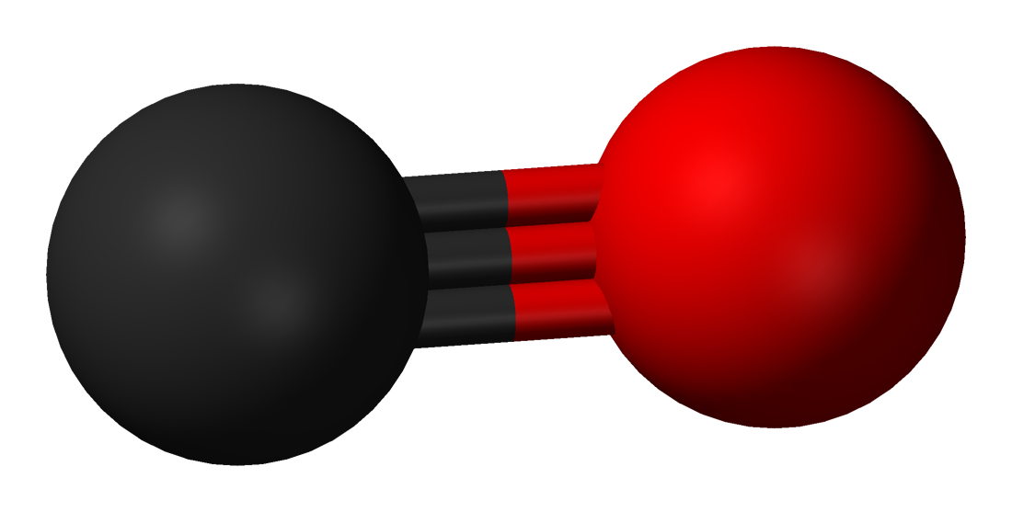

中毒：https://en.wikipedia.org/wiki/Carbon_monoxide

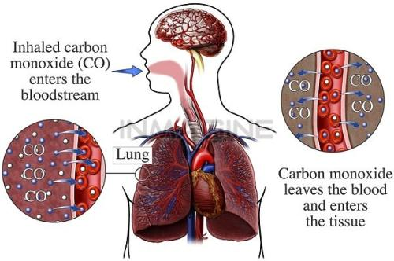

羰基配合物：

https://www.51wendang.com/doc/3105f5378d4f616475e557d4/3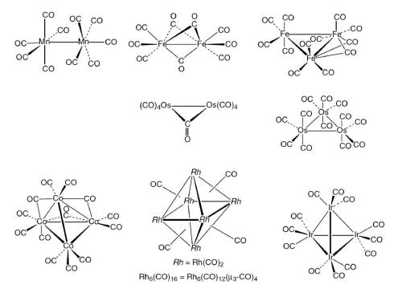

硅：

<http://cn.made-in-china.com/tupian/jinghuoglass-SomEzunCsNRa.html>

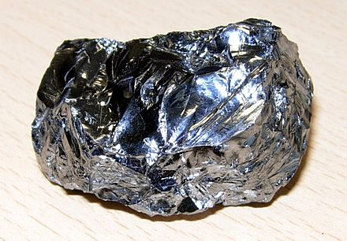

矿石：<https://b2b.hc360.com/viewPics/supplyself_pics/273650436.html>

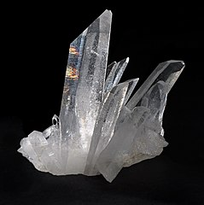

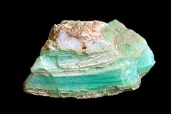

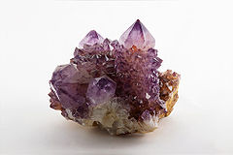

硅烷 自燃：<http://wap.yesky.com/news/kepu/rule/414/99633414.shtml>

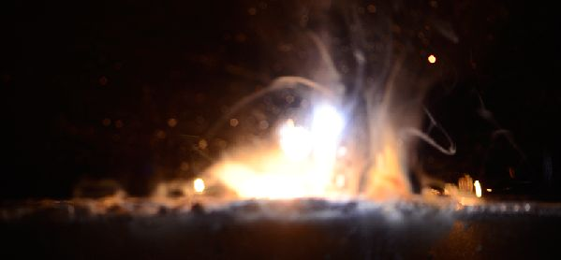

分子筛：<http://muchong.com/t-7453945-1-authorid-518329>

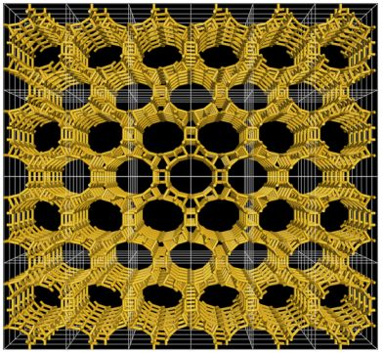

分子筛2：http://www.senwater.com/forum/thread-1758-1-1.html

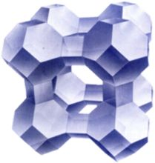

锡：

单质：<https://www.vcg.com/creative/1008937757>

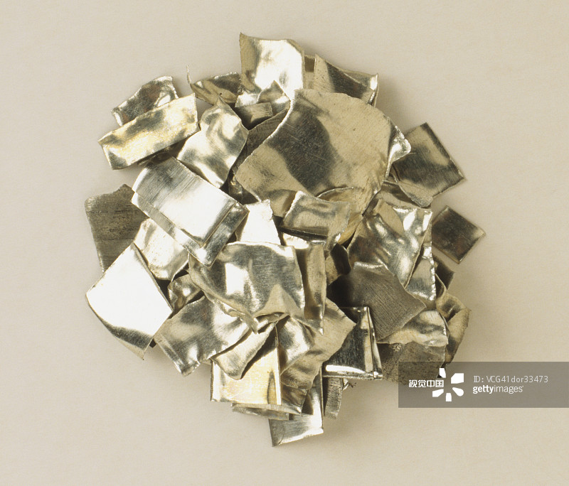

灰锡：<https://tieba.baidu.com/p/3559852514?red_tag=2136698609>

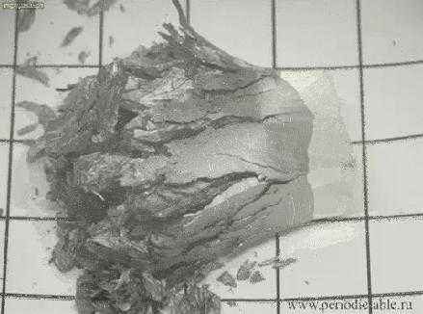

Sncl2：<https://b2b.hc360.com/supplyself/80308623971.html>

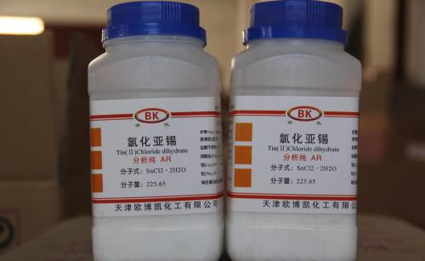

Sncl4：<https://baike.baidu.com/pic/%E4%BA%8C%E7%A1%AB%E5%8C%96%E9%94%A1/9334427/0/eac4b74543a98226ac808cd48082b9014b90eb84?fr=lemma&ct=single#aid=0&pic=eac4b74543a98226ac808cd48082b9014b90eb84>

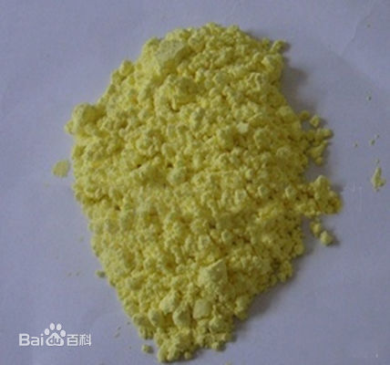

Sno2：

