**Usage of Online Judge**

1. The URL of CS100 OJ is <http://oj.cs100.online/>, you can open this website in your browser.
2. Click the “register” in upper-right corner.

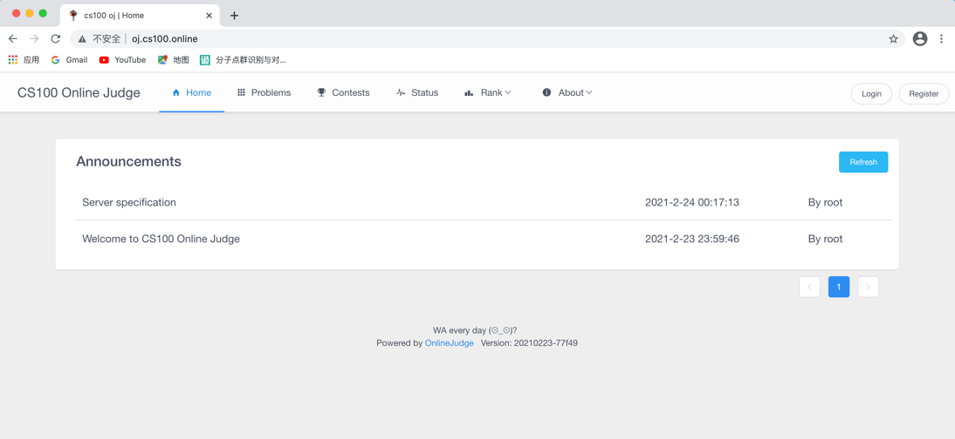

1. Enter your username and password.

The username should be set to **the prefix of your Shanghaitech e-mail**, or we will be unable to record your score.(e.g., if your e-mail is [geziwang@shanghaitech.edu.cn](mailto:geziwang@shanghaitech.edu.cn), then the username should be **geziwang**), and the e-mail should be your **Shanghaitech e-mail address**.

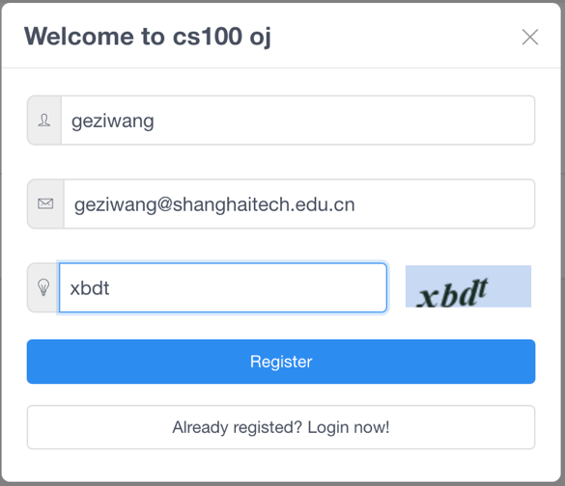

1. After registration, you will receive an e-mail in your inbox like this. You should reset your password by the given link as soon as possible.

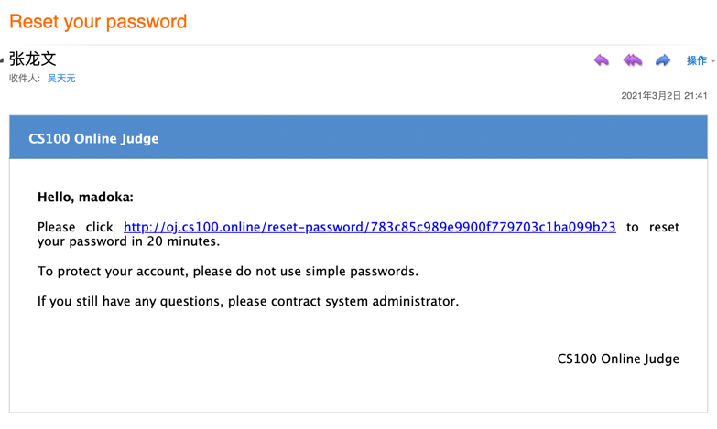

1. Click “Contest”, and you will find your homework problems.