Instruction

1. Install sbt.msi and extract typesafe-activator-1.3.12.zip(http://www.scala-sbt.org/download.html) then extract typesafe-activator-1.3.12.zip(https://www.lightbend.com/activator/download) go to activator-dist-1.3.12->bin run the activator.bat and activator-dist.bat and set system variable on windows named “PATH” point to bin folder of each to be able to run the command sbt and activator on command line(sbt.bin is at C:\Program Files (x86)\sbt)
2. Open command line interface(cmd or gitbash) and go to project directory run command “sbt clean compile” and if you want to create eclipse project run “sbt eclipse” then you can import existing project from eclipse IDE to view the source code
3. Install swagger ui plugin to your browser such as Chrome you can add it by clicking on the top-right corner of the browser screen and selecting more tools->extensions, at the bottom of the screen click Get more extensions and search for swagger ui then install it on chrome
4. Open terminal(Command line interface) like cmd or gitbash in windows inside project path
5. Run command => activator run, the application will be run at localhost:9000
6. Let’s play the application by opening web browser and go to url <http://localhost:9000/index>, you can see step to play the application below.
7. You also can see the API Document and test calling APIs by swagger ui pointing to file http://localhost:9000/assets/swagger/swagger.json and call the APIs directly or execute the curl command to fire the API from the swagger generated command(see below).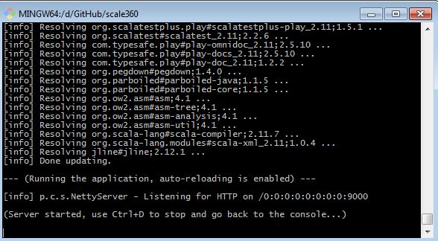

Run command “activator run”

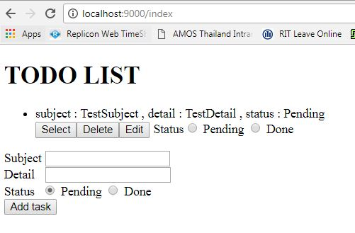

Go to url “localhost:9000/index” on browser. You can add a task by submitting the form, subject, detail and status required. Then, you also can select, edit(update), delete individual task by clicking the button below the task. The last one you are capable to change or update only the status of the task by choosing the radio button below the task.

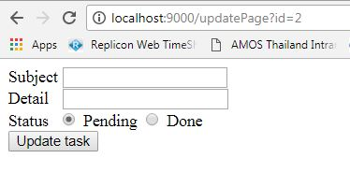

The edit(update page) will be shown after clicking Edit button.

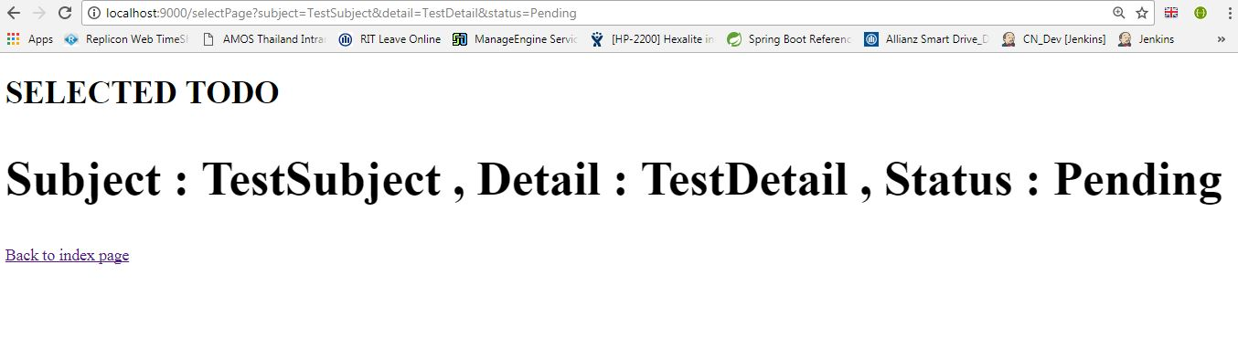

The select page will be shown after clicking select button. The chosen task will be shown on the page.

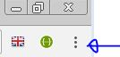

The picture shows the button of Chrome browser that navigates to install the swagger ui plugin which is capable to show the API document.

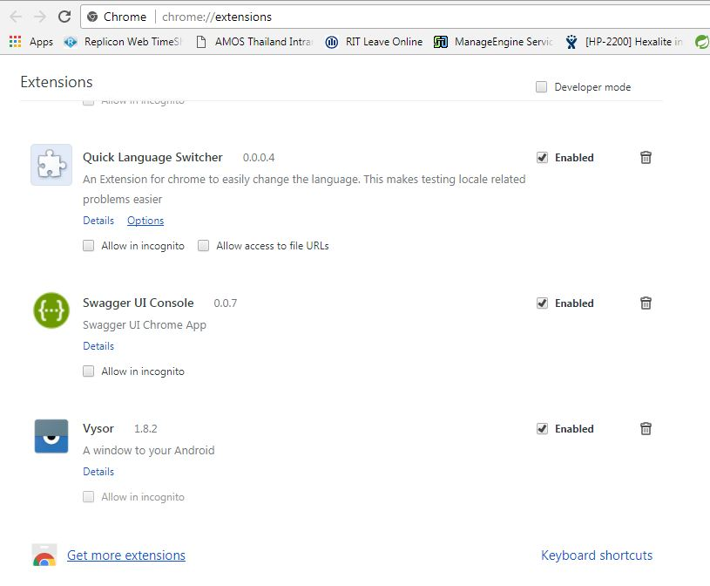

Click Get more extension link to get the swagger ui.

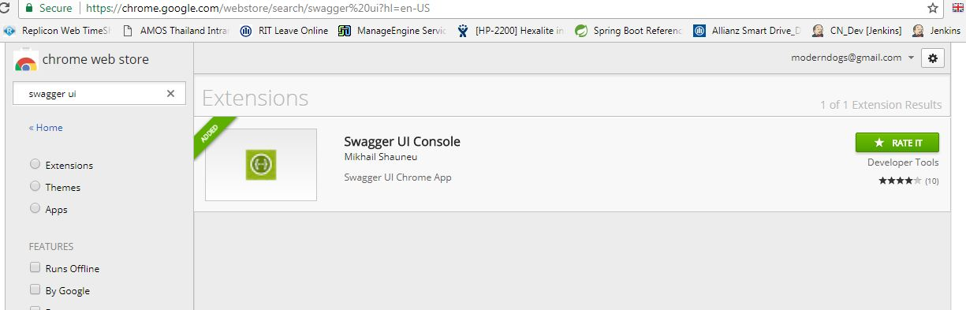

On the input text of the left hand side search for swagger ui and click install.



After installation click above button on chrome to open swagger ui.

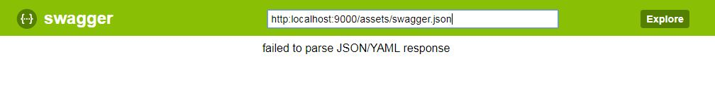

Type the url above and click explore to show the ui generated document.

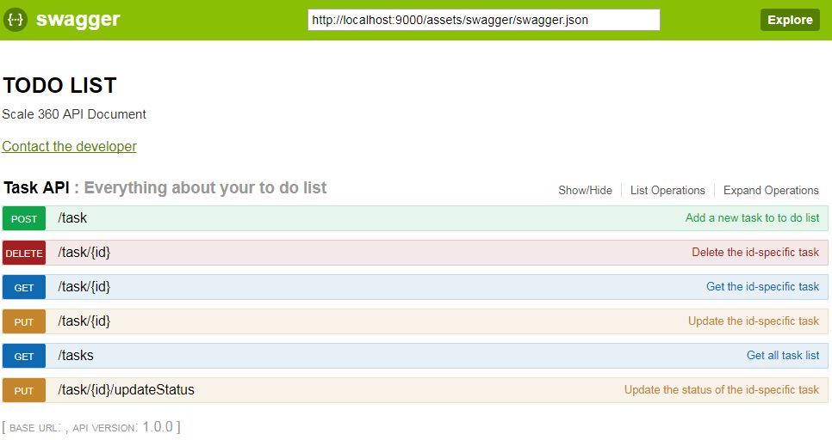

You can expand each API to see the detail.

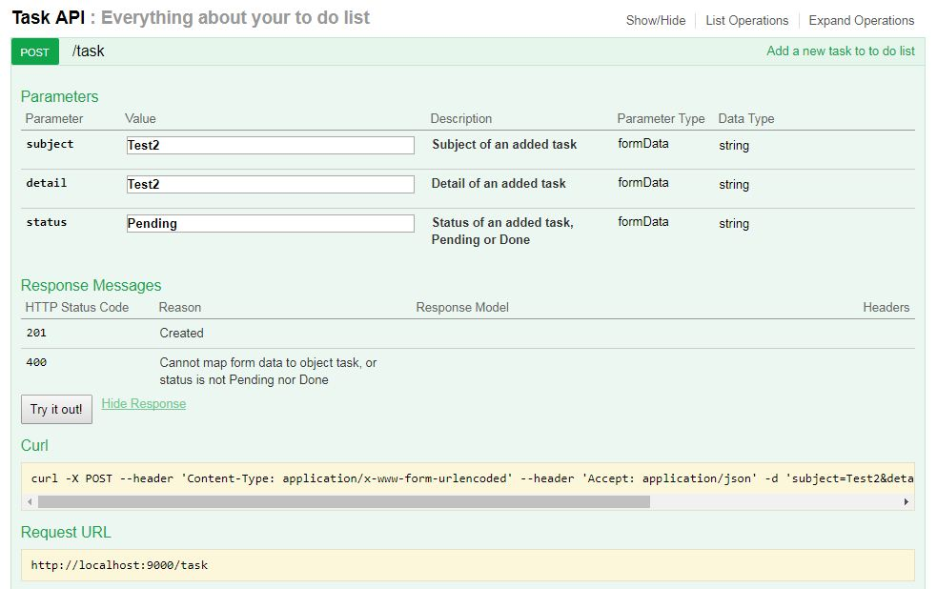

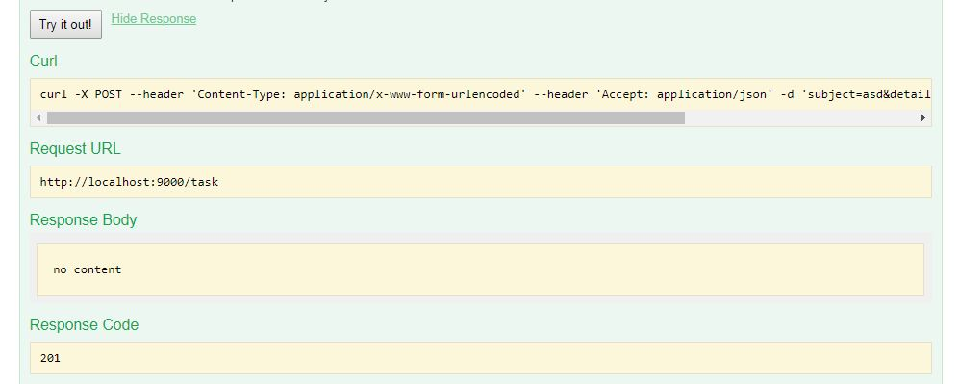

You can try inserting each required parameter then click “Try it out”, the API will be fired. Then, you can see the response code and/or response body; or you can copy the curl command to fire the API using command line interface.

Note. You can see the ID of task using API GET /tasks below.

