South China University of Technology
《Principle of Complier》Experiment Report
Experiment Title： LEXICAL ANALYSIS
Name： 黄鑫 Student ID： 202065073276
Class： 20计科全英联合班 Group： 6
Collaborator： 艾乐君 ID:202030430011
Teacher： 董敏
Description
【Objective and Requirement】
Objective：
Understand the lexical analysis
Requirement：
Use flex to realize the lexical analysis.
Use high level language to realize the lexical analysis by oneself.
【Environment】
Operating System：Windows 10
Content and Procedure
- Regular expression:
delim [ \n\t]
ws {delim}+
letter [A-Za-z]
digit [0-9]
digits [1-9]{digit}*
number {digits}(\.{digits})?(E[+-]?{digits})?
identifier (_|{letter})(_|{letter}|{digit})*
KEYWORD int|float|main|void|if|else|break|while|continue|return|const
operator [{}|]
comment \/\/{letter}*
comments \/\*.*\*\/
CHAR 'letter'
ERROR [^{ws}{identifier}{number}{KEYWORD}{operator}{comment}{comments}]
TIPS: single character we do not write the regular expression since it is simple.
2. FA:
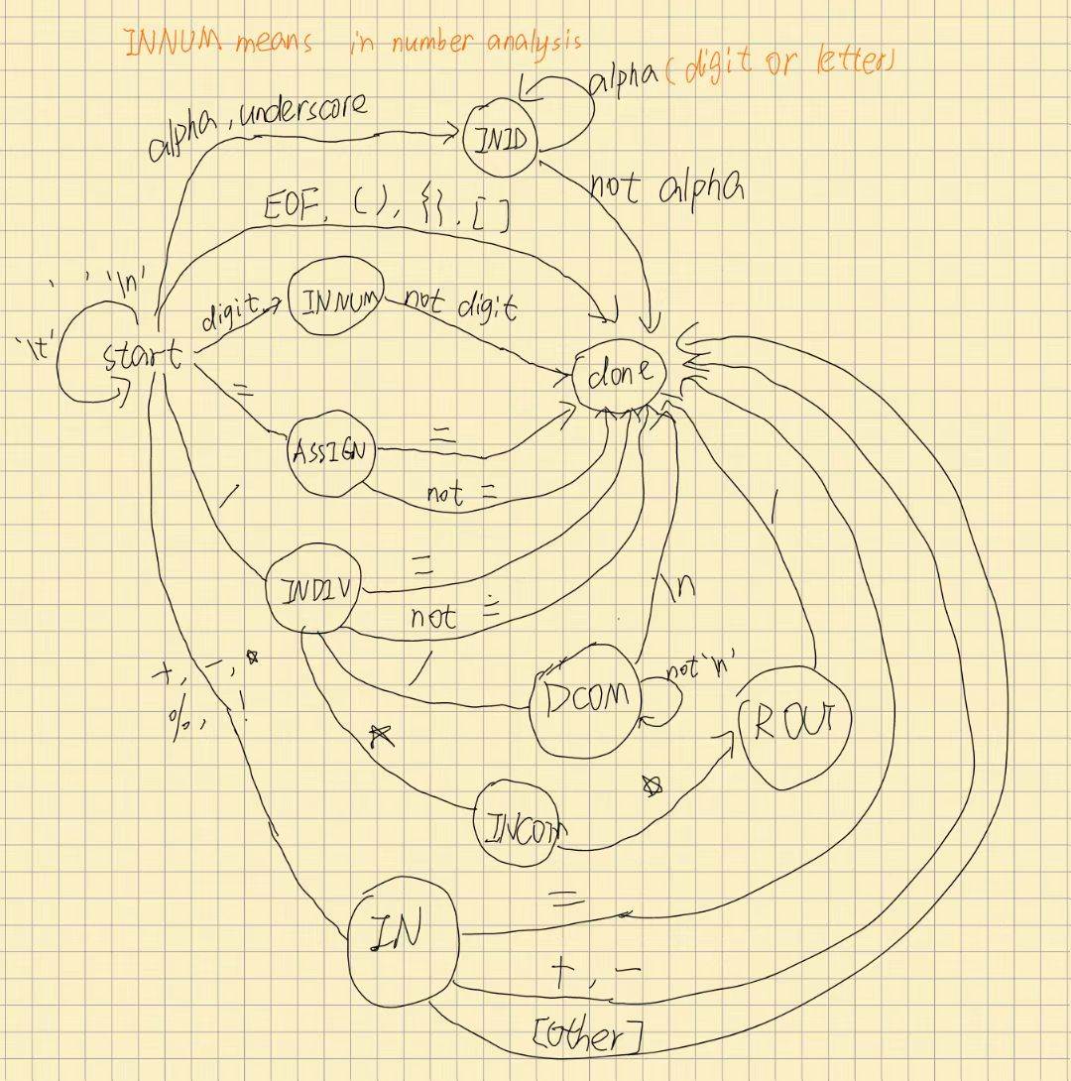
- Data Structure
- Use enumeration type to define types and states
- Use some functions to judge the type.
- Use print function to print the output.
- Use DFA function to read words one by one and analyze each word.
- Character table is defined as the enumeration type, just like the following. And since each value in the Types has unique integer to correspond, the table is generated naturally.
- DFA function design:
1.Accept a string as input.
2.Read this string’s character one by one.
3.According to the character, we ensure the state it should be in and ensure if this character should be saved with last temporary string.
4.Once it is in DONE state, we print the token.
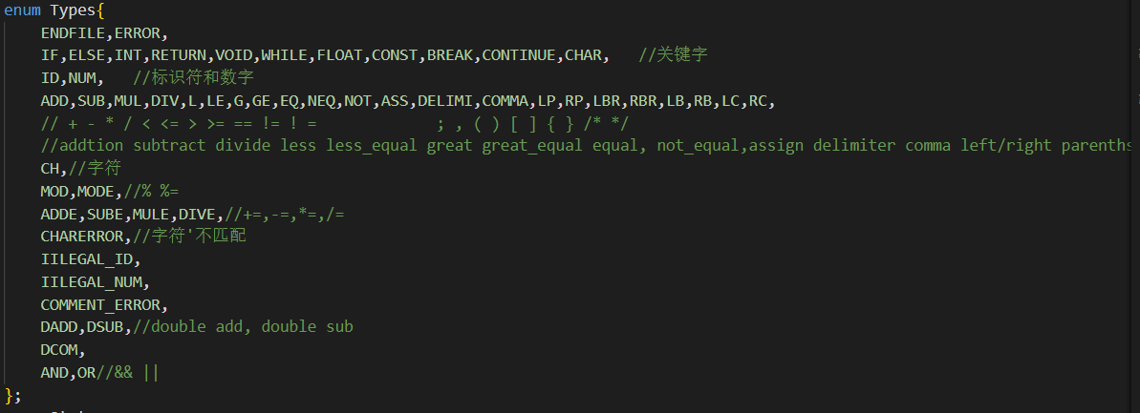
- RESLUT SCREENSHOOT:
- Test file:
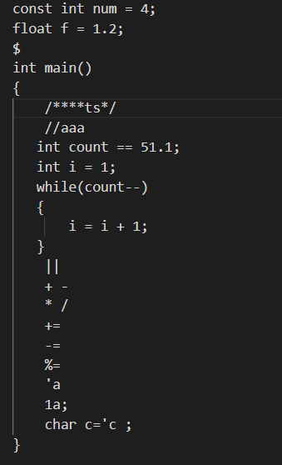
- RESULT:

FELX:
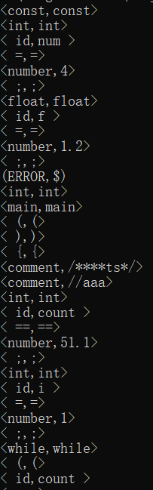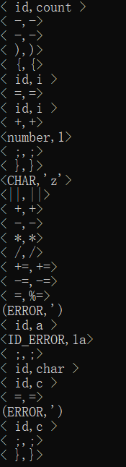
C++:
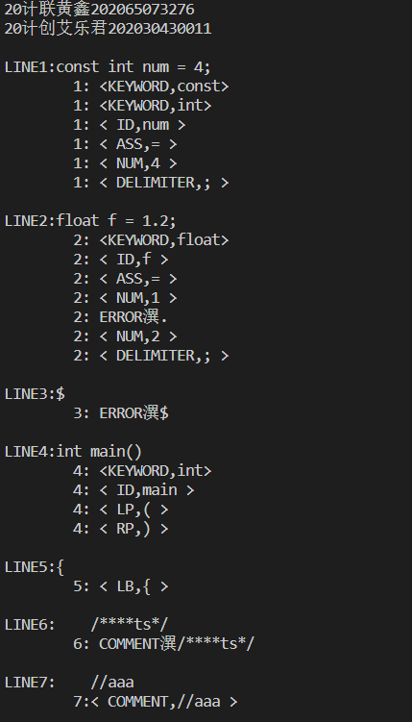
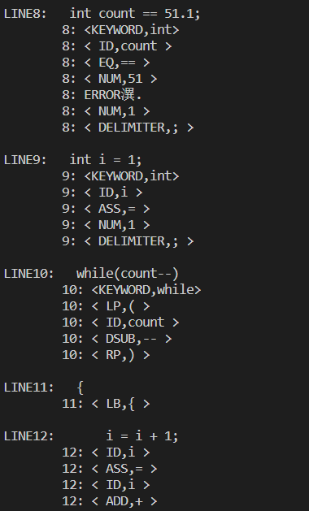
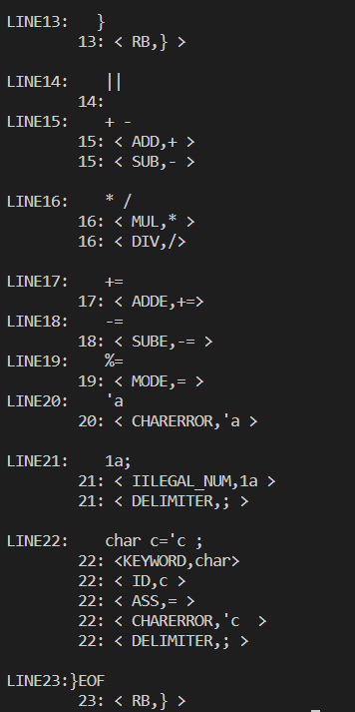
Conclusion
Flex is powerful、convenient and simple. We just define the regular expression and actions after matching.
Designing by ourselves is a little difficult. The most important is the DFA and DFA function.
Teacher’s Comments and Score
Comment：

Score： Signature：
Date：

