South China University of Technology
《Principle of Complier》Experiment Report
Experiment Title： Syntax, Sematic Analysis and Intermediate Code
Name： 黄鑫 Student ID： 202065073276
Class： 20计科全英联合班 Group： 6
Collaborator： 艾乐君 ID:202030430011
Teacher： 董敏
Description
【Objective and Requirement】
Objective：
Understand the Syntax, Sematic Analysis and Intermediate Code generation
Requirement：
Use bison to realize the Syntax, Sematic Analysis and Intermediate Code generation.
Use high level language to realize the Syntax, Sematic Analysis and Intermediate Code generation by oneself.
【Environment】
Operating System：Windows 10
Content and Procedure
- grammar sematic quadruple
Grammar | Attribute Grammar | Quadruple
ConstDecl:Const BType ConstDef ';' | ConsDef.Type=BType.Type | (:=,BType.Type,-, ConstDef.Type)
VarDecl:BType VarDef ';' | VarDef.Type=BType.Type | (:=,BType.Type,-, VarDef.Type)
BType:INT | BType.Type=’i’ | (:=,BType.Type,-,i)
BType:CHAR | BType.Type=’c’ | (:=,BType.Type,-,c)
ConstDef:Ident '=' ConstInitVal ';' | If ConstDef.Type==ConstInitVal.Type then if ConstDef.Type==’i’ then Ident.Type=’i’, Ident.Value=ConstInitVal.Value, Ident.address= ConstInitVal.Address  Else then Ident.Type=’c’, Ident.Name=ConstInitVal.Name, Ident.address= ConstInitVal.Address  Else ERROR | (:=, ConstInitVal.address, -, Ident.Address)
VarDef:Ident '=' InitVal | If VarDef.Type==InitVal.Type then  if VarDef.Type==’i’ then Ident.Type=’i’, Ident.Value=InitVal.Value, Ident.address= InitVal.Address  Else then Ident.Type=’c’, Ident.Name=InitVal.Name, Ident.address= InitVal.Address  Else ERROR | (:=,InitVal.address, -, Ident.Address)
ConstInitVal:Exp | ConstInitVal=Exp
InitVal:Exp | InitVal=Exp
Exp:E | Exp=E
E:E1 '+' T | If E1.type==T.type and E1.type==’i’ then E.Value=E1.Value+T.Value, E.Address=newAddress  Else ERROR | (+,E1.Address, T.Address, E.Address)
E:E1 '-' T | If E1.type==T.type and E1.type==’i’ then E.Value=E1.Value-T.Value, E.Address=newAddress  Else ERROR | (-,E1.Address, T.Address, E.Address)
E:T | E=T
T:T1'*' F | If T1.type==F.type and T1.type==’i’ then T.Value=T1.Value*F.Value, T.Address=newAddress  Else ERROR | (*,T1.Address, F.Address, T.Address)
T:T1 '/' F | If T1.type==F.type and T1.type==’i’ then T.Value=T1.Value/F.Value, T.Address=newAddress  Else ERROR | (/,T1.Address, F.Address, T.Address)
T: F | T=F
F:'(' E ')' | F=E
F:NUM | F.Value=NUM.Value  F.Type=’i’  F.Address=newAddress | (:=, NUM.Value, -, F.Value)
F:STRING | F.Name=NUM.Name  F.Type=’c’  F.Address=newAddress | (:=, STRING.Name, -, F.Name)
Stmt:LVal=Exp | If LVal.Type=Exp.Type then LVal.Address=Exp.Address  Stmt.Begin=newLocation  Stmt.End=Stmt.Begin+1 | (:=, Exp.Address, -, LVal.Address)  (:Stmt.Begin,-, newLocation)  (:Stmt.End,-, Stmt.Begin+1)
Stmt: IF '(' Cond ')' '{' Stmt1 '}' | If Cond.State=true then jump to Stmt1.Begin else jump to Stmt1.End  Stmt.Begin=newLocation  Stmt.End=Stmt.Begin+1 | (j=, Cond.State, 1, Stmt1.Begin)  (jump,-,-, Stmt1.End)  (:Stmt.Begin,-, newLocation)  (:Stmt.End,-, Stmt.Begin+1)
Stmt: IF '(' Cond ')' '{' Stmt1 '}' ELSE '{' Stmt2 '}' | If Cond.State=true then jump to Stmt1.Begin else jump to Stmt2.Begin  Stmt.Begin=newLocation  Stmt.End=Stmt.Begin+1 | (j=, Cond.State, 1, Stmt1.Begin)  (jump,-,-, Stmt2.Begin)  (:Stmt.Begin,-, newLocation)  (:Stmt.End,-, Stmt.Begin+1)
Stmt:WHILE '(' Cond ')' '{' Stmt1 '}' | Stmt.Begin=newLocation  Stmt.End=Stmt.Begin+1  If Con.State=true then jump to Stmt1.Begin else jump to Stmt.End  Stmt1.End=Stmt.Begin | (:Stmt.Begin,-, newLocation)  (:Stmt.End,-, Stmt.Begin+1)  (j=, Cond.State, 1, Stmt1.Begin)  (jump,-,-, Stmt.End)

- How to realize this experiment using yacc-bison?
- Modify the lab1.l file in the lab1, leaf those tokens that we need, then include “lab2.tab.h” which will be generated in later steps.
- Write a lab2.y file, after the first %{}% component, write a struct named “att” in the %union{} part. Since we need to use multiple attributes, the default yacc-bison only provides a yylval in “int” type, which is not enough for storing multiple attributes. Then we also use %type<att> and %token<att> to tell yacc-bison which non terminals and terminals will need to use which attributes.
- Write the non terminals’ production rules in the %% %% area. For some L-attribute attributes, we need to write the semantic rule block in the middle of the production rule, and use a temp value to represent the semantic value of this block, and the rules in later part can use this temp value. For example, the assignment statement.
- How to realize this experiment using c++?
General process:
(1)Read the file and execute lexical analysis and define the token class
(2)Store tokens in a array
(3)Read the tokens one by one in the parse part.
(4)In the parse part, we do the sematic analysis and intermediate code generation.
Important part:
1. We should define the functions according to the grammar.
2. For arithmetic expression, we should use operand stack and operator stack to realize the intermediate code generation
3. We should define the Quadruple class, the true chain, false chain

- Result of Bison
In CMD, write gcc lex.yy.c lab2.tab.c -o a to compile and write a to execute the bison. The file read is the test.txt. The result is shown as below:
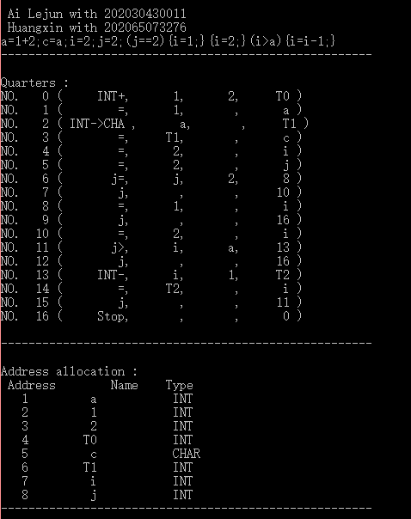
- C++ Result
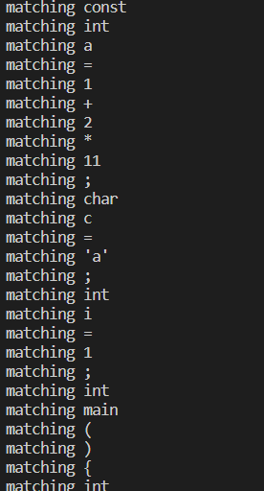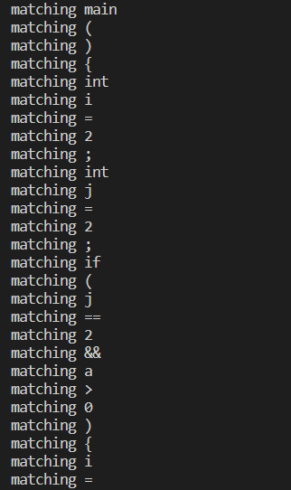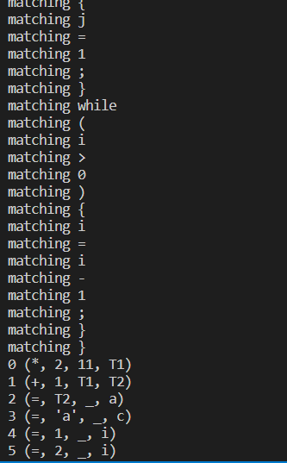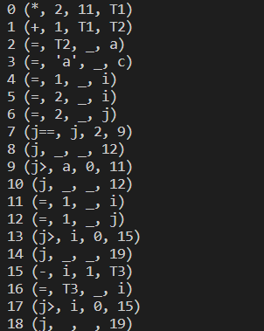

- Compare C++ with Bison
C++ can be implemented more easily. The quadruples can be generated in each time’s production in the recursive-descent program. In bison, it is generated by costructing LALR(1) parsing table automatically first. It has constructed 96 states in LALR table, which is much more complex than the recursive-decent. What is more, some complex information about specific details of arithmetic expressions cannot be written in bison and shown, showing the quadruples is very challenging in BISON than in C++.
Conclusion
YACC-BISON is a powerful tool for learners, but trying to write a C++ source code to implement the own rules for a new programming language is more efficient and easily. The bison is not so good to get start with when dealing with multiple attributes and trying to do some L-attribute operations, but these operations can be implemented easily in the recursive-descent program.
Teacher’s Comments and Score
Comment：

Score： Signature：
Date：

