

Computer Networks

Lab Report

Name ：黄鑫
Student ID ：202065073276
Class ：20计算机全英联合班
Collaborator(s) :

Task 1 Network Traffic Analysis

Purposes and tasks:
（1）Learn the use of wireshark. You can do this task on your own PC and own LAN.
（2）Learn analysis of network traffic caught.
（3）Explain TCP hand-shaking process.
（4）Learn how TCP hand-shaking failure can be handled.
（5）Analysis ARP packets
Steps:
1. Setting up experimental environment (skip this step, if your environment has all been set up)
（1）Wireshark
（2）PC connected to network
Download address: https://www.wireshark.org/

2. Basic operations on Wireshark
（1）Monitor on a particular network interface
（2）Capture particular packets.
Choose one interface
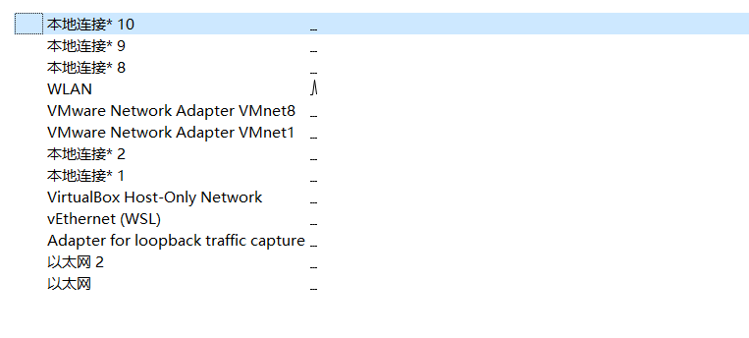
Filter the packets in the filter bar and you can use logic expression
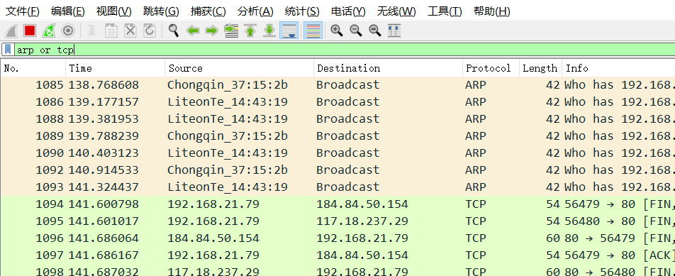
Click one packet, bottom of wireshark will show the details
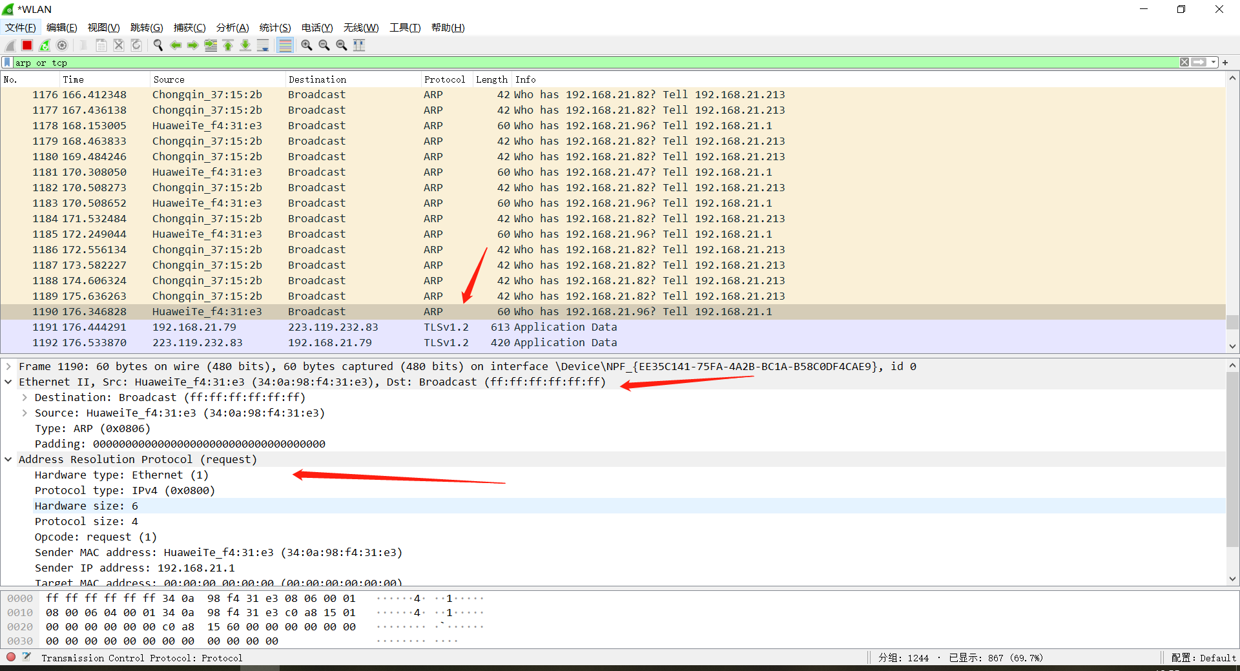

3. Record an example of a successful TCP three-hand-shaking
In the dos window, input: telnet bbs.newsmth.net
In the wireshark, it will show as following:
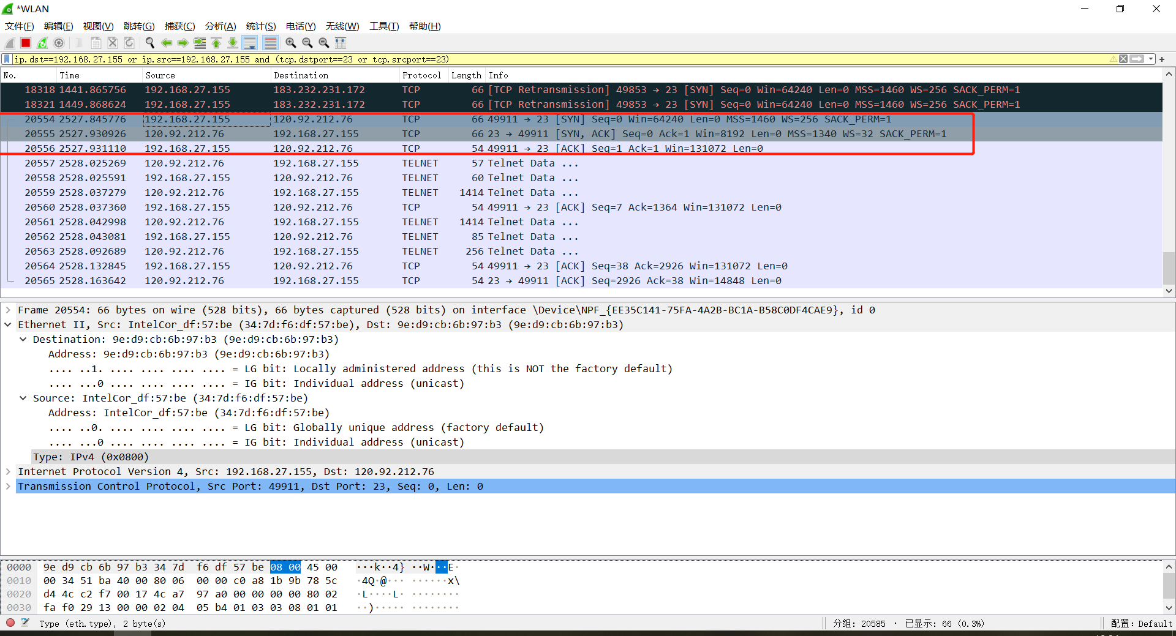

You can notice the detailed information such as sequence number, source port, destination port in the bottom of the window.
The first handshake:
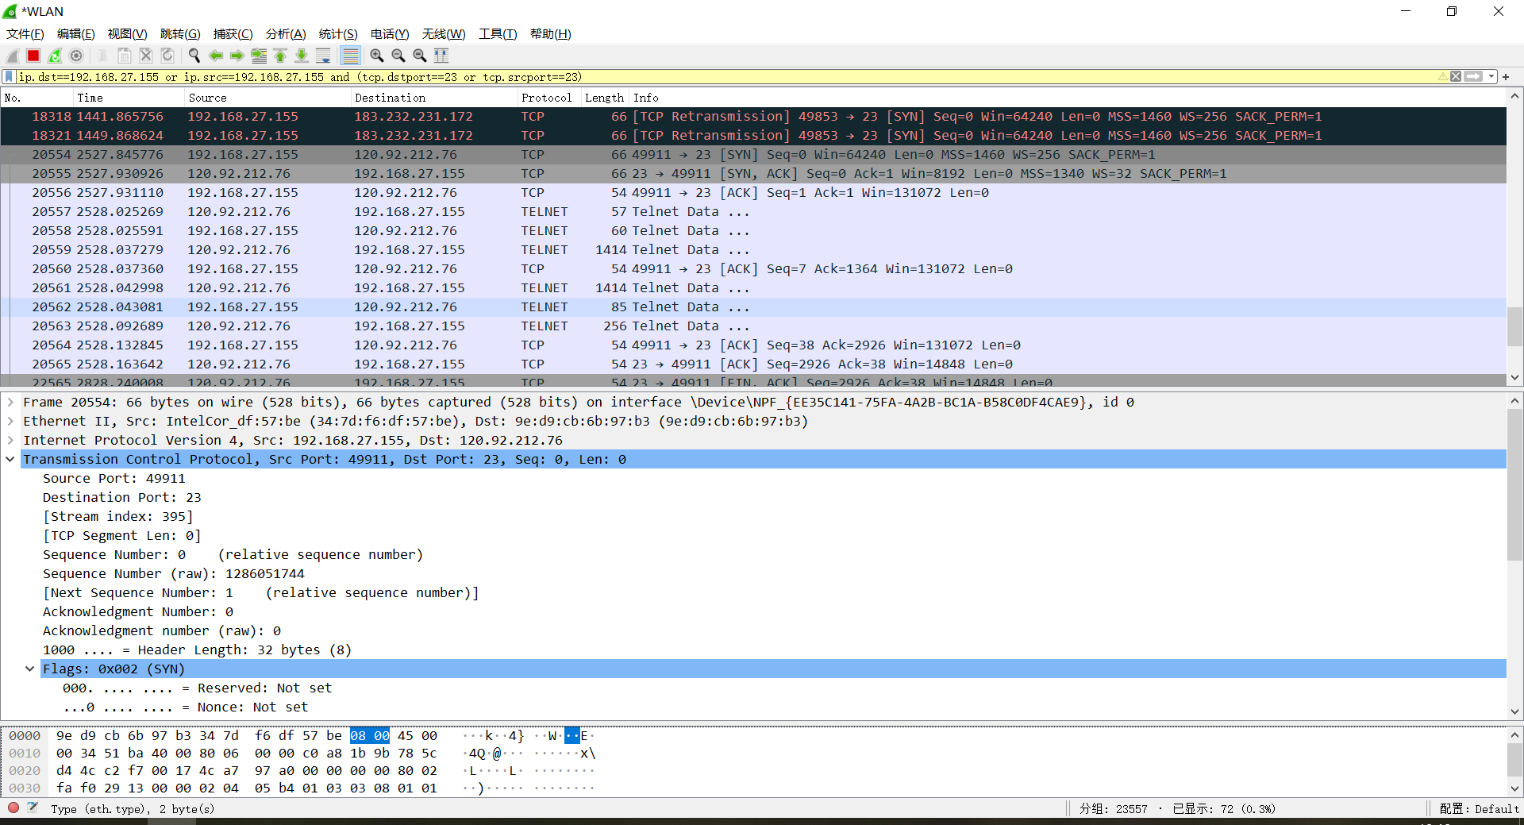
The second handshake:
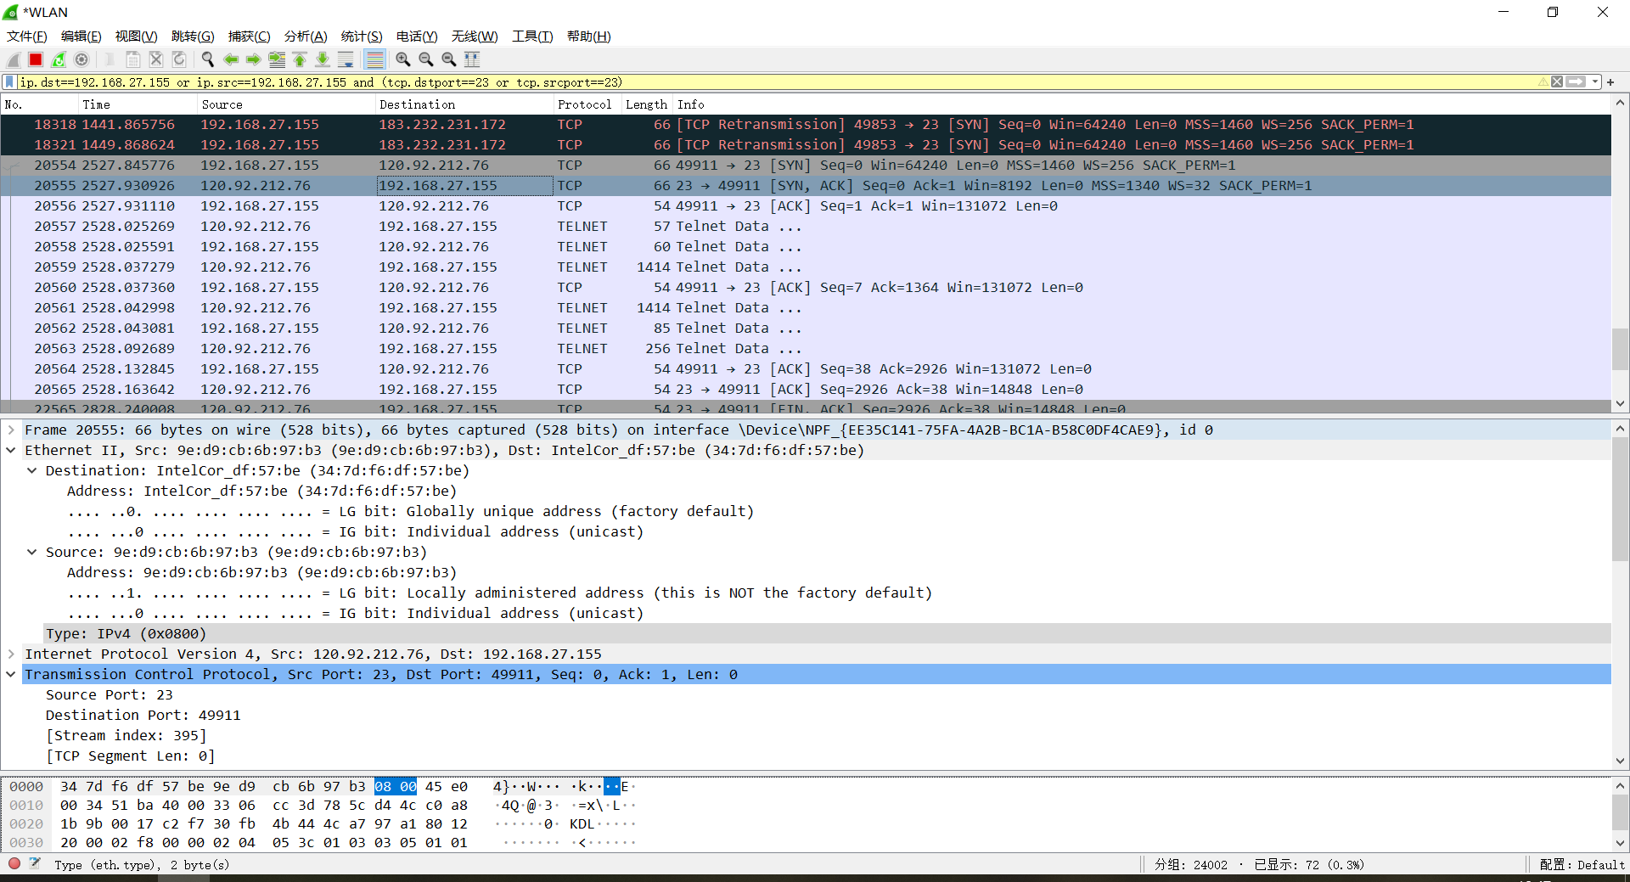
The third handshake:
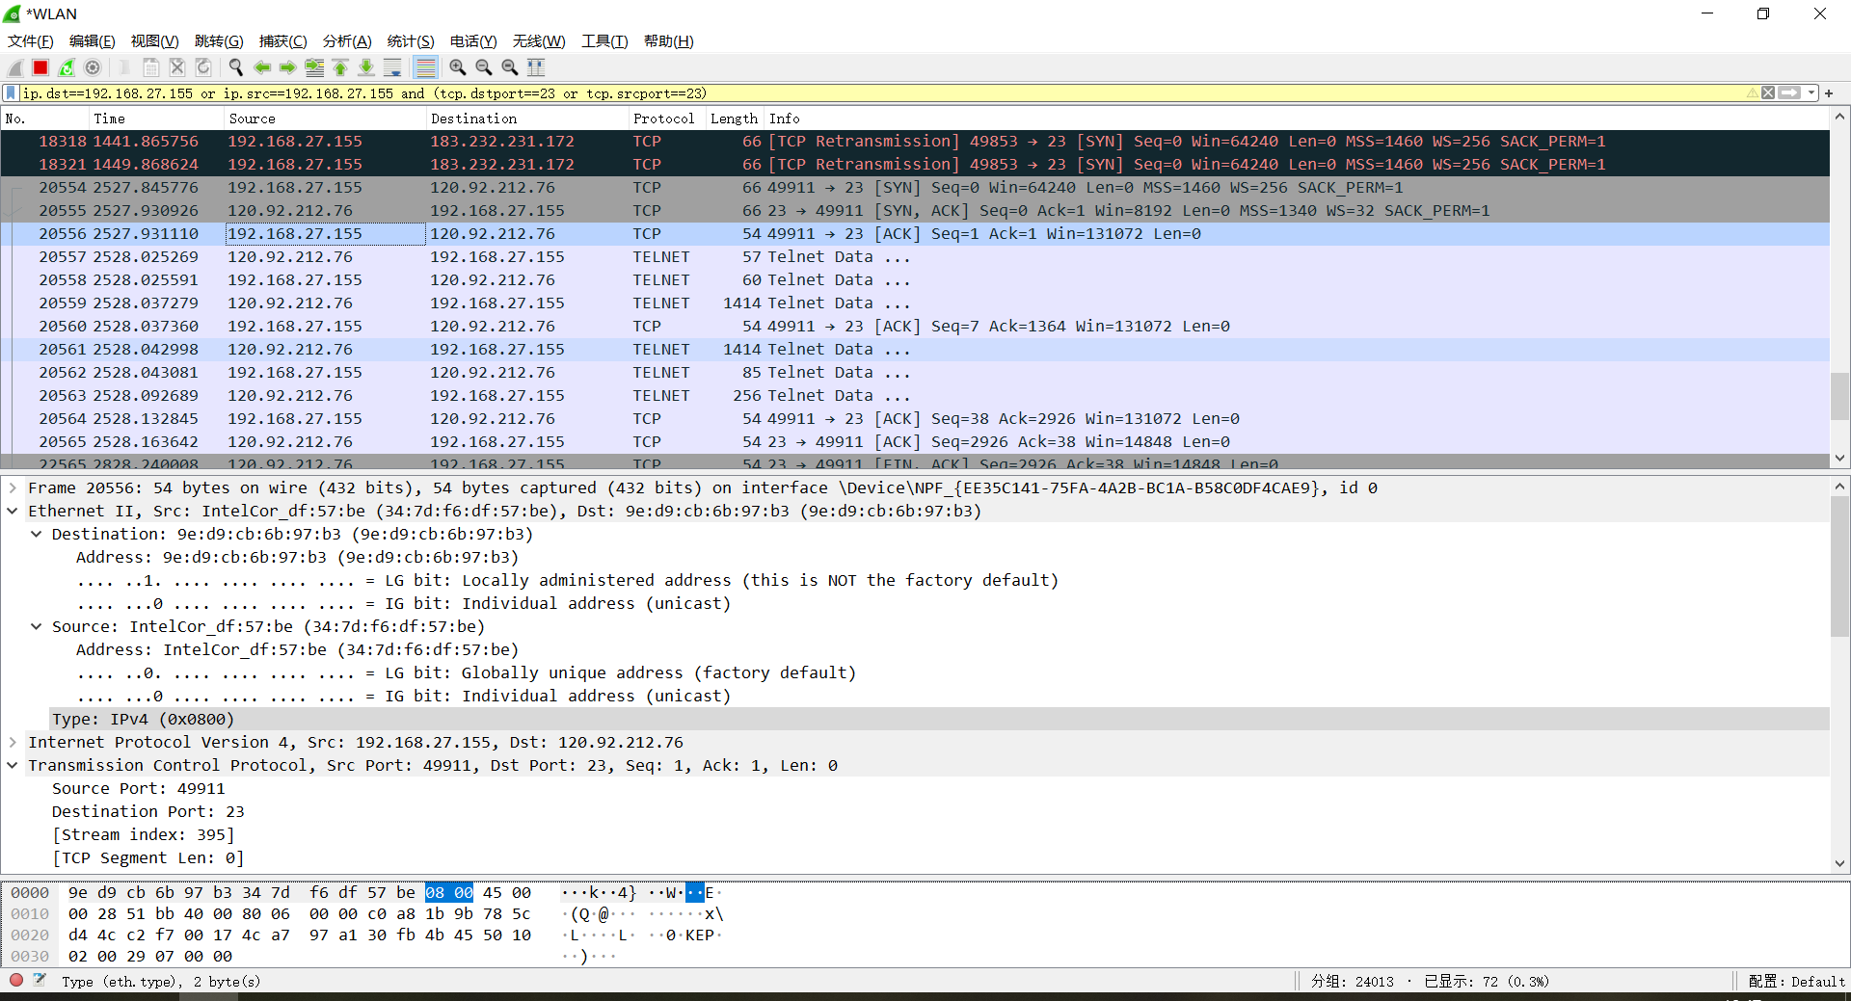
4. Record an example of hand-shaking failure
In the dos window, input: telnet www.baidu.com
It will retransmit.
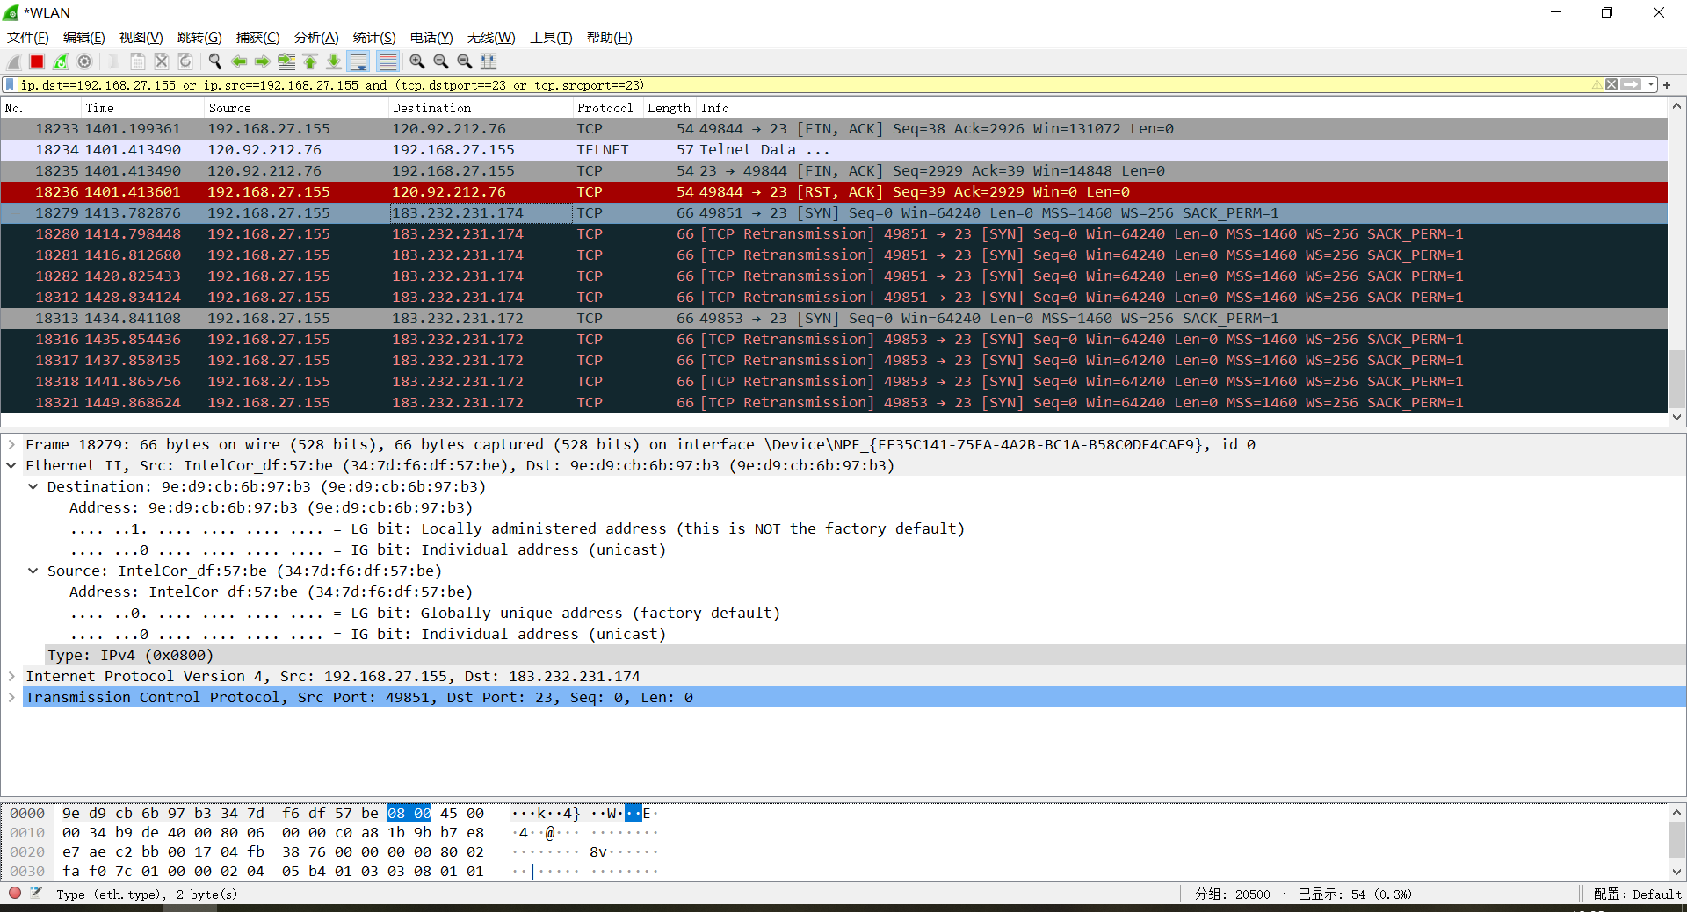
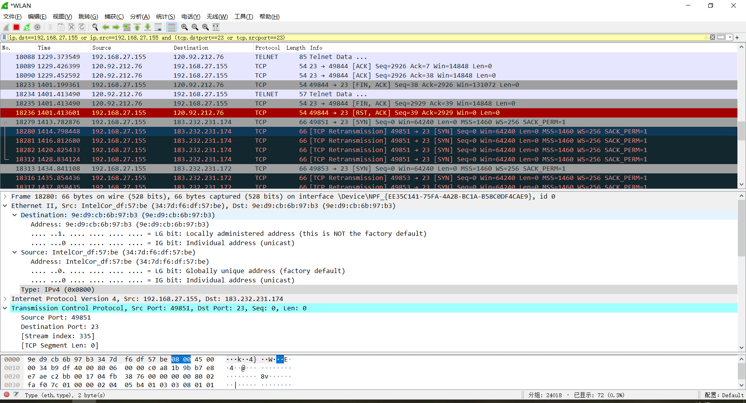

5. Monitoring ARP packets
Just filter the ARP protocol and delete the local arp cache.
Ping some address you like.
It will do broadcast.
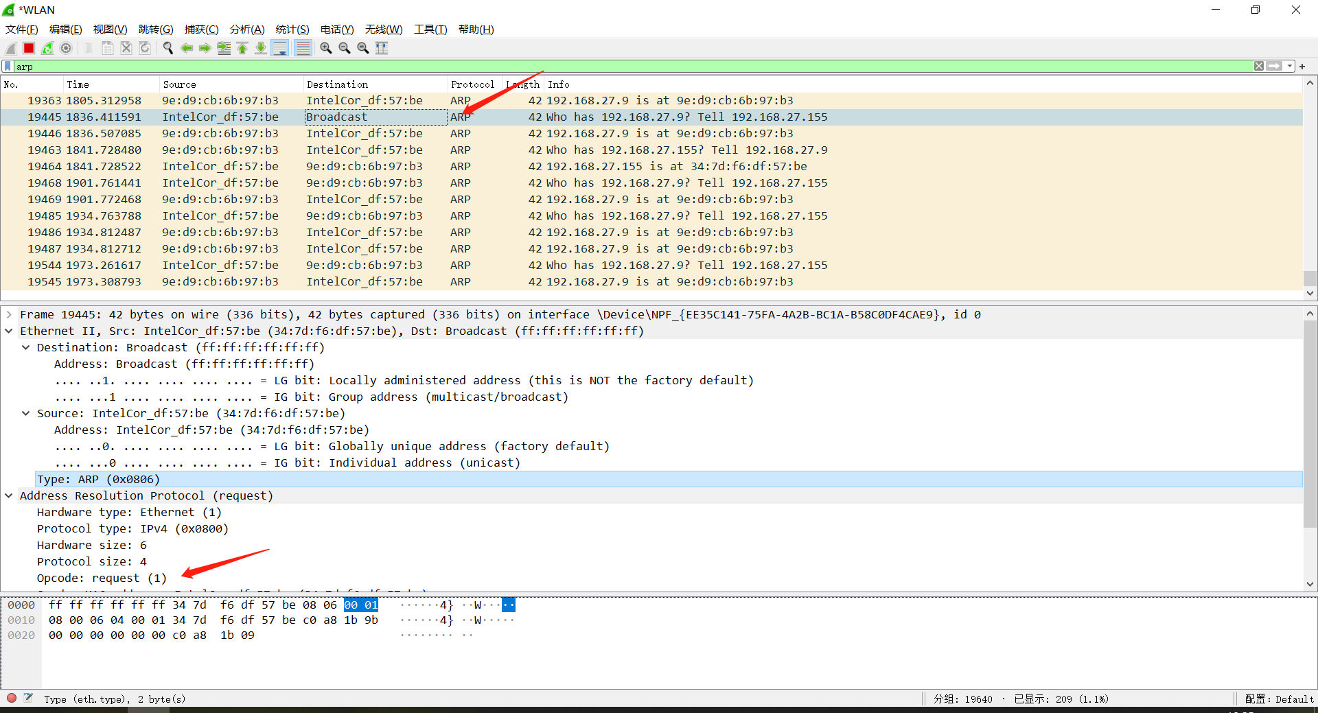
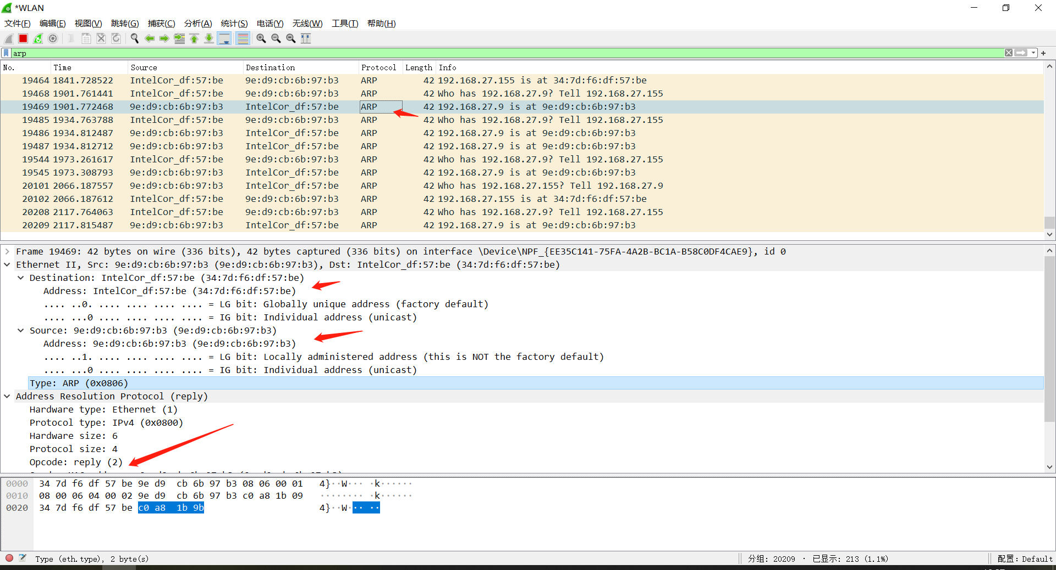

6. Monitoring ICMP packets

Just filter ICMP packets and Ping www.baidu.com
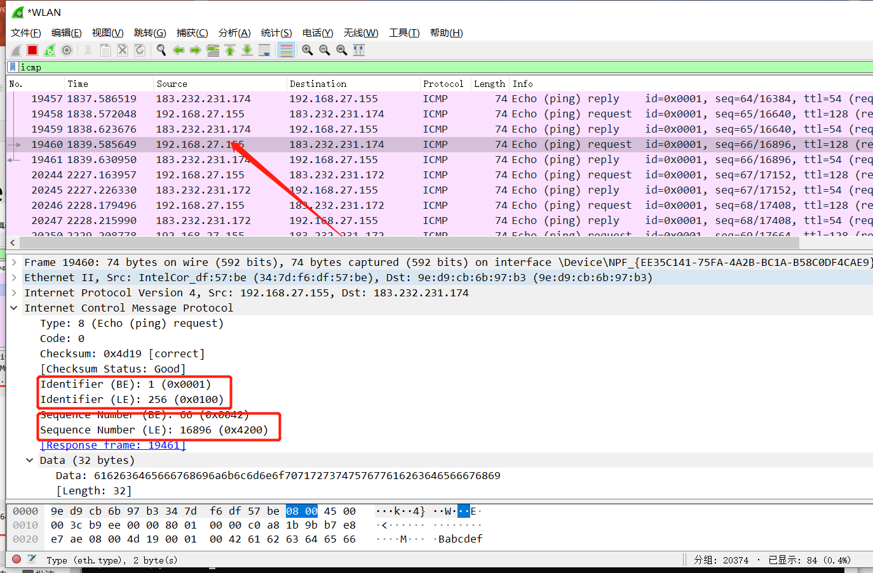

Task 2 Basic Router Operations & static Routing

1. Experimental Purposes
（1）Get familiar with Cisco PacketTracer and router
（2）Learn basic router operation command
（3）Static routing

2. Please answer following questions in your lab report

（1） What is router

Router is a hardware device that connects two or more networks and acts as a gateway between networks. It is a special intelligent network device that reads the address in each packet and then decides how to transmit it. It can understand different protocols, such as the Ethernet protocol used by a local area network and the TCP/IP protocol used by the Internet.

Router can analyze the destination address of data packets from various types of networks, and convert the address of non TCP/IP networks to TCP/IP addresses, or vice versa. Then, according to the selected routing algorithm, each packet is transmitted to the designated location according to the best route. So routers can connect non TCP/IP networks to the Internet.

（2）How can we remotely log onto a router?

What tools can be used?

How could you configure these tools?

Tools: web browser and a DNS provider.

The first thing to do is enable the remote access function of the router. Just type in your default gateway IP address in the address bar in a web browser, fill the username and password and log in. find the “Remote Access”. Turn it on.

The second thing is to enable DNS. To start, you have to connect with a DNS provider. There are numerous DNS providers online and some of them are given for free. Depending on the DNS you’ve chosen, setting it up may vary. The common step here is that you have to make a new hostname and a subdomain. Once you’ve created those things, go back to your router’s settings on your browser. Copy the hostname and subdomain on the DNS settings panel. When that’s done, you’ve set up your router for remote access. Your new domain will now have to end with a “:8080”.

To connect to your personal router remotely, go to your web browser on your phone. Type in your router’s IP address. It’s the same IP address you used when you were setting up the remote access. A log-in page will be displayed. Enter your admin username and your password. After that, you can now access all your router’s features from your phone.

（3）What are the five working modes of a router?

Prompts

Meaning/function

How can you switch between different modes?

Five working modes and their functions:
- User execution mode: global configuration mode, interface configuration mode, subinterface configuration mode, router configuration mode, and line configuration mode.
- Global config mode: As we type configure terminal to the user mode, we will enter into the global configuration mode. Commands entered in these modes are called global commands and they affect the running configuration of the router. In this mode, a different configuration like making a local database on the router by providing username and password can set enable and secret password, etc.
- Interface mode: In this mode, only the configuration of interfaces is done. Assigning an IP address to an interface, bringing up the interface are the common tasks done in this mode.
- Privileged mode: As we type enable to user mode, we enter into Privileged mode where we can view and change the configuration of the router. Different commands like show running-configuration, show IP interface brief, etc, can run on this mode which is used for troubleshooting purposes.
- ROMMON mode: We can enter this mode when we interrupt the boot process of the router. Generally, we enter in this mode while the password recovery process or Backing up of IOS on devices like TFTP server. It is like the BIOS mode of a PC.

The command we need:
- Enter privileged mode: enable
Exit privileged mode: disable
Enter setup mode: setup
Enter global config mode: config terminal
Exit global config mode: end
Enter interface mode: interface type slot/number
Enter line mode: line type slot/number
Enter router mode: router protocol
Exit global config mode: exit

（4）Describe the steps/commands of setting IP address on a router interface.
The command is following:
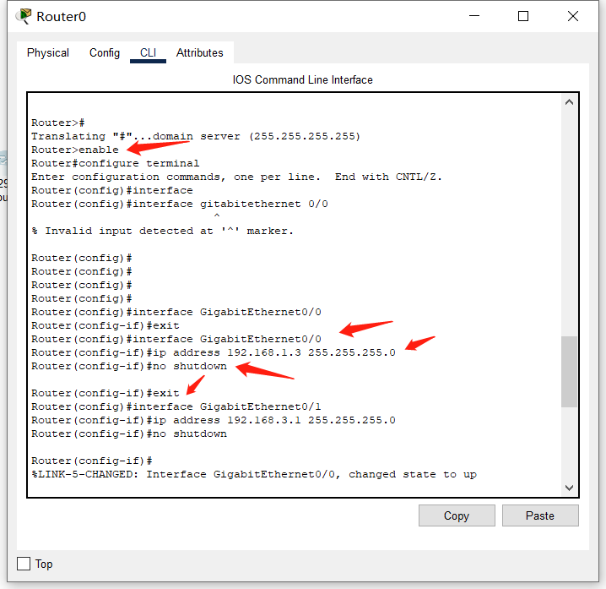
（5）Explain how ‘show’ command can be applied to
obtain router information
interface information/configuration
router information:
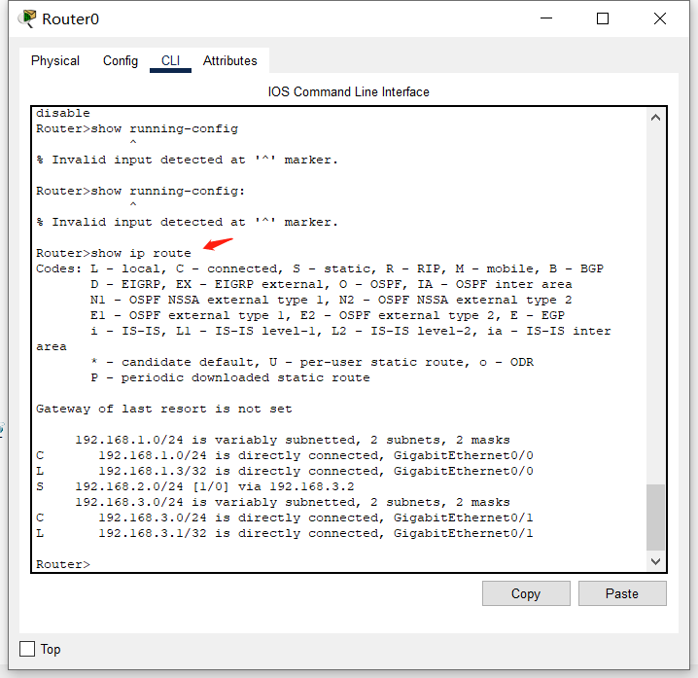
Interface information:
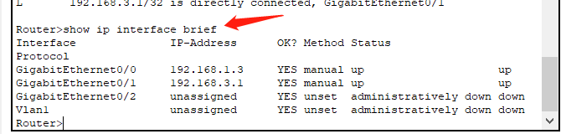
- Describe how routing entries can be manually configured.
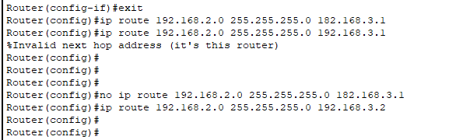
- Experimental Environment

（1）Network topology (for example)
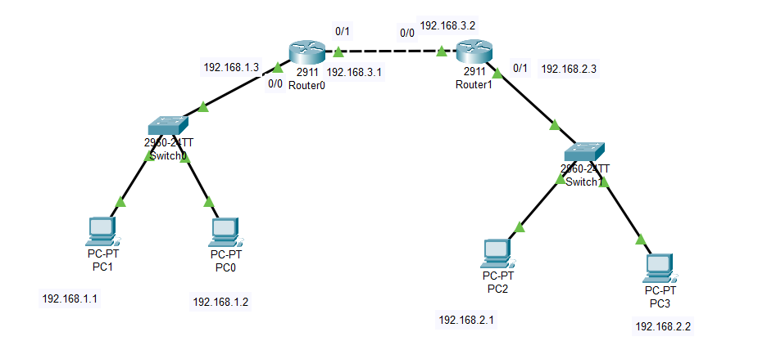
（2）Experiment devices
Two routers, two switches (optional), two PCs and cables.
（3）Experiment requirements
Given 3 C-class Network addresses: 192.168.1.0，192.168.2.0，192.168.3.0. (Just for example. You can design the networks as you like.)
- Using the above topology to design network, explain the address for each node and interface.
Please describe the commands/steps to configure these IP addresses

1)192.168.1.0 for left network. 192.168.2.0 for right network. 192.168.3.0 for the network between the two routers.
2)
For router:
For PC: using GUI.
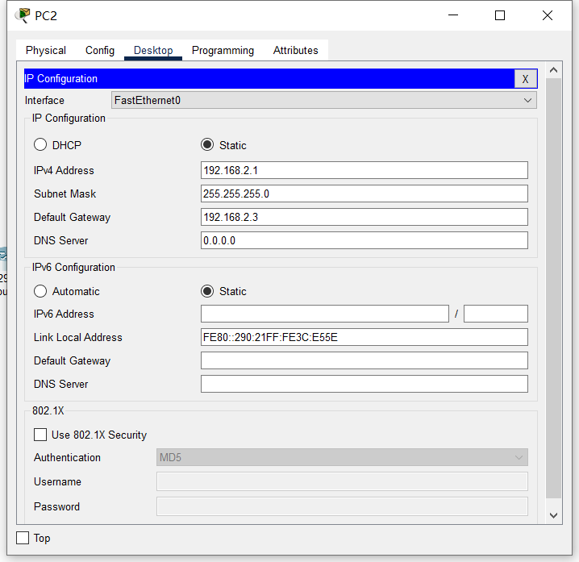
- Using static routing, to enable the workstations to communicate with each other.
Explain the routing entries on each router
Explain the commands/steps to configure routing entries

For router0: 192.168.1.3 is the gateway IP address for 192.168.1.0 network. 192.168.3.1 is the IP address in the network 192.168.3.0 for communicating with router1.
The similar to router1.

Command explanation:
For example: ip route 192.168.2.0 255.255.255.0 192.168.3.2
If we want go to 192.168.2.0 we need go via 192.168.3.2(which is next hop) 255.255.255.0 is the mask of 192.168.2.0

Task 3 Networking --- Dynamic routing

1. Experimental Purposes
（1）RIP configuration
（2）OSPF configuration

2. Experimental Environment
（1）Network topology (for example)
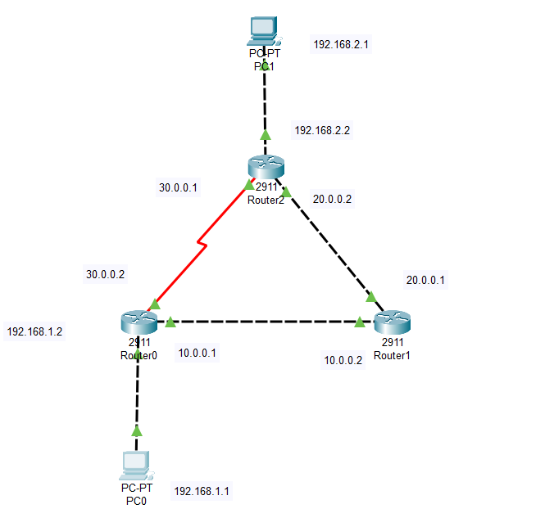
2）Experiment devices
Two routers, two switches (optional), two PCs and cables.
（3）Experiment requirements
Given 3 C-class Network addresses: 192.168.1.0，192.168.2.0，192.168.3.0. (Just for example. You can design the networks as you like.)
- Using the above topology to design network, explain the address for each node and interface.
The address noted is next to the device and interface.
For router, the steps/commands of IP configuration is following:
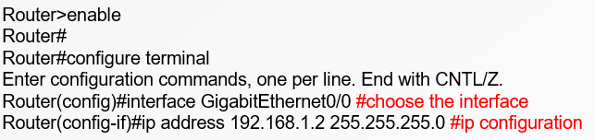
For PC, just use GUI as it is convenient.
- Using RIP, to enable the workstations to communicate with each other.
Explain RIP
Explain the commands/steps to configure dynamic routing

1. RIP:
The Routing information Protocol(RIP) is one of the oldest distance-vector routing protocols which employs hop count as a routing metric . RIP prevents routing loops by implementing a limit on the number of hops allowed in a path from source to destination. The largest number of hops allowed for RIP is 15, which limits the size of networks that RIP can support.
2. For example, we can network 10.0.0.0 to rip
Steps:
Enter privileged mode
Enter global configuration mode
Configure rip
exit
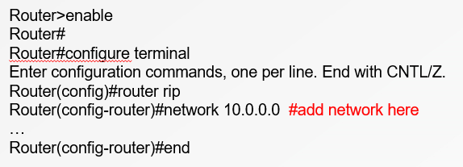
More:
Only consider the distance. Not consider the status.
If an ICMP leaves from PC0 to PC1. It will pass the 30.0.0.0 network while 30.0.0.0 is slow which uses serial DTE whose bandwidth is small.
It will not pass through the 10.0.0.0 and 20.0.0.0 because the distance is larger.

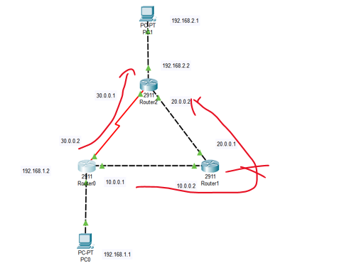
Load balancing(负载均衡)
Two ways will be both used
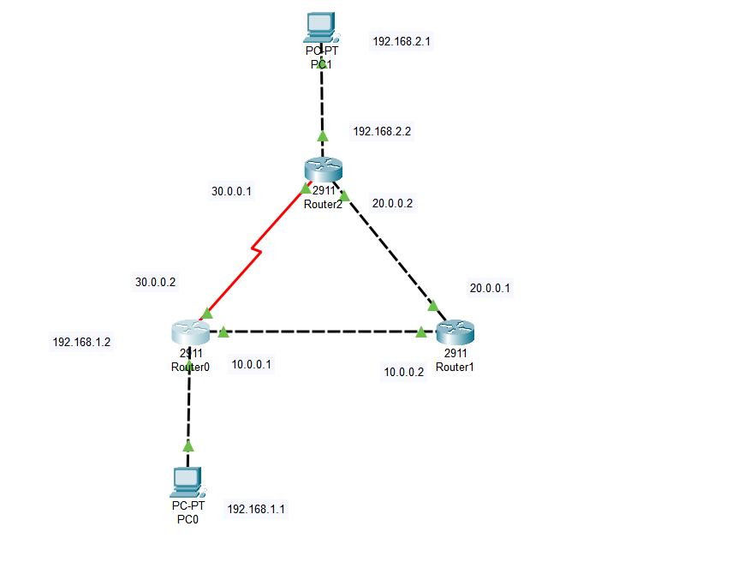
- Using OSPF routing, to enable the workstations to communicate with each other.
Explain OSPF
Explain the commands/steps to configure dynamic routing
Open Shortest Path First (OSPF) is a routing protoccal for internet protocol(IP) networks. It uses a link state routing(LSR) algorithm and falls into the group of interior gateway protocols (IGPs), operating within a single autonomous system (AS).
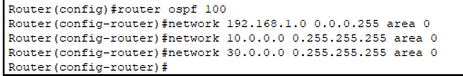
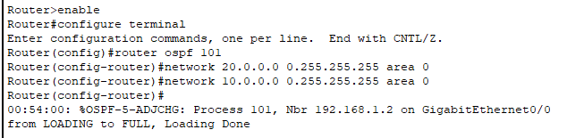
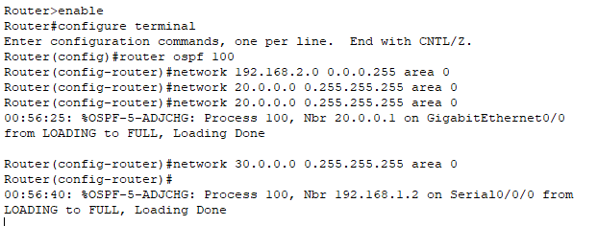
1. router ospf [process id]
process id has only local meaning and it is just the pid of this ospf.
2. network [network number] [antimask] area [area number].
Network number is what network the router connects to.
Antimask is the inverse of the mask of the network: 1 becomes 0 and 0 becomes 1.
Area number is used to specify the region in which it operates. (region 0 is the backbone region).
（4）Testing and confirmation
How can you test and confirm that the network is working fine?
RIP:
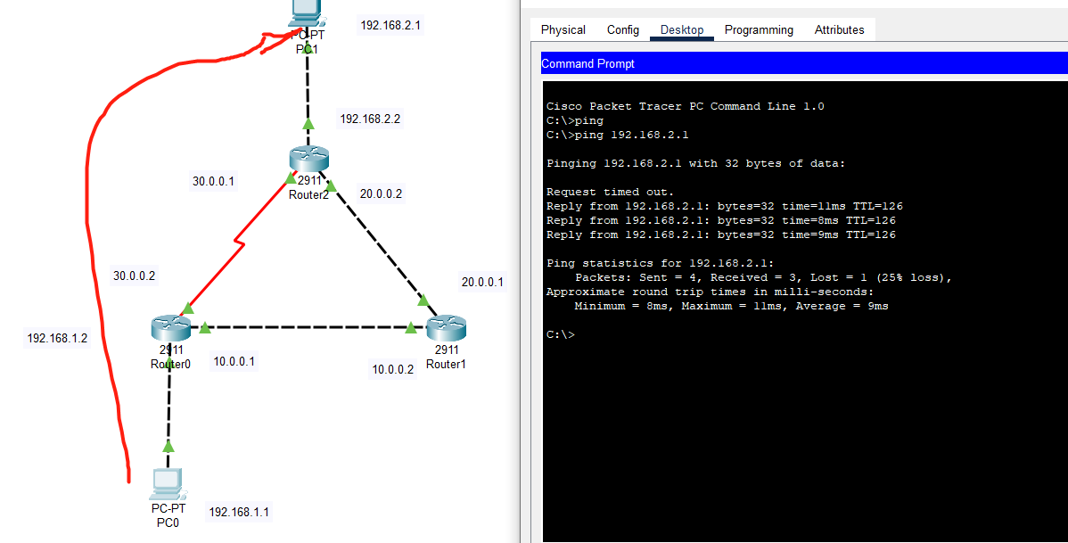
Normally, the first ping request will time out because PC0 need to get the MAC address of PC1 through ARP request.

OSPF:
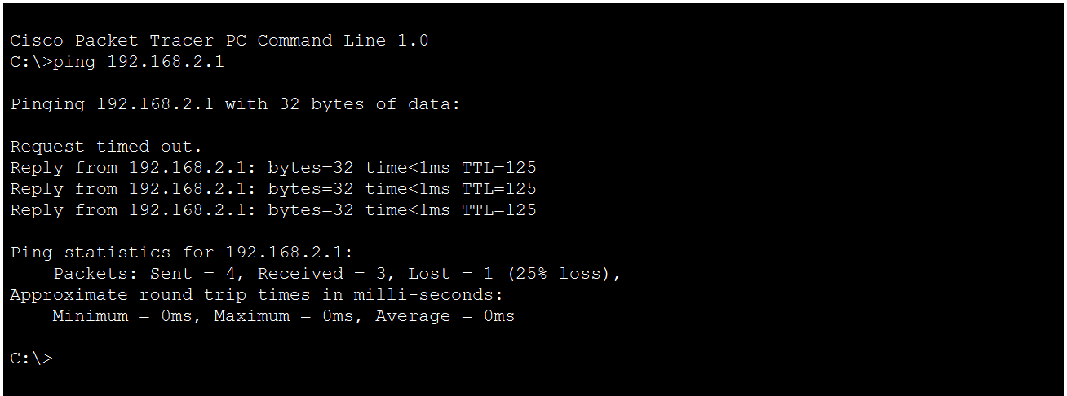
Normally, the first ping request will time out because PC0 need to get the MAC address of PC1 through ARP request.

Task 4 Socket Programming

1. Project Purpose
(1) Master the basic principles and methods of Socket network programming
(2) Understand the underlying principle of operation of Socket deeply

2. Project Content

2.1 Requirement
1) Basic: Implement a client and a server similar with ftp protocol; complete the basic function of file transfer.
List the files/directories
Change working-directory
Download file/s
Upload files/s
Create/remove files/directories
Etc…
2) Submit content: document report （include design document, using explanation）, source code，the content above store in 2 folder apart（Doc、Src）

High-layer encapsulation Socket cannot be used (like java class library, MFC and so on)

2.2 Reference Materials
Recommended reference books:
《UNIX Network Programming》Richard Stevens
《UNIX Environment Advanced Programming》
《TCP/IP Networking technology Volume III（Winsock edition）》

3. Project Environment
（1）Platform: Linux or Windows
（2）Developing Language: C or C++
（3）Developing Environment: no limitation, Visual C++, .NET, Vi and so on
（4）Group: 2 members/group or individual

4. Explanation requirements
Explain the design of your file transfer program.
Explain the usage of socket.h or winsock.h

Operation manual
How to use my program?
Environment: windows os
Compiling command: g++ socket.cpp -o socket -lws2_32 and g++ client.cpp -o client lws2_32
Execution command: ./socket(first executed) and ./clinet

Design of my file transfer program:
1. It looks like the terminal of a Linux OS.
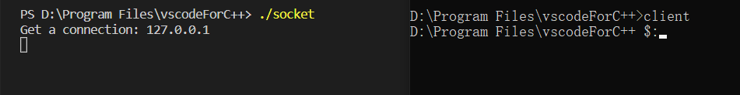
2. command in this program.
ls: List the files/directories
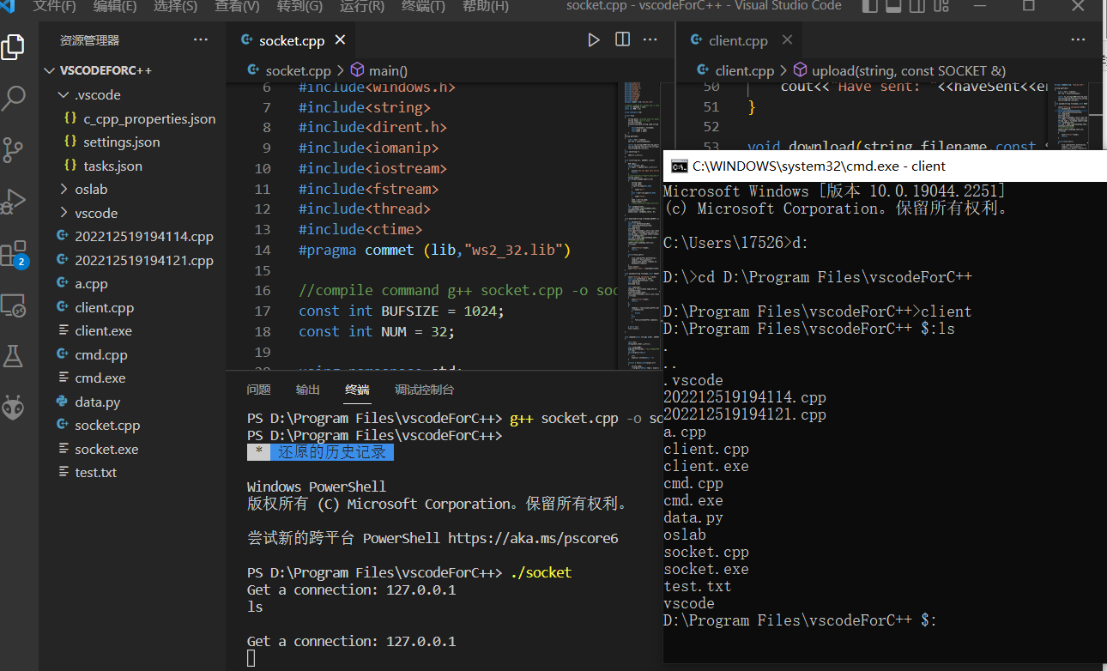

cd: Change working-directory
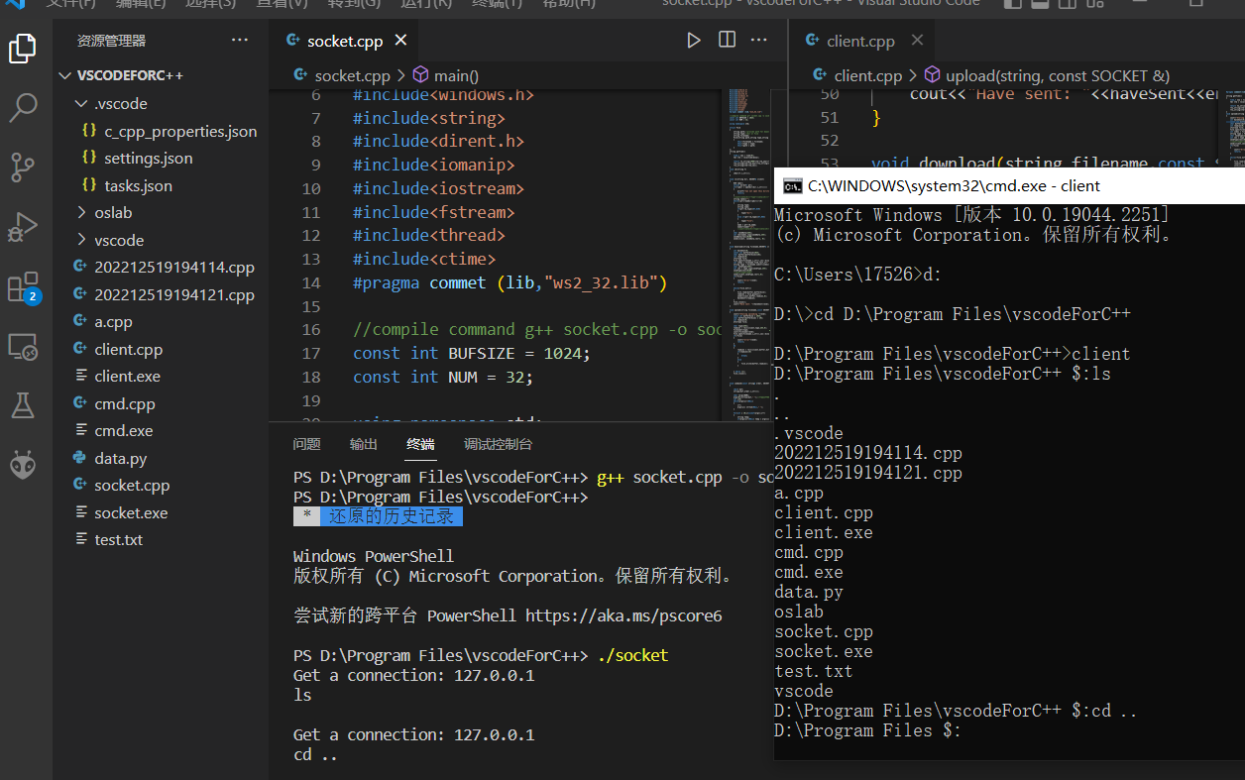
dload: Download file/s
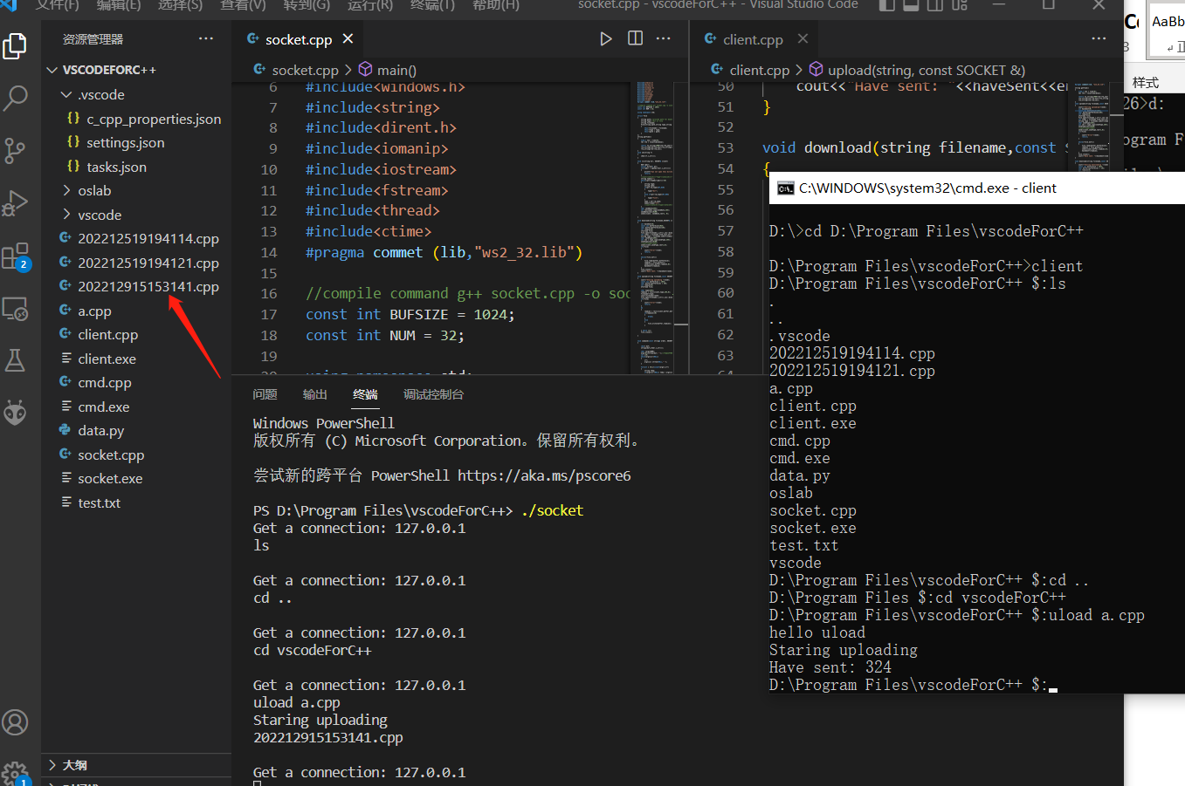

uload: Upload files/s
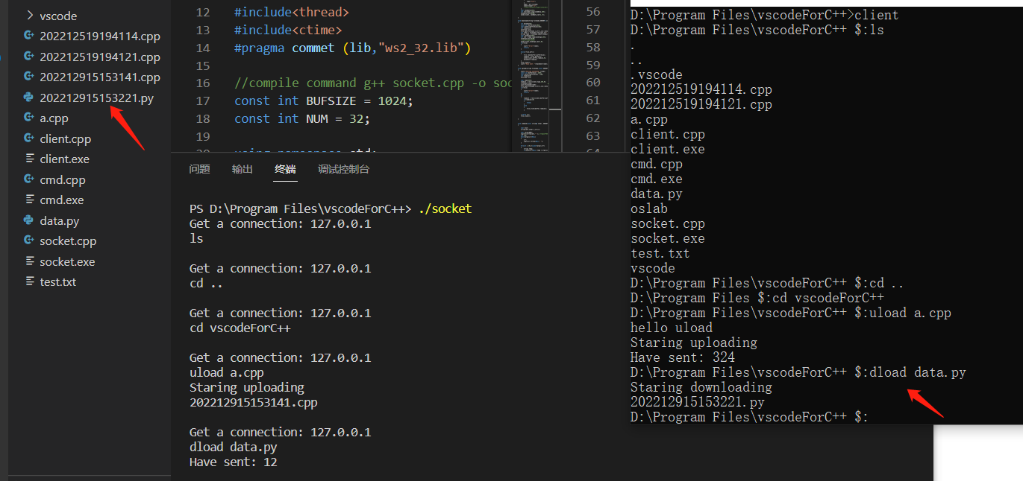
create/rm: Create/remove files
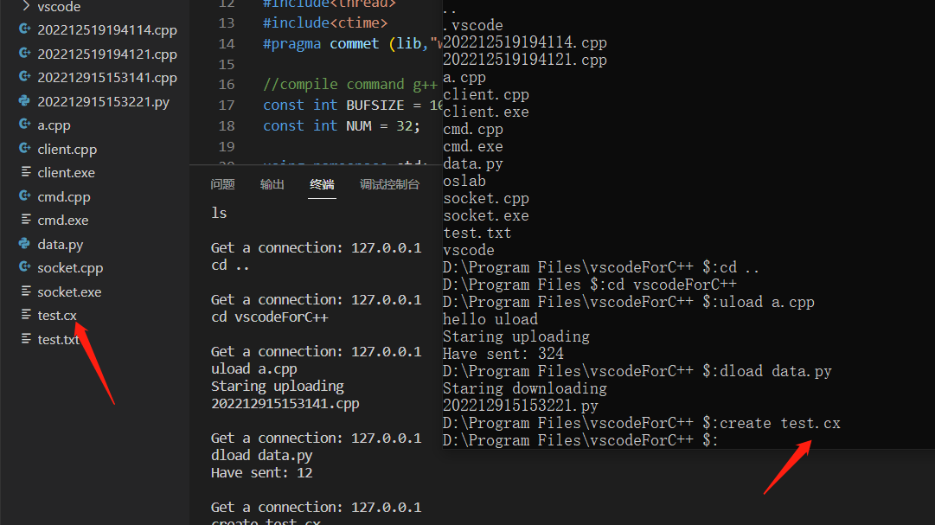
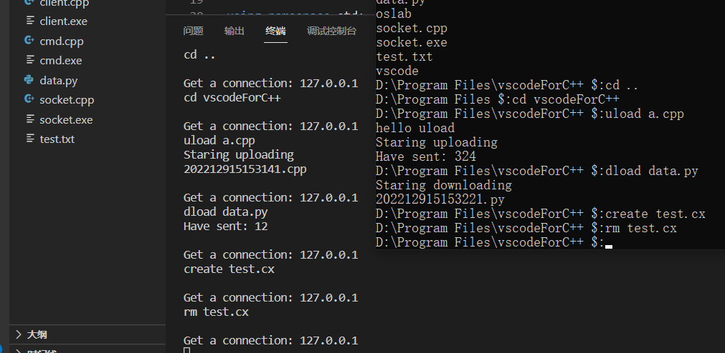
mkdir/rmdir: Create/remove directories
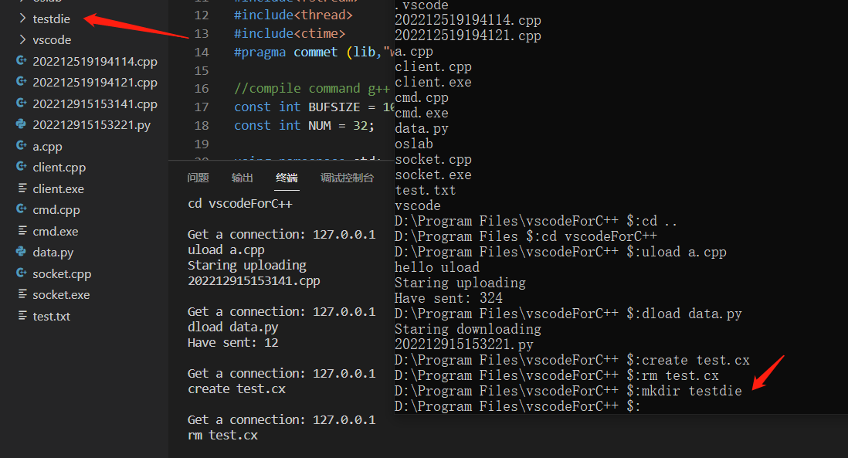
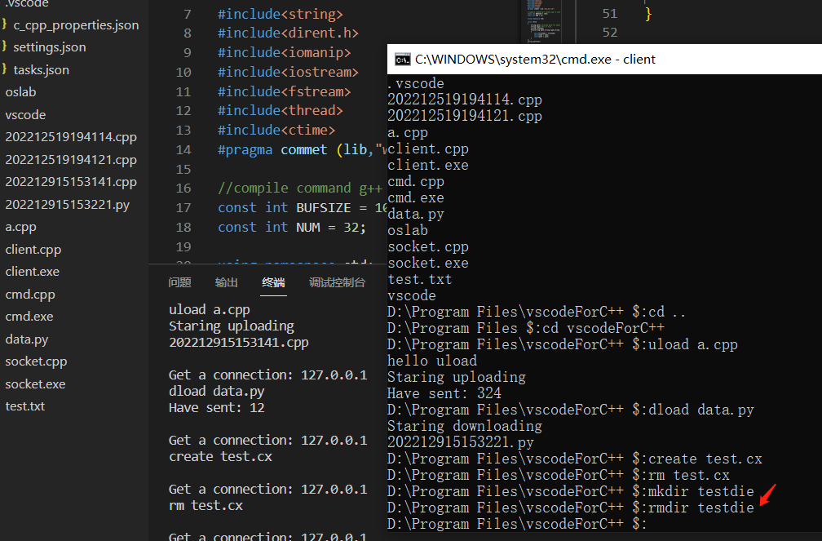
usage of winsock2.h
//initiate WSA(windows socket app)
WORD sockVersion=MAKEWORD(2,2);
WSADATA wsaData;//WSADATA structure

// start socket. It will return 0 when it is successfully set up
int WSAStartup(WORD wVersionRequested, LPWSADATA lpWSAData);

//create socket
SOCKET slisten=socket(AF_INET,SOCK_STREAM,IPPROTO_TCP);

//bind IP and address
sockaddr_in sin;// struct sockaddr_in is used to specify ipv4
sin.sin_family = AF_INET;
sin.sin_port = htons(8080);// set port
sin.sin_addr.S_un.S_addr = INADDR_ANY;//let system automatically get local address

//bind the socket and sockaddr_in
bind(slisten, (LPSOCKADDR)&sin, sizeof(sin))

//listen to the socket
listen(slisten,5)

//accept the message from another socket.
//params: clinet socket, remote client structure, length we receive.
accept (SOCKET, struct sockaddr *, int *);

//send message
//params: client socket, data to be send, data length, flag
send (SOCKET, const char *, int, int);

Conclusion
By using wireshark, I can do simple network traffic analysis. I can analyze the ARP, ICMP, three TCP handshakes.
By using Cisco Packet Tracer, I can do static routing configuration. During the process, I have learned a lot about router itself and the commands we need to configure a router.
By using Cisco Packet Tracer, I can configure the dynamic routing such as RIP and OSPF. During the process, I have learned more about the commands and the features of these two protocols.
By programming a file transfer application, I am familiar with the basic operations of winsock2.h.

Comments and mark:

