File: G07_Freezing_Trial1_trial_1_emg.csv

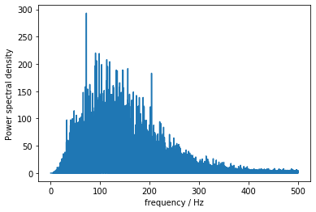

Periodogram of LEFT_TA

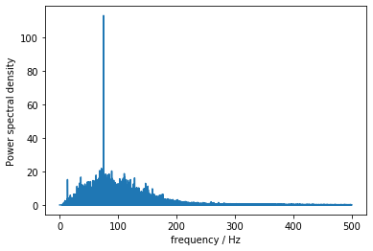

Periodogram of LEFT_TS

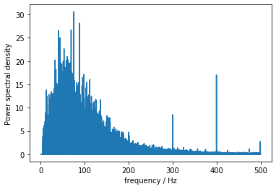

Periodogram of LEFT_ BF

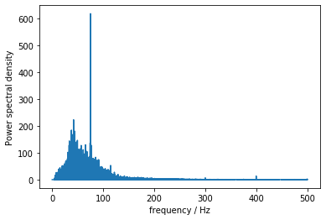

Periodogram of LEFT_ RF

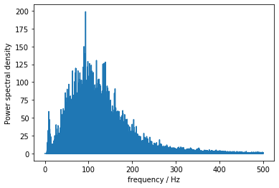

Periodogram of RIGHT_TA

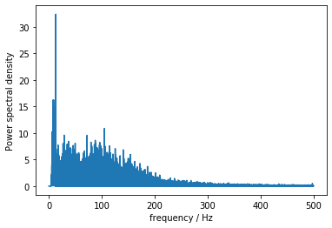

Periodogram of RIGHT_TS

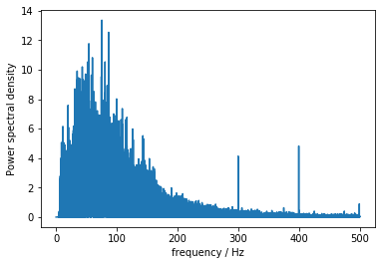

Periodogram of RIGHT_BF

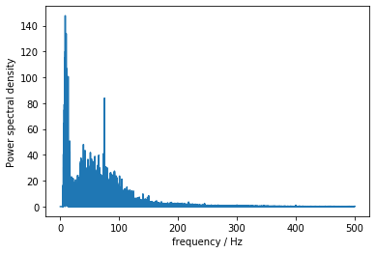

Periodogram of RIGHT_RF