Screenshots of the conversation:

Subscription

Unsubscription

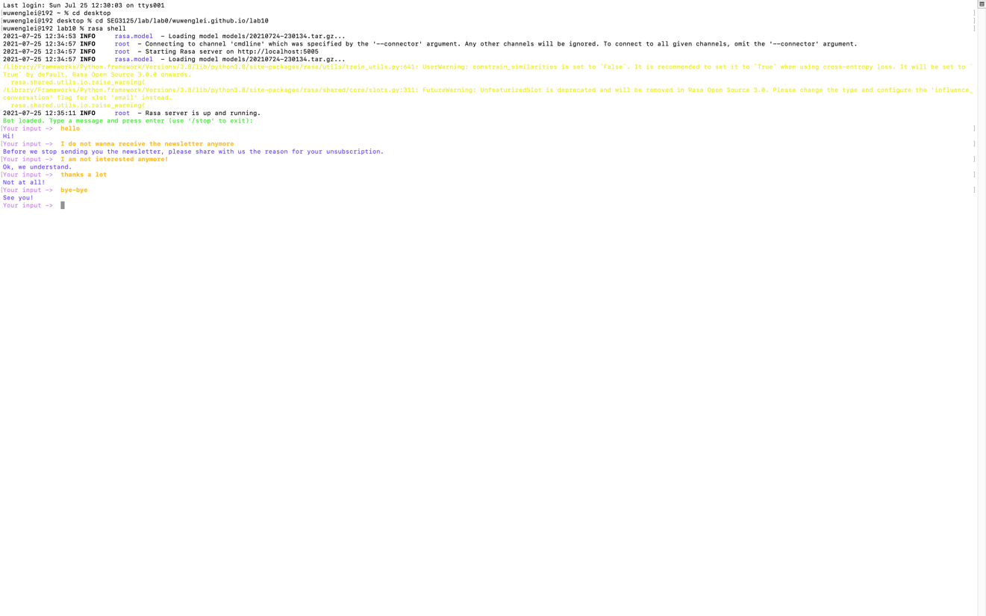

Screenshots of the implementation:

Q1. There are 4 new training examples relevant to the "greet" intent already defined.

图形用户界面, 文本, 应用程序

Q2. There is a new Thank You intent defined, containing 4 training examples.

Q3. There is one response action defined for the Thank You Intent, with 4 possible responses.

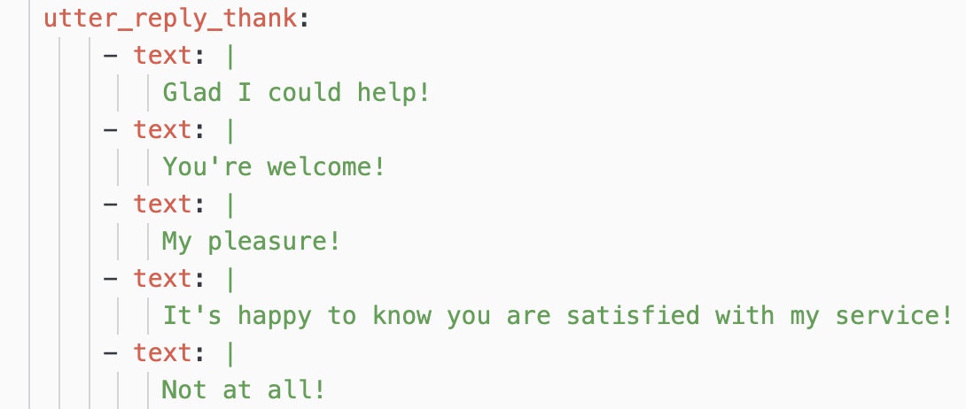

Q4. There is a new Goodbye intent defined, with 4 training examples.

文本

Q5. There is a response action defined for the Goodbye intent, with 4 possible responses.

Q6. The "greet and subscribe" story is correctly modified to have the Thank You and Goodbye at the end.

文本

Also see the conversation on the first page.

Q7. There is an new story to "greet and unsubscribe", and it can be activated.

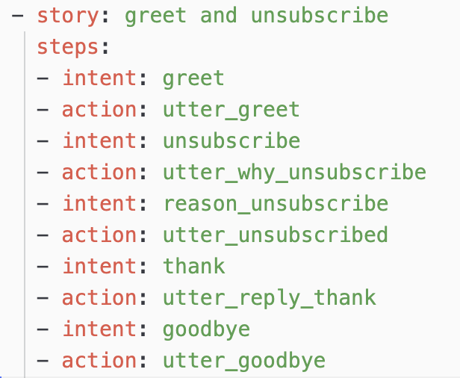

Also see the conversation on the first page.

Q8. There is an Unsubscribe intent defined with 4 training examples.

Q9. There is an response action defined for the Unsubscribe intent with 4 paraphrases for asking why

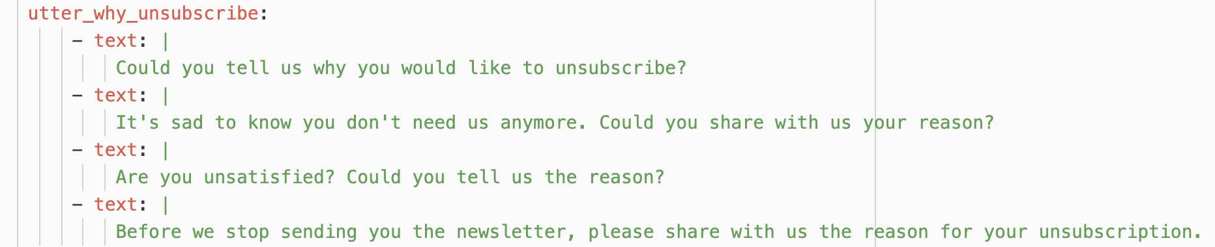

Q10. There is an Explanation intent defined (why unsubscribe) with 4 training examples.

Q11. There is a response action defined for the Explanation intent with 4 paraphrases for expressing empathy

Q12. The new story for Greet and Unsubcribe is unfolding correctly (request to unsubscribe, why, explanation, ok, thank you, goodbye).

Also see the conversation on the first page.