1 文档
https://open.weixin.qq.com/cgi-bin/showdocument?action=dir_list&t=resource/res_list&verify=1&id=open1419316505&token=&lang=zh_CN

https://blog.csdn.net/lishimin1012/article/details/73477660
1 拼接获取微信授权路径
- 无感授权和手动授权
- 回调路径域名和后台设置的域名要一致
- 回调路径要UrlEncode

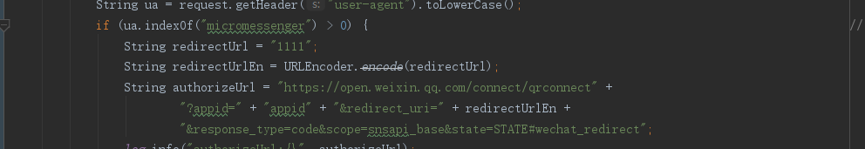
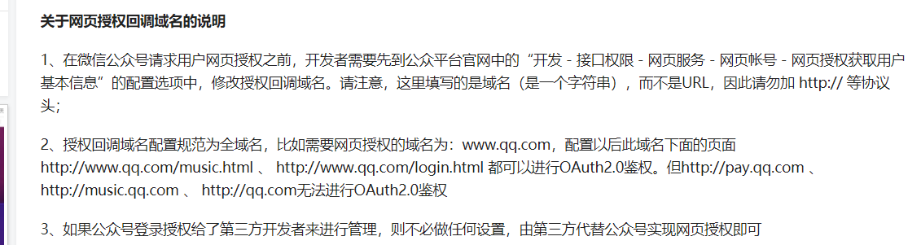
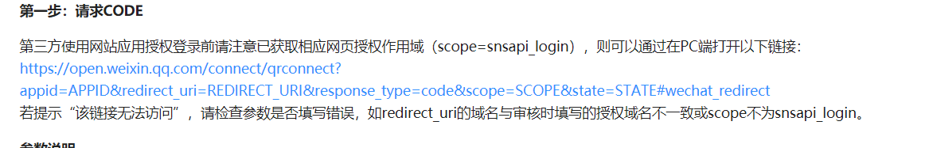
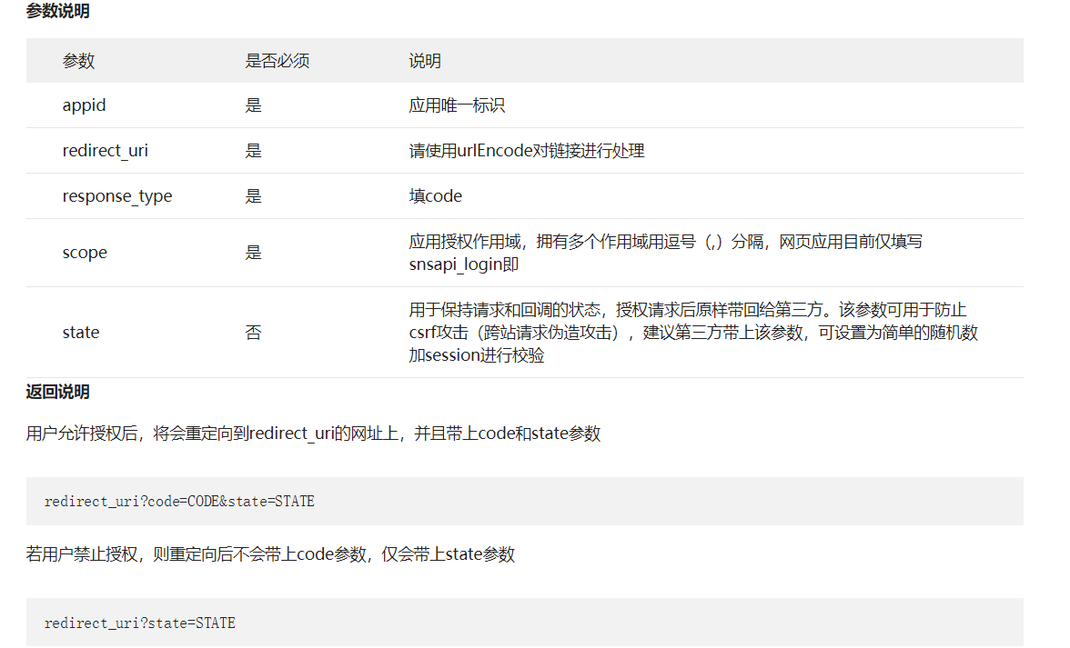
2 网页端获取回调路径里参数：authCode
3 拼接获取openId连接
String accessTokenUrl = "https://api.weixin.qq.com/sns/oauth2/access_token" +
"?appid=" + "appid" + "&secret=" + "secret" +
"&code=" + code + "&grant_type=authorization_code";

