Apply for APPKEY

<http://www.taobao.com/market/null/maijiayingyongjieru.php?spm=0.0.0.0.l4hQQz>

document

<http://www.taobao.com/market/market/mobile/yuanjin.php?spm=0.0.0.0.MyTYSg>

**聚划算（TaoBao** group buying**）**

**功能描述**

聚划算的团购分为普通商品团购和生活服务类商品团购。

用户参团后，在规定的限制时间内完成商品交易支付。同普通商品团购不同，生活服务类商品在交易完成后，淘宝会发送二维码（彩信或短信）到用户手机，用户凭借手机上的二维码到线下商家处享受团购服务。目前聚划算每天8点更新最新团购活动。

Functional description deals for group is divided into ordinary commodities group and life service class group. After user tuxedo, made within the time limit prescribed by the commodity trading. With ordinary commodity group is different, life service goods after the deal, taobao will send qr code (MMS or text message) to the user's phone, the user with a mobile phone qr code to the offline businesses enjoy the services. The bargain, update the latest group-buying activities at 8 o 'clock every day.

**申请方法**

**聚划算API属于增值API，无线应用申请聚划算API权限，需发送appkey、应用介绍、公司信息、使用场景至邮箱：mtop@taobao.com，审核时间为一周左右。**

Application method was getting the API belongs to value-added apis, wireless applications for deals for API access, need to send the appkey, application introduction, company information, use scenarios to email: mtop@taobao.com, audit time for a week or so.

**API列表**

|  |  |
| --- | --- |
| API | 参考地址reference address |
| taobao.ju.itemids.get | http://api.taobao.com/apidoc/api.htm?path=cid:10101-apiId:10786 |
| taobao.ju.cities.get | http://api.taobao.com/apidoc/api.htm?path=cid:10101-apiId:10501 |
| taobao.ju.cityitems.get | http://api.taobao.com/apidoc/api.htm?path=cid:10101-apiId:10788 |
| taobao.ju.todayitems.get | http://api.taobao.com/apidoc/api.htm?path=cid:10101-apiId:10787 |

**参考方案**The reference solution

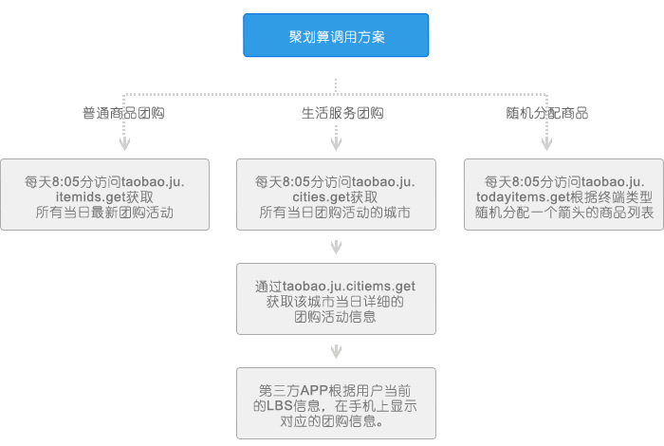  
**普通商品团购：**

每天8：05分访问taobao.ju.itemids.get 获取所有当日最新团购活动；General merchandise group purchase: 8:05-8:05-7:45-7:45-7:25-7:25-7:05-7:05-6:45-6:45 points every day visit taobao. Ju. Itemids. Get access to all the latest group-buying activities; taobao.ju.itemids.get

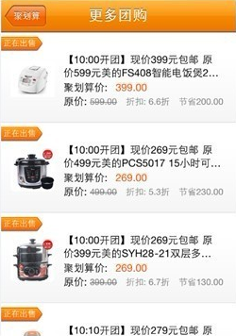  **生活服务类商品团购：**

每天8：05分访问taobao.ju.cities.get获取所有当日有团购活动的城市；Life service goods group purchase: 8:05-8:05-7:45-7:45-7:25-7:25-7:05-7:05-6:45-6:45 points every day visit taobao. Ju. Cities. Get access to all the city with a group-buying activities; taobao.ju.cities.get

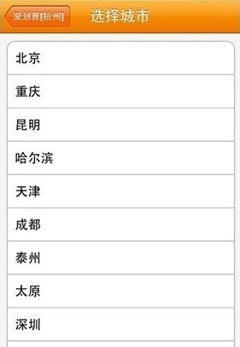

通过taobao.ju.cityitems.get获取该城市当日详细的团购活动信息

To get the city the same day the group-buying activities of information in detail



第三方APP根据用户当前的LBS信息，在手机上显示对应的团购信息。

Third-party APP according to user's information on current LBS, display the corresponding deals on mobile phones.

**随机获取分配的商品列表：**

Random access to the distribution of goods list:

    每天8：05分访问taobao.ju.todayitems.get获取根据终端类型随机分配的商品列表

    目前只有Android客户端终端类型下有独特的商品列表，其他终端类型下商品列表是统一的。

 To obtain a list of randomly assigned depending on the type of terminal products only under the Android client terminal type has a unique list of goods and other goods list is unified under the terminal type

**拼装**assembly

**WAP URL：**

得到ItemData对象后，将字段item_id提取出来，拼成一个手机端访问的WAP URL，之后需要APP使用内嵌浏览器访问团购商品交易页面，在WAP页上完成交易支付流程。

After they get ItemData object fields item_id extracted, Mosaic of a mobile terminal access WAP URL, then need the APP to use embedded browser to access a bulk commodity page, complete the transaction on the WAP page payment process.

**WAP url示例:** Example

[http://a.m.taobao.com/iitemid.htm?ttid=400000_12341234@ceshiapp_iphone_1.0.0&sid=xxxx&tg_key=small_index_groupid](http://a.m.taobao.com/iitemid.htm?spm=5027.182154.263768.1&ttid=400000_12341234@ceshiapp_iphone_1.0.0&imei=87B41A4F-B9C7-5BFB-99AF-523D15A6626E&imsi=87B41A4F-B9C7-5BFB-99AF-523D15A6626E&sid=xxxx&tg_key=small_index_groupid)

注：URL需要拼装的必要参数包含itemid（商品ID）、ttid（淘宝统计标识）sid（访问淘宝页面的wap session）、tg_key（聚划算商品组ID，请直接模仿上面的例子填写参数值small_index_groupid）。

Note: the URL need assemble necessary parameter contains the itemid (product ID), ttid statistical identification (taobao) sid (wap session visit taobao page), tg_key (deals for commodity group ID, please fill in the parameter value small_index_groupid directly to imitate the example above).

**ttid和sid请参考网页：**Please refer to page

[http://www.taobao.com/market/null/ttid.php](http://www.taobao.com/market/null/ttid.php?spm=5027.182154.263768.2)

（通过聚划算API得到的图片URL，需要根据规则拼装URL才能访问得到对应图片，规则如下：(image is obtained by getting the API URL, need according to the rules of the assembled URL to access the corresponding images, the rules are as follows:

http://img01.taobaocdn.com/tps/ + IMG_URL）