**Global Fog**

The **Global Fog**image effect creates camera-based exponential fog. All calculations are done in world space which makes it possible to have height-based fog modes that can be used for sophisticated effects (see example).

全局雾图像特效是基于相机的指数雾。所有的计算均在世界空间内完成，才可能创建出更加复杂的基于高度雾模式的效果。

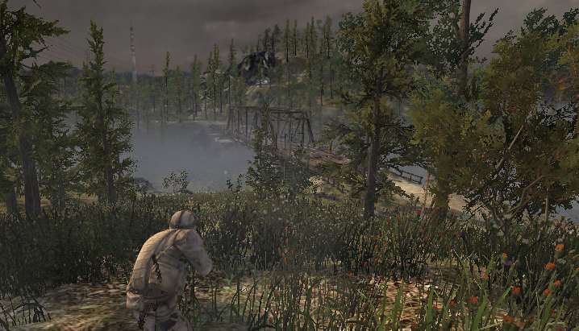Example of global fog, demonstrating both distance and height based fog

全局雾的例子，展示了基于距离和高度的雾。

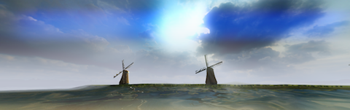

Example of “cheating” at atmospheric effects using global fog

使用全局雾效的大气效果

As with the other [image effects](http://docs.unity3d.com/540/Documentation/Manual/comp-ImageEffects.html), you must have the [Standard Assets Effects package](http://docs.unity3d.com/540/Documentation/Manual/HOWTO-InstallStandardAssets.html) installed before it becomes available.

和其他图像特效一样，你必须在使用它之前安装标准的资源特效包。

**Properties**

**属性**

| ***Property:*** | ***Function:*** |
| --- | --- |
| **Fog Mode**  **雾的模式** | The available types of fog, based on distance, height or both  可用类型的雾，基于距离，高度，或两者 |
| **Start Distance**  **开始距离** | The distance at which the fog starts fading in, in world space units.  在世界空间单位中，雾开始淡入的距离。 |
| **Global Density**  **全局密度** | The degree to which the Fog Color accumulates with distance.  在一定距离雾气聚集的程度。 |
| **Height Scale**  **高度比例** | The degree to which the fog density reduces with height (when height-based fog is enabled).  雾浓度随高度衰减的程度（当使用基于高度的雾效时开启）。 |
| **Height**  **高度** | The world space Y coordinate where fog starts to fade in.  雾效开始淡入的世界空间高度。 |
| **Global Fog Color**  **全局雾颜色** | The color of the fog.  雾的颜色 |

**Hardware Support**

**硬件支持**

This effect requires a graphics card that supports Depth Textures. See the [Graphics Hardware Capabilities and Emulation](http://docs.unity3d.com/540/Documentation/Manual/GraphicsEmulation.html) page for further details and a list of compliant hardware.

这个效果要求显卡支持深度贴图。参见[Graphics Hardware Capabilities and Emulation](http://docs.unity3d.com/540/Documentation/Manual/GraphicsEmulation.html)页面了解进一步的细节和兼容的硬件里列表。