**Material**

**材质**

[SWITCH TO SCRIPTING](http://docs.unity3d.com/540/Documentation/ScriptReference/Material.html)

Materials are used in conjunction with [Mesh Renderers](http://docs.unity3d.com/540/Documentation/Manual/class-MeshRenderer.html), [Particle Systems](http://docs.unity3d.com/540/Documentation/Manual/class-ParticleSystem.html) and other rendering components used in Unity. They play an essential part in defining how your object is displayed.

材质会同[Mesh Renderers](http://docs.unity3d.com/540/Documentation/Manual/class-MeshRenderer.html), [Particle Systems](http://docs.unity3d.com/540/Documentation/Manual/class-ParticleSystem.html) 还有其他渲染组件一起使用。他们是定义对象显示的重要角色.

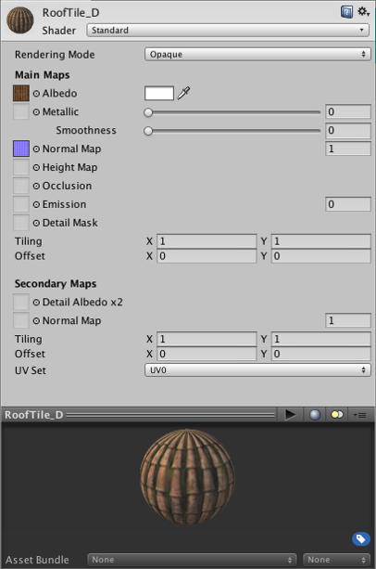

A typical Material inspector

一个典型的材质面板

**Properties**

**属性**

The properties that a Material’s inspector displays are determined by the Shader that the Material uses. A **shader** is a specialised kind of graphical program that determines how texture and lighting information are combined to generate the pixels of the rendered object onscreen. See the manual section about [Shaders](http://docs.unity3d.com/540/Documentation/Manual/Shaders.html) for in-depth information about how they are used in a Unity project.

材质的展示面板的展示的属性取决于材质使用的着色器。着色器是一种决定如何结合纹理和光照信息来生成像素点从而对屏幕上对象进行渲染的特殊图像程序。参见关于[Shaders](http://docs.unity3d.com/540/Documentation/Manual/Shaders.html) 的部分的手册深入了解他们在Unity工程里如何使用。