**https://docs.unity3d.com/Manual/script-Bloom.html**

**Bloom**

**泛光**

**Blooming** is the optical effect where light from a bright source (such as a glint) appears to leak into surrounding objects. The **Bloom** image effect adds bloom and also automatically generates lens flares in a highly efficient way. Bloom is a very distinctive effect that can make a big difference to a scene and may suggest a magical or dreamlike environment especially when used in conjunction with [HDR](http://docs.unity3d.com/540/Documentation/Manual/HDR.html) rendering. On the other hand, given proper settings it’s also possible to enhance photorealism using this effect. Glow around very bright objects is a common phenomena observed in film and photography, where luminance values differ vastly. Bloom is an enhanced version of the simpler but optimized [Bloom (Optimized)](http://docs.unity3d.com/540/Documentation/Manual/script-BloomOptimized.html) and older [Bloom And Flares](http://docs.unity3d.com/540/Documentation/Manual/script-BloomAndFlares.html) image effects.

泛光是光从一个明亮的光源（如相机的闪光）慢慢照亮到周围物体的一种光学效应。泛光效果可以增加光晕并且自动添加高效的镜头光晕。泛光是一个非常独特的效果，能使一个场景发生很大差异，可以添加魔幻般的感觉，特别是在HDR（高动态渲染）渲染的情况下。另外，适当的调整特效可以使画面增强真实感。当光照对比差异很大的情况时，非常明亮的物体周围会发光，这种现象在电影和摄影的时候是很常见的。Bloom是更简单的加强版，优化过的[Bloom (Optimized)](http://docs.unity3d.com/540/Documentation/Manual/script-BloomOptimized.html) 是旧的[Bloom And Flares](http://docs.unity3d.com/540/Documentation/Manual/script-BloomAndFlares.html)图像特效

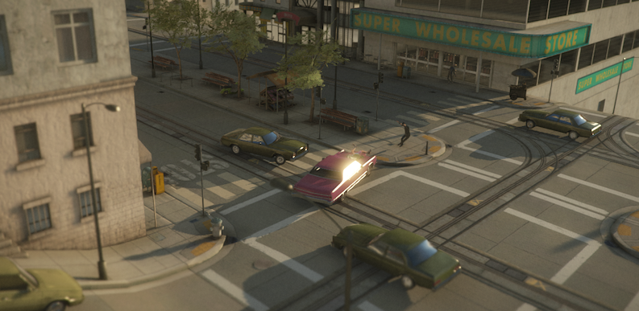This example shows a proper HDR glow as created by the **Bloom** effect. In this scene, bloom uses a threshold of 1.0 indicating that only HDR reflections, highlights or emissive surfaces glow, but common lighting is generally unaffected. In this particular example, only the car window (sporting the reflection of HDR sun values) glows.

这个例子展示了一个适当调节HDR后的泛光效果。在这个场景中,我们设置阈值是1.0，只有HDR反射，高光或自发光表面反射，普通照明不受影响。在这个例子中，只有车窗(侧面反射了HDR的阳光值)发光。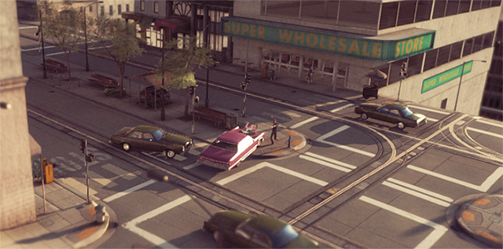Here is the same scene shown without the **Bloom** effect. Using Bloom can add realism to your scenes.

这是一个不带泛光特效的相同场景。使用泛光可以使你的场景更加真实。

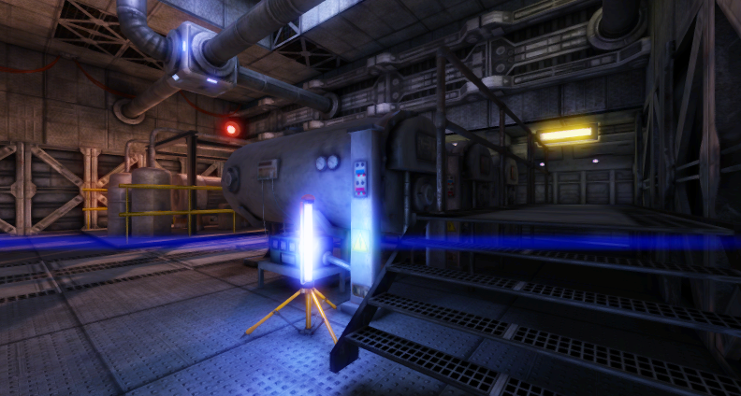Example showing **Anamorphic Lens Flares** result as created by the **Bloom** effect

例子展示了泛光处理后的变形镜头光晕

As with the other [image effects](http://docs.unity3d.com/540/Documentation/Manual/comp-ImageEffects.html), you must have the [Standard Assets Effects package](http://docs.unity3d.com/540/Documentation/Manual/HOWTO-InstallStandardAssets.html) installed before it becomes available.

同其他[图像效果](http://docs.unity3d.com/540/Documentation/Manual/comp-ImageEffects.html)一样，你必须安装[标准特效资源包](http://docs.unity3d.com/540/Documentation/Manual/HOWTO-InstallStandardAssets.html)才可以使用

**Properties**

**属性**

| ***Property:*** | ***Function:*** |
| --- | --- |
| **Quality**  **品质** | High quality preserves high frequencies and reduces aliasing.  高质量需要高频率并能降低锯齿 |
| **Mode**  **模式** | Choose complex mode to show advanced options.  选择复合模式弹出高级选项 |
| **Blend**  **混合** | The method used to add bloom to the color buffer. The softer Screen mode is better for preserving bright image details but doesn’t work with HDR.  此模式能在颜色缓存中添加泛光，柔和的屏幕模式能更好的表现光亮图片细节，但此模式在HDR中无效果。 |
| **HDR** | Whether bloom is using HDR buffers. This will result in a different look as pixel intensities may leave the [0,1] range, see details in [tonemapping](http://docs.unity3d.com/540/Documentation/Manual/script-Tonemapping.html) and [HDR](http://docs.unity3d.com/540/Documentation/Manual/HDR.html).  决定该特效是否使用HDR缓存。像素亮度超过[0,1]范围HDR将导致一个不同的视觉感受，具体细节可见[tonemapping](http://docs.unity3d.com/540/Documentation/Manual/script-Tonemapping.html) 和[HDR](http://docs.unity3d.com/540/Documentation/Manual/HDR.html). |

|  |  |
| --- | --- |
| **Intensity**  **强度** | The global light intensity of the added light (affects bloom and lens flares).  附加光（影响特效的光源）的全局光强度。 |
| **Threshold**  **阈值** | Regions of the image brighter than this threshold receive blooming (and potentially lens flares).  图像中亮度高于该阈值的区域将产生泛光效果（以及潜在的透镜光晕效果）。 |
| **RGB** **Threshold**  **RGB阈值** | Chose different thresholds for R, G and B.  选择不同的RGB阈值 |

|  |  |
| --- | --- |
| **Blur iterations**   模糊迭代次数 | The number of times gaussian blur is applied. More iterations improve smoothness but take extra time to process and hide small frequencies.  高斯模糊应用的次数。更多的迭代次数会增强画面的柔顺度，但同样需要额外的时间来处理和隐藏小细节的频率。 |
| **Sample distance**  **采样距离** | The max radius of the blur. Does not affect performance.  最大模糊半径，不会影响性能。 |

|  |  |
| --- | --- |
| **Lens Flares**  **光晕** | The type of lens flare. The options are Ghosting, Anamorphic or a mix of the two.  光晕的类型，有重影、变形或者是两者的融合。 |
| **Local intensity**  **局部强度** | Local intensity used only for lens flares. 0 disables lens flares entirely.  此属性仅用于光晕，0表示完光晕完全无效果 |
| **Threshold**  **阈值** | The accumulative light intensity threshold that defines which image parts are candidates for lens flares.  它限定了光晕对图像中哪些部分产生影响。 |

**Blend Modes: Add and Screen**

**混合模式：叠加和屏幕模式**

Blend modes determine the way that two images will be combined when overlaid. Each pixel from the base image is combined mathematically with the pixel in the corresponding position in the overlay image. Two blend modes are available for this image effect, Add and Screen.

混合模式决定了当两张图像重叠时的合并方法。原图的每像素会根据数学运算与重叠的图像相对的坐标进行合并。两种混合模式都支持，叠加模式和屏幕模式。

**Add Mode**

**增加模式**

When the images are blended in Add mode, the values of the color channels (red, green and blue) are simply added together and clamped to the maximum value of 1. The overall effect is that areas of each image that aren’t especially bright can easily blend to maximum brightness in the result. The final image tends to lose color and detail and so Add mode is useful when a dazzling “white out” effect is required.

当图像是叠加模式混合时，各个颜色通道只要简单的相加即可，最大限制是1.总体的效果是每一张图片

**Screen Mode**

**屏幕模式**

Screen mode is so named because it simulates the effect of projecting the two source images onto a white screen simultaneously. Each color channel is combined separately but identically to the others. Firstly, the channel values of the two source pixels are inverted (ie, subtracted from 1). Then, the two inverted values are multiplied together and the result is inverted. The result is brighter than either of the two source pixels but it will be at maximum brightness only if one of the source colors was also. The overall effect is that more color variation and detail is preserved, leading to a gentler effect than Add mode.

之所以叫屏幕模式是因为它模拟的是同时将两个源图像投射到白色的屏幕而的产生的效果。每个颜色通道联合了另一张图对应的颜色通道。首先，两个源图像的通道值互相“倒置”（即被1减）。然后，两个倒置的值相乘。然后再将结果倒置。

其结果是比任何两个源象素的明亮，但其结果也会达到最大亮度当且仅当有一个源图像达到最大亮度。总体效果上比叠加模式会保留更多的颜色变化及源图像中的细节，会比叠加模式温和的效果。

**Hardware Support**

**硬件支持**

This effect should run on all hardware that Unity supports.

这种效果可以运行在所有Unity支持的硬件上。