User Manual



Introduce BundleExtension
BundleExtension is a complete solution of dynamic resource management for network game . It has AssetBundle packaging, compression, encryption, version management, dynamic update, load, calls, and other functions, so as to help you from the cumbersome and indispensable resource maintenance work. And all you need to do is perform a few mouse clicks and then put the AssetBundles to the server.
BundleExtension has the following features:
Seamless docking Unity5.0 AssetBundle management mechanism, create AssetBundle through Unity5 and subsequent work through BundleExtension.
Assetbundle one-click packaging: Support PC, IOS and Android cross-platform development. Support for multiple platforms distribution which do not conflict.
Assetbundle compression: LZMA compression to ensure maximum compression ratios are adopted to decrease the resource dimension.
Assetbundle content protection: The AES256 for your Assetbundle is encrypted, preventing decompiled by others.
File contrast: Contrast online and local AssetBundle files and automatically update with the new version of the file.
Update events support: Provide detailed state change events, such as load file number, load, bytes, etc., convenient for you to make a progress bar.
Synchronous loading the updated Assetbundle: Organization code, convenient developers do not need the WWW and coroutines.
Assetbundle cache: Each Assetbundle from disk loaded in memory to save a copy, to improve the efficiency of repeat creation.
Does not produce any disk cache file.
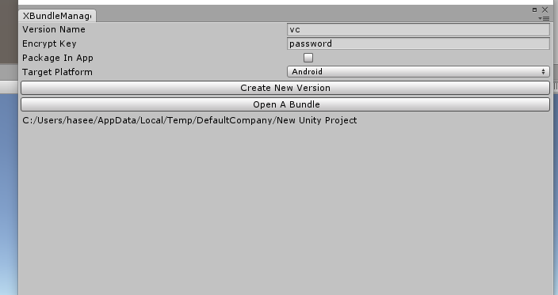
Interface specification
Open the BundleExtension panel, as shown:
Click"Window/BundleManager Window"Menu.

BundleExtension panel shows:
Version File Name:Release notes file, the file to realize online and local resources. To name. The file will save AssetBundle with you in the same folder.NOTE:Do not input any file extension("vc" is correct,but "vc.data" is wrong).
Bundle Encrypt Key:AssetBundle encryption key, without the key is unable to load the AssetBundle. The key will be needed in your update code. Please don't change after setting up, otherwise may cause the local file with old key encrypted cannot be loaded.
Target Platform:The package of AssetBundle target platform. Measured Windows, Android and IOS. Other support platform theory but has not yet to test.
Bundle Output Folder:Package AssetBundles to /{project_path}/AssetBundles/{Target_Platform}/{Bundle_Output_Folder}
Package In App:Package AssetBundles to Resources folder.If you choose this, the AssetBundles will be packaged into your application.
Create New Version:Start packing AssetBundle and generate version file.
Operation process
First you need to pack the resource set to AssetBundle,see: http://docs.unity3d.com/Manual/BuildingAssetBundles5x.html
After setting up AssetBundle, open BundleExtension panel, select the Package In App, and then click the Create New Version button, then your AssetBundle will be packaged into your application.So that you submit to the app store first ipa or apk contains the necessary resources.
Write code to update AssetBundles In the project. (Please refer to the Demo.cs).
When you need to update resources after your application is in business, open BundleExtension panel, make sure no selected Package In App, and then click the Create New Version button. Wait for after the completion of the packaging, you can upload all files from / {project_path}/AssetBundles/{Target_Platform}/to your CDN server.

