**Name:** Youmeng Li

**ID:** 0528314

**Project_1:** Alien Sniper (Flash game with Action Script 3)

**User Guide**

**Control:** Using direction arrows to move cannon left and right and using space to fire.

**Introduction:** In this game, the aliens invade the earth by UFOs. You need to control cannon and smash them. At first, you have 2 minutes to smash small UFOs; the speed of UFOs appearing will become faster and faster as time goes by. After this, the Boss UFO will appear and throw bombs from the sky. Your final task is that to wreck it.



**Special Ability:** In the game, you can get these balls from UFO as this picture has showed. “E” ball can improve your cannon’s ability, let it can shoot 3 bullets at the same time. However, it only keep 5 seconds. “B” ball is a big bomb, and it can help you smash all the UFOs which are on the screen right now. “H” ball will plus your HP by 1 point. In the Game, you have 10 points for HP totally.

**Start Menu:** You can get simple information about control and game introduction in “Introduction” option.

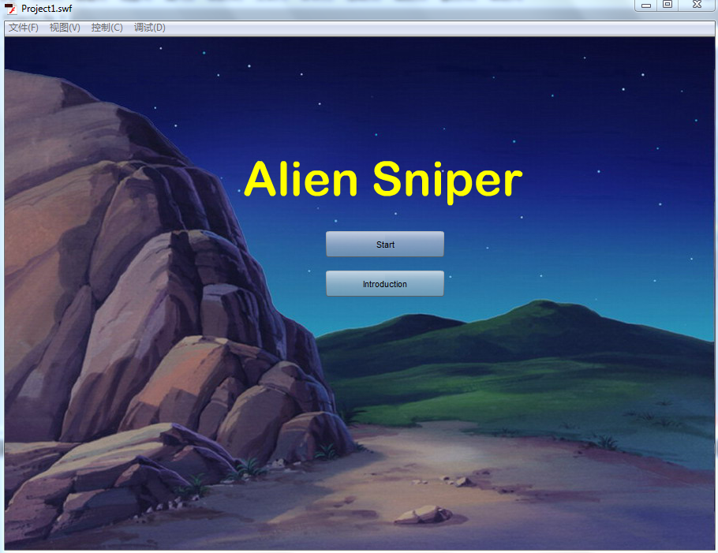

**Game Screen:** In this screenshot, you get enhancing ability which can let you shoot 3 bullets at the same time. There is a time count bar in the lower right corner.

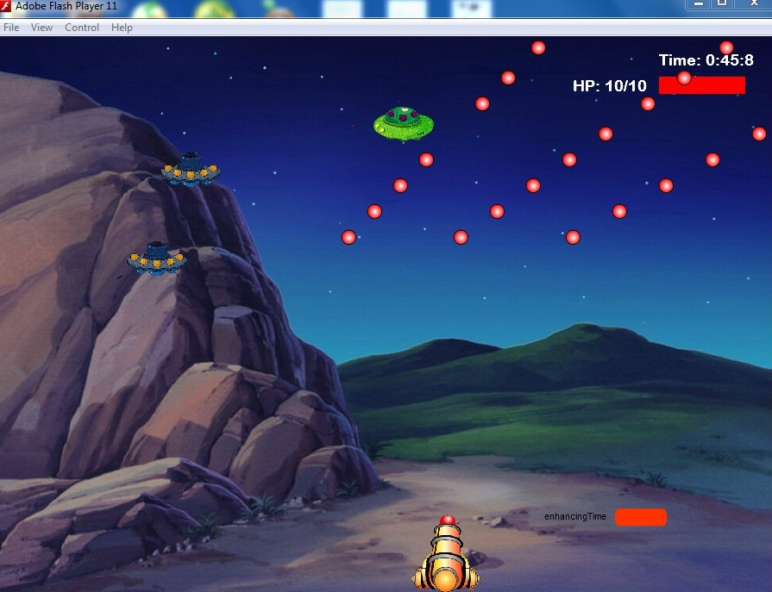

**Boss Fight:** The boss has several lights on its body, these lights stand for its HP. The boss also throw bombs to ground. So, you need to smash all the lights so that you can save the earth finally.

