To play music and render the UI, you should include “winmm.lib” and “pdcurses.lib”.

Steps(use Code::Blocks as an example):

1. click the “build option” of your program.

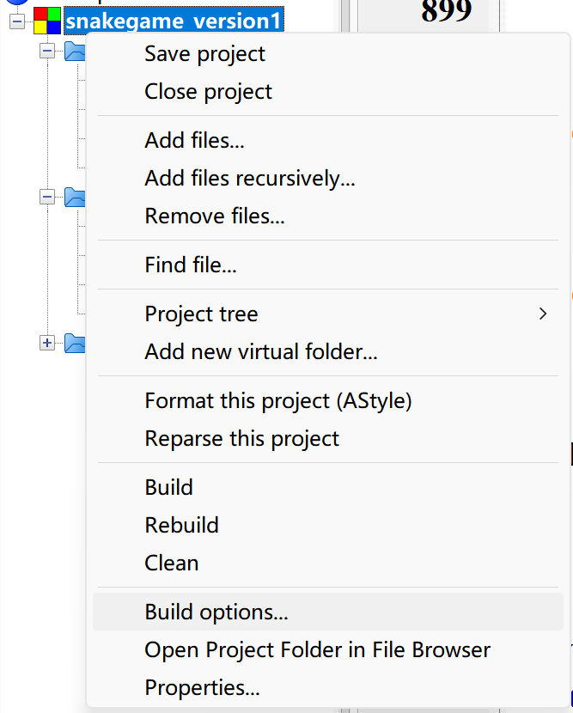

1. “Search directions” -> “Linker” -> “Add” , and then select the directories which respectively include the “winmm.lib” and “pdcurses.lib”.

Tips: You can download our repo and directly put the two files to your current directory.

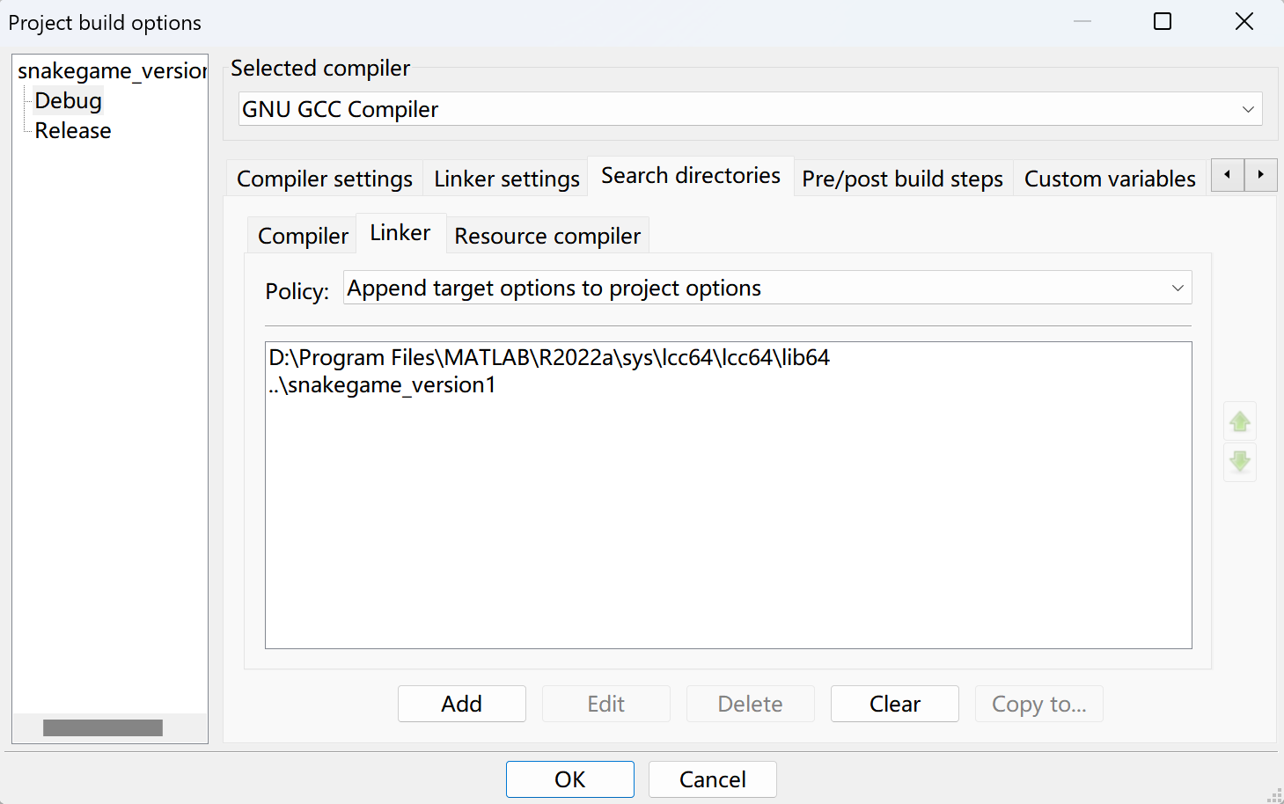

1. “Linker setting” -> “Add” , input “winmm” and “pdcurses” step by step.

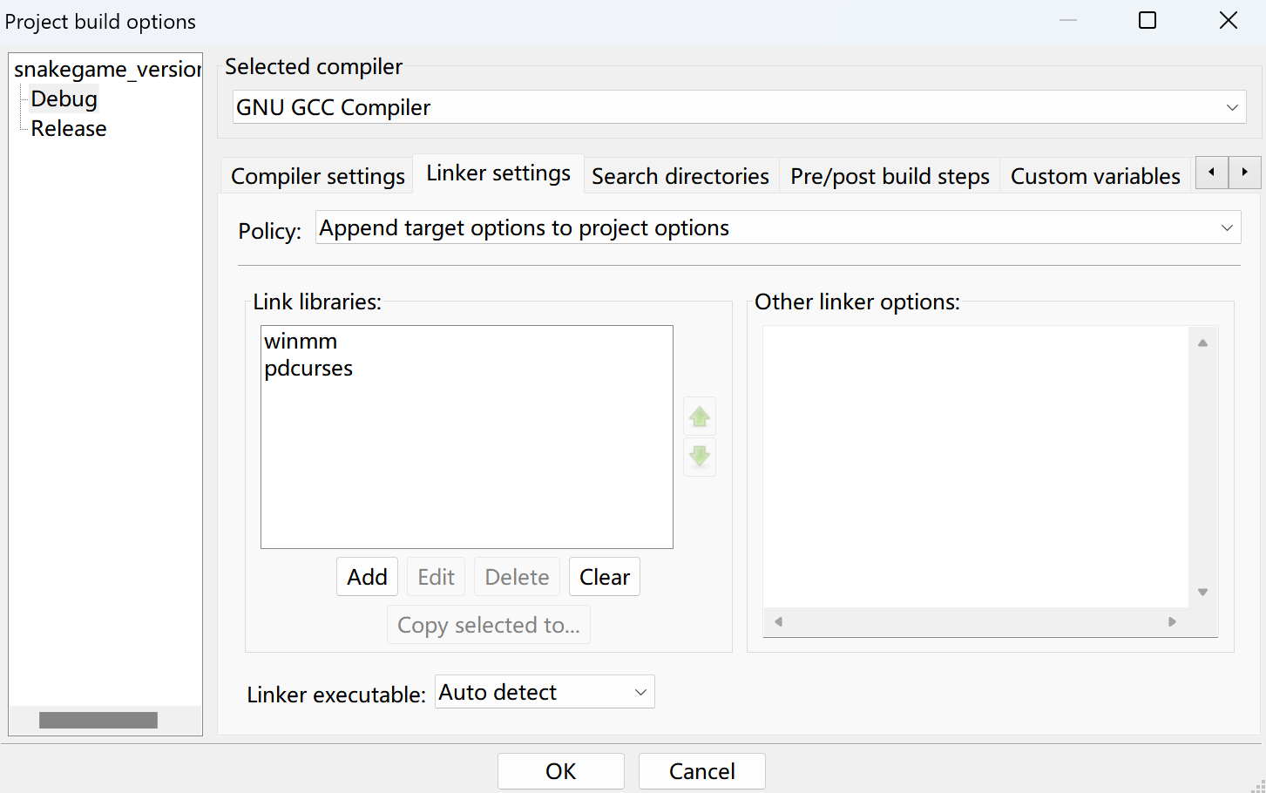

4.By now, you have successfully configure the environment, let`s get hands dirty!