**AltAnalyze Results Viewer Manual**

**Basics**

The AltAnalyze Results Viewer is a convenient way to view and manipulate results from a project. Use the **Open Project** button to open the file dialog. Select the project’s **root directory** (directory the containing *ExpressionInput* folder); the list of available data types to view will appear on the left hand panel, directly underneath the button. This is the **top tree**. The Results Viewer will load the tables and images produced by AltAnalyze. Blue items are selectable via a double click, whereas grey items are directories containing selectable items; select the arrow to expand each directory. You can search for a particular item in the tree using the Search->Tree option on the status bar.

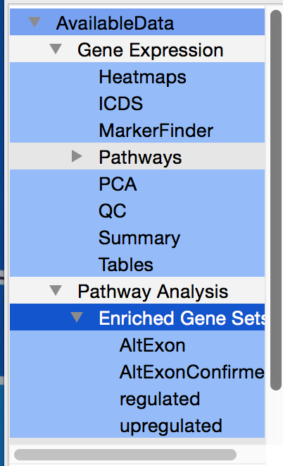

The Open->File option on the menu will only open one file. **It may or may not be functional in the viewer!** The best method for viewing your results is through the Open Project option.

Once selected, the list of files related to the data type selected will appear in a selectable list, directly underneath the top tree. This is the **bottom tree**. The bottom tree contains the files pertaining to the data type selected in the top tree. Upon selecting a file in the bottom tree via a double click, the file’s associated table and png will appear in the right hand panel, the **viewing panel**. At the bottom of the viewing panel there are three separate tabs; **PNG**, **Table**, and **Interactive**.

While the PNG tab contains an unalterable image, the Table tab contains all the values from the text file. To look for particular values within the table, either use the “Table” option underneath the Search menu or the “Filter” option underneath the Table menu. The search option will find all cells that have any characters typed in the search prompt and highlight them. All matches will appear in the **log** at the bottom of the window. The filter option works similar to the search option; however, instead of highlighting cells that match characters in the prompt, all rows will be deleted that do not contain a cell that contain characters entered in the prompt.

The sort method can be accessed through the Table menu under “Sort”; or in the upper right hand panel. Enter the column to sort the table by, and choose ascending or descending from the radio button options. You can clear the table at any time by choosing the “Clear Panel” option under the View menu option (or the eraser icon in the toolbar).

**Result Categories**

When a project first loads, by default, the differential expression summary table will load. This contains a summary of the number of differentially expressed genes for each statistical comparison and filters used. Depending on the experiment and options run, three major categories of results are available from the **top tree** viewer: 1) Gene Expression, 2) Pathway Analysis, and 3) Splicing. Clicking the left-hand triangle next to any of these will let you explore addition **result sets** related to each. Clicking on any of these results sets will load the specific files in each sub-directory. By default, the first file present in that directory will be viewed in the main viewing panel. The path for every loaded file will appear in the bottom dialogue.

**Visualization**

The Interactive tab allows for a flexible visualization of the selected data. Options change depending on the type of file viewed. **Not all files are compatible!** Make sure your selected file is compatible for an interactive view. Once you hit the “Run” button, your plot should appear in a new window. In the current version, only files with “PCA” or “hierarchical” in the filenames are compatible with interactive runs. Otherwise, no options will be available.

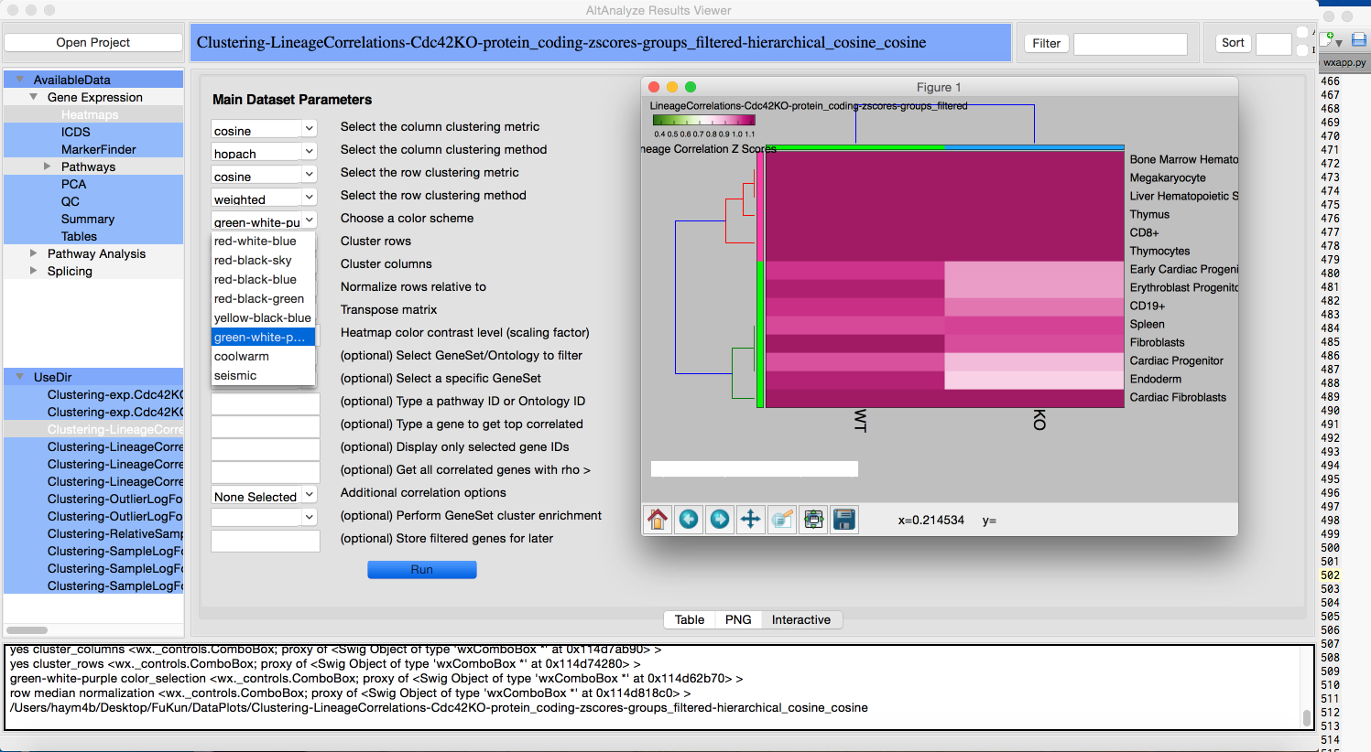

For the file with the prefix **DATASET** (under Tables), there is an additional option for visualizing data. Upon loading a DATASET file, right click on the row to initialize a drop down menu from the mouse cursor. Select the option “plot” to visualize data for that particular row. The blue column represents the averages, while the black line shows the standard error.

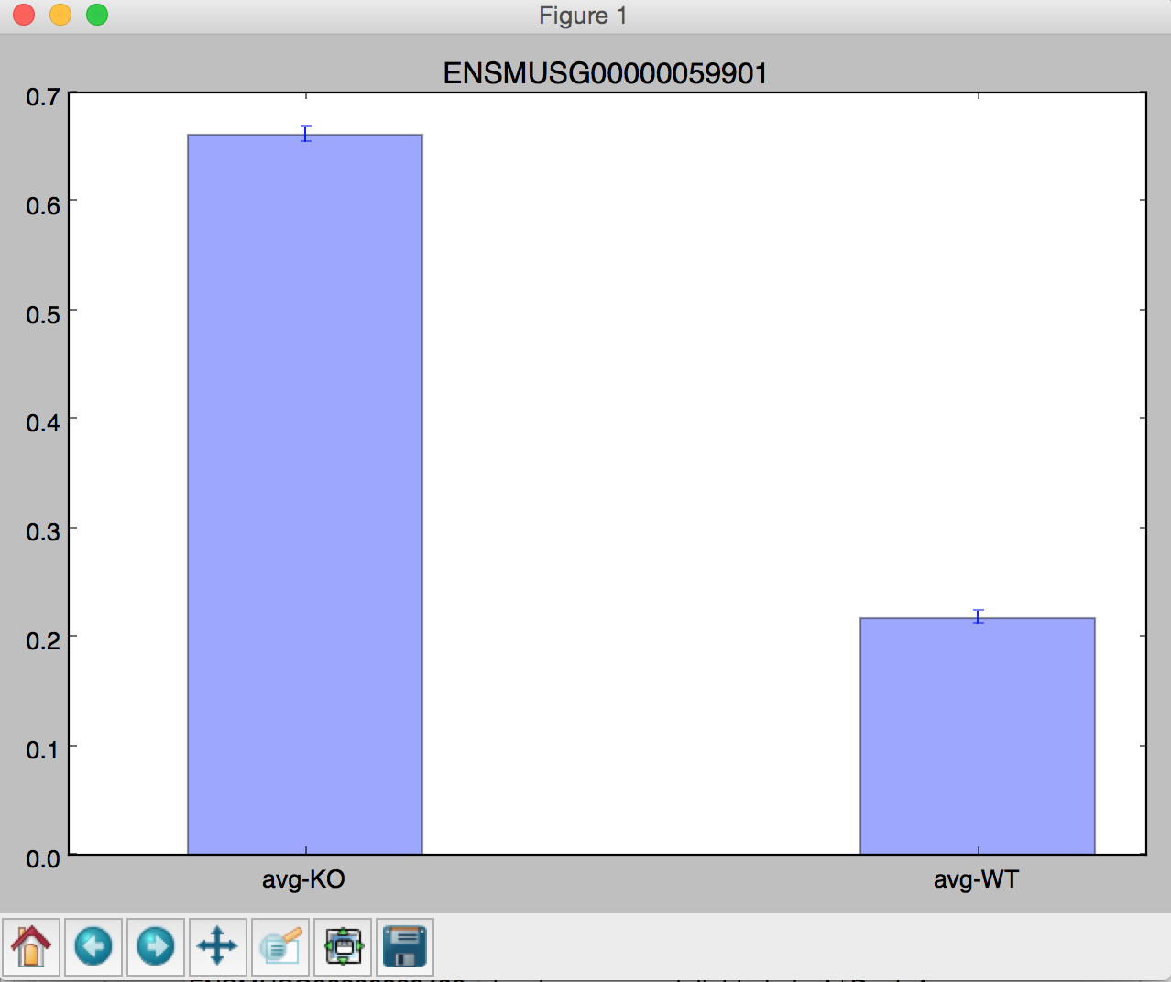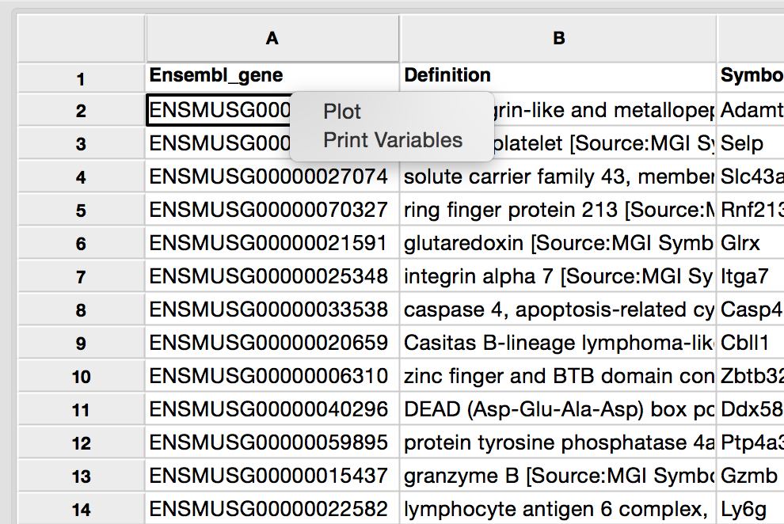

Selecting SplicePlot (if available for you dataset), will produce a plot of exon expression for the gene for all indicated groups of samples.

**Future Development**

Additional interactive options are being added to the viewer to improve the user experience of AltAnalyze. Please let us know if you have recommendations.