Total supply is 999999:

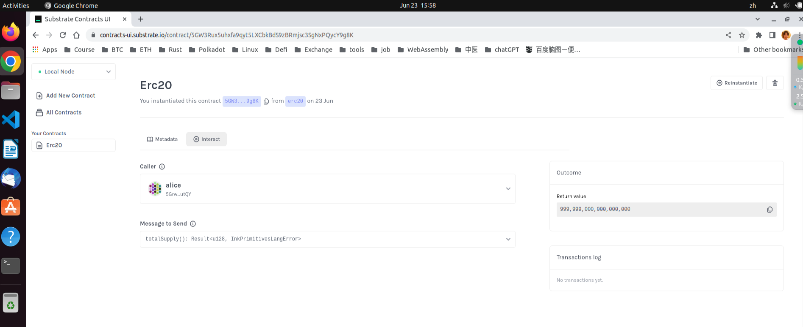

Balance of alice is 999999:

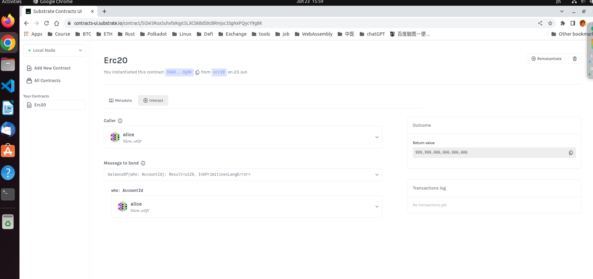

Transfer 9 tokens from alice to bob:

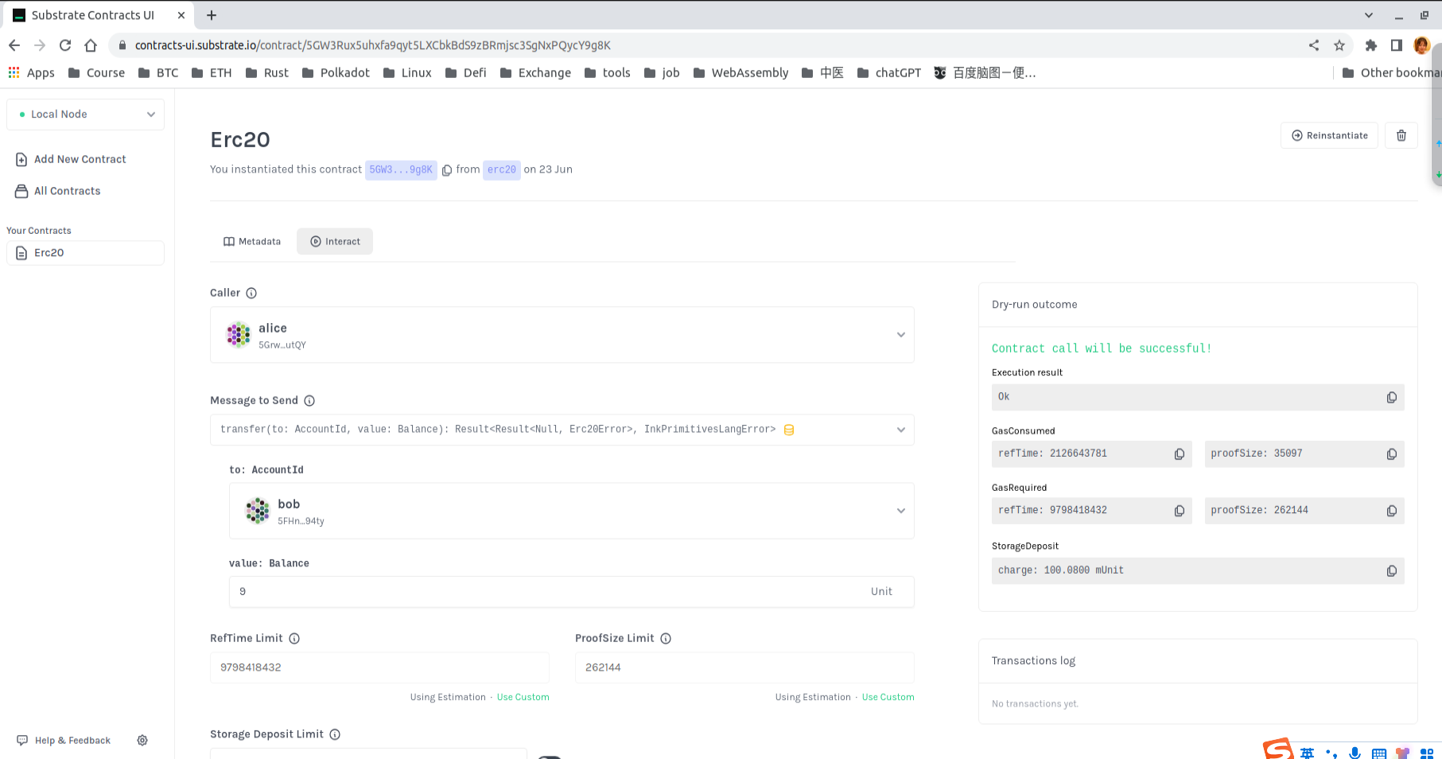

alice balance changed from 999999 to 999990

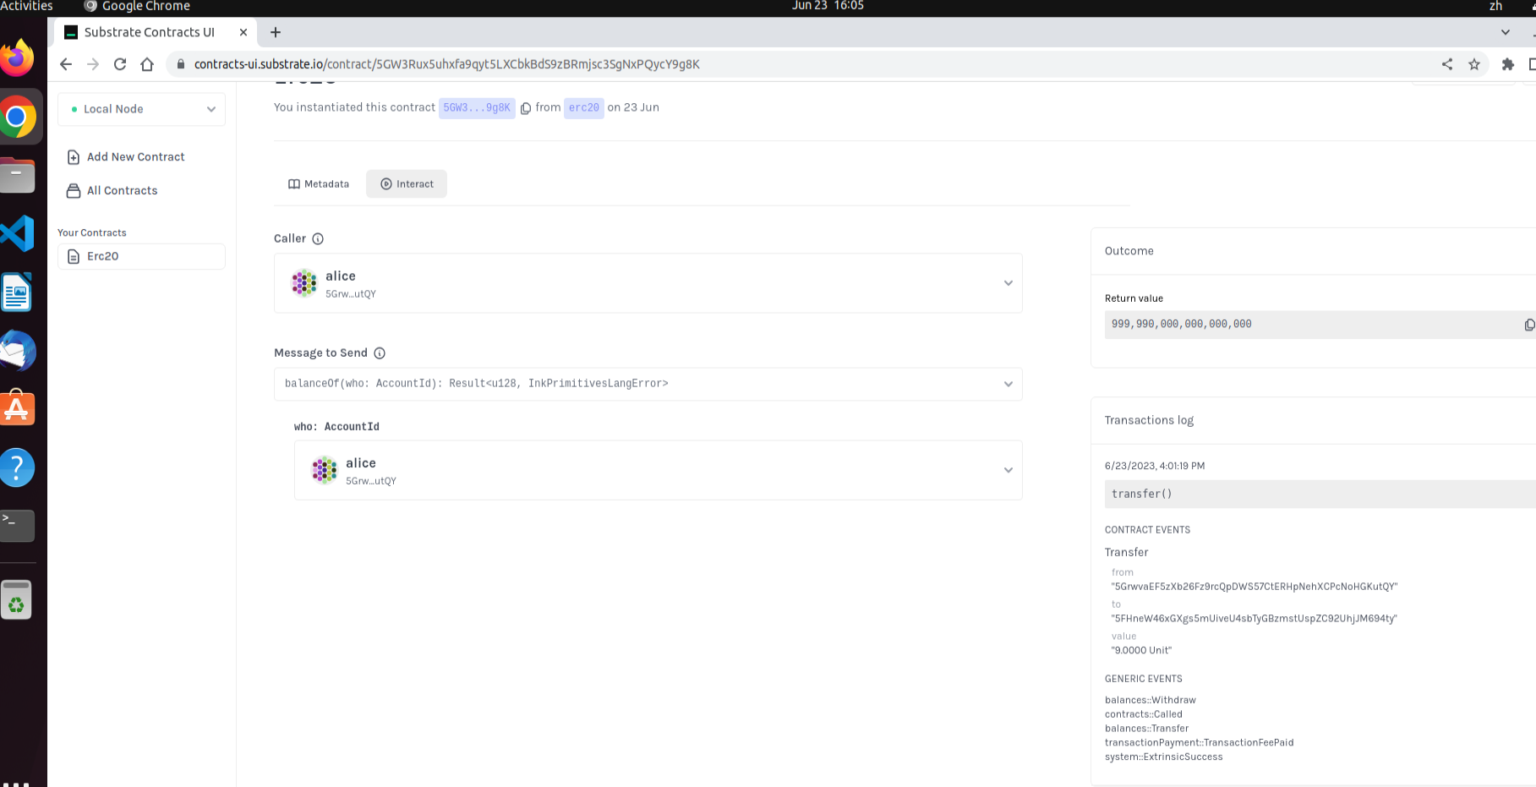

bob balance changed from 0 to 9

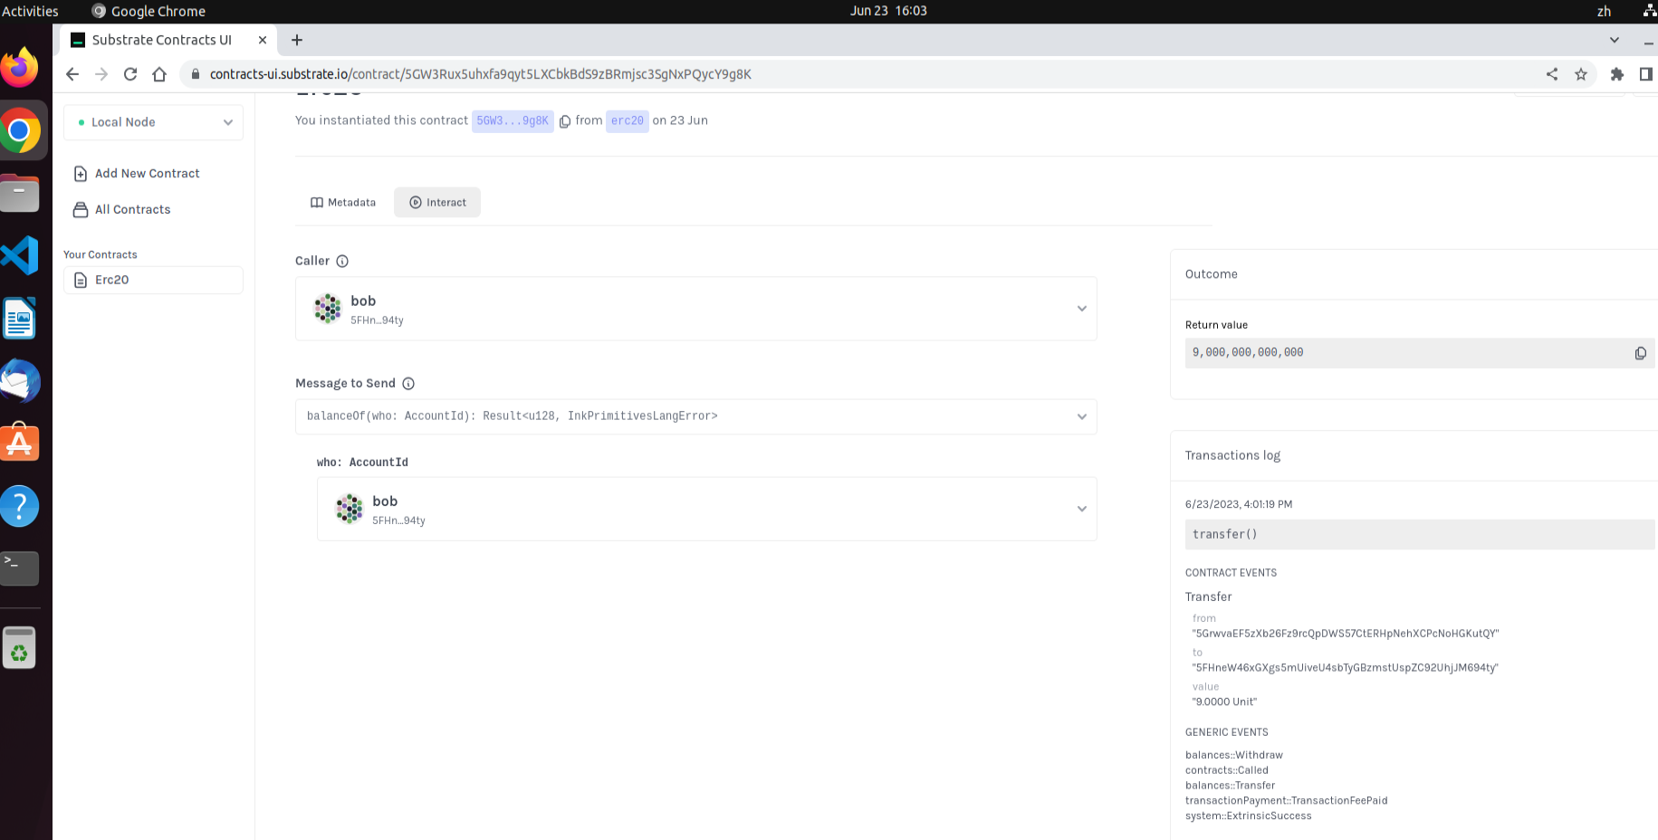

alice approve 500 tokens for alice_stash：

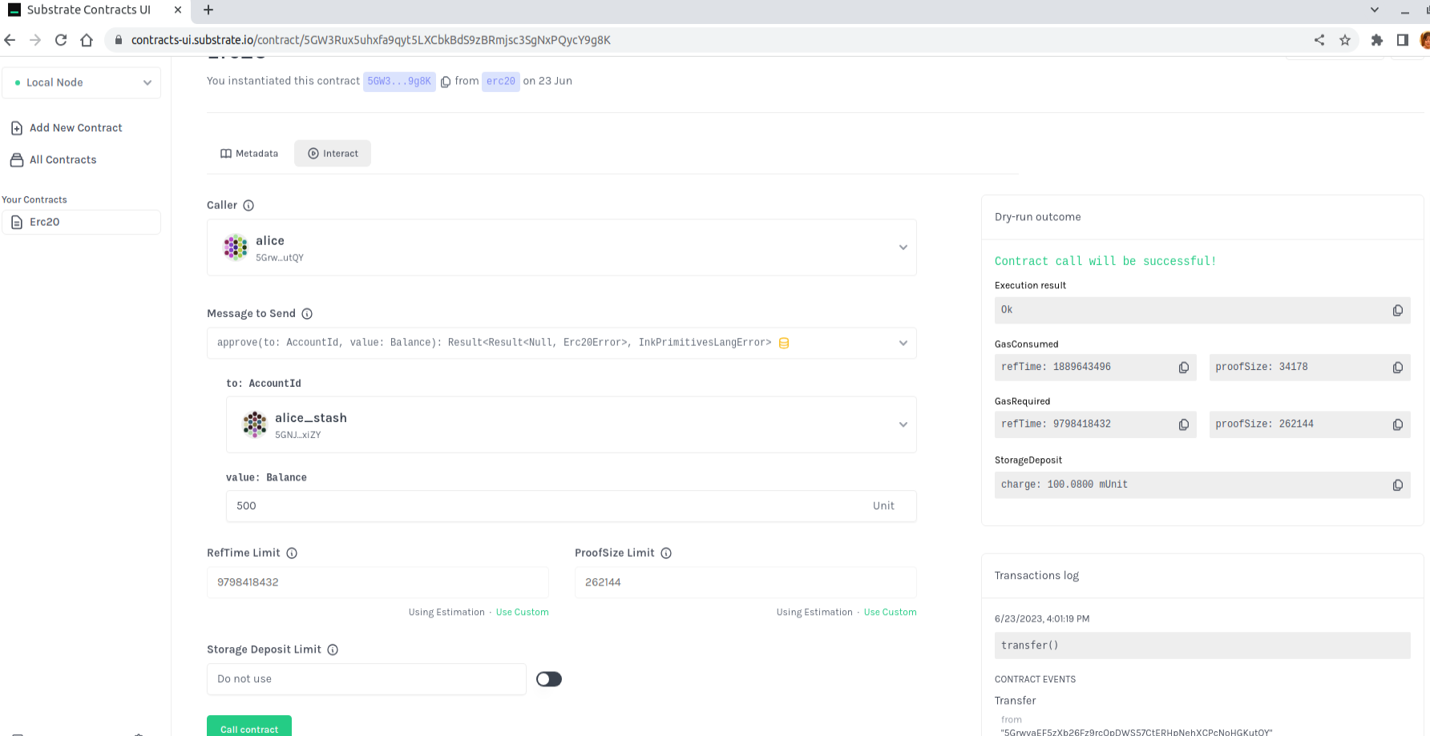

alice transfer 300 tokens from alice_stash to bob_stash:

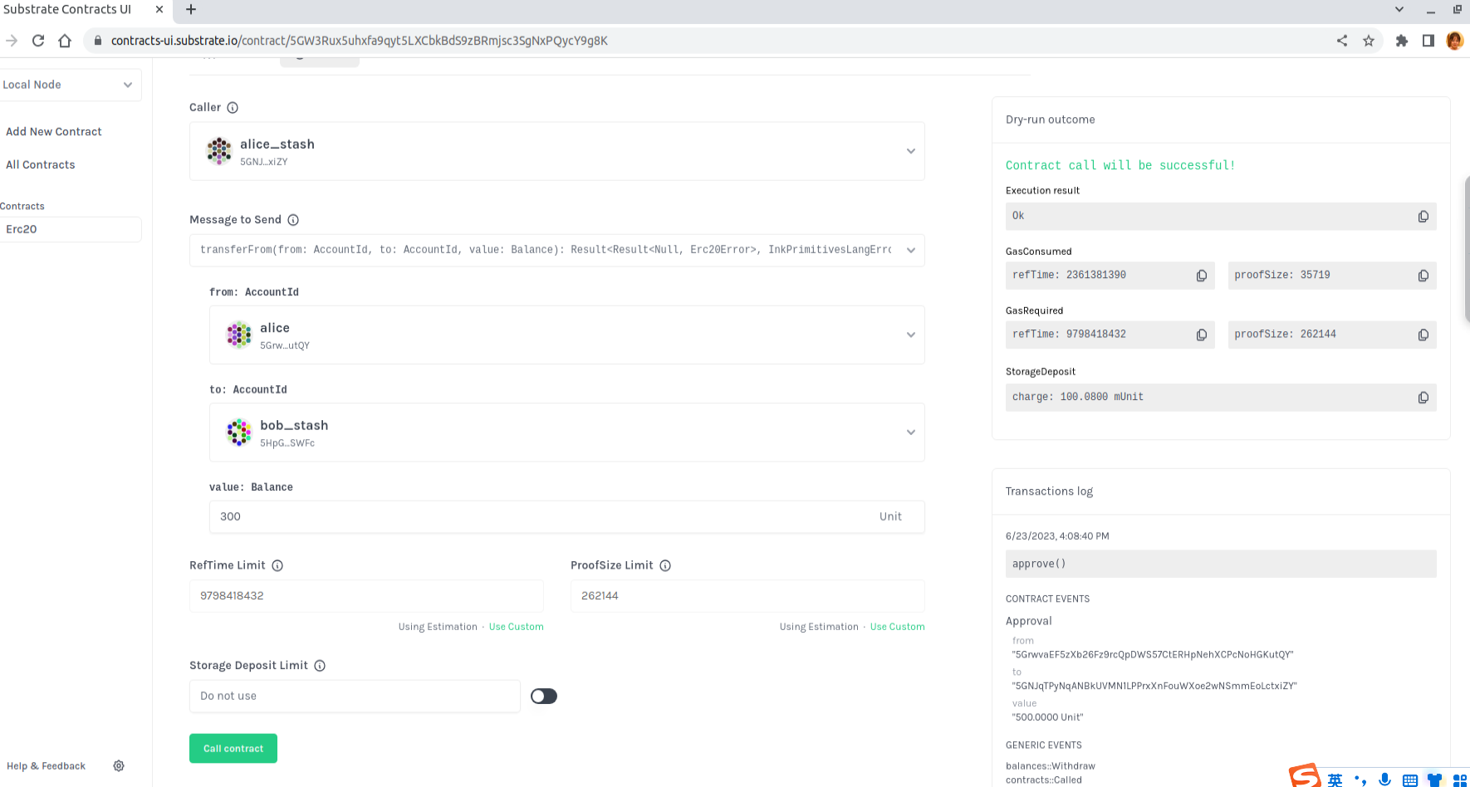

blice_stash changed from 999990 to 999690  
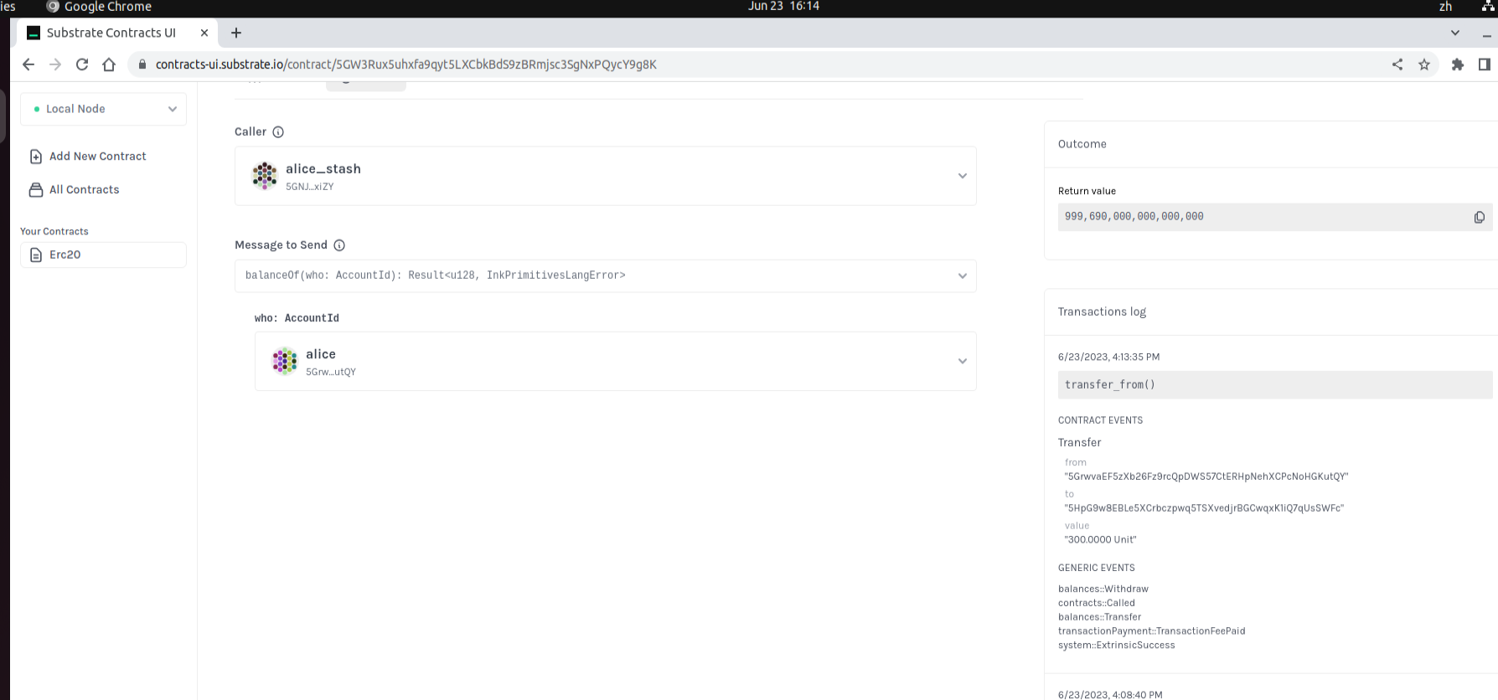

bob_stash changed from 0 to 300：

