## Homework3-1:

Unit test passed:

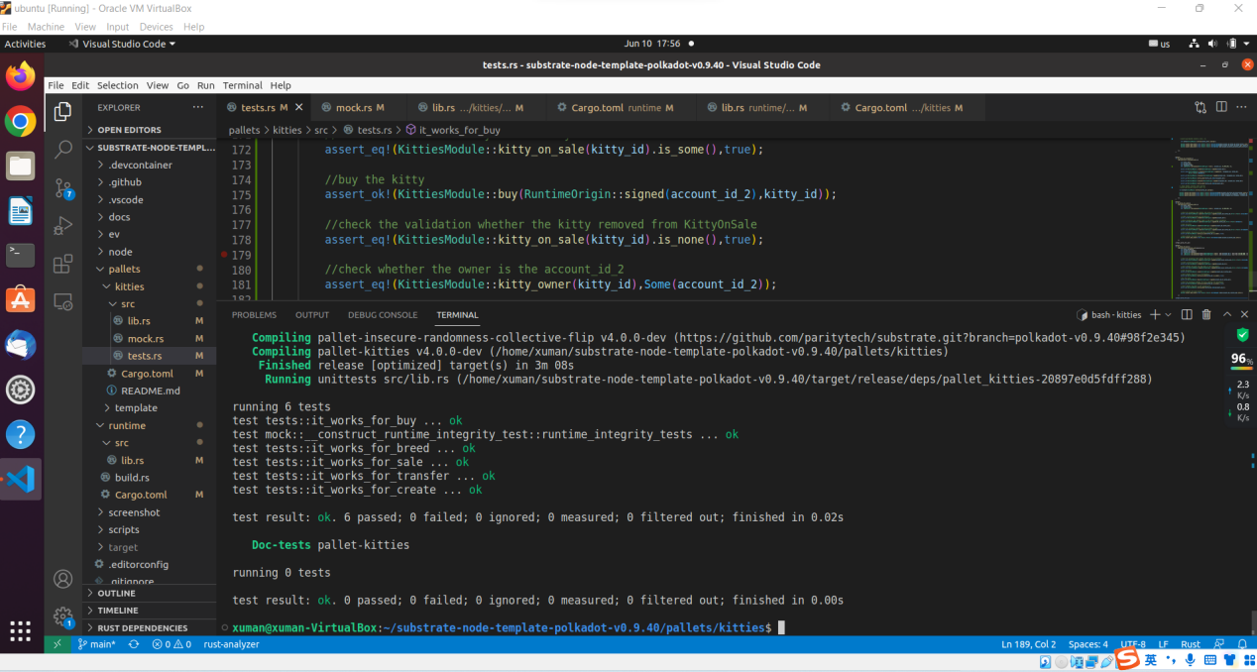

Add new logic to runtime ,and compile successfully:

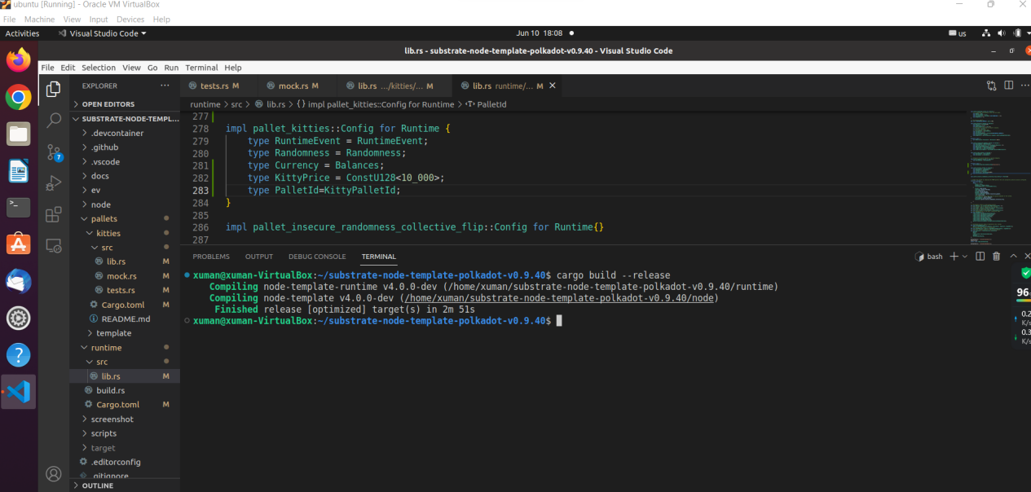

Boot the node successfully:

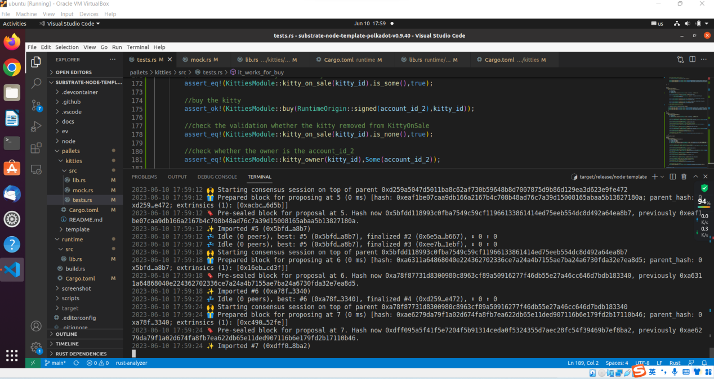

## Homework3-2:

### **v0->v1->v2 upgrade:**

In version 0, create two kitties:

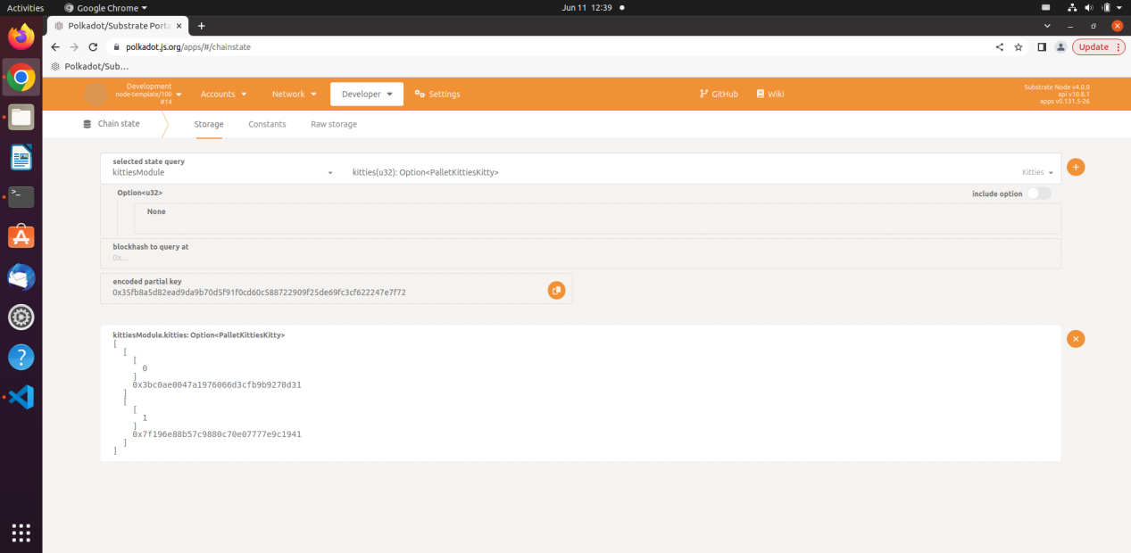

In version1, the two kittites have their 4byte name:

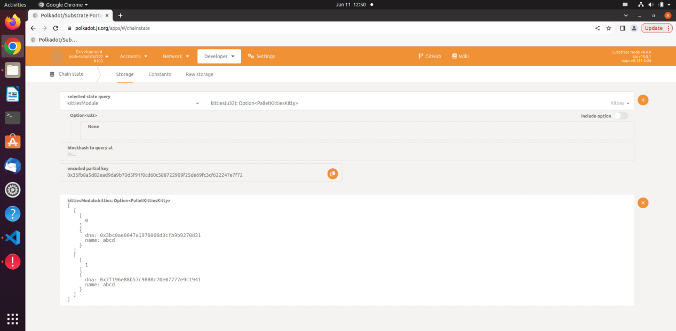

In version2, the kitties’ name changed to 8byte:

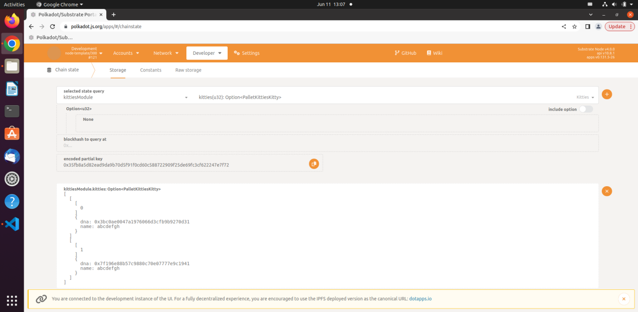

### **v0->v2 upgrade:**

Go back to v0 data, there are 2 kitties.

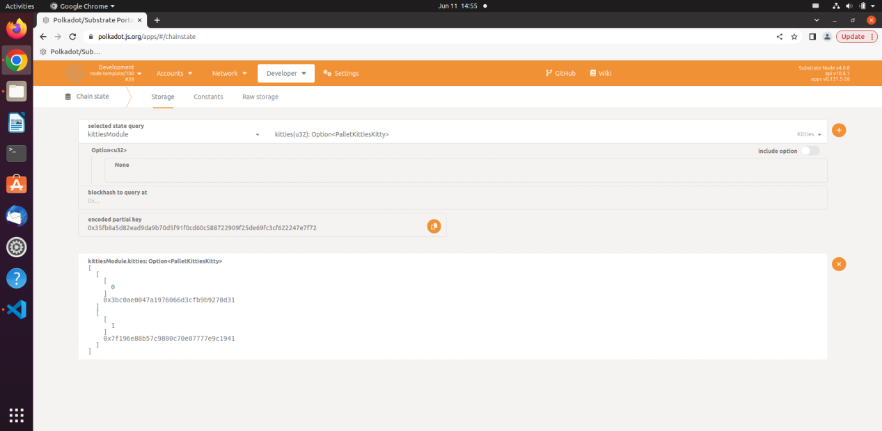

After upgrade to v2, the kitties have their names.

