1.

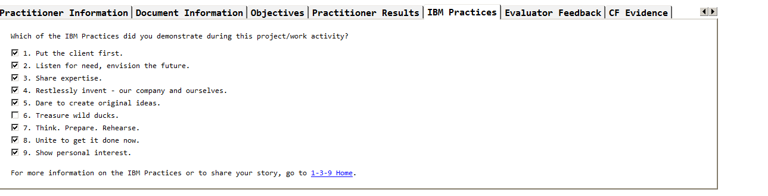

2.



**Execution**

**Work products & deliverables**  - Delivers high quality, accurate, analytically and technically sound work products/deliverables to address complex business commitments; work products can be harvested as Intellectual Capital (ICap) for similar assignments or projects; Enhances existing tools, methodologies and/or approaches, or develops new ones to produce high quality results that add value for the client.

**Problem solving/Innovation**  - Develops detailed mitigation or risk strategies that can be used to minimize or eliminate identified issues on a project or task; Uses advanced analytical skills to define and/or clarify issues to support decisions or recommendations; formulates detailed plans for improvements to procedures and processes that enhance quality and efficiency.

**Relationships**

**Client Focus & Partnership**  - Fosters an environment of trust and mutual respect, responsibility and accountability with the client; Sets realistic expectations and manages those expectations throughout the assignment; communicates any limitations or discrepancies in a timely and honest manner to minimize confusion and promote client satisfaction; honors commitments made or negotiates to a 'win-win' position with the client; Works intensively with the client to understand and assess the client's business and/or technical environment in order to develop a new or custom solution to address the client's needs; receives individual recognition from client for excellence in work.

**Teamwork & Collaboration**  - Promotes teamwork across the IBM and client teams; demonstrates flexibility when presented with alternatives to manage work or address issues; places best interests of the team ahead of self interests; Motivates low performing teams and/or team members, and transforms them to productivity and high performance; mentors/encourages others to take on greater responsibilities to build skills; Facilitates understanding across team of others whose background, culture, language or work style differs from one's own; manages team through any conflicts that arise due to these types of differences and fosters an atmosphere of tolerance and inclusion.

**Professional Effectiveness**

**Time management**  - Submits work ahead of schedule to support project timelines; Manages personal schedule to find time to take on additional responsibilities to support the assignment; self-directed management of workload

**Communication**  - Adept at effectively leveraging multiple mediums and tools to create a convincing and compelling oral or written presentation; Anticipates questions and proactively addresses issues based on knowledge of issue/client needs; Produces exceptional, concise communications; documents contain few or no errors in grammar, spelling, and punctuation.

**Ownership & Personal Responsibility**  - Assumes the authority to get work done, even if not in primary job scope; takes full responsibility for own actions as well as those of the team; Takes personal ownership of difficult situations and sees through to resolution; Sees through conflict and criticism to objectively discern issues; turns criticism into opportunities for growth and development.

**Leading Others (if applicable)**

**Collaborative Influence**  - Successfully resolves internal, IBM cross-organization issues/challenges; recognizes and promotes the work of others for the overall benefit of the team; Challenges prevailing practices to make lasting and systemic changes that enhance IBM's performance.

**Develops IBM people and communities**  - Readily recognizes and commends high performance of the team and/or individuals on the team; capable of delivering tough messages in a manner that is specific, behavioral, and respectful to others; Structures work in a way that develops the capability of individuals in the group in addition to completing the immediate task; finds challenging and relevant assignments and developmental opportunities for others.

**Business & Financial Management (if applicable)**

**Financial Management**  - Not Applicable

**Project Management**  - Manages scope based on the agreed Statement of Work and the contract between IBM and the client; processes authorized change requests when required; consistently manages resources within scope of the project; Builds trusting and respectful relationships with Client and team sets realistic expectations while also communicating any limitations in a timely and honest manner; builds strong project team using the same principles; Applies appropriate project management methodologies and tools; demonstrates thorough understanding of Delivery Excellence and the Seven Keys; manages project using the Seven Keys on a monthly basis.