# On-Demand Instances

## instances type/computing power

off course

## region:

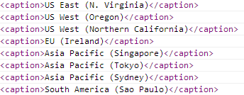

For small instances, US East (N. Virginia) and US West (Oregon) is cheapest.

## os:

For small instances, Linux is always cheaper.

# Reserved Instances

Reserved Instances can be purchased directly from AWS for 1 or 3 year terms.

Light and Medium Utilization Reserved Instances also are billed by the instance-hour for the time that instances are in a running state; if you do not run the instance in an hour, there is zero usage charge.

Heavy Utilization Reserved Instances are billed for every hour during the entire Reserved Instance term (which means you’re charged the hourly fee regardless of whether any usage has occurred during an hour).

Using the Reserved Instance Marketplace, you have the flexibility to purchase Reserved Instances from AWS Reserved Instance Marketplace Sellers for terms ranging between 1 month to 36 months (depending on available selection).

Can also sell the remainder of Reserved Instances! Decide the selling price ourselves (Amazon will offer suggestion price).

Reserved Instances can be sold after they have been active for at least 30 days and once AWS has received the upfront payment.

You can sell up to $50,000 in Reserved Instances per year.

Each Reserved Instance sold on the Amazon EC2 Reserved Instance Marketplace will be charged a service fee of 12% on the total upfront price.

## Inherit on-demand instances

## Utilization

Light, Medium, Heavy

## Term

1yr, 3yr

Small/US East (N. Virginia)/Linux/in $

|  |  |  |  |  |
| --- | --- | --- | --- | --- |
|  | Upfront | Hourly | Min # of hour | Min # of day |
| On demand |  | 0.065 |  |  |
| Light 1yr | 69 | 0.039 | 1769 | 73 |
| Light 3yr | 106.3 | 0.031 | 3429 | 142 |
| Medium 1yr | 160 | 0.024 | 6666 | 277 |
| Medium 3yr | 250 | 0.019 | 13157 | 548 |
| Heavy 1yr | 195 | 0.016 | 12187 | 507>365 |
| Heavy 3yr | 300 | 0.013 | 23076 | 961<365*3 |

# Spot Instances

To use Spot Instances, you place a Spot Instance request, specifying the instance type, the Availability Zone desired, the number of Spot Instances you want to run, and the maximum price you are willing to pay per instance hour.

the Spot Price history is available via the Amazon EC2 API and the AWS Management Console. If your maximum price bid exceeds the current Spot Price, your request is fulfilled and your instances will run until either you choose to terminate them or the Spot Price increases above your maximum price (whichever is sooner).

Small (Default) $0.007 per Hour

Spot Instance Requests can be one-time or persistent. Use Persistent Requests for Continuous Tasks:

It’s important to note three points:

(1) You will often pay less per hour than your maximum bid price. Amazon EC2 adjusts the Spot Price periodically as requests come in and available supply changes. Everyone pays that same Spot Price for that period regardless of whether their maximum bid price was higher. You will never pay more than your maximum bid price per hour.

(2) If you’re running Spot Instances and your maximum price no longer meets or exceeds the current Spot Price, your instances will be terminated. This means that you will want to make sure that your workloads and applications are flexible enough to take advantage of this opportunistic capacity.

(3) Spot Instance Requests can be one-time or persistent. A one-time request will only be satisfied once; a persistent request is eligible for consideration again after the associated Spot Instance is terminated.

If you terminate your instance, you pay for any partial hour used (as you do for On-Demand or Reserved Instances). However, if the Spot Price goes above your maximum price and your instance is terminated by Amazon EC2, you will not be charged for any partial hour of usage.

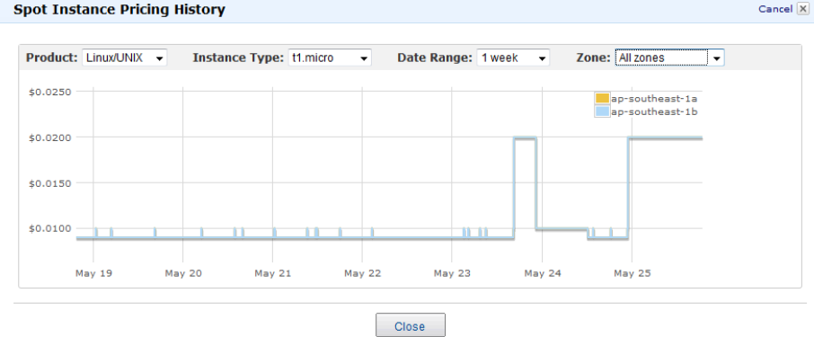

Get more historical data for training/streaming?

# Model

give total workload?

Min money, time

Money:

from one on-demand instance, whose cost is fixed, free for one year, 0.065/hour after one year

from spot instances, the more such intances, the lower money cost from the on-demand instance(will save 0.065/hour after one year, no meaning inside one year), the lower time cost

**Slaves on other machines than the one hosts master, is not that “efficient”.**

from data transfer fee if biding for instances in different available zones, even diff regions, for cheap prices.

lower money cost, lower time cost, higher quality(at most two can be achieved at one time)

## Data Transfer fee:

### Availability Zone Data Transfer

* $0.00 per GB – all data transferred between instances in the same Availability Zone using private IP addresses.

### Regional Data Transfer

* $0.01 per GB – all data transferred between instances in different Availability Zones in the same region.

### Five regions, each region contains multiple availability zone.

### Public and Elastic IP and Elastic Load Balancing Data Transfer

* $0.01 per GB in/out – If you choose to communicate using your Public or Elastic IP address or Elastic Load Balancer inside of the Amazon EC2 network, you’ll pay Regional Data Transfer rates even if the instances are in the same Availability Zone.