The **n-queens** puzzle is the problem of placing n queens on an n x n chessboard such that no two queens attack each other.

Given an integer n, return *all distinct solutions to the****n-queens puzzle***. You may return the answer in **any order**.

Each solution contains a distinct board configuration of the n-queens' placement, where 'Q' and '.' both indicate a queen and an empty space, respectively.

**Example 1:**

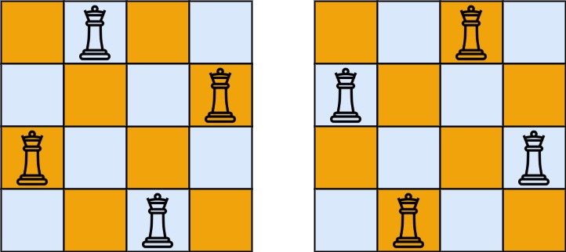

**Input:** n = 4

**Output:** [[".Q..","...Q","Q...","..Q."],["..Q.","Q...","...Q",".Q.."]]

**Explanation:** There exist two distinct solutions to the 4-queens puzzle as shown above

**Example 2:**

**Input:** n = 1

**Output:** [["Q"]]

**Constraints:**

* 1 <= n <= 9