Here is title for this post
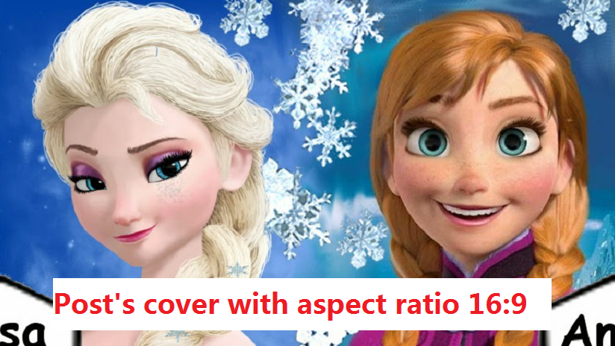
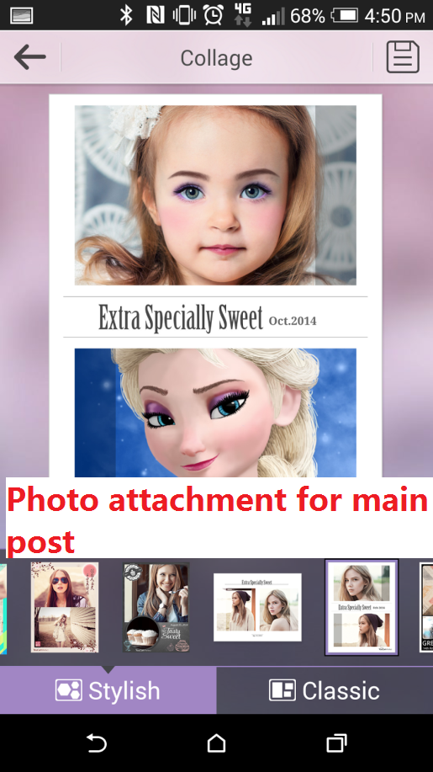

Content for main post. Currently we only support for hyperlink, like YouCam Makeup. No other font styling are supported.
We support multiple paragraph for a single post.

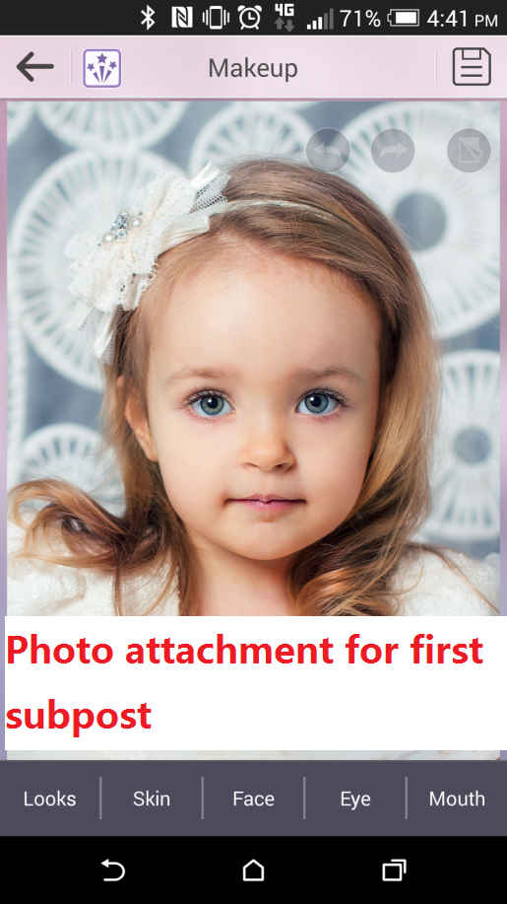
A new sub-post will create when a new image added after some text.
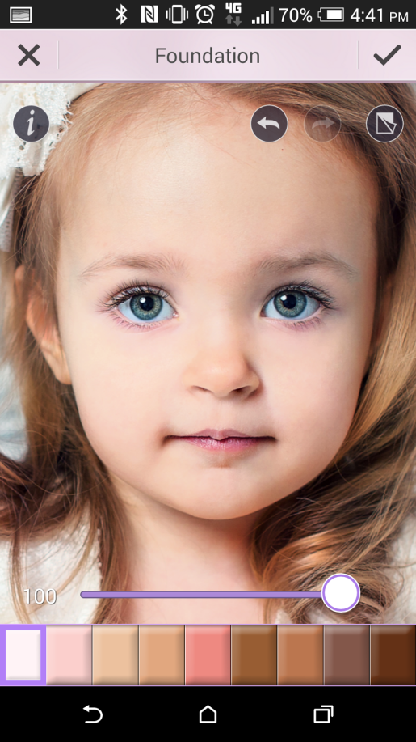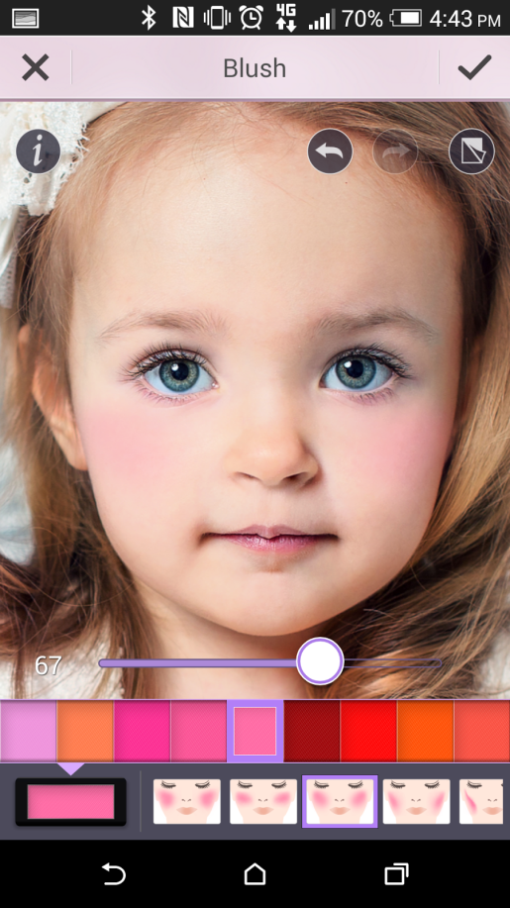
Consecutive images will only create one sub-post.

