*Gourav Khadge and Leif Park Jordan*

Model Reference Adaptive Control of Satellite Orientation GUI:

Background and Analysis

This GUI is a visualization of the motion about one axis of a communications satellite oriented through an adaptive controller. This GUI also explores the addition of Gaussian dither to the input signal to enhance the rate of convergence of the adaptive controller.

An adaptive controller can be of great utility as it can provide a controller that optimizes itself over time to the existing system, even with limited information on the parameters of the system. Limitations on this information can be due to an initial lack of information, or an imprecisely measured change in parameters due to damage or other unexpected changes. In this case, the controller has limited information of , the moment of inertia of the satellite.

**System Dynamics**

The motion of the satellite is such that:

where : satellite attitude angle

: control input

: moment of inertia about mass center (uncertain value)

We are aiming to control the system such that it behaves as a second order critically damped system decaying towards our reference input. That is, the system should follow the model reference:

with reference dynamics, .

**Controller Background**

The adaptive controller in this GUI is an adaptive PD controller given by:

If the system parameters were fully known, the desired choice of P and D would be:

to match the reference model. However, with limited information, we choose the initial values based on an estimate of J, .

The controller parameters are functions of time:



with and being the desired values of P and D.

**Controller Design**

Defining the state variables:

, the difference between the actual output and the reference model output





Now the state equations can be written:



The controller is designed for global Lyapunov stability, using the Lyapunov function:



where  are positive constants chosen such that the Lyapunov stability criterion ( is satisfied.

Taking the derivative of V(**x)**, we find:

Substituting values of the state variable time derivatives for this system and simplifying

For to be less than or equal to zero for all values of the state variables, the first, third, and fourth terms must be 0. The second term is negative definite.

Thus, the following must hold:

From this, we find:

and are equivalent to and respectively. These can be solved from the latter two equations, giving us our adaptive controller:

where ** are arbitrary positive constants

**Dither Background**

Dither is a noise injected into a signal for various purposes. In adaptive controllers, it can be used to introduce artificial perturbations into the system that will allow the adaptive controller to tune itself faster. By adding artificial perturbations, the system gains enhanced opportunities to compare its behaviors to those it desires, and adjust accordingly.

**Results**

A standard procedure on a satellite might be to adjust the orientation to another fixed position. This is equivalent to a single step input. Running this input through our adaptive controller as shown in Figure 1, the controller’s values of P and D are seen to change towards their final values. P rises from 100 to 102 (Desired P = 200) and D rises from 20 to 22 (Desired D = 40). The Lyapunov function decreases from 70 to 65.

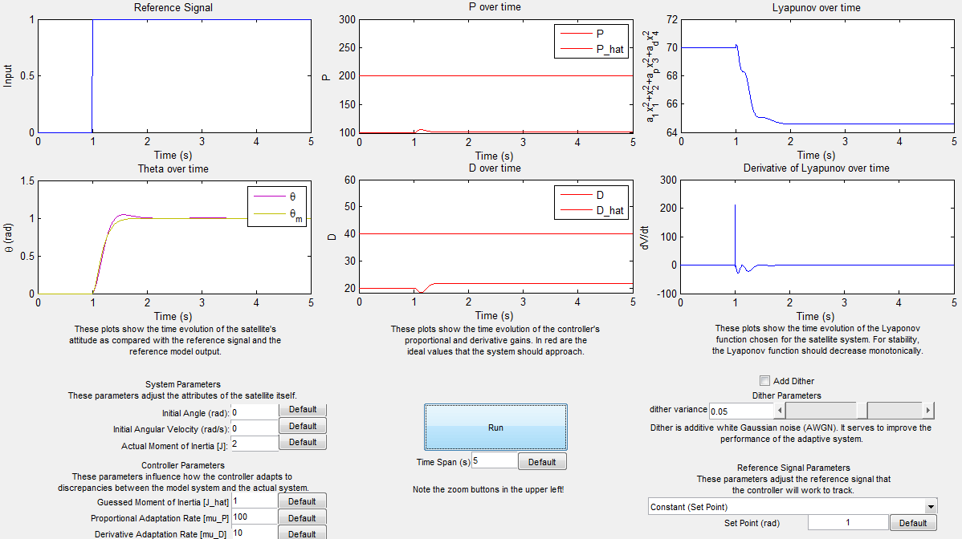

Figure 1: Step input (no dither) with adaptive controller

The ability of our controller to learn from this step input is clearly limited, as the controller does not experience a significant amount of time in which the model reference differs from the controller’s own values. The simplest way to give our controller more learning time is to put it through more “exercises” by running several step responses in a row. Figure 2 shows the a pulse train input to the controller with a 5 second period. This allows the controller to have an opportunity to “learn” on each attitude change. This is seen in the more changing values of P and D which can be seen to jump at each pulse closer to their desired values. The Lyapunov can be seen to be steadily decreasing towards zero. Visually in the time domain, the behavior of the controller and the model reference become increasingly indistinguishable in the lower left plot.

To give the controller even more learning time, 5% dither is introduced to the pulse train signal as shown in Figure 3. The controller adapts much quicker, and the Lyapunov function is nearly zero within 50 seconds.

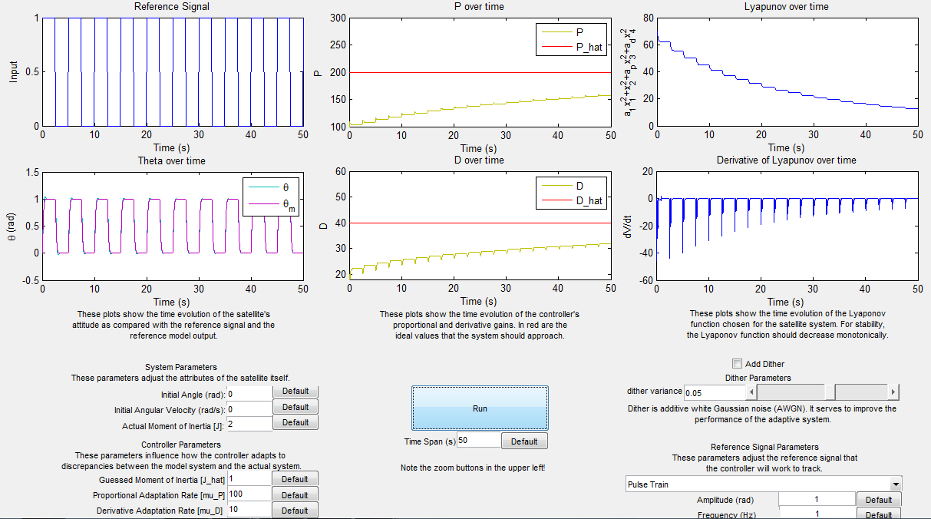

Figure 2: Pulse train (no dither) with adaptive controller.

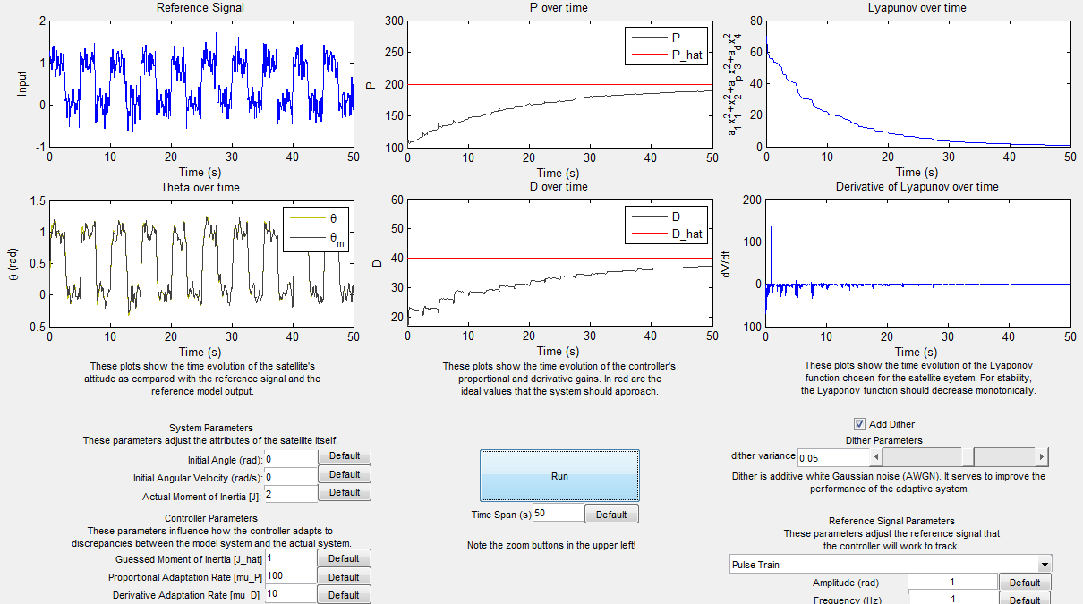

Figure 3: Same pulse train with 5% variance dither added to reference signal.

The effect of adding even more dither is apparent. By doubling the dither to 10% as shown in Figure 4, we find the P and D values converge even faster. The controller appears to approach similarly low values of the Lyapunov function is nearly half the time.

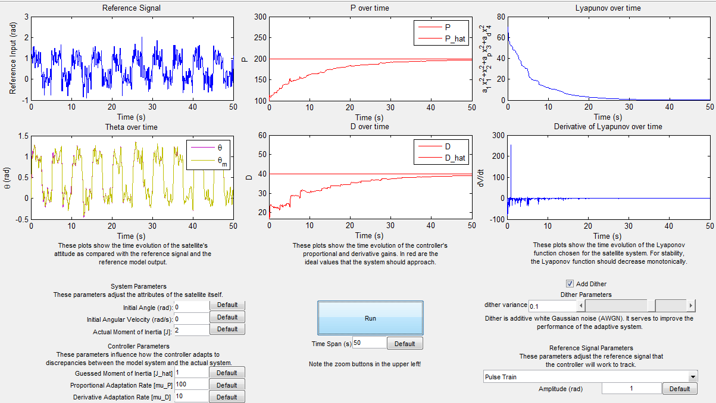

Figure 4: Pulse train with 10% dither

The effects of and are made apparent by adjusting their values. The previous figures used and . Figure 5 shows a pulse train (10% dither) reference with and . Reducing has effects of decreasing the rate of convergence of P. Increasing makes the system more response to large spikes in the reference.

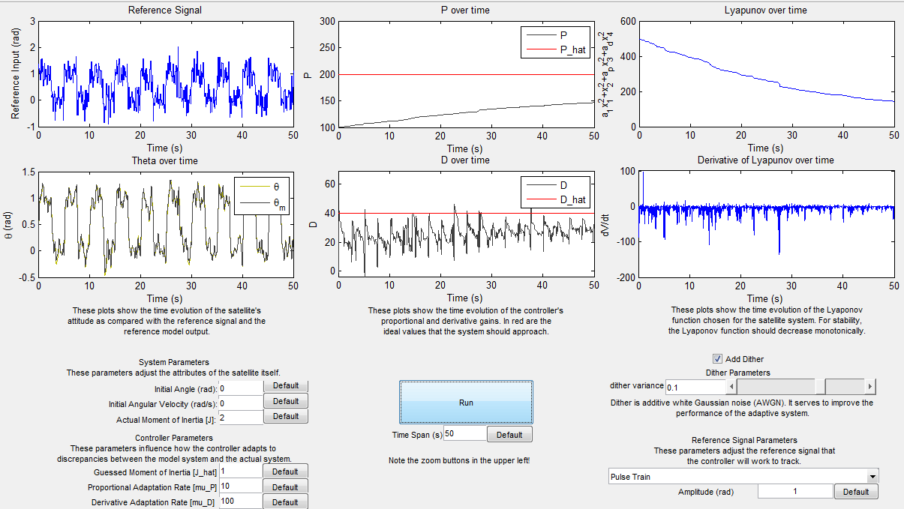

Figure 5: Pulse train (10% dither) and

Another noticeable artifact of the satellite control system is its difficulty in handling sinusoidal references as shown in Figure 6. The controller has difficulty realizing the correct value of P and D, and its behavior noticeably worsens over time as seen in the time domain plot’s lack of convergence and the Lyapunov plot’s increasing value of the Lyapunov function (which may be due to numerical error, since we don’t expect the Lyapunov function to increase for any input.)

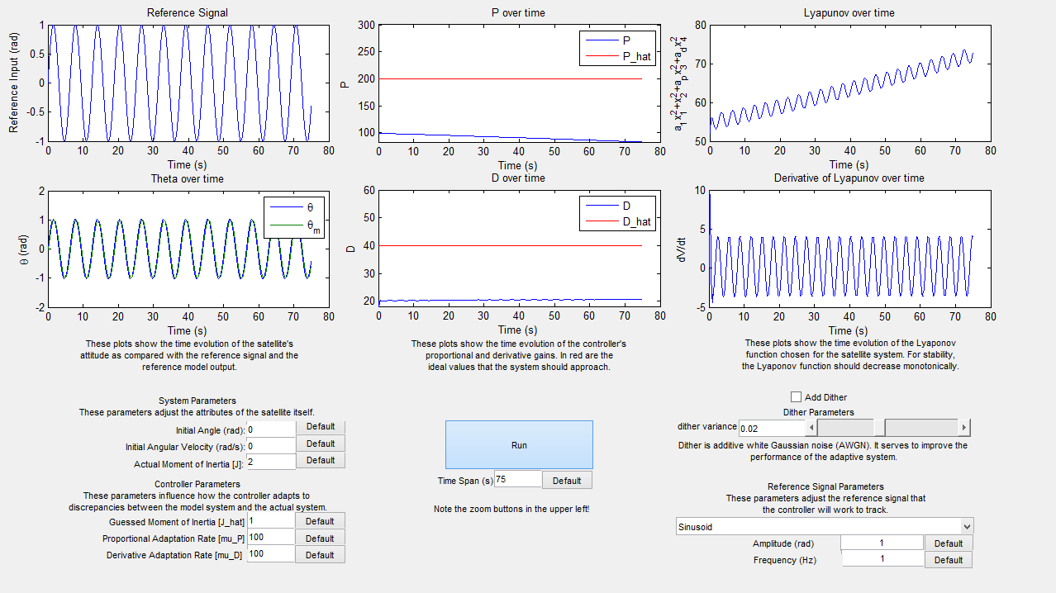

Figure 6: Sinusoidal reference

However, the addition of even 2% dither as seen in Figure 7 is enough to determinately stabilize the system.

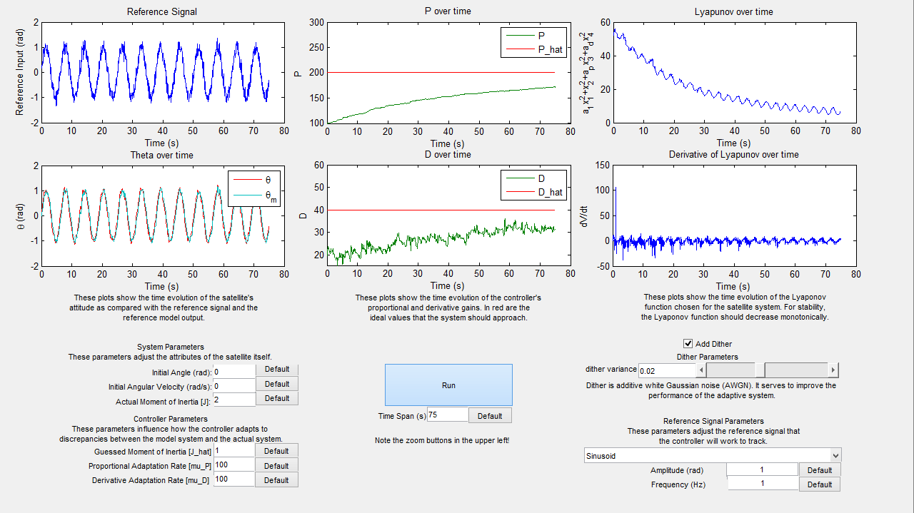

Figure 7: Sinusoidal reference with dither

**Conclusion**

The adaptive controller is an effective way to make an incompletely characterized system track certain types of inputs. Our GUI provides the user with the opportunity to investigate the effect of changing the controller parameters such as and . It also allows the user to investigate the influence of estimation quality by varying the difference between the estimated moment of inertia and real moment of inertia of the system.

Despite its effectiveness at stabilizing the satellite system, the adaptive controller has a limited capacity to “learn” once it has stabilized the system at a particular set point. In addition, the controller has poor performance tracking some types of reference signals, such as sinusoids. Our GUI demonstrates the effectiveness of using more complex references, such as pulse trains and AWGN dither, to train the controller. These inputs provide more opportunities for the controller to adapt to the true properties of the system, allowing it to more quickly approach the optimal values of proportional and derivative gain.