Hbase安装部署以及基本使用

Hbase官网：<https://hbase.apache.org>

1. **hbase部署涉及到需要改动的配置文件hbase-site.xml和hbase.env.xml**

* hbase-site.xml

默认配置：

<?xml version="1.0"?>

<?xml-stylesheet type="text/xsl" href="configuration.xsl"?>

<configuration>

<property>

<name>hbase.zookeeper.quorum</name>

<value>example1,example2,example3</value>

<description>The directory shared by RegionServers.

</description>

</property>

<property>

<name>hbase.zookeeper.property.dataDir</name>

<value>/export/zookeeper</value>

<description>Property from ZooKeeper config zoo.cfg.

The directory where the snapshot is stored.

</description>

</property>

<property>

<name>hbase.rootdir</name>

<value>hdfs://example0:8020/hbase</value>

<description>The directory shared by RegionServers.

</description>

</property>

<property>

<name>hbase.cluster.distributed</name>

<value>true</value>

<description>The mode the cluster will be in. Possible values are

false: standalone and pseudo-distributed setups with managed ZooKeeper

true: fully-distributed with unmanaged ZooKeeper Quorum (see hbase-env.sh)

</description>

</property>

</configuration>

* hbase.env.sh

# The java implementation to use.

export JAVA_HOME=/usr/java/jdk1.8.0/

# The maximum amount of heap to use. Default is left to JVM default

export BASE_HEAPSIZE=4G

启动并且验证/bin/start-hbase.sh 使用jps命令查看节点状态

进入hbase的shell命令行 ./hbase shell

* 1. **hbase的基本操作命令**

1. 创建表 ：create '表名称', '列名称1','列名称2','列名称N'

create ‘test2’,’col1’,’col2’

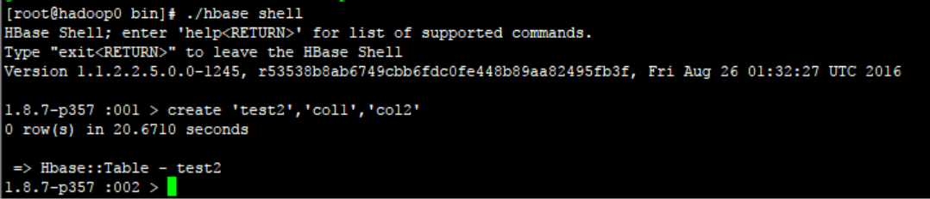

1. 添加记录：put '表名称', '行名称', '列名称:', '值' 向数据表中插入数据

Put ‘test2’,’row1’,’col1’,’hello world’

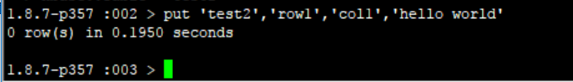

1. 查看记录 get '表名称', '行名称'

get ‘test2’,’row1’

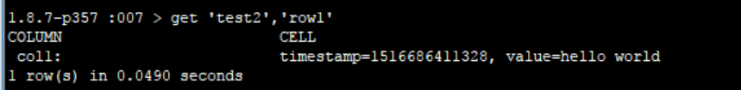

1. 查看表中的记录总数 count '表名称'

count ‘cbas_user_action’

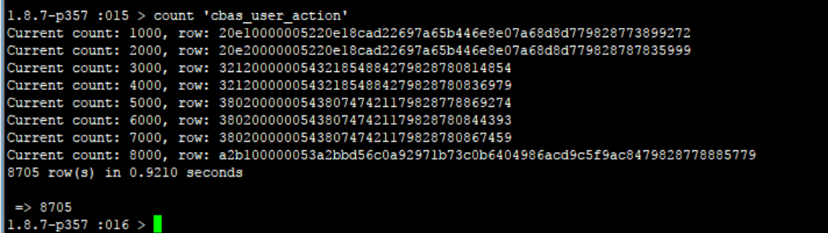

1. 删除记录 delete '表名' ,'行名称' , '列名称'

delete ‘test2’,’row2’,’col2’

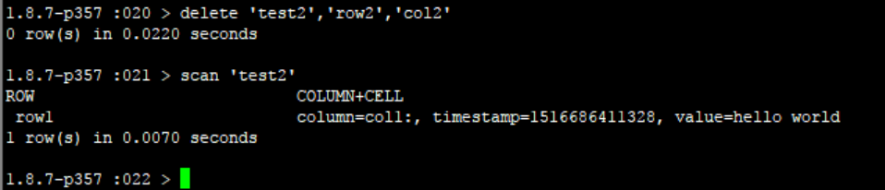

1. 删除一张表 先要屏蔽该表，才能对该表进行删除，第一步 disable '表名称' 第二步 drop '表名称'

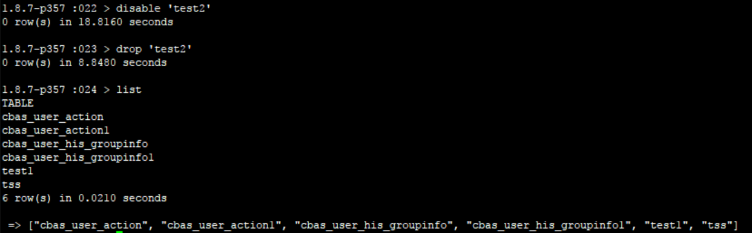

1. 查看所有记录 scan "表名称"

scan ‘test2’

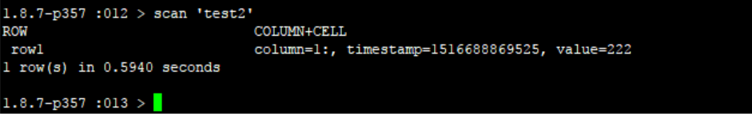

1. exists '表名' 查看数据表是否存在

exists ‘test2’

