Name: Wu, Hana Date: 11/20/2022

NYU NetID: yw6775

Section: 001

**Project Part 2**

**Professor’s Comments:**

**Affirmation of my Independent Effort:** *Hana Wu*

1. Data Lake

Chronic Disease Indicators (CDI) from Centers for Disease Control and Prevention (CDC)

<https://chronicdata.cdc.gov/Chronic-Disease-Indicators/U-S-Chronic-Disease-Indicators-CDI-/g4ie-h725>

Demographic Factors: Gender, Ethnicity, Location,

Time: YearStart, YearEnd

Type: Alcohol, Arthritis, Cancer, Cardiovascular Disease, Chronic Kidney Disease, Chronic Obstructure Pulmonary Disease, Diabetes, Disability, Immunization, Mental Health, Nutrition, Physical Activity, and Weight Status, Older Adults, Oral Health, Overarching Conditions, Reproductive Health, Tobacco

Dynamic Factors: Questions (e.g. Secondary schools offer less healthy foods than competitive foods )

1. Please refer to next page

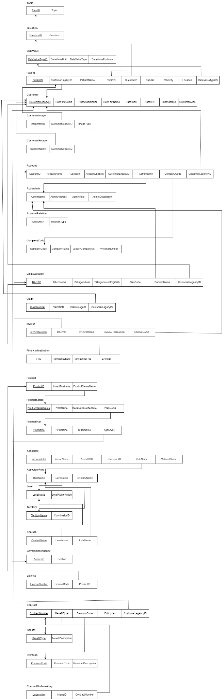

1. IBM Insurance industry reference architecture is the best fit for this situation. It is a hybrid cloud architecture and it enables customer acquisition, claims, the customer experience process, and business functions.

<https://www.ibm.com/cloud/architecture/architectures/insurance/reference-architecture/>

1. Microsoft Azure

