Name: Wu, Hana Date: 12/4/2022

NYU NetID: yw6775

Section: 001

**Project Part 3**

**Professor’s Comments:**

**Affirmation of my Independent Effort:** *Hana Wu*

* 1. Indexing:
     1. BenefitsCostSharing: StandardComponentId
     2. BussinessRules: ProductID IssueId
     3. Network: NetworkId
     4. PlanAttributes: PlanId
     5. Rate: PlanId BusinessYear
     6. ServiceArea: ServiceAreaId
     7. ChronicDiseaseIndicator: TopicId StateCode
     8. KidneyDisease: id
  2. Partitioning Table Storage
  3. Integrity Constraints: id should be unique

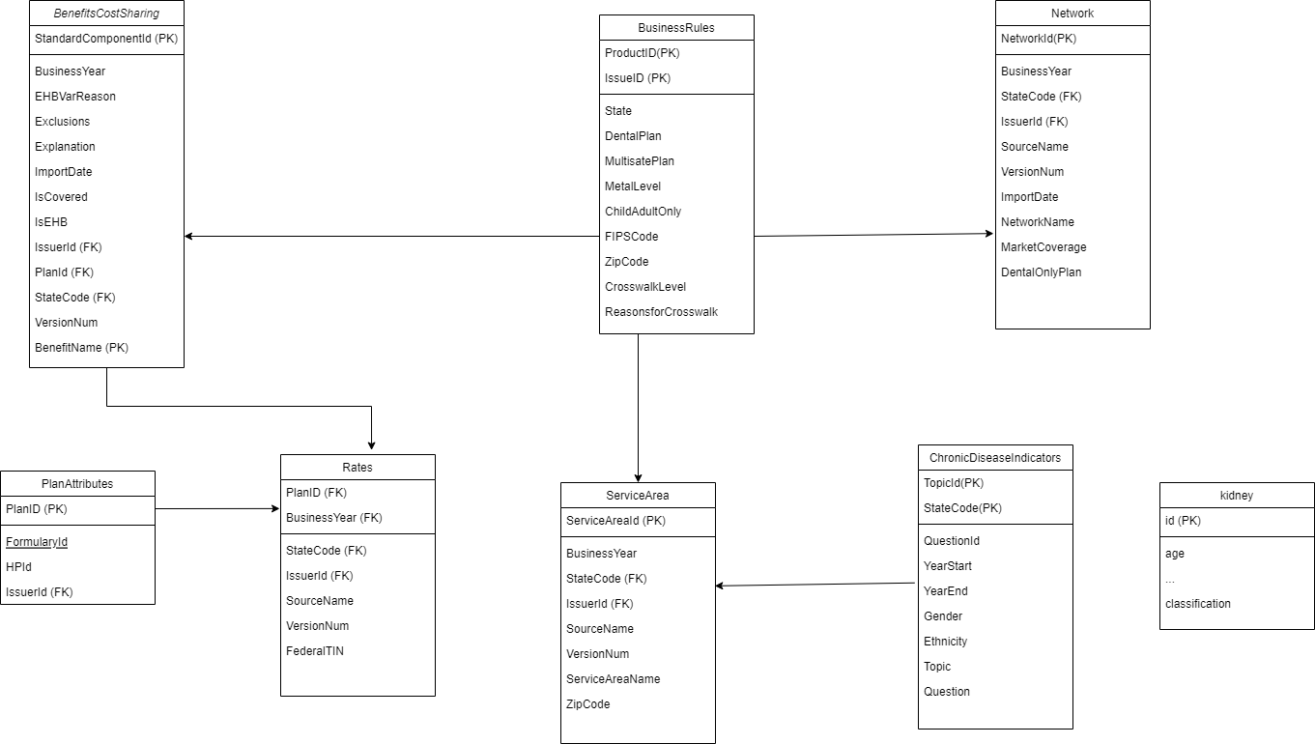

* 1. Predict which type of person is more likely to have chronic diseases
  2. Which type of person is more likely to have chronic diseases
  3. Which type of person is more likely to buy health insurance
  4. The probability of people who have chronic diseases would like to buy health insurance
  5. Which indicators would cause people to have chronic diseases

1. Predict chronic disease with different indicators or features: Please refer to the DBProject.ipynb

