Task 1:Manipulating Environment Variables
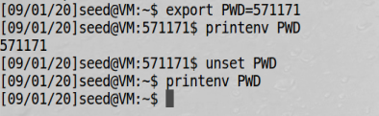

Task 2: Passing Environment Variables from Parent Process to Child Process
运行➀：
XDG_VTNR=7
XDG_SESSION_ID=c1
XDG_GREETER_DATA_DIR=/var/lib/lightdm-data/seed
CLUTTER_IM_MODULE=xim
SESSION=ubuntu
ANDROID_HOME=/home/seed/android/android-sdk-linux
GPG_AGENT_INFO=/home/seed/.gnupg/S.gpg-agent:0:1
TERM=xterm-256color
VTE_VERSION=4205
XDG_MENU_PREFIX=gnome-
SHELL=/bin/bash
DERBY_HOME=/usr/lib/jvm/java-8-oracle/db
QT_LINUX_ACCESSIBILITY_ALWAYS_ON=1
LD_PRELOAD=/home/seed/lib/boost/libboost_program_options.so.1.64.0:/home/seed/lib/boost/libboost_filesystem.so.1.64.0:/home/seed/lib/boost/libboost_system.so.1.64.0
WINDOWID=60817418
UPSTART_SESSION=unix:abstract=/com/ubuntu/upstart-session/1000/1416
GNOME_KEYRING_CONTROL=
GTK_MODULES=gail:atk-bridge:unity-gtk-module
USER=seed
LS_COLORS=rs=0:di=01;34:ln=01;36:mh=00:pi=40;33:so=01;35:do=01;35:bd=40;33;01:cd=40;33;01:or=40;31;01:mi=00:su=37;41:sg=30;43:ca=30;41:tw=30;42:ow=34;42:st=37;44:ex=01;32:*.tar=01;31:*.tgz=01;31:*.arc=01;31:*.arj=01;31:*.taz=01;31:*.lha=01;31:*.lz4=01;31:*.lzh=01;31:*.lzma=01;31:*.tlz=01;31:*.txz=01;31:*.tzo=01;31:*.t7z=01;31:*.zip=01;31:*.z=01;31:*.Z=01;31:*.dz=01;31:*.gz=01;31:*.lrz=01;31:*.lz=01;31:*.lzo=01;31:*.xz=01;31:*.bz2=01;31:*.bz=01;31:*.tbz=01;31:*.tbz2=01;31:*.tz=01;31:*.deb=01;31:*.rpm=01;31:*.jar=01;31:*.war=01;31:*.ear=01;31:*.sar=01;31:*.rar=01;31:*.alz=01;31:*.ace=01;31:*.zoo=01;31:*.cpio=01;31:*.7z=01;31:*.rz=01;31:*.cab=01;31:*.jpg=01;35:*.jpeg=01;35:*.gif=01;35:*.bmp=01;35:*.pbm=01;35:*.pgm=01;35:*.ppm=01;35:*.tga=01;35:*.xbm=01;35:*.xpm=01;35:*.tif=01;35:*.tiff=01;35:*.png=01;35:*.svg=01;35:*.svgz=01;35:*.mng=01;35:*.pcx=01;35:*.mov=01;35:*.mpg=01;35:*.mpeg=01;35:*.m2v=01;35:*.mkv=01;35:*.webm=01;35:*.ogm=01;35:*.mp4=01;35:*.m4v=01;35:*.mp4v=01;35:*.vob=01;35:*.qt=01;35:*.nuv=01;35:*.wmv=01;35:*.asf=01;35:*.rm=01;35:*.rmvb=01;35:*.flc=01;35:*.avi=01;35:*.fli=01;35:*.flv=01;35:*.gl=01;35:*.dl=01;35:*.xcf=01;35:*.xwd=01;35:*.yuv=01;35:*.cgm=01;35:*.emf=01;35:*.ogv=01;35:*.ogx=01;35:*.aac=00;36:*.au=00;36:*.flac=00;36:*.m4a=00;36:*.mid=00;36:*.midi=00;36:*.mka=00;36:*.mp3=00;36:*.mpc=00;36:*.ogg=00;36:*.ra=00;36:*.wav=00;36:*.oga=00;36:*.opus=00;36:*.spx=00;36:*.xspf=00;36:
QT_ACCESSIBILITY=1
LD_LIBRARY_PATH=/home/seed/source/boost_1_64_0/stage/lib:/home/seed/source/boost_1_64_0/stage/lib:
XDG_SESSION_PATH=/org/freedesktop/DisplayManager/Session0
XDG_SEAT_PATH=/org/freedesktop/DisplayManager/Seat0
SSH_AUTH_SOCK=/run/user/1000/keyring/ssh
DEFAULTS_PATH=/usr/share/gconf/ubuntu.default.path
SESSION_MANAGER=local/VM:@/tmp/.ICE-unix/1724,unix/VM:/tmp/.ICE-unix/1724
XDG_CONFIG_DIRS=/etc/xdg/xdg-ubuntu:/usr/share/upstart/xdg:/etc/xdg
DESKTOP_SESSION=ubuntu
PATH=/home/seed/bin:/usr/local/sbin:/usr/local/bin:/usr/sbin:/usr/bin:/sbin:/bin:/usr/games:/usr/local/games:.:/snap/bin:/usr/lib/jvm/java-8-oracle/bin:/usr/lib/jvm/java-8-oracle/db/bin:/usr/lib/jvm/java-8-oracle/jre/bin:/home/seed/android/android-sdk-linux/tools:/home/seed/android/android-sdk-linux/platform-tools:/home/seed/android/android-ndk/android-ndk-r8d:/home/seed/.local/bin
QT_IM_MODULE=ibus
QT_QPA_PLATFORMTHEME=appmenu-qt5
XDG_SESSION_TYPE=x11
PWD=/home/seed/Documents/chapter 0
JOB=dbus
XMODIFIERS=@im=ibus
JAVA_HOME=/usr/lib/jvm/java-8-oracle
GNOME_KEYRING_PID=
LANG=en_US.UTF-8
GDM_LANG=en_US
MANDATORY_PATH=/usr/share/gconf/ubuntu.mandatory.path
COMPIZ_CONFIG_PROFILE=ubuntu
IM_CONFIG_PHASE=1
GDMSESSION=ubuntu
SESSIONTYPE=gnome-session
GTK2_MODULES=overlay-scrollbar
SHLVL=1
HOME=/home/seed
XDG_SEAT=seat0
LANGUAGE=en_US
LIBGL_ALWAYS_SOFTWARE=1
GNOME_DESKTOP_SESSION_ID=this-is-deprecated
XDG_SESSION_DESKTOP=ubuntu
LOGNAME=seed
DBUS_SESSION_BUS_ADDRESS=unix:abstract=/tmp/dbus-fByrajMkVh
J2SDKDIR=/usr/lib/jvm/java-8-oracle
XDG_DATA_DIRS=/usr/share/ubuntu:/usr/share/gnome:/usr/local/share/:/usr/share/:/var/lib/snapd/desktop
QT4_IM_MODULE=xim
LESSOPEN=| /usr/bin/lesspipe %s
INSTANCE=
XDG_RUNTIME_DIR=/run/user/1000
DISPLAY=:0
XDG_CURRENT_DESKTOP=Unity
GTK_IM_MODULE=ibus
J2REDIR=/usr/lib/jvm/java-8-oracle/jre
LESSCLOSE=/usr/bin/lesspipe %s %s
XAUTHORITY=/home/seed/.Xauthority
_=./a

运行➁：
XDG_VTNR=7
XDG_SESSION_ID=c1
XDG_GREETER_DATA_DIR=/var/lib/lightdm-data/seed
CLUTTER_IM_MODULE=xim
SESSION=ubuntu
ANDROID_HOME=/home/seed/android/android-sdk-linux
GPG_AGENT_INFO=/home/seed/.gnupg/S.gpg-agent:0:1
TERM=xterm-256color
VTE_VERSION=4205
XDG_MENU_PREFIX=gnome-
SHELL=/bin/bash
DERBY_HOME=/usr/lib/jvm/java-8-oracle/db
QT_LINUX_ACCESSIBILITY_ALWAYS_ON=1
LD_PRELOAD=/home/seed/lib/boost/libboost_program_options.so.1.64.0:/home/seed/lib/boost/libboost_filesystem.so.1.64.0:/home/seed/lib/boost/libboost_system.so.1.64.0
WINDOWID=60817418
UPSTART_SESSION=unix:abstract=/com/ubuntu/upstart-session/1000/1416
GNOME_KEYRING_CONTROL=
GTK_MODULES=gail:atk-bridge:unity-gtk-module
USER=seed
LS_COLORS=rs=0:di=01;34:ln=01;36:mh=00:pi=40;33:so=01;35:do=01;35:bd=40;33;01:cd=40;33;01:or=40;31;01:mi=00:su=37;41:sg=30;43:ca=30;41:tw=30;42:ow=34;42:st=37;44:ex=01;32:*.tar=01;31:*.tgz=01;31:*.arc=01;31:*.arj=01;31:*.taz=01;31:*.lha=01;31:*.lz4=01;31:*.lzh=01;31:*.lzma=01;31:*.tlz=01;31:*.txz=01;31:*.tzo=01;31:*.t7z=01;31:*.zip=01;31:*.z=01;31:*.Z=01;31:*.dz=01;31:*.gz=01;31:*.lrz=01;31:*.lz=01;31:*.lzo=01;31:*.xz=01;31:*.bz2=01;31:*.bz=01;31:*.tbz=01;31:*.tbz2=01;31:*.tz=01;31:*.deb=01;31:*.rpm=01;31:*.jar=01;31:*.war=01;31:*.ear=01;31:*.sar=01;31:*.rar=01;31:*.alz=01;31:*.ace=01;31:*.zoo=01;31:*.cpio=01;31:*.7z=01;31:*.rz=01;31:*.cab=01;31:*.jpg=01;35:*.jpeg=01;35:*.gif=01;35:*.bmp=01;35:*.pbm=01;35:*.pgm=01;35:*.ppm=01;35:*.tga=01;35:*.xbm=01;35:*.xpm=01;35:*.tif=01;35:*.tiff=01;35:*.png=01;35:*.svg=01;35:*.svgz=01;35:*.mng=01;35:*.pcx=01;35:*.mov=01;35:*.mpg=01;35:*.mpeg=01;35:*.m2v=01;35:*.mkv=01;35:*.webm=01;35:*.ogm=01;35:*.mp4=01;35:*.m4v=01;35:*.mp4v=01;35:*.vob=01;35:*.qt=01;35:*.nuv=01;35:*.wmv=01;35:*.asf=01;35:*.rm=01;35:*.rmvb=01;35:*.flc=01;35:*.avi=01;35:*.fli=01;35:*.flv=01;35:*.gl=01;35:*.dl=01;35:*.xcf=01;35:*.xwd=01;35:*.yuv=01;35:*.cgm=01;35:*.emf=01;35:*.ogv=01;35:*.ogx=01;35:*.aac=00;36:*.au=00;36:*.flac=00;36:*.m4a=00;36:*.mid=00;36:*.midi=00;36:*.mka=00;36:*.mp3=00;36:*.mpc=00;36:*.ogg=00;36:*.ra=00;36:*.wav=00;36:*.oga=00;36:*.opus=00;36:*.spx=00;36:*.xspf=00;36:
QT_ACCESSIBILITY=1
LD_LIBRARY_PATH=/home/seed/source/boost_1_64_0/stage/lib:/home/seed/source/boost_1_64_0/stage/lib:
XDG_SESSION_PATH=/org/freedesktop/DisplayManager/Session0
XDG_SEAT_PATH=/org/freedesktop/DisplayManager/Seat0
SSH_AUTH_SOCK=/run/user/1000/keyring/ssh
DEFAULTS_PATH=/usr/share/gconf/ubuntu.default.path
SESSION_MANAGER=local/VM:@/tmp/.ICE-unix/1724,unix/VM:/tmp/.ICE-unix/1724
XDG_CONFIG_DIRS=/etc/xdg/xdg-ubuntu:/usr/share/upstart/xdg:/etc/xdg
DESKTOP_SESSION=ubuntu
PATH=/home/seed/bin:/usr/local/sbin:/usr/local/bin:/usr/sbin:/usr/bin:/sbin:/bin:/usr/games:/usr/local/games:.:/snap/bin:/usr/lib/jvm/java-8-oracle/bin:/usr/lib/jvm/java-8-oracle/db/bin:/usr/lib/jvm/java-8-oracle/jre/bin:/home/seed/android/android-sdk-linux/tools:/home/seed/android/android-sdk-linux/platform-tools:/home/seed/android/android-ndk/android-ndk-r8d:/home/seed/.local/bin
QT_IM_MODULE=ibus
QT_QPA_PLATFORMTHEME=appmenu-qt5
XDG_SESSION_TYPE=x11
PWD=/home/seed/Documents/chapter 0
JOB=dbus
XMODIFIERS=@im=ibus
JAVA_HOME=/usr/lib/jvm/java-8-oracle
GNOME_KEYRING_PID=
LANG=en_US.UTF-8
GDM_LANG=en_US
MANDATORY_PATH=/usr/share/gconf/ubuntu.mandatory.path
COMPIZ_CONFIG_PROFILE=ubuntu
IM_CONFIG_PHASE=1
GDMSESSION=ubuntu
SESSIONTYPE=gnome-session
GTK2_MODULES=overlay-scrollbar
SHLVL=1
HOME=/home/seed
XDG_SEAT=seat0
LANGUAGE=en_US
LIBGL_ALWAYS_SOFTWARE=1
GNOME_DESKTOP_SESSION_ID=this-is-deprecated
XDG_SESSION_DESKTOP=ubuntu
LOGNAME=seed
DBUS_SESSION_BUS_ADDRESS=unix:abstract=/tmp/dbus-fByrajMkVh
J2SDKDIR=/usr/lib/jvm/java-8-oracle
XDG_DATA_DIRS=/usr/share/ubuntu:/usr/share/gnome:/usr/local/share/:/usr/share/:/var/lib/snapd/desktop
QT4_IM_MODULE=xim
LESSOPEN=| /usr/bin/lesspipe %s
INSTANCE=
XDG_RUNTIME_DIR=/run/user/1000
DISPLAY=:0
XDG_CURRENT_DESKTOP=Unity
GTK_IM_MODULE=ibus
J2REDIR=/usr/lib/jvm/java-8-oracle/jre
LESSCLOSE=/usr/bin/lesspipe %s %s
XAUTHORITY=/home/seed/.Xauthority
_=./a

用diff命令发现没有不同:
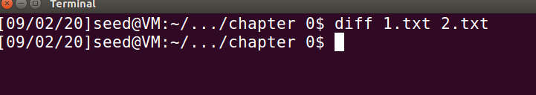
结论：fork()出来的子进程完全继承了父进程的环境变量

Task 3: Environment Variables and execve()
在运行原程序 即execve("/usr/bin/env", argv, NULL); ➀时，发现无输出
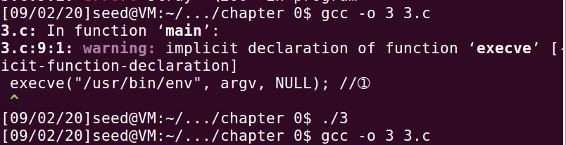
在运行修改后时发现有环境变量的输出（输出太多只截取了一部分）：
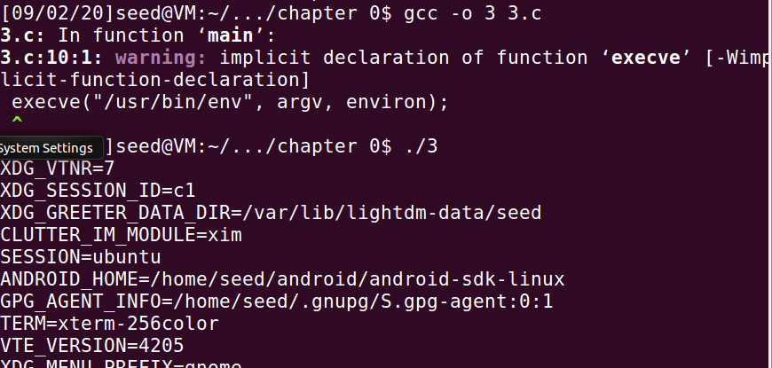

结论：函数execve（）中第三个参数为NULL时，就强制给了env这个可执行文件的可继承环境变量为空，所以显示它的环境变量为空，当第三个参数为environ时，这时候它继承的环境变量就为environ了。

Task4：Environment Variables and system()

运行结果：
LESSOPEN=| /usr/bin/lesspipe %s
GNOME_KEYRING_PID=
USER=seed
LANGUAGE=en_US
J2SDKDIR=/usr/lib/jvm/java-8-oracle
XDG_SEAT=seat0
SESSION=ubuntu
XDG_SESSION_TYPE=x11
COMPIZ_CONFIG_PROFILE=ubuntu
LD_LIBRARY_PATH=/home/seed/source/boost_1_64_0/stage/lib:/home/seed/source/boost_1_64_0/stage/lib:
SHLVL=1
LIBGL_ALWAYS_SOFTWARE=1
J2REDIR=/usr/lib/jvm/java-8-oracle/jre
HOME=/home/seed
QT4_IM_MODULE=xim
DESKTOP_SESSION=ubuntu
QT_LINUX_ACCESSIBILITY_ALWAYS_ON=1
GTK_MODULES=gail:atk-bridge:unity-gtk-module
XDG_SEAT_PATH=/org/freedesktop/DisplayManager/Seat0
INSTANCE=
DBUS_SESSION_BUS_ADDRESS=unix:abstract=/tmp/dbus-fByrajMkVh
GNOME_KEYRING_CONTROL=
QT_QPA_PLATFORMTHEME=appmenu-qt5
MANDATORY_PATH=/usr/share/gconf/ubuntu.mandatory.path
IM_CONFIG_PHASE=1
SESSIONTYPE=gnome-session
LOGNAME=seed
GTK_IM_MODULE=ibus
WINDOWID=60817418
_=./4
DEFAULTS_PATH=/usr/share/gconf/ubuntu.default.path
XDG_SESSION_ID=c1
TERM=xterm-256color
GNOME_DESKTOP_SESSION_ID=this-is-deprecated
GTK2_MODULES=overlay-scrollbar
PATH=/home/seed/bin:/usr/local/sbin:/usr/local/bin:/usr/sbin:/usr/bin:/sbin:/bin:/usr/games:/usr/local/games:.:/snap/bin:/usr/lib/jvm/java-8-oracle/bin:/usr/lib/jvm/java-8-oracle/db/bin:/usr/lib/jvm/java-8-oracle/jre/bin:/home/seed/android/android-sdk-linux/tools:/home/seed/android/android-sdk-linux/platform-tools:/home/seed/android/android-ndk/android-ndk-r8d:/home/seed/.local/bin
DERBY_HOME=/usr/lib/jvm/java-8-oracle/db
SESSION_MANAGER=local/VM:@/tmp/.ICE-unix/1724,unix/VM:/tmp/.ICE-unix/1724
GDM_LANG=en_US
XDG_MENU_PREFIX=gnome-
XDG_SESSION_PATH=/org/freedesktop/DisplayManager/Session0
XDG_RUNTIME_DIR=/run/user/1000
DISPLAY=:0
LD_PRELOAD=/home/seed/lib/boost/libboost_program_options.so.1.64.0:/home/seed/lib/boost/libboost_filesystem.so.1.64.0:/home/seed/lib/boost/libboost_system.so.1.64.0
LANG=en_US.UTF-8
XDG_CURRENT_DESKTOP=Unity
LS_COLORS=rs=0:di=01;34:ln=01;36:mh=00:pi=40;33:so=01;35:do=01;35:bd=40;33;01:cd=40;33;01:or=40;31;01:mi=00:su=37;41:sg=30;43:ca=30;41:tw=30;42:ow=34;42:st=37;44:ex=01;32:*.tar=01;31:*.tgz=01;31:*.arc=01;31:*.arj=01;31:*.taz=01;31:*.lha=01;31:*.lz4=01;31:*.lzh=01;31:*.lzma=01;31:*.tlz=01;31:*.txz=01;31:*.tzo=01;31:*.t7z=01;31:*.zip=01;31:*.z=01;31:*.Z=01;31:*.dz=01;31:*.gz=01;31:*.lrz=01;31:*.lz=01;31:*.lzo=01;31:*.xz=01;31:*.bz2=01;31:*.bz=01;31:*.tbz=01;31:*.tbz2=01;31:*.tz=01;31:*.deb=01;31:*.rpm=01;31:*.jar=01;31:*.war=01;31:*.ear=01;31:*.sar=01;31:*.rar=01;31:*.alz=01;31:*.ace=01;31:*.zoo=01;31:*.cpio=01;31:*.7z=01;31:*.rz=01;31:*.cab=01;31:*.jpg=01;35:*.jpeg=01;35:*.gif=01;35:*.bmp=01;35:*.pbm=01;35:*.pgm=01;35:*.ppm=01;35:*.tga=01;35:*.xbm=01;35:*.xpm=01;35:*.tif=01;35:*.tiff=01;35:*.png=01;35:*.svg=01;35:*.svgz=01;35:*.mng=01;35:*.pcx=01;35:*.mov=01;35:*.mpg=01;35:*.mpeg=01;35:*.m2v=01;35:*.mkv=01;35:*.webm=01;35:*.ogm=01;35:*.mp4=01;35:*.m4v=01;35:*.mp4v=01;35:*.vob=01;35:*.qt=01;35:*.nuv=01;35:*.wmv=01;35:*.asf=01;35:*.rm=01;35:*.rmvb=01;35:*.flc=01;35:*.avi=01;35:*.fli=01;35:*.flv=01;35:*.gl=01;35:*.dl=01;35:*.xcf=01;35:*.xwd=01;35:*.yuv=01;35:*.cgm=01;35:*.emf=01;35:*.ogv=01;35:*.ogx=01;35:*.aac=00;36:*.au=00;36:*.flac=00;36:*.m4a=00;36:*.mid=00;36:*.midi=00;36:*.mka=00;36:*.mp3=00;36:*.mpc=00;36:*.ogg=00;36:*.ra=00;36:*.wav=00;36:*.oga=00;36:*.opus=00;36:*.spx=00;36:*.xspf=00;36:
XMODIFIERS=@im=ibus
XDG_SESSION_DESKTOP=ubuntu
XAUTHORITY=/home/seed/.Xauthority
XDG_GREETER_DATA_DIR=/var/lib/lightdm-data/seed
SSH_AUTH_SOCK=/run/user/1000/keyring/ssh
SHELL=/bin/bash
QT_ACCESSIBILITY=1
GDMSESSION=ubuntu
LESSCLOSE=/usr/bin/lesspipe %s %s
GPG_AGENT_INFO=/home/seed/.gnupg/S.gpg-agent:0:1
UPSTART_SESSION=unix:abstract=/com/ubuntu/upstart-session/1000/1416
XDG_VTNR=7
QT_IM_MODULE=ibus
PWD=/home/seed/Documents/chapter 0
JAVA_HOME=/usr/lib/jvm/java-8-oracle
CLUTTER_IM_MODULE=xim
ANDROID_HOME=/home/seed/android/android-sdk-linux
XDG_CONFIG_DIRS=/etc/xdg/xdg-ubuntu:/usr/share/upstart/xdg:/etc/xdg
XDG_DATA_DIRS=/usr/share/ubuntu:/usr/share/gnome:/usr/local/share/:/usr/share/:/var/lib/snapd/desktop
VTE_VERSION=4205
JOB=dbus

Task 5: Environment Variable and Set-UID Programs
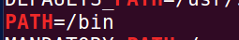


发现该程序的环境变量有刚刚添加的内容，但奇怪的时LD_LIBRARY_PATH并未找到,应该是ruid与suid不一致导致的。

Task 6: The PATH Environment Variable and Set-UID Programs
未改变权限：
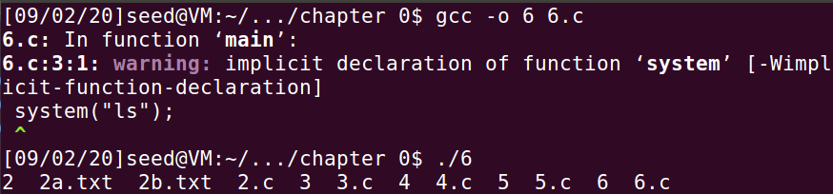

改变权限为root 并设置为set-uid程序，发现不能输出

利用实验报告提供方法进行操作：发现又能成功显示目录。
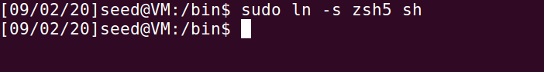
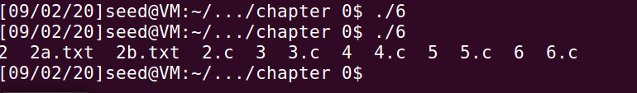

Task 7: The LD PRELOAD Environment Variable and Set-UID Programs
在动态链接库下，输出结果如下：
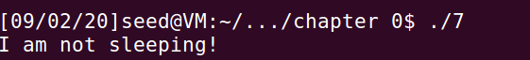
设为Set-UID程序之后，结果如下
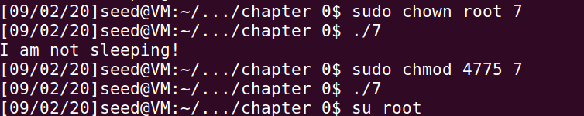

Task 8: Invoking External Programs Using system() versus execve()
1:在system（）时可删除
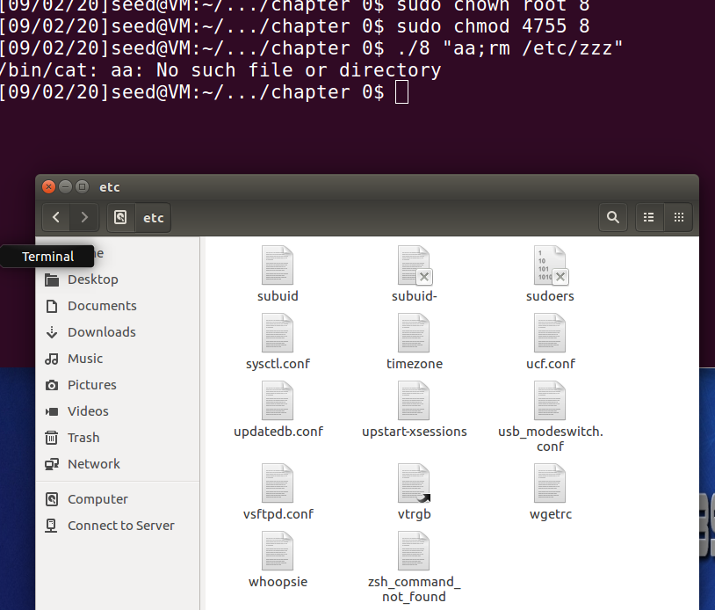
2.在execv()时不可删除

Task 9: Capability Leaking
首先我们发现以普通用户权限运行 无法打开/etc/zzz
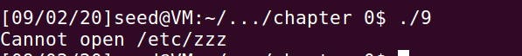
我们修改为root权限并且设为setuid程序 发现可以读取/etc/zzz不再弹出 cannot open /etc/zzz
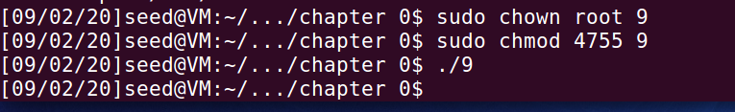
在root全县辖重新添加动态库：
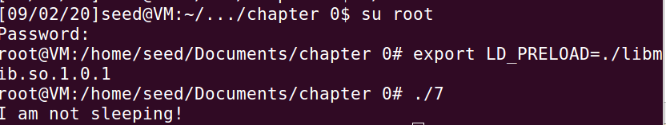
将可执行文件所有权改为新用户，并在seed下exprot动态库并执行：
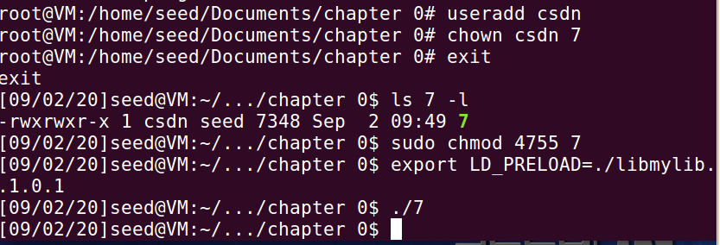

程序调用者与程序owner不一致时，ruid与euid不一致时，便不会链接到动态链接库。

