实战双目imx219_rk3588

参考文档
https://www.cnblogs.com/Tronlong818/p/18330038
https://www.cnblogs.com/Tronlong818/articles/19155776
https://github.com/JA-cmd-wq/yolov8-helmet-rk3588-multithread/blob/main/docs/TUTORIAL.md

正确接线
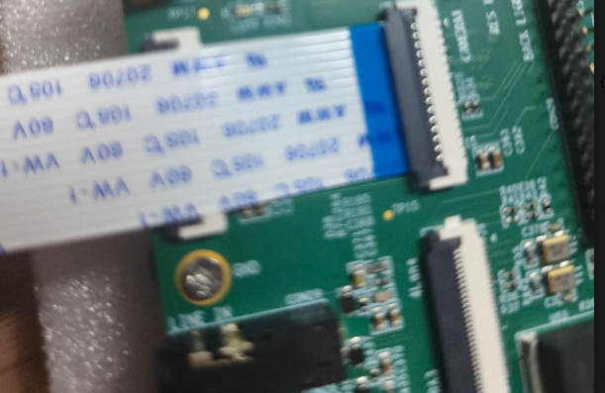

基本信息
模型：/root/yolov8_rk3588/int8_best.rknn
图片：/root/yolov8_rk3588/tupian
结果：/root/yolov8_rk3588/result

检测板子摄像头必备文件

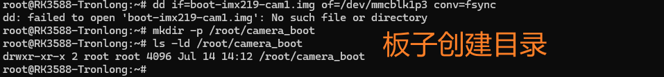

激活环境
cd /root/yolov8_rk3588
source rknn310/bin/activate

烧录其中一个
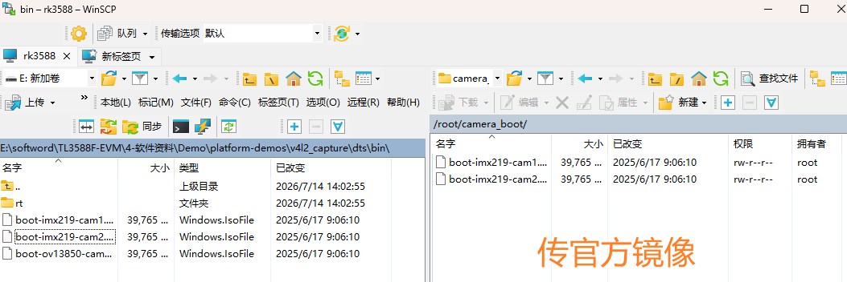

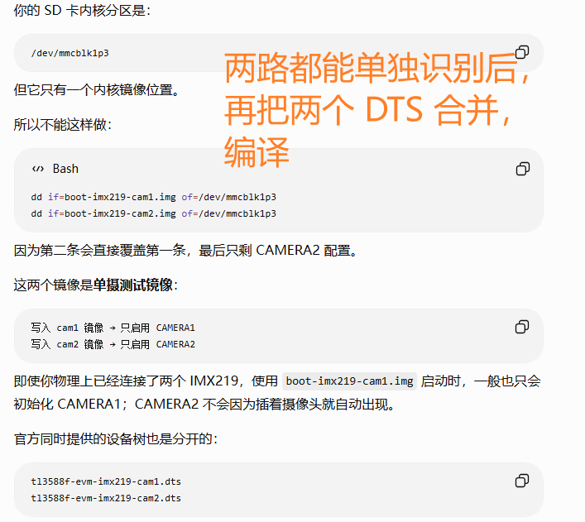

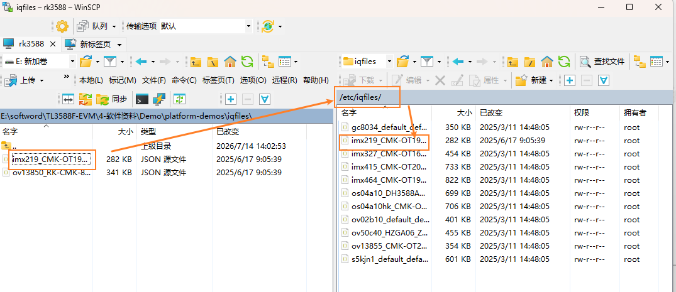

检测板子摄像头图片文件
[capture_imx219_jpg.py]

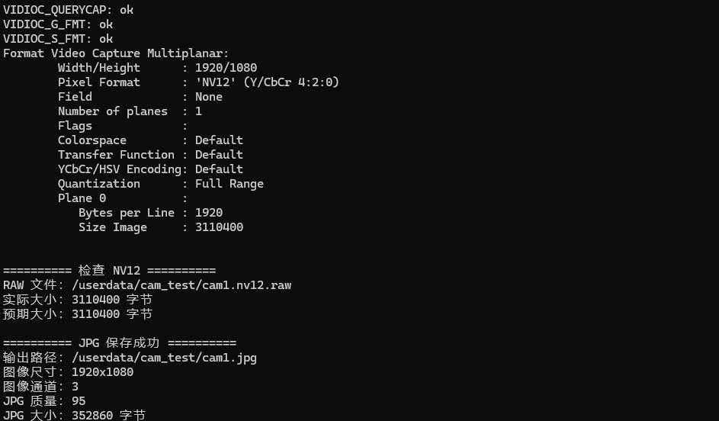



检测板子摄像头单目视频检测
先检查视频和停止旧程序
下面全部在 RK3588板端执行：
Plain Text
cd /root/yolov8_rk3588
source rknn310/bin/activate
pkill -f dual_yolov8_rknn_camera.py 2>/dev/null || true
pkill -f video_yolov8_rknn.py 2>/dev/null || true
pkill -f 'v4l2-ctl.*video22' 2>/dev/null || true
pkill -f 'v4l2-ctl.*video31' 2>/dev/null || true
echo "========== 检查视频 =========="
ls -lh /root/yolov8_rk3588/tupian/video_test.mp4
python - <<'PY'
import cv2
path = "/root/yolov8_rk3588/tupian/video_test.mp4"
cap = cv2.VideoCapture(path)
if not cap.isOpened():
raise RuntimeError(f"无法打开视频：{path}")
fps = cap.get(cv2.CAP_PROP_FPS)
width = int(cap.get(cv2.CAP_PROP_FRAME_WIDTH))
height = int(cap.get(cv2.CAP_PROP_FRAME_HEIGHT))
frames = int(cap.get(cv2.CAP_PROP_FRAME_COUNT))
print(f"视频路径：{path}")
print(f"分辨率：{width}x{height}")
print(f"FPS：{fps}")
print(f"总帧数：{frames}")
if fps > 0:
print(f"视频时长：{frames / fps:.2f} 秒")
cap.release()
PY

[yolov8_rknn_camera.py]

启动实时检测
推荐先按视频原始帧率播放：
Plain Text
cd /root/yolov8_rk3588
source rknn310/bin/activate
python -u video_yolov8_rknn.py \
--video /root/yolov8_rk3588/tupian/video_test.mp4 \
--model /root/yolov8_rk3588/int8_best.rknn \
--input-size 640 \
--conf 0.25 \
--nms 0.45 \
--preview-width 960 \
--jpeg-quality 80 \
--port 8081 \
--realtime

检测板子摄像头单目实时检测

[yolov8_rknn_infer.py]

[20260714-0655-03.5318343.mp4]

C：先双目测距，再把 YOLO 检测框与距离融合显示

提前准备（检测板子摄像头双目文件）
Windows 资料盘→ Ubuntu 22.04 编译主机
因为硬件层面：支持。CAMERA1、CAMERA2 都是独立的 2-Lane MIPI CSI 接口，RK3588 的 CSI/ISP 输入能力也足以容纳多路摄像头 ，官方现成镜像层面：没有明确提供双 IMX219 镜像
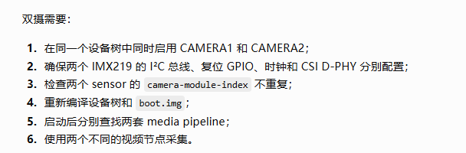
Ubuntu 终端执行（#官方手册给出的 LinuxSDK 依赖集合）：
Plain Text
sudo apt-get update
sudo apt-get install -y \
git ssh make gcc libssl-dev \
liblz4-tool expect expect-dev g++ patchelf chrpath \
gawk texinfo diffstat binfmt-support qemu-user-static \
live-build bison flex fakeroot cmake \
gcc-multilib g++-multilib unzip device-tree-compiler \
ncurses-dev libgucharmap-2-90-dev bzip2 expat \
gpgv2 cpp-aarch64-linux-gnu libgmp-dev libmpc-dev \
bc python-is-python3
检查基础工具：
Plain Text
dtc --version
make --version
gcc --version
lz4 -V
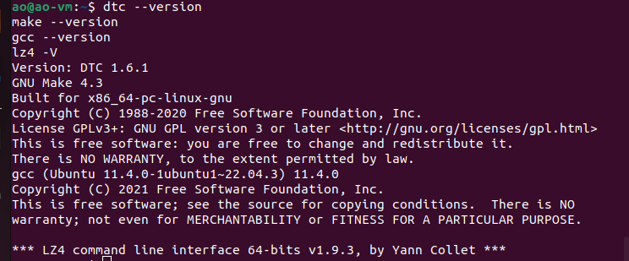
→解压 LinuxSDK
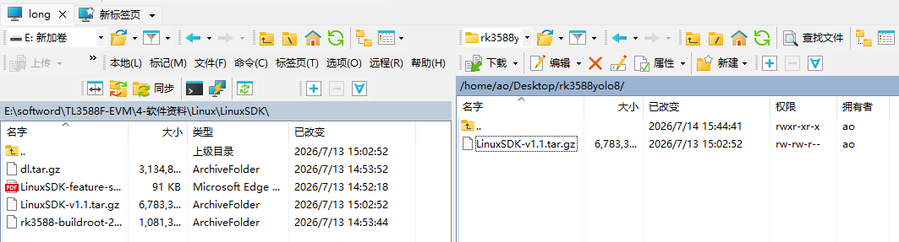
打开 Ubuntu 终端执行：
Plain Text
cd /home/ao/Desktop/rk3588yolo8
echo "========== 压缩包 =========="
ls -lh LinuxSDK-v1.1.tar.gz
echo "========== 磁盘空间 =========="
df -h /home/ao
export SDK_ROOT="$HOME/RK3588/rk3588_linux_release"
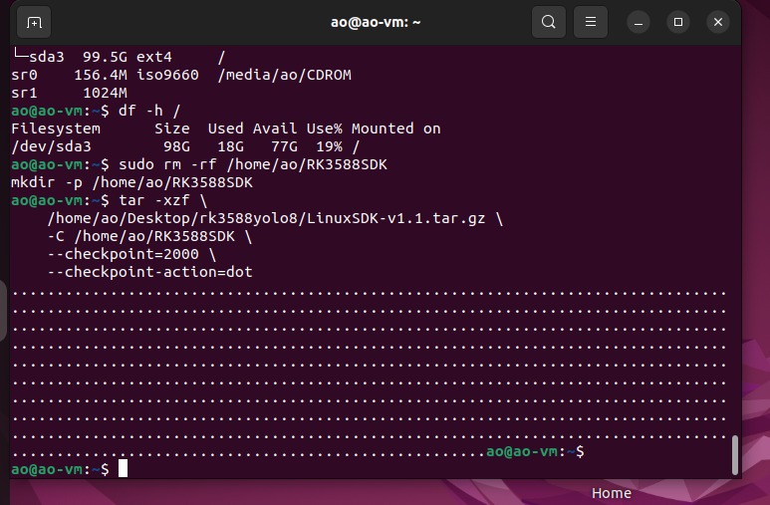
解压完成后找 SDK 顶层：
Plain Text
find /home/ao/RK3588SDK \
-maxdepth 5 \
-type f \
-name build.sh \
-print
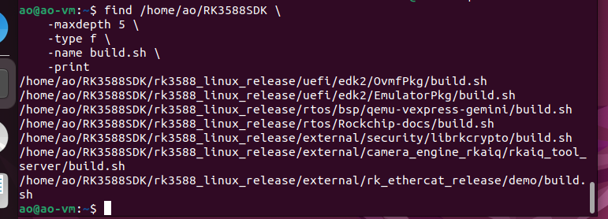
自动记录 SDK 路径
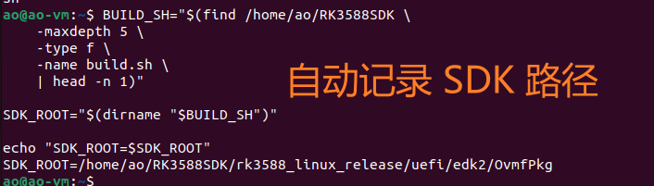
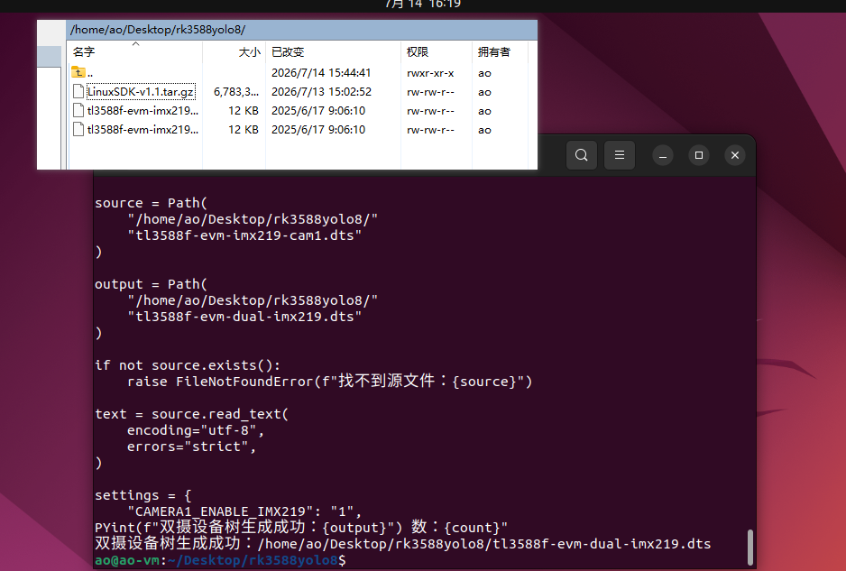

第一阶段：在 Ubuntu 编译双摄 boot.img

→ 放入双摄 DTS
执行下面整段命令：
Plain Text
cd /home/ao/Desktop/rk3588yolo8
python3 - <<'PY'
from pathlib import Path
import re
source = Path(
"/home/ao/Desktop/rk3588yolo8/"
"tl3588f-evm-imx219-cam1.dts"
)
output = Path(
"/home/ao/Desktop/rk3588yolo8/"
"tl3588f-evm-dual-imx219.dts"
)
if not source.exists():
raise FileNotFoundError(f"找不到源文件：{source}")
text = source.read_text(
encoding="utf-8",
errors="strict",
)
settings = {
"CAMERA1_ENABLE_IMX219": "1",
"CAMERA2_ENABLE_IMX219": "1",
"CAMERA3_ENABLE_OV13850": "0",
}
for macro, value in settings.items():
pattern = (
rf"(?m)^(\s*#define\s+"
rf"{re.escape(macro)}\s+)"
rf"[01](\s*)$"
)
text, count = re.subn(
pattern,
rf"\g<1>{value}\g<2>",
text,
)
if count != 1:
raise RuntimeError(
f"修改 {macro} 失败，匹配次数：{count}"
)
output.write_text(
text,
encoding="utf-8",
)
print(f"双摄设备树生成成功：{output}")
PY
验证结果：
Plain Text
echo "========== 双摄宏配置 =========="
grep -nE \
"CAMERA1_ENABLE_IMX219|CAMERA2_ENABLE_IMX219|CAMERA3_ENABLE_OV13850" \
/home/ao/Desktop/rk3588yolo8/tl3588f-evm-dual-imx219.dts
必须看到：
Plain Text
#define CAMERA1_ENABLE_IMX219 1
#define CAMERA2_ENABLE_IMX219 1
#define CAMERA3_ENABLE_OV13850 0
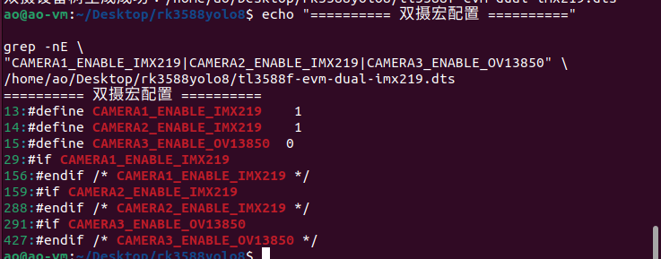

继续检查文件：
Plain Text
ls -lh \
/home/ao/Desktop/rk3588yolo8/tl3588f-evm-dual-imx219.dts
sha256sum \
/home/ao/Desktop/rk3588yolo8/tl3588f-evm-dual-imx219.dts
head -n 20 \
/home/ao/Desktop/rk3588yolo8/tl3588f-evm-dual-imx219.dts

确认前面的 SDK_ROOT 变量仍然存在：
Plain Text
echo "$SDK_ROOT"
如果输出为空，重新设置：
Plain Text
BUILD_SH="$(find /home/ao/RK3588SDK \
-maxdepth 5 \
-type f \
-name build.sh \
| head -n 1)"
SDK_ROOT="$(dirname "$BUILD_SH")"
复制双摄文件：
Plain Text
DTS_DIR="$SDK_ROOT/kernel/arch/arm64/boot/dts/rockchip"
test -d "$DTS_DIR" || {
echo "错误：设备树目录不存在：$DTS_DIR"
exit 1
}
cp -av \
/home/ao/Desktop/rk3588yolo8/tl3588f-evm-dual-imx219.dts \
"$DTS_DIR/"
检查：
Plain Text
ls -lh \
"$DTS_DIR/tl3588f-evm-dual-imx219.dts"
grep -nE \
"CAMERA1_ENABLE_IMX219|CAMERA2_ENABLE_IMX219|CAMERA3_ENABLE_OV13850" \
"$DTS_DIR/tl3588f-evm-dual-imx219.dts"
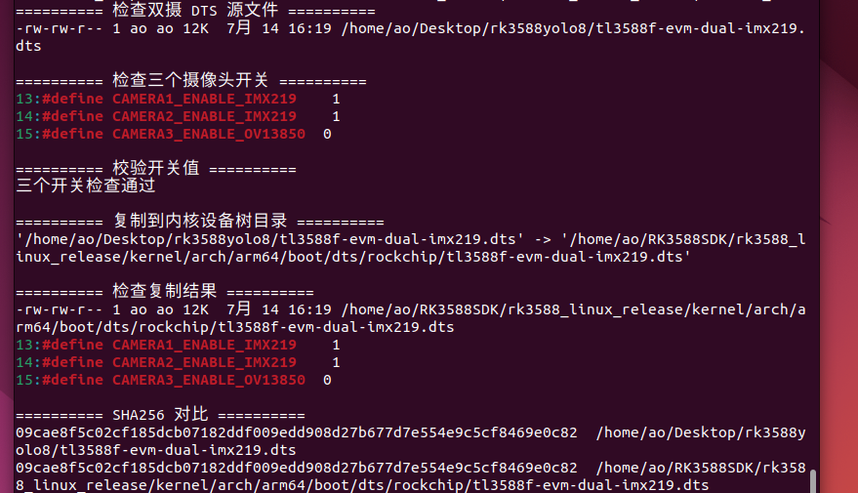

1设置固定路径并检查磁盘空间
整段复制：
Plain Text
SDK_ROOT="/home/ao/RK3588SDK/rk3588_linux_release"
DTS_DIR="$SDK_ROOT/kernel/arch/arm64/boot/dts/rockchip"
DUAL_DTS="$DTS_DIR/tl3588f-evm-dual-imx219.dts"
BOARD_CONFIG="$SDK_ROOT/device/rockchip/rk3588/tl3588_evm_defconfig"
echo "========== 基础路径 =========="
echo "SDK_ROOT=$SDK_ROOT"
echo "DUAL_DTS=$DUAL_DTS"
echo "BOARD_CONFIG=$BOARD_CONFIG"
echo
echo "========== 文件检查 =========="
test -x "$SDK_ROOT/build.sh" || {
echo "错误：找不到可执行的 build.sh"
exit 1
}
test -f "$DUAL_DTS" || {
echo "错误：找不到双摄 DTS：$DUAL_DTS"
exit 1
}
test -f "$BOARD_CONFIG" || {
echo "错误：找不到板级配置：$BOARD_CONFIG"
exit 1
}
echo "基础文件检查通过"
echo
echo "========== 磁盘空间 =========="
df -h "$SDK_ROOT"
echo
echo "========== 双摄开关 =========="
grep -nE \
'CAMERA1_ENABLE_IMX219|CAMERA2_ENABLE_IMX219|CAMERA3_ENABLE_OV13850' \
"$DUAL_DTS"

2选择 TL3588F-EVM 编译配置
Plain Text
cd "$SDK_ROOT"
./build.sh lunch:tl3588_evm_defconfig

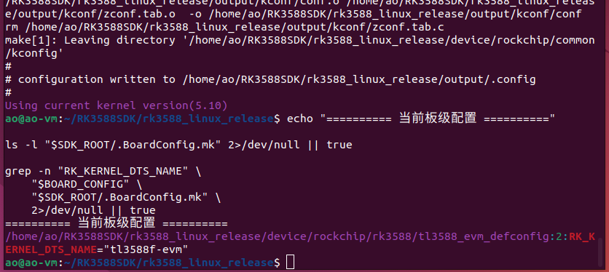

3修改设备树名称
设备树文件名是：
Plain Text
tl3588f-evm-dual-imx219.dts
配置中必须填写不带 .dts 后缀的名称：
Plain Text
tl3588f-evm-dual-imx219
先备份：
Plain Text
CONFIG_BACKUP="${BOARD_CONFIG}.before-dual-imx219-$(date +%Y%m%d-%H%M%S)"
cp -av \
"$BOARD_CONFIG" \
"$CONFIG_BACKUP"
echo "配置备份：$CONFIG_BACKUP"
然后自动修改：
Plain Text
python3 - "$BOARD_CONFIG" <<'PY'
from pathlib import Path
import re
import sys
path = Path(sys.argv[1])
target = 'RK_KERNEL_DTS_NAME="tl3588f-evm-dual-imx219"'
lines = path.read_text(
encoding="utf-8",
).splitlines()
output = []
replaced = False
for line in lines:
# 只替换当前生效、没有被 # 注释的配置
if re.match(
r"^\s*RK_KERNEL_DTS_NAME\s*=",
line,
):
if not replaced:
output.append(target)
replaced = True
continue
output.append(line)
if not replaced:
output.append(target)
path.write_text(
"\n".join(output) + "\n",
encoding="utf-8",
)
print(f"已设置：{target}")
PY
验证配置：
Plain Text
echo "========== DTS 编译名称 =========="
grep -nE \
'^[[:space:]]*RK_KERNEL_DTS_NAME=' \
"$BOARD_CONFIG"
ACTIVE_COUNT="$(
grep -cE \
'^[[:space:]]*RK_KERNEL_DTS_NAME=' \
"$BOARD_CONFIG"
)"
if [ "$ACTIVE_COUNT" -ne 1 ]; then
echo "错误：生效的 RK_KERNEL_DTS_NAME 数量不是 1"
exit 1
fi
grep -qE \
'^RK_KERNEL_DTS_NAME="tl3588f-evm-dual-imx219"$' \
"$BOARD_CONFIG" || {
echo "错误：DTS 名称设置不正确"
exit 1
}
echo "DTS 名称设置通过"
正常结果：
Plain Text
RK_KERNEL_DTS_NAME="tl3588f-evm-dual-imx219"
官方手册也是通过修改：
Plain Text
device/rockchip/rk3588/tl3588_evm_defconfig
中的 RK_KERNEL_DTS_NAME 来切换设备树。
重新加载板级配置：
Plain Text
cd "$SDK_ROOT"
./build.sh lunch:tl3588_evm_defconfig
再次检查：
Plain Text
grep -nE \
'^[[:space:]]*RK_KERNEL_DTS_NAME=' \
"$BOARD_CONFIG"
grep -n "RK_KERNEL_DTS_NAME" \
"$SDK_ROOT/.BoardConfig.mk" \
2>/dev/null || true

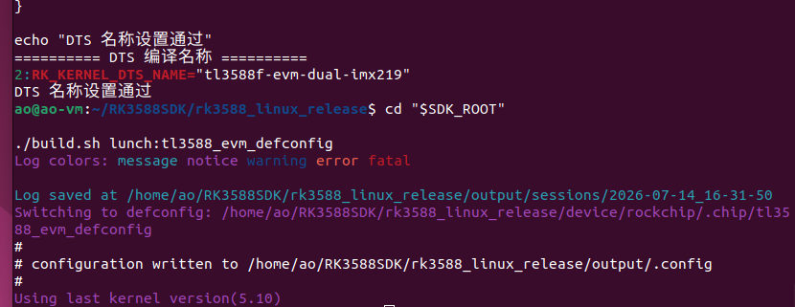

第二阶段：保持 Linux-RT 内核配置
你板子当前运行的是：
Plain Text
Linux 5.10.209-rt89
因此不要直接编译成普通 Linux 内核，继续使用 RT 配置。

1. 备份默认内核配置
Plain Text
cd "$SDK_ROOT/kernel"
KERNEL_DEFCONFIG="arch/arm64/configs/rockchip_linux_defconfig"
KERNEL_BACKUP="${KERNEL_DEFCONFIG}.before-dual-imx219-$(date +%Y%m%d-%H%M%S)"
cp -av \
"$KERNEL_DEFCONFIG" \
"$KERNEL_BACKUP"
echo "内核配置备份：$KERNEL_BACKUP"

2. 合并 RT 配置
整段复制：
Plain Text
cd "$SDK_ROOT/kernel"
make ARCH=arm64 \
rockchip_linux_defconfig \
rockchip_rt.config
make ARCH=arm64 savedefconfig
test -f defconfig || {
echo "错误：没有生成 defconfig"
exit 1
}
cp -av \
defconfig \
arch/arm64/configs/rockchip_linux_defconfig
检查 RT 配置：
Plain Text
echo "========== RT 配置检查 =========="
grep -E \
'CONFIG_PREEMPT_RT|CONFIG_PREEMPT=' \
arch/arm64/configs/rockchip_linux_defconfig \
.config \
2>/dev/null || true
官方 Linux-RT 编译方法也是：
Plain Text
make ARCH=arm64 rockchip_linux_defconfig rockchip_rt.config
make ARCH=arm64 savedefconfig
mv defconfig arch/arm64/configs/rockchip_linux_defconfig
然后返回 SDK 顶层运行 ./build.sh kernel。

第三阶段：编译 boot.img

1. 开始编译
Plain Text
cd "$SDK_ROOT"
BUILD_LOG="$SDK_ROOT/build-dual-imx219-$(date +%Y%m%d-%H%M%S).log"
echo "编译日志：$BUILD_LOG"
set -o pipefail
./build.sh kernel 2>&1 | tee "$BUILD_LOG"
BUILD_RESULT="${PIPESTATUS[0]}"
echo
echo "build.sh 返回值：$BUILD_RESULT"
if [ "$BUILD_RESULT" -ne 0 ]; then
echo "内核编译失败，禁止继续写入开发板"
echo
echo "最后 100 行日志："
tail -n 100 "$BUILD_LOG"
exit "$BUILD_RESULT"
fi
首次编译可能持续较长时间，终端持续输出编译信息属于正常现象。
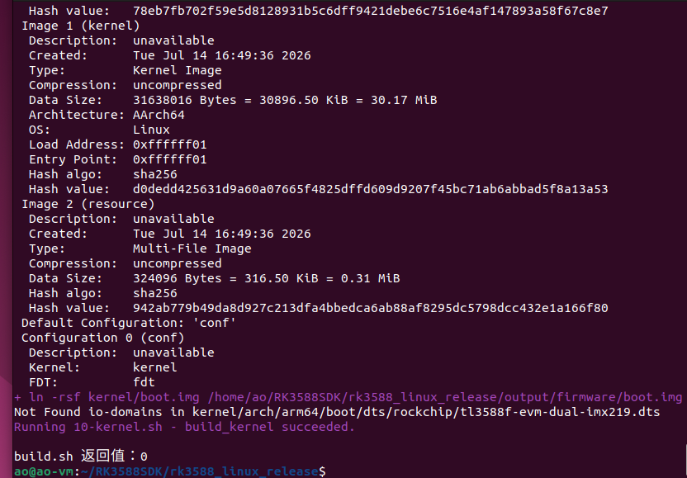

2. 检查是否存在编译错误
Plain Text
echo "========== 编译错误扫描 =========="
grep -nEi \
'(^|[[:space:]])error:|fatal:|undefined reference|No rule to make target' \
"$BUILD_LOG" \
| tail -n 50 || true
如果上面的扫描出现明确的 error: 或 fatal:，先不要继续。

3. 检查双摄 DTB

tl3588f-evm-imx219-cam1.dts | #define CAMERA1_ENABLE_IMX219 1  #define CAMERA2_ENABLE_IMX219 0  #define CAMERA3_ENABLE_OV13850 0 | 合并成  #define CAMERA1_ENABLE_IMX219 1  #define CAMERA2_ENABLE_IMX219 1  #define CAMERA3_ENABLE_OV13850 0
tl3588f-evm-imx219-cam2.dts | #define CAMERA1_ENABLE_IMX219 0  #define CAMERA2_ENABLE_IMX219 1  #define CAMERA3_ENABLE_OV13850 0

Plain Text
DTB_PATH="$SDK_ROOT/kernel/arch/arm64/boot/dts/rockchip/tl3588f-evm-dual-imx219.dtb"
echo "========== 双摄 DTB =========="
test -f "$DTB_PATH" || {
echo "错误：没有生成双摄 DTB：$DTB_PATH"
exit 1
}
ls -lh "$DTB_PATH"
file "$DTB_PATH"
sha256sum "$DTB_PATH"
可以反编译检查关键节点：
Plain Text
dtc \
-I dtb \
-O dts \
-o /tmp/tl3588f-dual-check.dts \
"$DTB_PATH"
echo "========== 编译后设备树检查 =========="
grep -nE \
'sony,imx219|rkisp0-vir0|rkisp0-vir1|mipi2-csi2|mipi3-csi2' \
/tmp/tl3588f-dual-check.dts \
| head -n 50
至少应看到两处：
Plain Text
sony,imx219
统计：
Plain Text
grep -c 'sony,imx219' \
/tmp/tl3588f-dual-check.dts
预期输出：
Plain Text
2
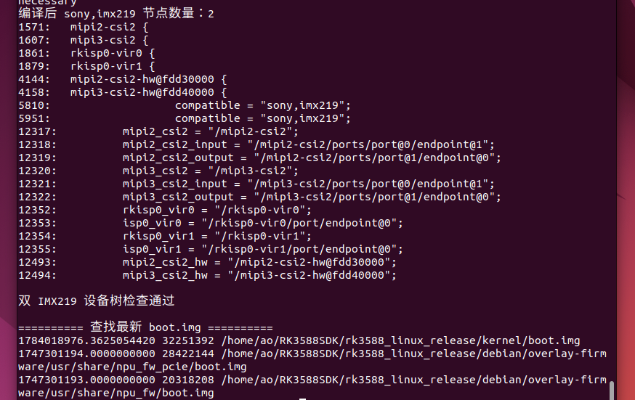

4. 检查 boot.img
官方内核编译完成后，会在：
Plain Text
output/firmware/boot.img
生成内核镜像，且 boot.img 同时包含内核和设备树。
执行：
Plain Text
BOOT_IMAGE="$SDK_ROOT/output/firmware/boot.img"
echo "========== boot.img =========="
test -f "$BOOT_IMAGE" || {
echo "错误：没有生成 boot.img：$BOOT_IMAGE"
exit 1
}
ls -lh "$BOOT_IMAGE"
file "$BOOT_IMAGE"
BOOT_SIZE="$(stat -c '%s' "$BOOT_IMAGE")"
echo "boot.img 字节数：$BOOT_SIZE"
if [ "$BOOT_SIZE" -ge 67108864 ]; then
echo "错误：boot.img 大于或等于 64MiB"
echo "禁止写入 /dev/mmcblk1p3"
exit 1
fi
echo "boot.img 大小检查通过"
另存为明确名称：
Plain Text
FINAL_BOOT="$SDK_ROOT/output/firmware/boot-dual-imx219.img"
cp -av \
"$BOOT_IMAGE" \
"$FINAL_BOOT"
sha256sum "$FINAL_BOOT" \
| tee "${FINAL_BOOT}.sha256"

5. 检查编译出的内核版本
Plain Text
echo "========== 编译内核版本 =========="
cat "$SDK_ROOT/kernel/include/config/kernel.release" \
2>/dev/null || true
grep -E \
'CONFIG_LOCALVERSION|CONFIG_PREEMPT_RT' \
"$SDK_ROOT/kernel/.config" \
2>/dev/null || true
预期应接近：
Plain Text
5.10.209-rt89-...
出现完全不同的内核主版本或没有 rt 时，不要写入板子。

双摄 DTB：包含 2 个 sony,imx219
CSI：mipi2-csi2、mipi3-csi2
ISP：rkisp0-vir0、rkisp0-vir1
内核：5.10.209-rt89
实时补丁：CONFIG_PREEMPT_RT=y
boot.img：32,251,392 字节，小于 64 MiB 分区
SHA256：11cd1054e8f6a2ea86e077ae5686996fb5aa049207b30ecc645b4867845dbe3f

第四阶段：把镜像传到 RK3588
以下仍在 Ubuntu 执行。
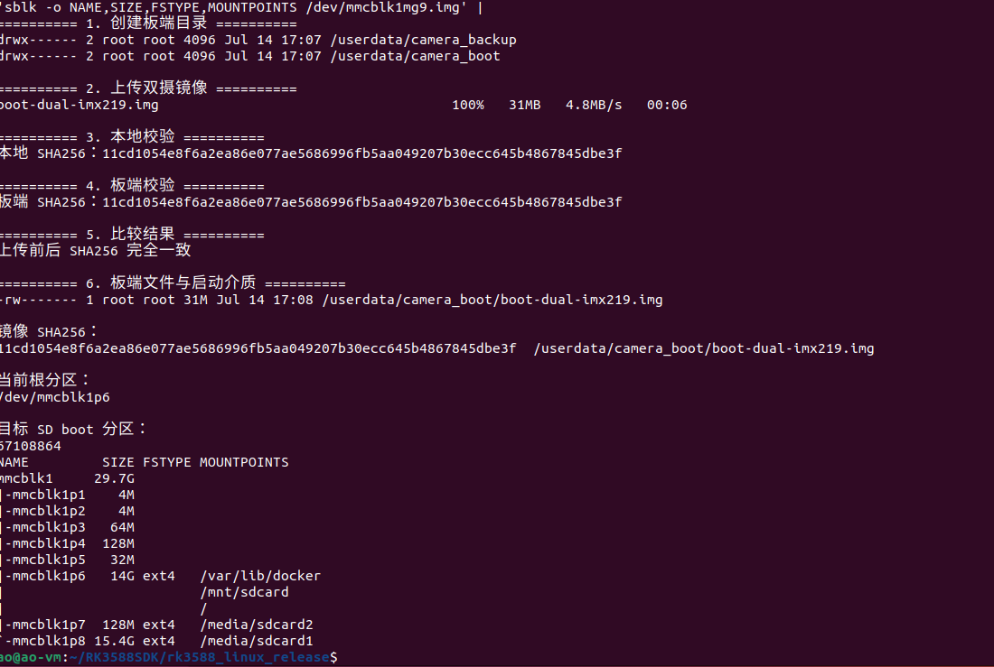
在 Ubuntu 虚拟机终端完整复制：
Plain Text
BOARD_IP="192.168.10.66"
BOARD="root@$BOARD_IP"
SDK_ROOT="/home/ao/RK3588SDK/rk3588_linux_release"
FINAL_BOOT="$SDK_ROOT/output/firmware/boot-dual-imx219.img"
EXPECTED_SHA="11cd1054e8f6a2ea86e077ae5686996fb5aa049207b30ecc645b4867845dbe3f"
echo "========== 1. 创建板端目录 =========="
ssh "$BOARD" '
mkdir -p /userdata/camera_boot
mkdir -p /userdata/camera_backup
ls -ld \
/userdata/camera_boot \
/userdata/camera_backup
'
echo
echo "========== 2. 上传双摄镜像 =========="
scp \
"$FINAL_BOOT" \
"$BOARD:/userdata/camera_boot/boot-dual-imx219.img"
echo
echo "========== 3. 本地校验 =========="
LOCAL_SHA="$(
sha256sum "$FINAL_BOOT" |
awk '{print $1}'
)"
echo "本地 SHA256：$LOCAL_SHA"
echo
echo "========== 4. 板端校验 =========="
REMOTE_SHA="$(
ssh "$BOARD" \
'sha256sum /userdata/camera_boot/boot-dual-imx219.img' |
awk '{print $1}'
)"
echo "板端 SHA256：$REMOTE_SHA"
echo
echo "========== 5. 比较结果 =========="
if [ "$LOCAL_SHA" != "$EXPECTED_SHA" ]; then
echo "错误：本地镜像不是预期镜像"
exit 1
fi
if [ "$REMOTE_SHA" != "$EXPECTED_SHA" ]; then
echo "错误：板端镜像 SHA256 不正确"
exit 1
fi
if [ "$LOCAL_SHA" != "$REMOTE_SHA" ]; then
echo "错误：上传前后镜像不一致"
exit 1
fi
echo "上传前后 SHA256 完全一致"
echo
echo "========== 6. 板端文件与启动介质 =========="
ssh "$BOARD" '
ls -lh /userdata/camera_boot/boot-dual-imx219.img
echo
echo "镜像 SHA256："
sha256sum /userdata/camera_boot/boot-dual-imx219.img
echo
echo "当前根分区："
findmnt -no SOURCE /
echo
echo "目标 SD boot 分区："
blockdev --getsize64 /dev/mmcblk1p3
lsblk -o NAME,SIZE,FSTYPE,MOUNTPOINTS /dev/mmcblk1
'

第五阶段：板端备份并写入 SD 卡
通过 SSH 登录：
Plain Text
ssh "$BOARD"
从这里开始，命令是在 RK3588 板端执行。

1. 检查启动介质和目标分区
整段复制：
Plain Text
echo "========== 当前根文件系统 =========="
ROOT_SOURCE="$(findmnt -no SOURCE /)"
echo "$ROOT_SOURCE"
if [ "$ROOT_SOURCE" != "/dev/mmcblk1p6" ]; then
echo "错误：当前不是从预期 SD 分区 /dev/mmcblk1p6 启动"
echo "禁止继续写入"
exit 1
fi
echo
echo "========== 分区信息 =========="
lsblk -o NAME,SIZE,FSTYPE,MOUNTPOINTS
TARGET_PARTITION="/dev/mmcblk1p3"
IMAGE="/userdata/camera_boot/boot-dual-imx219.img"
test -b "$TARGET_PARTITION" || {
echo "错误：目标分区不存在：$TARGET_PARTITION"
exit 1
}
test -f "$IMAGE" || {
echo "错误：镜像不存在：$IMAGE"
exit 1
}
IMAGE_SIZE="$(stat -c '%s' "$IMAGE")"
PARTITION_SIZE="$(blockdev --getsize64 "$TARGET_PARTITION")"
echo "镜像大小：$IMAGE_SIZE 字节"
echo "分区大小：$PARTITION_SIZE 字节"
if [ "$IMAGE_SIZE" -gt "$PARTITION_SIZE" ]; then
echo "错误：镜像大于目标分区"
exit 1
fi
echo "启动介质与镜像大小检查通过"
你这里必须写：
Plain Text
/dev/mmcblk1p3
不要写：
Plain Text
/dev/mmcblk0p3
mmcblk0p3 是 eMMC 内核分区；官方手册规定 SD 卡内核镜像写入 /dev/mmcblk1p3。

2. 备份当前可用的 CAMERA1 boot 分区
Plain Text
mkdir -p /userdata/camera_backup
BACKUP_IMAGE="/userdata/camera_backup/boot-sd-before-dual-$(date +%Y%m%d-%H%M%S).img"
echo "备份到：$BACKUP_IMAGE"
dd \
if=/dev/mmcblk1p3 \
of="$BACKUP_IMAGE" \
bs=4M \
status=progress \
conv=fsync
sync
检查备份：
Plain Text
ls -lh "$BACKUP_IMAGE"
sha256sum "$BACKUP_IMAGE" \
| tee "${BACKUP_IMAGE}.sha256"
备份应约为：
Plain Text
64 MiB

3. 最后确认镜像
Plain Text
echo "========== 待写入镜像 =========="
ls -lh \
/userdata/camera_boot/boot-dual-imx219.img
sha256sum \
/userdata/camera_boot/boot-dual-imx219.img
echo
echo "========== 当前根分区 =========="
findmnt -no SOURCE /
echo
echo "========== 目标分区 =========="
lsblk -o NAME,SIZE,FSTYPE,MOUNTPOINTS \
/dev/mmcblk1

4. 写入双摄 boot.img
整段复制：
Plain Text
cat > /root/flash_dual_imx219_sd.sh <<'SH'
#!/bin/bash
set -euo pipefail
IMAGE="/userdata/camera_boot/boot-dual-imx219.img"
TARGET="/dev/mmcblk1p3"
EXPECTED_ROOT="/dev/mmcblk1p6"
EXPECTED_SHA="11cd1054e8f6a2ea86e077ae5686996fb5aa049207b30ecc645b4867845dbe3f"
BACKUP_DIR="/userdata/camera_backup"
TIMESTAMP="$(date +%Y%m%d-%H%M%S)"
BACKUP_IMAGE="$BACKUP_DIR/boot-sd-before-dual-$TIMESTAMP.img"
echo "========================================"
echo " TL3588F-EVM 双 IMX219 boot 写入程序"
echo "========================================"
echo
echo "========== 1. 检查启动来源 =========="
ROOT_SOURCE="$(findmnt -no SOURCE /)"
echo "当前根分区：$ROOT_SOURCE"
if [ "$ROOT_SOURCE" != "$EXPECTED_ROOT" ]; then
echo "错误：当前不是从 $EXPECTED_ROOT 启动"
echo "禁止写入，避免误操作 eMMC"
exit 1
fi
echo "启动来源检查通过"
echo
echo "========== 2. 检查目标分区 =========="
test -b "$TARGET" || {
echo "错误：目标分区不存在：$TARGET"
exit 1
}
if findmnt "$TARGET" >/dev/null 2>&1; then
echo "错误：$TARGET 当前已挂载，禁止写入"
exit 1
fi
lsblk -o NAME,SIZE,FSTYPE,MOUNTPOINTS
echo
echo "目标分区：$TARGET"
echo "目标容量：$(blockdev --getsize64 "$TARGET") 字节"
echo
echo "========== 3. 检查双摄镜像 =========="
test -f "$IMAGE" || {
echo "错误：镜像不存在：$IMAGE"
exit 1
}
ls -lh "$IMAGE"
ACTUAL_SHA="$(sha256sum "$IMAGE" | awk '{print $1}')"
echo "预期 SHA256：$EXPECTED_SHA"
echo "实际 SHA256：$ACTUAL_SHA"
if [ "$ACTUAL_SHA" != "$EXPECTED_SHA" ]; then
echo "错误：镜像 SHA256 不一致"
echo "禁止写入"
exit 1
fi
IMAGE_SIZE="$(stat -c '%s' "$IMAGE")"
PARTITION_SIZE="$(blockdev --getsize64 "$TARGET")"
echo "镜像大小：$IMAGE_SIZE 字节"
echo "分区大小：$PARTITION_SIZE 字节"
if [ "$IMAGE_SIZE" -gt "$PARTITION_SIZE" ]; then
echo "错误：镜像大于目标分区"
exit 1
fi
echo "镜像检查通过"
echo
echo "========== 4. 备份当前 boot 分区 =========="
mkdir -p "$BACKUP_DIR"
echo "备份位置：$BACKUP_IMAGE"
dd \
if="$TARGET" \
of="$BACKUP_IMAGE" \
bs=4M \
status=progress \
conv=fsync
sync
BACKUP_SIZE="$(stat -c '%s' "$BACKUP_IMAGE")"
echo "备份文件大小：$BACKUP_SIZE 字节"
if [ "$BACKUP_SIZE" -ne "$PARTITION_SIZE" ]; then
echo "错误：备份文件大小与分区大小不一致"
exit 1
fi
sha256sum "$BACKUP_IMAGE" | tee "${BACKUP_IMAGE}.sha256"
echo "当前 boot 分区备份成功"
echo
echo "========== 5. 最终确认 =========="
echo "镜像：$IMAGE"
echo "目标：$TARGET"
echo "备份：$BACKUP_IMAGE"
echo
echo "即将覆盖 SD 卡 boot 分区。"
echo "请输入 WRITE_SD_BOOT 继续："
read -r CONFIRM
if [ "$CONFIRM" != "WRITE_SD_BOOT" ]; then
echo "输入不匹配，写入已取消"
exit 1
fi
echo
echo "========== 6. 写入双摄 boot.img =========="
dd \
if="$IMAGE" \
of="$TARGET" \
bs=4M \
status=progress \
conv=fsync
sync
blockdev --flushbufs "$TARGET" 2>/dev/null || true
echo
echo "========== 7. 读取分区并校验 =========="
READBACK_SHA="$(
head -c "$IMAGE_SIZE" "$TARGET" |
sha256sum |
awk '{print $1}'
)"
echo "镜像 SHA256：$EXPECTED_SHA"
echo "回读 SHA256：$READBACK_SHA"
if [ "$READBACK_SHA" != "$EXPECTED_SHA" ]; then
echo "错误：写入后的数据校验失败"
echo "暂时不要重启"
exit 1
fi
echo
echo "========================================"
echo "双摄 boot.img 写入并校验成功"
echo "备份文件：$BACKUP_IMAGE"
echo "========================================"
echo
echo "确认两颗 IMX219 排线已经插好后执行："
echo "sync && reboot"
SH
chmod +x /root/flash_dual_imx219_sd.sh
bash -n /root/flash_dual_imx219_sd.sh &&
echo "脚本语法检查通过"

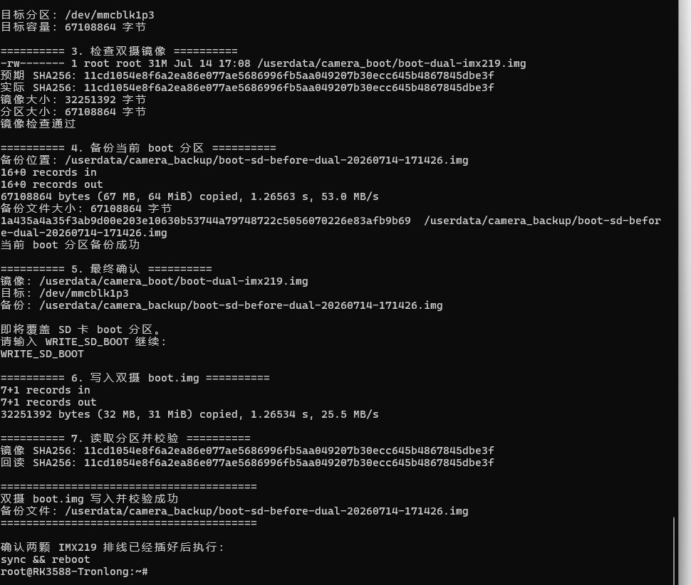

Plain Text
sync
reboot

第六阶段：重启后验证两颗 IMX219
确保两颗摄像头都在断电状态下插好排线，再启动。不要热插拔 MIPI CSI 摄像头。
重新 SSH 登录：
Plain Text
ssh root@你的板子IP

1. 查看系统和设备树
Plain Text
echo "========== 启动来源 =========="
findmnt -no SOURCE /
echo
echo "========== 内核 =========="
uname -a
echo
echo "========== 设备树型号 =========="
tr -d '\0' < /proc/device-tree/model
echo
设备树型号预期：
Plain Text
TL3588F-EVM-CAMERA

2. 检查两颗传感器
Plain Text
echo "========== 两颗 IMX219 =========="
dmesg |
grep -Ei \
'imx219|Model ID|csi2-dphy|mipi[0-9]-csi2|rkcif-mipi|rkisp0-vir' |
tail -n 300
重点寻找：
Plain Text
imx219 1-0010: Model ID 0x0219
imx219 3-0010: Model ID 0x0219
统计传感器：
Plain Text
dmesg |
grep -E \
'imx219 [0-9]+-0010: Model ID'
理想结果是两行：
Plain Text
1-0010 → CAMERA1
3-0010 → CAMERA2

3. 检查 media 和 video 节点
Plain Text
echo "========== MEDIA =========="
ls -l /dev/media* 2>/dev/null
echo
echo "========== CAMERA LINKS =========="
ls -l /dev/video-camera* 2>/dev/null || \
echo "暂未生成 video-camera 软链接"
echo
echo "========== V4L2 DEVICES =========="
v4l2-ctl --list-devices
双摄正常时应出现两套 ISP 管线，通常分别对应：
Plain Text
rkisp0-vir0
rkisp0-vir1
不要只凭 /dev/video11、/dev/video20 之类的数字判断，因为启用双摄后设备编号可能重新排列。

4. 检查媒体拓扑
Plain Text
for MEDIA in /dev/media*; do
[ -e "$MEDIA" ] || continue
echo
echo "========== $MEDIA =========="
media-ctl -p -d "$MEDIA" |
grep -E \
'model|imx219|rkisp_mainpath|rkisp0-vir|rkcif-mipi|device node name'
done
需要确认：
Plain Text
第一颗 IMX219 → rkisp0-vir0 → 一个 rkisp_mainpath
第二颗 IMX219 → rkisp0-vir1 → 另一个 rkisp_mainpath
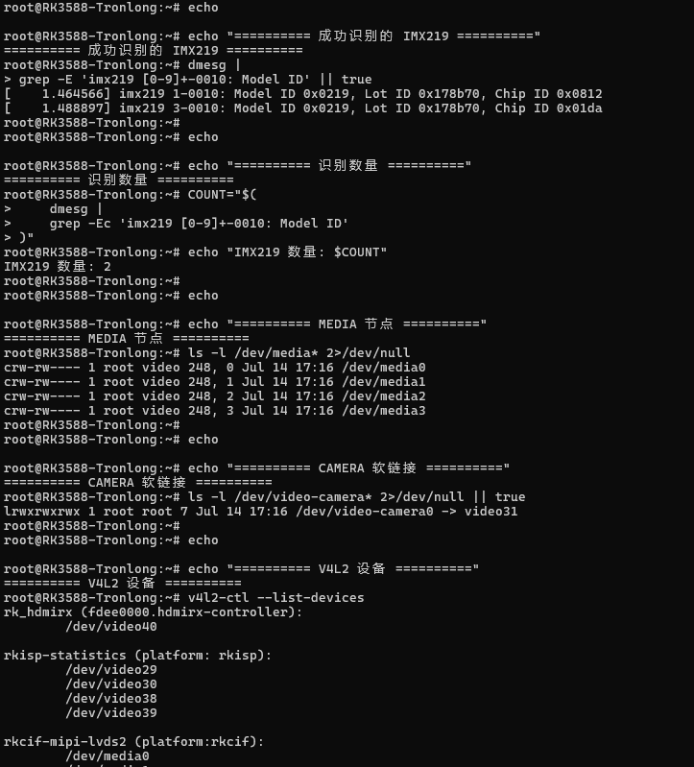

第七阶段：同时采集两路画面
先确认存在：
Plain Text
ls -l /dev/video-camera0 /dev/video-camera1
存在后执行：
Plain Text
mkdir -p /userdata/dual_cam_test
CAM1="/dev/video-camera0"
CAM2="/dev/video-camera1"
rm -f \
/userdata/dual_cam_test/cam1.raw \
/userdata/dual_cam_test/cam2.raw \
/tmp/cam1.log \
/tmp/cam2.log
同时启动两路采集：
Plain Text
v4l2-ctl \
-d "$CAM1" \
--set-fmt-video=width=1920,height=1080,pixelformat=NV12 \
--stream-mmap=4 \
--stream-skip=10 \
--stream-count=1 \
--stream-to=/userdata/dual_cam_test/cam1.raw \
--stream-poll \
> /tmp/cam1.log 2>&1 &
PID1="$!"
v4l2-ctl \
-d "$CAM2" \
--set-fmt-video=width=1920,height=1080,pixelformat=NV12 \
--stream-mmap=4 \
--stream-skip=10 \
--stream-count=1 \
--stream-to=/userdata/dual_cam_test/cam2.raw \
--stream-poll \
> /tmp/cam2.log 2>&1 &
PID2="$!"
wait "$PID1"
RESULT1="$?"
wait "$PID2"
RESULT2="$?"
echo "CAMERA1 返回值：$RESULT1"
echo "CAMERA2 返回值：$RESULT2"
echo
echo "========== CAMERA1 日志 =========="
tail -n 30 /tmp/cam1.log
echo
echo "========== CAMERA2 日志 =========="
tail -n 30 /tmp/cam2.log
echo
echo "========== 文件大小 =========="
ls -lh \
/userdata/dual_cam_test/cam1.raw \
/userdata/dual_cam_test/cam2.raw
stat -c '%n：%s 字节' \
/userdata/dual_cam_test/cam1.raw \
/userdata/dual_cam_test/cam2.raw
两路都应为：
Plain Text
3110400 字节
即：
Plain Text
1920 × 1080 × 1.5 = 3110400

阶段1：双路 IMX219 同时采集
左相机 CAMERA1：/dev/video22
右相机 CAMERA2：/dev/video31
模型：/root/yolov8_rk3588/int8_best.rknn
类别：100- O-O-S

阶段2：左右图分别做 YOLO 空货架检测
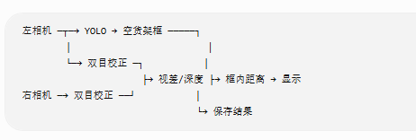
cd /root/yolov8_rk3588
source rknn310/bin/activate
python -u dual_yolov8_rknn_camera.py
实时：http://192.168.10.66:8080/

参数log
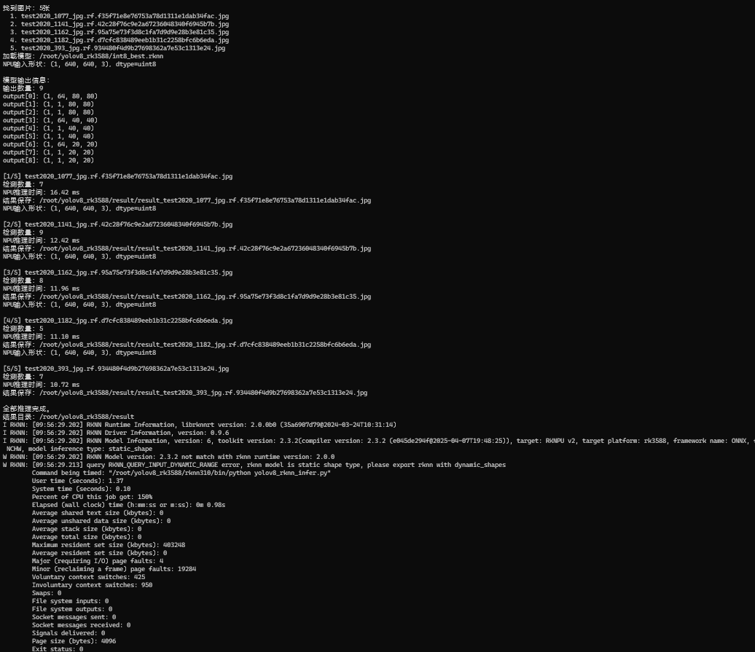

阶段3：双目标定参数
[dual_yolov8_rknn_camera.py]
优化后代码
[20260717-0202-16.4856711.mp4]
加载

阶段4：立体校正与视差计算

阶段5：把目标框中心映射到深度图

阶段6：显示“空货架 + 距离”

第0阶段：恢复生产环境
先检查原双摄镜像还在不在：
Plain Text
ls -lh \
/userdata/camera_boot/boot-dual-imx219.img \
/userdata/camera_backup/* \
2>/dev/null
sha256sum \
/userdata/camera_boot/boot-dual-imx219.img \
2>/dev/null
正确镜像预期 SHA：
Plain Text
11cd1054e8f6a2ea86e077ae5686996fb5aa049207b30ecc645b4867845dbe3f
然后确认启动介质：
Plain Text
findmnt -no SOURCE /
lsblk -o NAME,SIZE,FSTYPE,MOUNTPOINTS
你之前的文档针对 SD 启动明确使用：
Plain Text
根分区：/dev/mmcblk1p6
boot 分区：/dev/mmcblk1p3
并要求写入前备份、检查镜像大小、校验 SHA、写入后回读校验。
不要直接执行未经检查的 dd。优先使用你之前已经生成并通过语法检查的：
Plain Text
/root/flash_dual_imx219_sd.sh
确认文件存在：
Plain Text
test -x /root/flash_dual_imx219_sd.sh && \
echo "恢复脚本存在" || \
echo "恢复脚本不存在"
存在时：
Plain Text
/root/flash_dual_imx219_sd.sh
输入：
Plain Text
WRITE_SD_BOOT
写入并回读校验成功后：
Plain Text
sync
reboot

重要参数

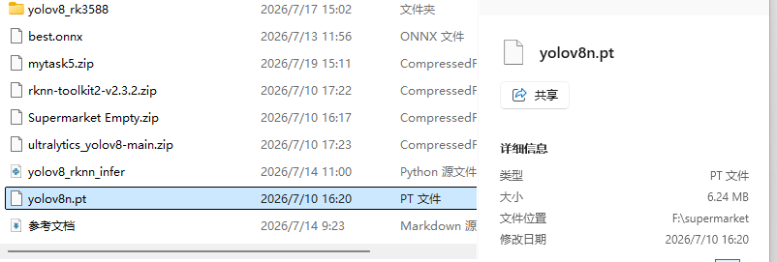
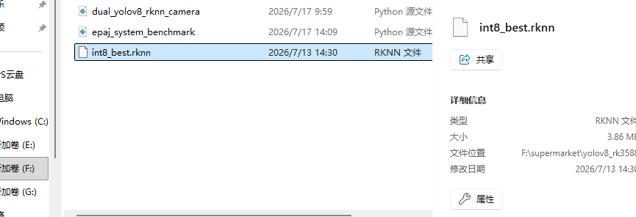

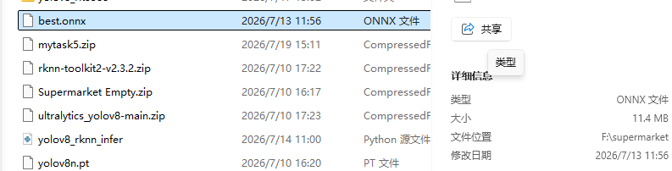

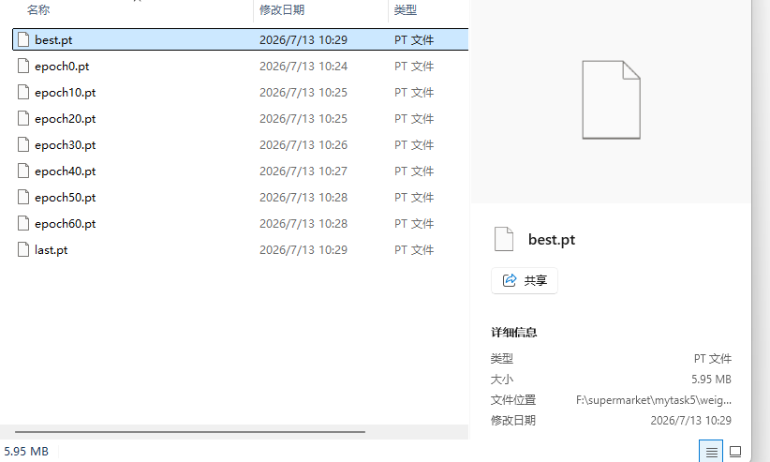

问题文档

摄像头识别不到

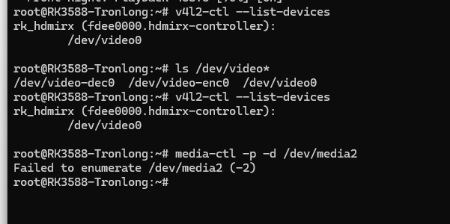

解压sdk容量不足
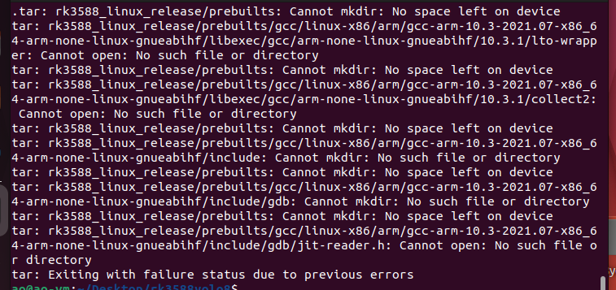
关闭 Ubuntu 虚拟机 → 在虚拟机软件中把虚拟硬盘从 20GB 扩到约 100GB → 启动 Ubuntu → 扩展 sda3 分区 → 扩展 ext4 文件系统 → 重新完整解压 LinuxSDK
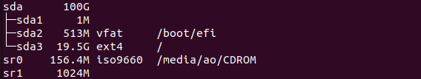
如果没有 growpart，先安装：
Plain Text
sudo apt-get update
sudo apt-get install -y cloud-guest-utils
然后再执行：
Plain Text
sudo growpart /dev/sda 3
sudo resize2fs /dev/sda3
df -hT / lsblk -o NAME,SIZE,FSTYPE,MOUNTPOINTS
