**Name:** Wu Zengfu  
**Admission Number:** p2033457  
**Class:** DIT/FT/2B/21

**Feature 3: Configure Page**

1. The setting icon on the top right of the page is used to toggle the configuration panel, the panel is hidden initially.  
   
2. To open the panel, click on the setting icon.
3. The configuration panel should show with the following configurations:  
    i) Refresh Rate (ms)  
    ii) Duration (min)  
   iii) Bucket Size (sec)  
   iv) Colors of all charts  
   
4. Select a color for arrival-rate chart that is not green  
   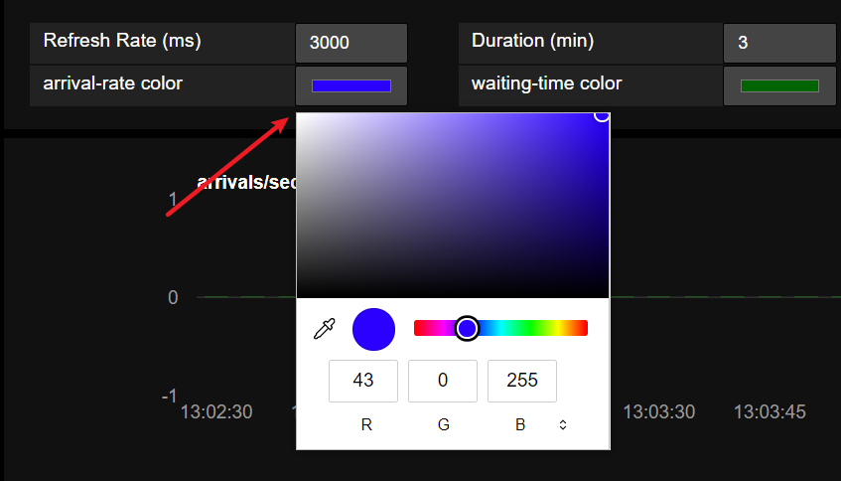
5. The corresponding color will show for arrival-rate chart on next refresh  
   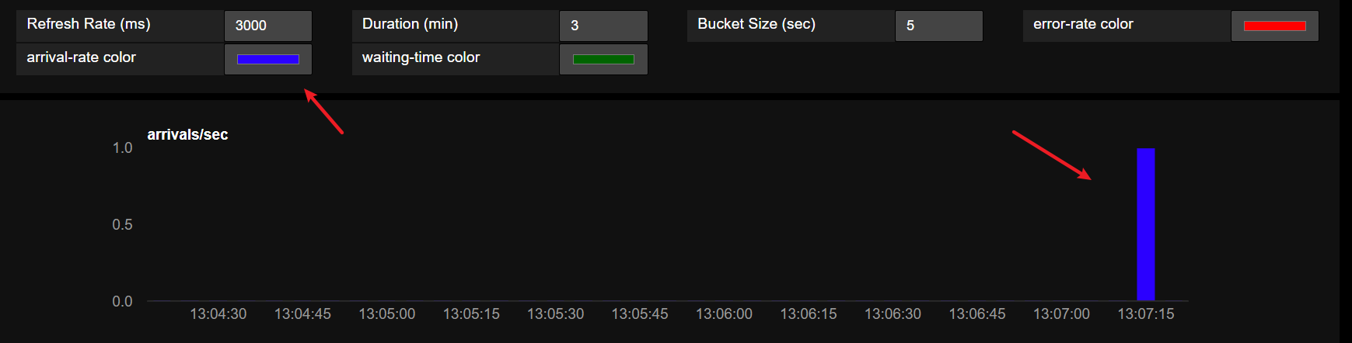
6. Do the same steps for other charts to change colors.
7. Update the refresh rate from 3000 to 200 which causes the chart to refresh every 0.2 seconds. Hence, the refresh icon for each chart will appear at a faster rate.  
   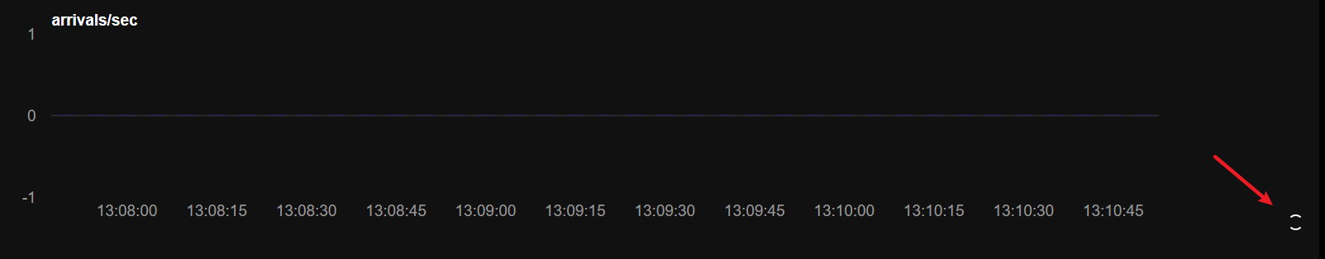
8. Update the duration from 3 to 15 which allows the chart to fetch the data from 15 mins ago.  
   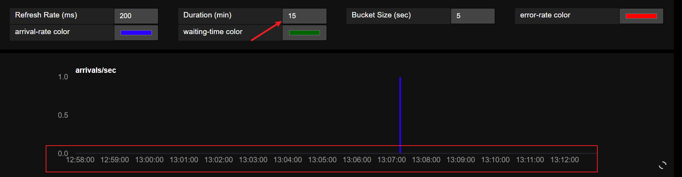
9. Revert refresh rate to 3000 and duration to 3.
10. Send an enqueue request every one second for 10 second. You should be able to see 2-3 bars.  
    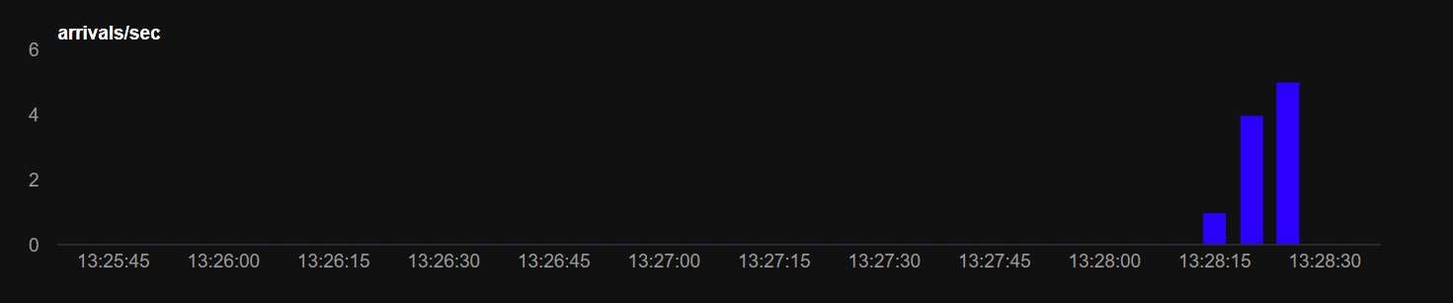
11. Now, change the bucket size to 1. You should be able to see exactly 10 bars  
    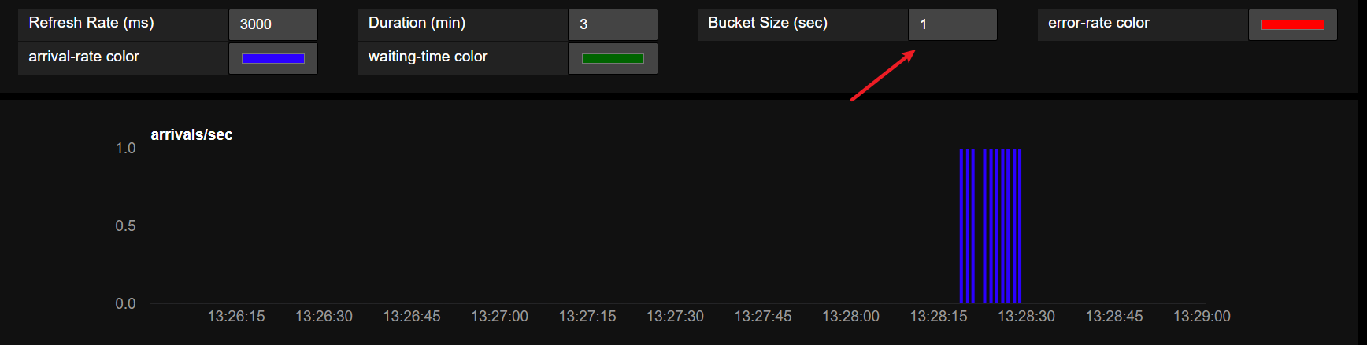
12. We have done the configurations for all, click on the setting icon to close the panel. As such, the panel will be hidden, you may click on the icon again to open if you need to.  
    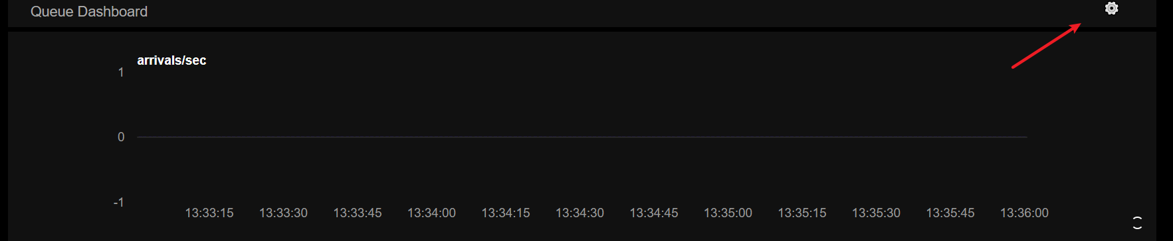
13. As of now, you should be able to configure the following:   
     a. Color of charts  
     b. Refresh Rate  
     c. Duration  
     d. Bucket Size  
     e. Toggle of panel   
      
    * The change of chart color is scalable for new charts, when a new chart is added, the configuration panel should be able to show the corresponding new configuration for that new chart.
14. To test the extendibility of this function:   
     a. In **index.html**, copy the error-rate chart and then create a new chart, rename it as ‘testing-chart’  
    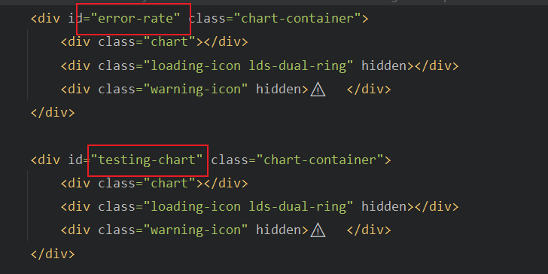  
       
     b. In **charts.mjs**, copy the ‘error-rate’ chart and rename it as ‘testing-chart’. Change the color to the one you like, in this case we will use yellow.  
    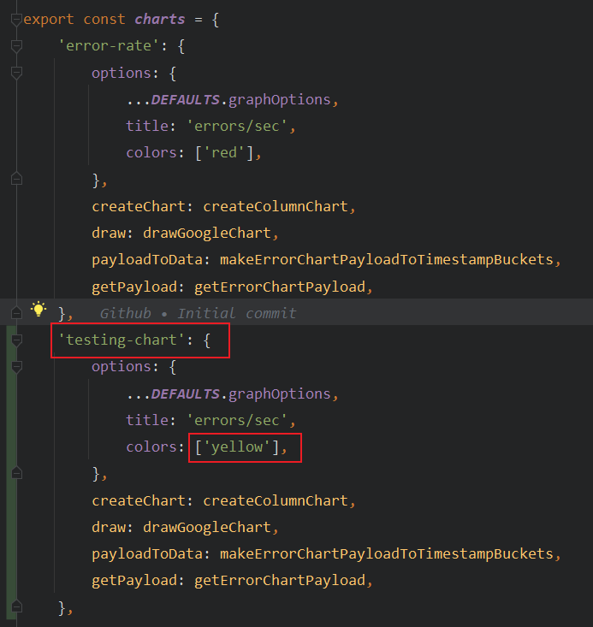

c. Open the website, you will be able to see a new chart is created. You will also see the new color configuration for this chart ‘testing-chart color’ created with the color that you stated in step b.  
 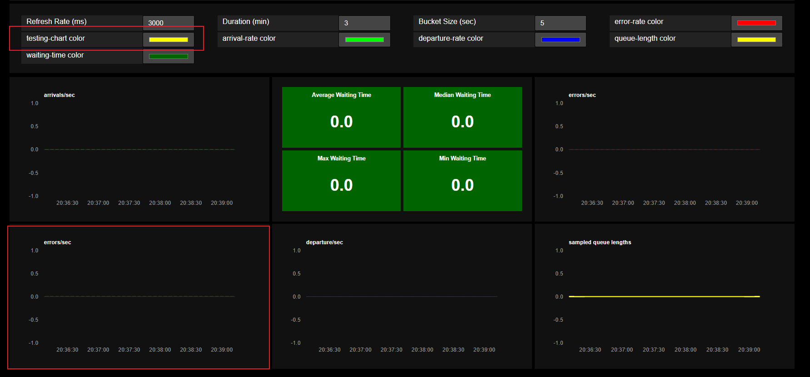

d. Since this chart is copied from error-chart, let’s make some URL NOT FOUND errors to our backend.  
 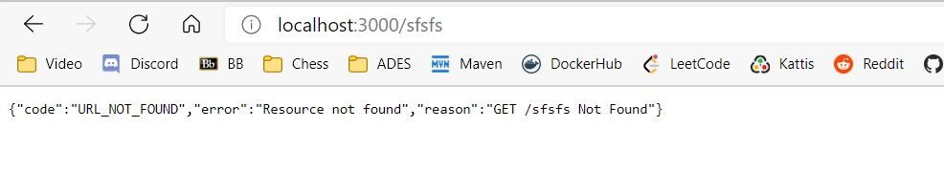  
 e. Go back to our frontend website, you should be able to see some bars appeared in our new chart.  
 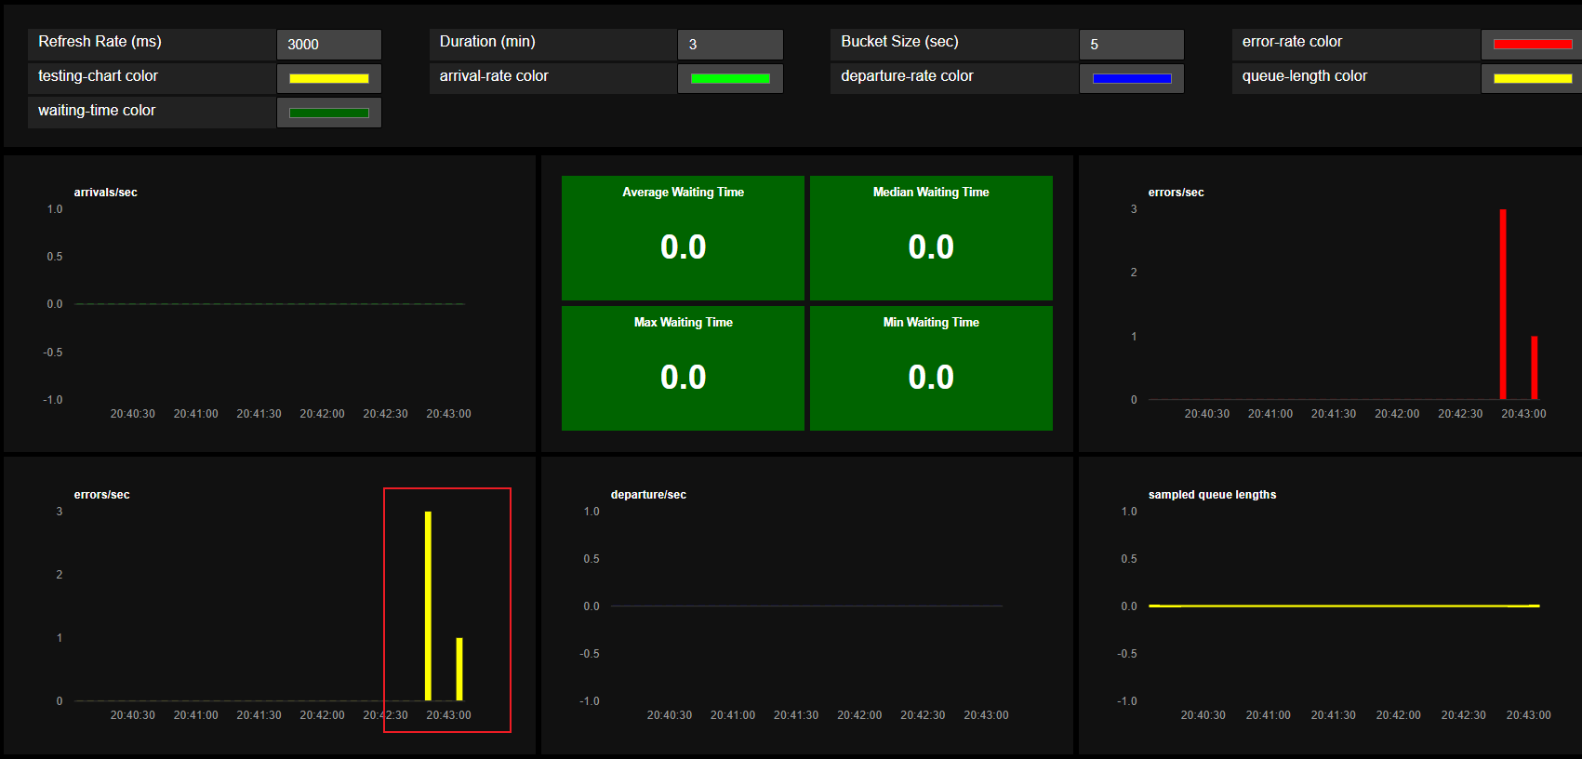

f. Change the color of this bar to [255,255,255], wait for the next refresh, you should be able to see the color has been changed to white!  
 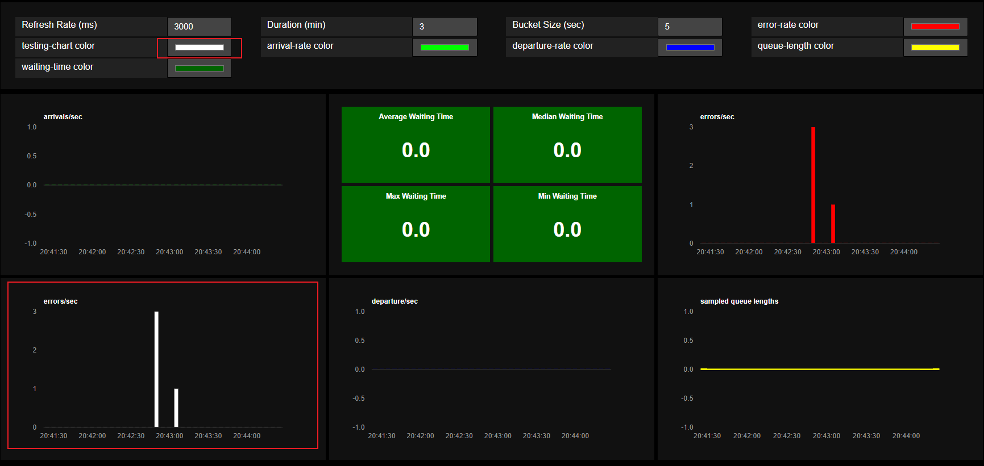

**Name:** Ng Ern Xuan, Malcolm  
**Admission Number:** p2020994  
**Class:** DIT/FT/2B/21

**Feature 6: Fill Page**

1. The expand icon on the top right of each chart is used to toggle the size of it.

1. To expand the chart, click the expand icon.
2. The chart should now have a larger width, only displaying the chart of which the expand icon is clicked, and the expand icon will now change to a minimize icon.

1. Click on the minimize icon, the chart will revert back to it’s original size.

