The Answer of Assignment 2
#COMP 9414
#z5102175
#ZESHI WU

Q1 :

I use the heuristic formula as
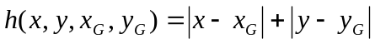
(b)
(i) No, the SLD is not admissible now.
When it moves diagonally, the moves computed by SLD will be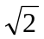 , however, the real moves is 2 as has been defined.

S
G

(ii) No, it is not admissible
the moves computed by heuristic in (Q1a) is 2, more than real moves which is 1, thus it is not admissible.

S
G

(iii) The best admissible heuristic I can devise is that
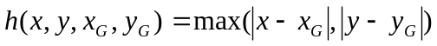

Q2:
(a)
 | Start10 | Start12 | Start20 | Start30 | Start40
UCS | 2565 | Mem | Mem | Mem | Mem
IDS | 2407 | 13812 | 5297410 | Time | Time
A* | 33 | 26 | 915 | Mem | Mem
IDA*(Man) | 29 | 21 | 915 | Mem | Mem
IDA*(Mis) | 35 | 87 | 4345 | 2105465 | Time

(b)
Code for A*Search, with Count Misplaced Tiles Heuristic:
misdist(X/Y, X/Y, H):_
H is 0 , ! .
misdist ( _/_ ,_ /_ , H) :−
H is 1 , ! .
totdist ( [ Tile | Tiles ] , [ Position | Positions ] , D) :−
misdist ( Tiles, Positions , D1 ) ,
totdist ( Tiles , Positions , D2 ) ,
D i s D1 + D2 .

C)
1. UCS finds the cheapest goal provided path cost is monotonically increasing along each path. Thus it is slowest and more likely to run out of memory
2. IDS visits all nodes, which is complete.Thus it easily run out of time. Its time complexity is O(b^{d}).
3. A* is minimize f(n)=h(n)+g(n) according to its algorithm.
It preserve efficiency of Greedy Search but avoid expanding paths that are already expensive. It combines the advantages of UCS and greedy search, thus it faster than the previous two algorithm.
- IDA*(Man) combines the advantages of IDS and A*, thus it is a low-memory variant, which is admissible and the fastest.
- IDA*(Mis) has a greedy heuristic function, therefore it likely run out time due to its algorithm feature.

Q3:
(a)
 | Start 50 |  | Start 60 |  | Start 64
IDA* | 50 | 1462512 | 60 | 321252368 | 64 | 1209086782
1.2 | 52 | 191438 | 62 | 230861 | 66 | 431033
1.4 | 66 | 116174 | 82 | 4432 | 94 | 190278
1.6 | 100 | 33504 | 148 | 55626 | 162 | 235848
1.8 | 240 | 35557 | 314 | 8814 | 344 | 2209
Greedy | 164 | 5447 | 166 | 1617 | 184 | 2174
(b)
Change the following code from idastar.pl :
F1 is G1*H1
To heuristic.pl :
F1 is G1*0.8+ H1*1.2 %W is 1.2.
%F1 is G1*(2-W) + H1*W
%it would produce different result
(c)
As can be seen in (a)
(d)
The speed increases as w increases, since the number of the expanded nodes decrease straightly. However, the results become worse as w increases, because the length of generated path increases. So there is a balance between time and quality.

Q4:
(a)
My game tree of depth 4, where each internal node has exactly 2 children, with values from 0 to 15 for the leaves and in such a way that the alpha-beta algorithm prunes as many nodes as possible:

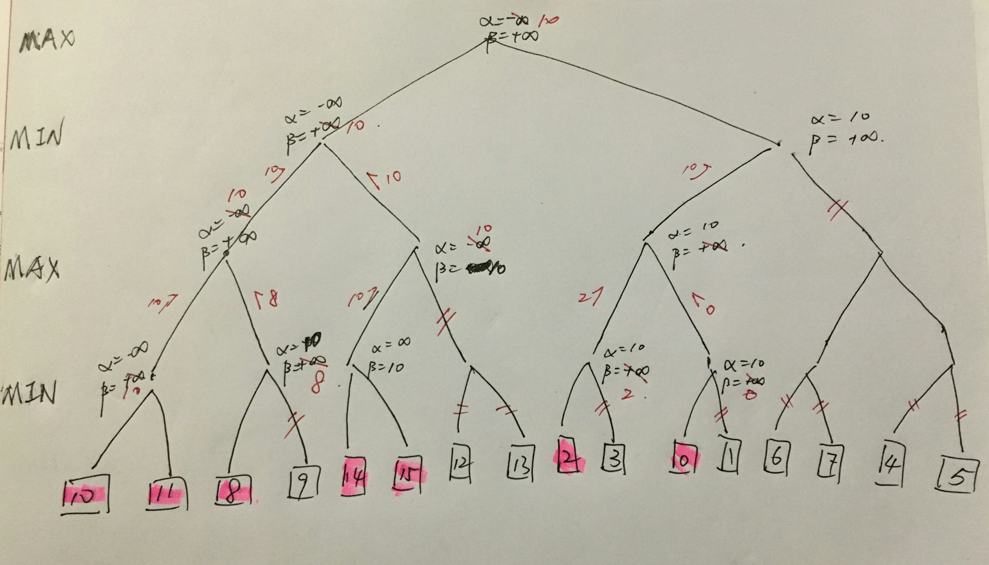
(b)
As can be see in (a). 7 of the original 16 game tree leaves are evaluated while 9 leaves are pruned.

(c)
Shape of pruned game tree of depth 4, where each internal node has exactly 3 children:
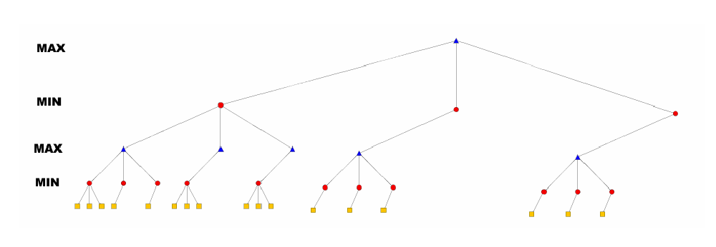
17 of the original 81 game tree leaves are evaluated.

D)
The time complexity is about O(b^{d/2}).
where b = branching factor, d = depth of the tree, O = the limiting behavior of a function when the argument tends towards a particular value or infinity and the base case is when all the preferred nodes are expanded first.
The number of leaf node positions evaluated is about

O(b ∗ 1 ∗ b ∗ 1 ∗ ... ∗ b)
for odd depth and
O(b ∗ 1 ∗ b ∗ 1 ∗ ... ∗ 1)
for even depth, or
Thus , the time complexity is about O(b^{d/2}) in average.

