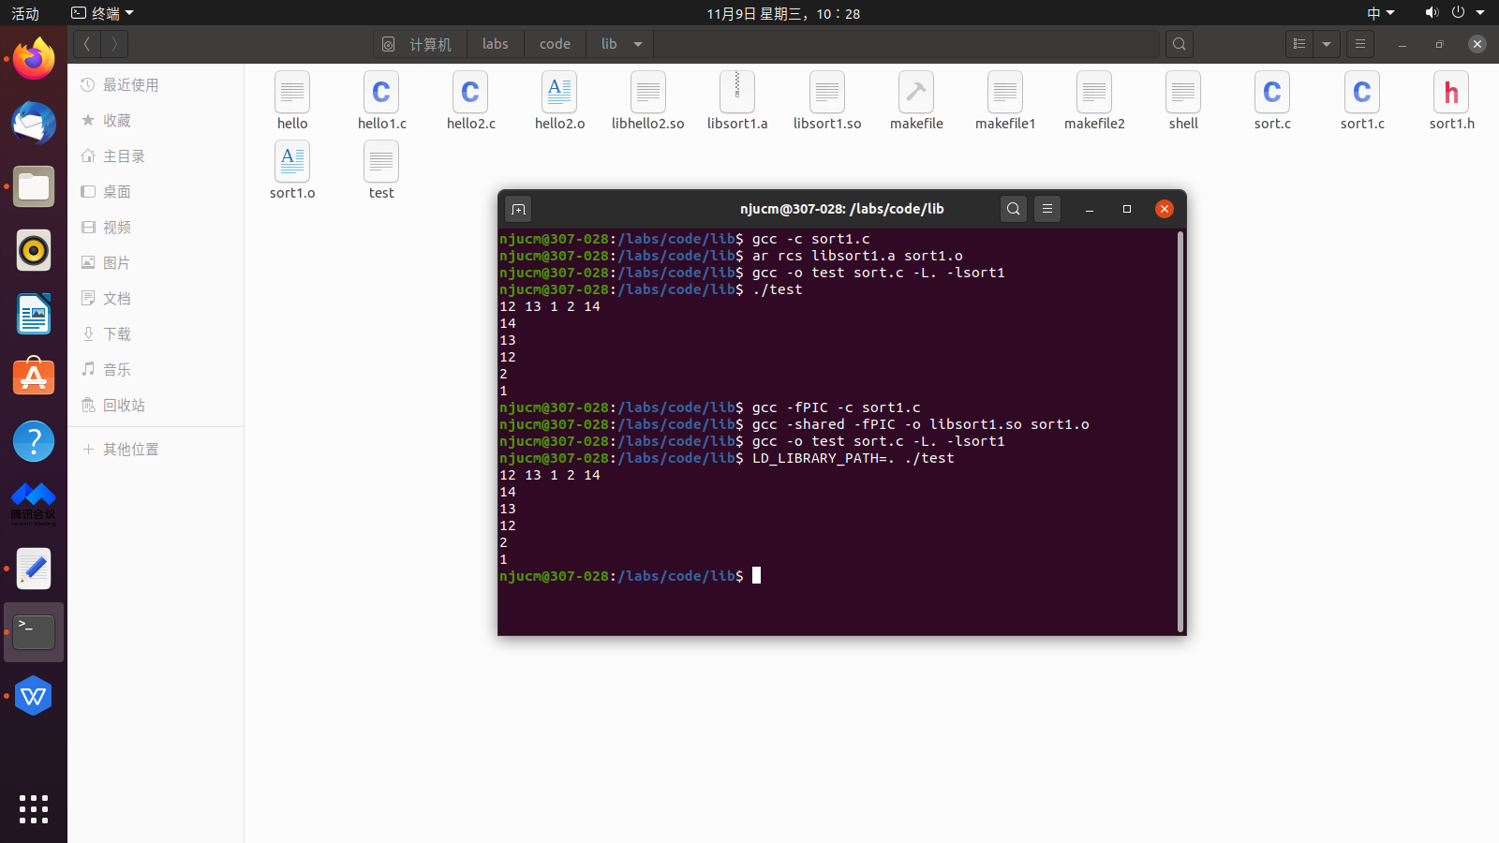

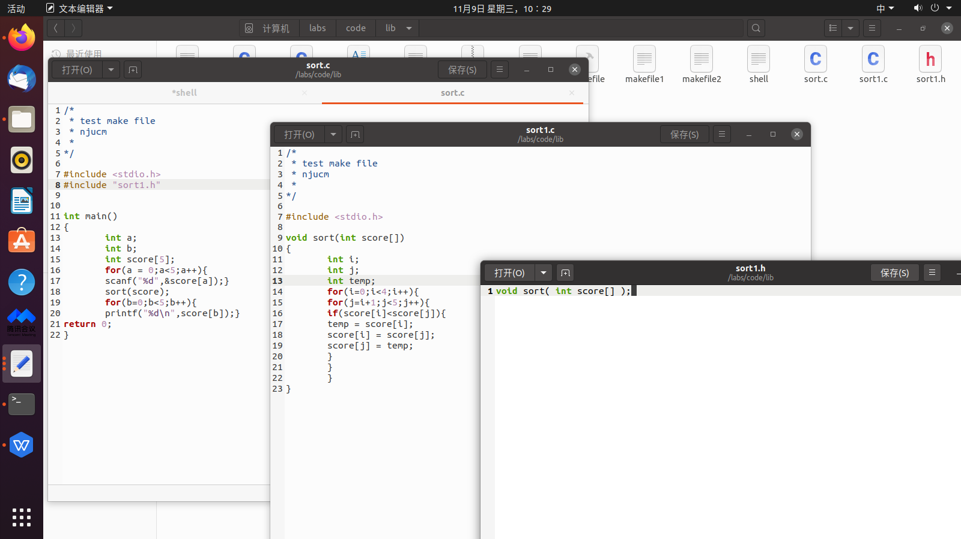

**sort.c**

/*

* test make file

* njucm

*

*/

#include <stdio.h>

#include "sort1.h"

int main()

{

int a;

int b;

int score[5];

for(a = 0;a<5;a++){

scanf("%d",&score[a]);}

sort(score);

for(b=0;b<5;b++){

printf("%d\n",score[b]);}

return 0;

}

**sort1.c**

/*

* test make file

* njucm

*

*/

#include <stdio.h>

void sort(int score[])

{

int i;

int j;

int temp;

for(i=0;i<4;i++){

for(j=i+1;j<5;j++){

if(score[i]<score[j]){

temp = score[i];

score[i] = score[j];

score[j] = temp;

}

}

}

}

**sort1.h**

void sort( int score[] );