**I. Explain the following terms（30~ 40 words for each）（2\*10’）**

1. adolescence

2. crimes

3. laws

4. culture

5. norms

6. folkways

7. socialization

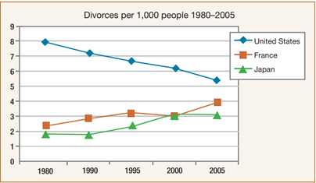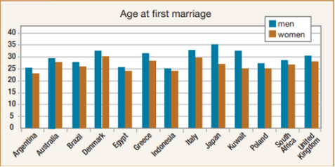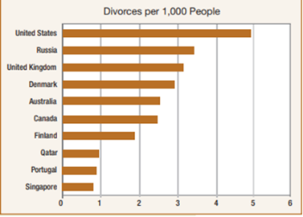**II Describe the changes revealed in the following bar chart with at least 50 words (1\*20’)**

**III Translation (1\*20’)**

1. From parents, teachers, and their peers, boys and girls learn the gender roles. Increasingly today, many parents try to bring up their children in a gender-neutral way. They encourage their sons to express their feelings. They encourage their daughters to be independent. However, parents may find it difficult to bring up their children in a gender-neutral way. They are continually fighting against the gender lessons of television, books, peers and school.
2. Even though scientific studies have shown that there are some biological differences between male and female brains, these differences are too small to explain the difference in boys’ and girls’ achievement. As a result, researchers have looked for other reasons for this gender gap in achievement.
3. Values and norms vary from culture to culture. As a result, some norms and their underlying values may be considered important in one society but not in another. The difference in values and norms can sometimes lead to cross-cultural misunderstandings. Both values and norms may change with time. However, norms for behavior sometimes persist ever after their underlying values have changed.
4. In some societies, a marriage is traditionally a union between families rather than individuals. In many countries, particularly in Asia, arranged marriages are still quite common. This means that the parents decide whom their child will marry. They often choose a young man or woman from the same community with a similar background because they believe this kind of marriage will be successful.

**IV Answer the following question (at least 80 words) (1\*40’)**

1. Use some examples to explain the different ways boys and girls are brought up.
2. Analyze the different family forms in China and explain the major forms of family unit today.
3. Illustrate your idea of the relationship between gender and academic achievement.
4. Try to explain the importance of peer groups for adolescents’ development.