OPC UA Java Stack Test
Software Design Description

Author: Jouni Aro
Date: 19.10.2007
Version: 0.2
Status: Draft

Table of Contents
1. Version history 3
2. Introduction 3
2.1 Identification 3
2.2 System overview 3
2.3 Document overview 4
2.4 References 4
2.5 Abbreviations and Terminology 4
3. Architectural design 5
3.1 TestCase 5
3.2 TestClient 6
3.2.1 Client components 6
3.2.2 Client execution 6
3.3 TestServer 10
3.3.1 TestServer components 10
3.3.2 TestServer execution 11
4. Adding support for new test case types 11
5. Running the tests 12
5.1 Define the tests 12
5.2 Start the server 12
5.3 Start the client 12
5.4 Stop the server 16
5.5 Examine the results 16
6. Known issues 23
6.1 Stack test issues 23
6.2 Java stack (proxy/stub) issues 23

Version history
0.1 | First draft | 19.10.2007 | Jouni Aro
0.2 | Known issues in Java Stack explained in more detail | 19.10.2007 | Jouni Aro

Introduction

Identification
This document describes the design of the OPC UA Java Stack Test applications. The applications are written by Prosys PMS Ltd.
The stack test applications are written to perform the tasks described in the [StackTest Overview], in a similar way to the .NET counterparts. However, a bit different design approach has been taken, to enable more flexible and hopefully reliable development of the applications.
This paragraph shall contain a full identification of the system to which this document applies, including, as applicable, identification number(s), title(s), abbreviation(s), version number(s), and release number(s).

System overview
The stack test is designed to validate that the OPC UA stack implementations transfer data unmodified between the OPC UA client and server applications. It does not veri any client or server specific functionality, or implementation of OPC UA services. Only the different data types and behaviour in certain complicated situations are tested.
The Stack Test system consists of a TestClient and TestServer. They both read the same TestSequence from a shared XML document TestCases.xml. The format of the file is defined in ‘UA Test Definition.xsd’ schema. The TestSequence defines the tests to execute.
The TestSequence consists a number of TestCases, which are defined with certain parameters. The different test case types are defined in [StackTest Overview]. The TestCases consist of a number of iterations, which define how many times the same test is executed. For each iteration different data is used in the call.
The applications use an external PseudoRandom Generator, to get random data to be used for the tests.
The TestClient runs the TestSequence. For each test case, it calls the TestStack (or TestStackEx) service in TestServer with a random input and the server responds with respective random output. They both validate that the data sent over the OC UA stack equals to what they would expect, according to the TestSequence.
Both applications write the test results to a TestLog.xml.
Test Client
Test Server
TestCases.xml
TestLog.xml
TestLog.xml
TestStack requests
TestStack response
Defines the test sequence to run.
The client runs the tests according
to this – and the server expects
the same sequence.
PseudoRandom
Generator
1. The client calls TestStack interface on the server with PseudoRandom data
2. The server verifies the request data
3. The server responds with PseudoRandom data
4. The client verifies the response data
Both applications write log of the results.
PseudoRandom is an external component that can be used in all environments → the tests can also verify cross-platform communications.
Figure 1. Overview of the stack test components.
This paragraph shall briefly state the purpose of the system to which this document applies. It shall describe the general nature of the system; summarize the history of system development, operation, and maintenance; identify the project sponsor, acquirer, user, developer, and support agencies; identify current and planned operating sites; and list other relevant documents.

Document overview
This paragraph shall summarize the purpose and contents of this document and shall describe any security or privacy considerations associated with its use.

References
This section shall list the number, title, revision, and date of all documents referenced in this specification. This section shall also identify the source for all documents.
[StackTest Overview] | Randy Armstrong: UA Stack Test Harness Design Overview, 9.2.2007

Abbreviations and Terminology

Architectural design

TestCase
The different test case types are defined with a hierarchy of classes. The base class is TestCase, but different test case data and behavior is defined by descendant classes.
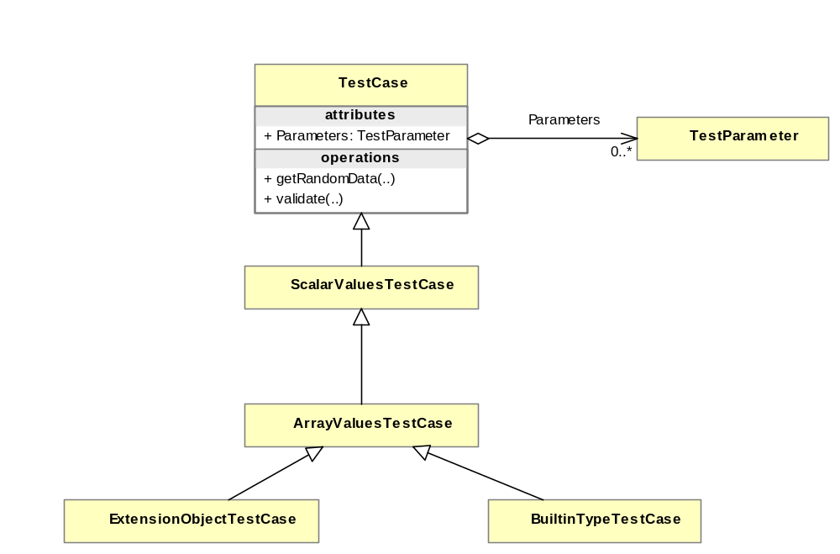
Figure 2. Actual TestCase classes.
The basic tests just override getRandomData to return random data using the specific parameters for that test type (i.e. ScalarValuesTestCase will return random scalar data, whereas ArrayValuesTestCase returns array data).
The classes implemented so far are in the above figure. Each overrides getRandomData to return appropriate data.

TestClient

Client components
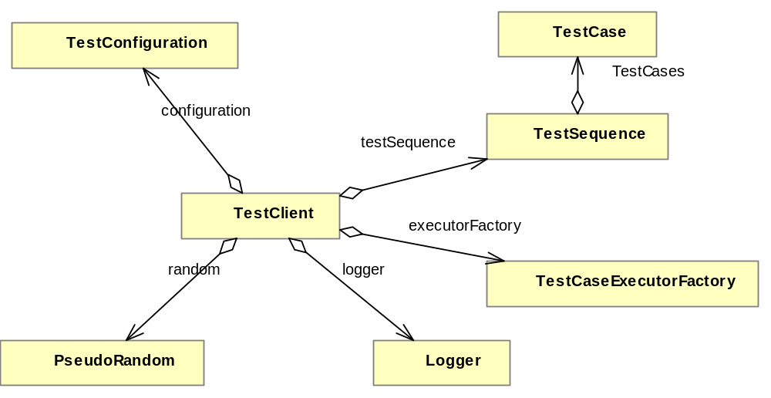
Figure 3. TestClient and its members.

Client execution

TestClient.main
TestClient.main defines the client application as follows:
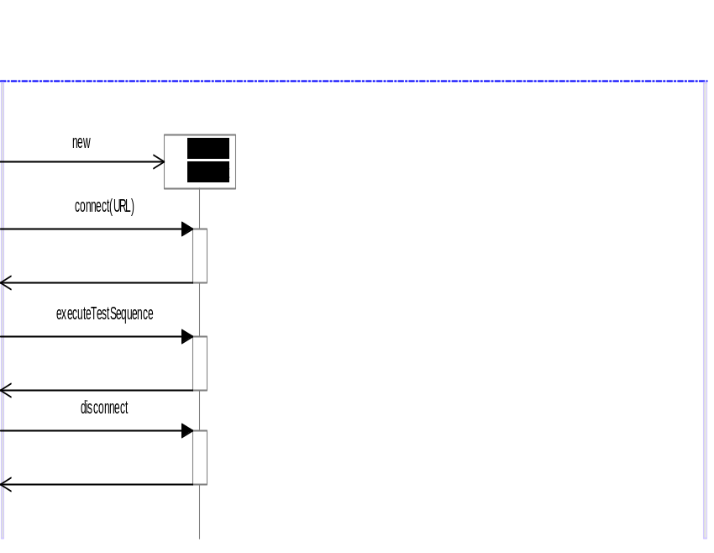
Figure 4. TestClient main.

TestClient initialization
TestClient constructor initializes all the objects., Specifically, it initializes the executorMap, which defines which test case types are supported and which executor to run for each type.
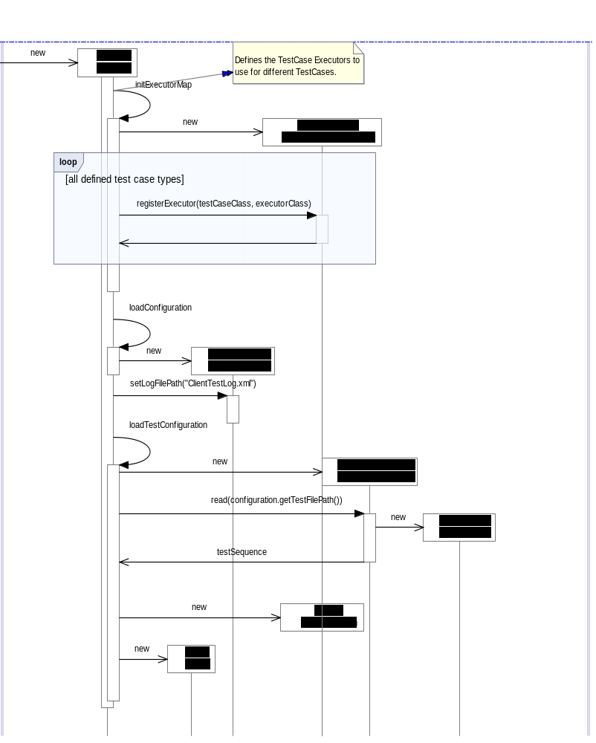
Figure 5. Client inialization.

TestClient.executeTestSequence
After initialization the client connects to the server, and runs executeTestSequence, which will loop through all the testCases. For each test case, it will search for the appropriate executor and then run the iterations using that executor.
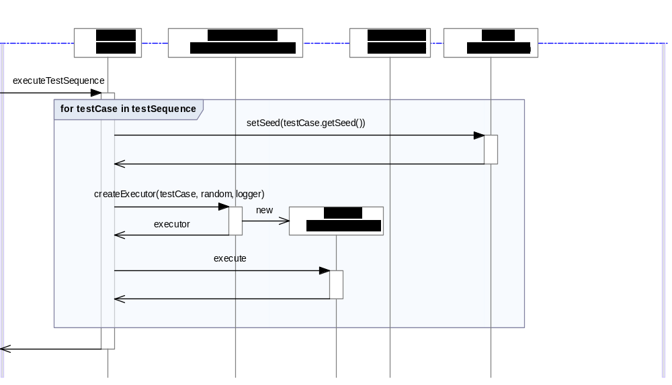
Figure 6. ExecuteTestSequence
The TestCaseExecutor is defined to run the following sequence. The start and end of a test case are notified by special iteration numbers, so that the server can also prepare and end each test case.
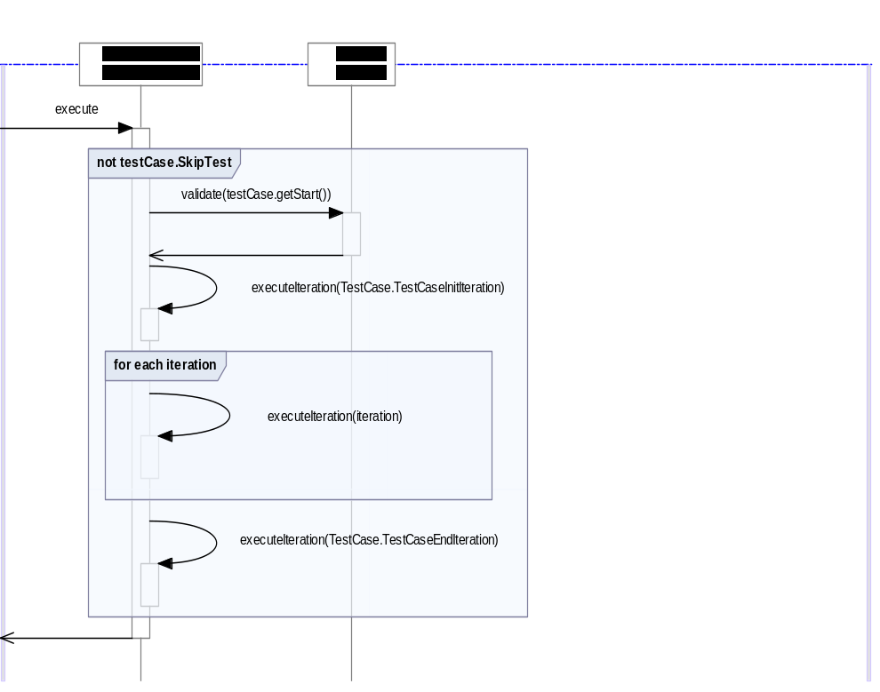
Figure 7. Executing a TestCase with the TestCaseExecutor.
This is the main loop where the test case is executed, one iteration at a time. The base class, TestCaseexecutor defines how the sequence goes. To override the default behaviour for more specific tests, you can override beginIteration, executeIteration and endIteraion, respectively.
The default sequence is as follows
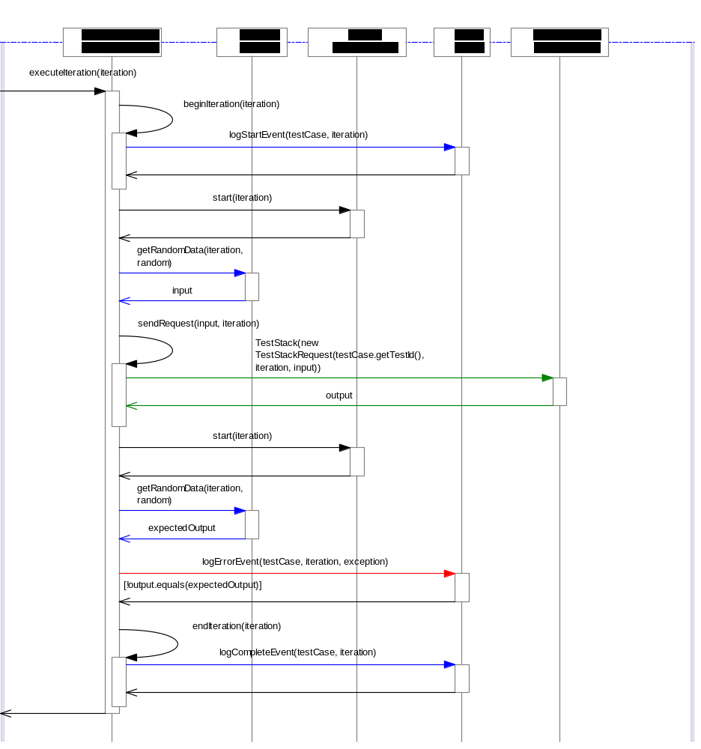
Figure 8. Default iteration sequence.
Note that TestCase is the base class, but the actual test cases will be specific classes, depending on the type of test, as described in section 3. In the default iteration sequence, the key factor is the random data, which is retrieved from the TestCase object.

TestServer

TestServer components
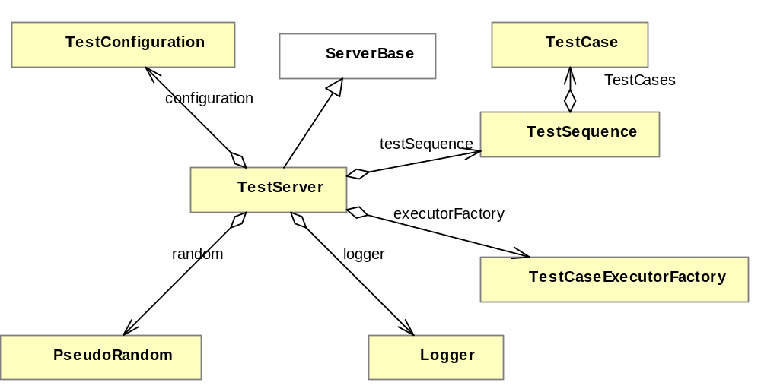
Figure 9. TestServer classes.
The server side is very similar to the client side. Instead of running the test sequence, however, it passively listens to calls to the TestStack and TestStackEx.

TestServer execution
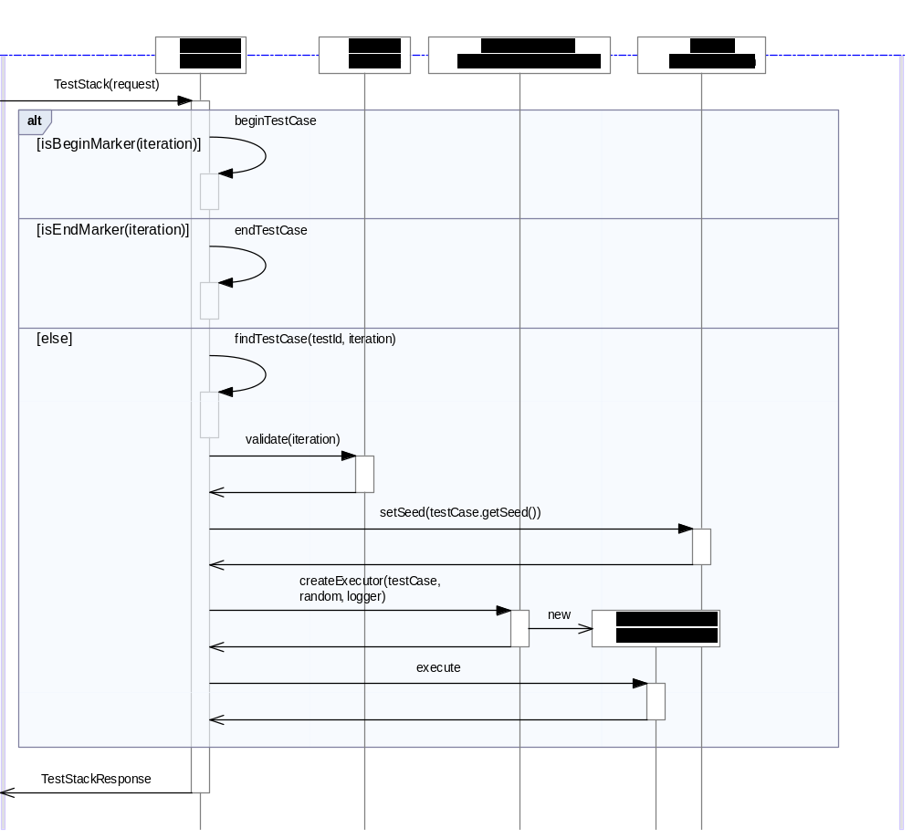
Figure 10. TestServer.TestStack
The request from the client contains enough information so that the server can identify which testCase and which iteration is to be executed. It will then execute a sequence similar to what the client does. The server verifies that the input received from the client equals to expectedInput, which it gets from the same PseudoRandom generator. After that it generates the output, which the client will then validate, when it gets the response back. If the server finds a problem in the test, it will report it to the client as a ServiceResultException, which in the client will be shown in the client console (and log) as
org.opcfoundation.ua.encoding.exception.ServiceFaultException: BadUnexpectedError (0x80080000) "An unexpected error occurred."

Adding support for new test case types
To add a new test case type, a new class must be derived from TestCase. The class name must be exactly defined as <TestCaseName>TestCase, where <TestCaseName> is the value of he respecting Name field in TestCases.xml.
Also it might be necessary to define a custom TestCaseExecutor for the client side and server side. However, at the moment the executorFactory fails to create any other than the standard executory types.

Running the tests

Define the tests
Modify the resources/TestCases.xml.
<?xml version="1.0" encoding="utf-8"?>
<TestSequence xmlns="http://opcfoundation.org/UA/Test" HaltOnError="true" LogDetailLevel="11">
<TestCase>
<Name>ScalarValues</Name>
<Seed>3</Seed>
<Start>0</Start>
<Count>30</Count>
<Parameter>
<Name>MaxStringLength</Name>
<Value>1024</Value>
</Parameter>
</TestCase>
<TestCase>
<Name>ArrayValues</Name>
<Seed>60000</Seed>
<Start>0</Start>
<Count>30</Count>
<Parameter>
<Name>MaxStringLength</Name>
<Value>1024</Value>
</Parameter>
<Parameter>
<Name>MaxArrayLength</Name>
<Value>256</Value>
</Parameter>
</TestCase>
</TestSequence>

Start the server
Run org.opcfoundation.ua.stacktest.server.TestServer. You should see this in the console:
EncodeableFactory: Class org.opcfoundation.ua.encoding.dictionary.UserIdentityToken does not have a NodeId.
EncodeableFactory: Class org.opcfoundation.ua.encoding.dictionary.FilterOperand does not have a NodeId.
EncodeableFactory: Class org.opcfoundation.ua.encoding.dictionary.HistoryReadDetails does not have a NodeId.
EncodeableFactory: Class org.opcfoundation.ua.encoding.dictionary.MonitoringFilter does not have a NodeId.
EncodeableFactory: Class org.opcfoundation.ua.encoding.dictionary.MonitoringFilterResult does not have a NodeId.
log4j:WARN No appenders could be found for logger (org.apache.commons.betwixt.XMLIntrospector).
log4j:WARN Please initialize the log4j system properly.
TestSequence: HaltOnError=false, RandomDataStepSize=7, LogDetailLevel=0xffffffff
TestCase[ID=1]: Name=ScalarValues,Count=30,Seed=3,ResponseSeed=0,Start=0,Parameters:[MaxStringLength=1024];
TestCase[ID=2]: Name=ArrayValues,Count=30,Seed=60000,ResponseSeed=0,Start=0,Parameters:[MaxStringLength=1024];[MaxArrayLength=256];

0: OpcUa_ListenerEvent_Open (Good)
Server open
Supported services: TestStackEx, TestStack
Press enter to exit.

Start the client
Run org.opcfoundation.ua.stacktest.client.TestClient – it will execute the tests. This is a sample output
log4j:WARN No appenders could be found for logger (org.apache.commons.betwixt.XMLIntrospector).
log4j:WARN Please initialize the log4j system properly.
TestSequence: HaltOnError=false, RandomDataStepSize=7, LogDetailLevel=0xffffffff
TestCase[ID=1]: Name=ScalarValues,Count=30,Seed=3,ResponseSeed=0,Start=0,Parameters:[MaxStringLength=1024];
TestCase[ID=2]: Name=ArrayValues,Count=30,Seed=60000,ResponseSeed=0,Start=0,Parameters:[MaxStringLength=1024];[MaxArrayLength=256];

EncodeableFactory: Class org.opcfoundation.ua.encoding.dictionary.UserIdentityToken does not have a NodeId.
EncodeableFactory: Class org.opcfoundation.ua.encoding.dictionary.FilterOperand does not have a NodeId.
EncodeableFactory: Class org.opcfoundation.ua.encoding.dictionary.HistoryReadDetails does not have a NodeId.
EncodeableFactory: Class org.opcfoundation.ua.encoding.dictionary.MonitoringFilter does not have a NodeId.
EncodeableFactory: Class org.opcfoundation.ua.encoding.dictionary.MonitoringFilterResult does not have a NodeId.
TestCase[ID=1]: Name=ScalarValues,Count=30,Seed=3,ResponseSeed=0,Start=0,Parameters:[MaxStringLength=1024];
TestCase[ID=1]: ScalarValues, iteration=0, input=0
TestCase[ID=1]: ScalarValues, iteration=0, output=0
TestCase[ID=1]: ScalarValues, iteration=0, expectedOutput=0
TestCase[ID=1]: ScalarValues, iteration=1, input=AnyValue(null)
TestCase[ID=1]: ScalarValues, iteration=1, output=AnyValue(null)
TestCase[ID=1]: ScalarValues, iteration=1, expectedOutput=AnyValue(null)
TestCase[ID=1]: ScalarValues, iteration=2, input=AnyValue(null)
TestCase[ID=1]: ScalarValues, iteration=2, output=AnyValue(null)
TestCase[ID=1]: ScalarValues, iteration=2, expectedOutput=AnyValue(null)
TestCase[ID=1]: ScalarValues, iteration=3, input=AnyValue(null)
TestCase[ID=1]: ScalarValues, iteration=3, output=AnyValue(null)
TestCase[ID=1]: ScalarValues, iteration=3, expectedOutput=AnyValue(null)
TestCase[ID=1]: ScalarValues, iteration=4, input=AnyValue(null)
TestCase[ID=1]: ScalarValues, iteration=4, output=AnyValue(null)
TestCase[ID=1]: ScalarValues, iteration=4, expectedOutput=AnyValue(null)
TestCase[ID=1]: ScalarValues, iteration=5, input=LA SYYS 01 09:00:00 UTC 2001
TestCase[ID=1]: ScalarValues, iteration=5, org.opcfoundation.ua.encoding.exception.ServiceFaultException: BadUnexpectedError (0x80080000) "An unexpected error occurred."
Diagnostics Info: null
Status code: BadUnexpectedError (0x80080000) "An unexpected error occurred."

TestCase[ID=1]: ScalarValues, iteration=6, input=-1
TestCase[ID=1]: ScalarValues, iteration=6, output=-1
TestCase[ID=1]: ScalarValues, iteration=6, expectedOutput=-1
TestCase[ID=1]: ScalarValues, iteration=7, input=3298368643
TestCase[ID=1]: ScalarValues, iteration=7, output=3298368643
TestCase[ID=1]: ScalarValues, iteration=7, expectedOutput=3298368643
TestCase[ID=1]: ScalarValues, iteration=8, input=2680461596
TestCase[ID=1]: ScalarValues, iteration=8, output=2680461596
TestCase[ID=1]: ScalarValues, iteration=8, expectedOutput=2680461596
TestCase[ID=1]: ScalarValues, iteration=9, input=0.0
TestCase[ID=1]: ScalarValues, iteration=9, output=0.0
TestCase[ID=1]: ScalarValues, iteration=9, expectedOutput=0.0
TestCase[ID=1]: ScalarValues, iteration=10, input=255
TestCase[ID=1]: ScalarValues, iteration=10, output=255
TestCase[ID=1]: ScalarValues, iteration=10, expectedOutput=255
TestCase[ID=1]: ScalarValues, iteration=11, input=9a553c2d-7a87-3701-ab02-0aff7fc47a4f
TestCase[ID=1]: ScalarValues, iteration=11, output=9a553c2d-7a87-3701-ab02-0aff7fc47a4f
TestCase[ID=1]: ScalarValues, iteration=11, expectedOutput=9a553c2d-7a87-3701-ab02-0aff7fc47a4f
TestCase[ID=1]: ScalarValues, iteration=12, input=-32768
TestCase[ID=1]: ScalarValues, iteration=12, output=-32768
TestCase[ID=1]: ScalarValues, iteration=12, expectedOutput=-32768
TestCase[ID=1]: ScalarValues, iteration=13, input=AnyValue(byte[])
TestCase[ID=1]: ScalarValues, iteration=13, org.opcfoundation.ua.encoding.exception.ServiceFaultException: BadUnexpectedError (0x80080000) "An unexpected error occurred."
Diagnostics Info: null
Status code: BadUnexpectedError (0x80080000) "An unexpected error occurred."

TestCase[ID=1]: ScalarValues, iteration=14, input=AnyValue(null)
TestCase[ID=1]: ScalarValues, iteration=14, output=AnyValue(null)
TestCase[ID=1]: ScalarValues, iteration=14, expectedOutput=AnyValue(null)
TestCase[ID=1]: ScalarValues, iteration=15, input=KE HELMI 17 22:29:42 UTC 1982
TestCase[ID=1]: ScalarValues, iteration=15, output=KE HELMI 17 22:29:42 UTC 1982
TestCase[ID=1]: ScalarValues, iteration=15, expectedOutput=KE HELMI 17 22:29:42 UTC 1982
TestCase[ID=1]: ScalarValues, iteration=16, input=Good (0x0) "A pre-defined constant for a Good status."
TestCase[ID=1]: ScalarValues, iteration=16, output=Good (0x0) "A pre-defined constant for a Good status."
TestCase[ID=1]: ScalarValues, iteration=16, expectedOutput=Good (0x0) "A pre-defined constant for a Good status."
TestCase[ID=1]: ScalarValues, iteration=17, input=4294967295
TestCase[ID=1]: ScalarValues, iteration=17, output=4294967295
TestCase[ID=1]: ScalarValues, iteration=17, expectedOutput=4294967295
TestCase[ID=1]: ScalarValues, iteration=18, input=EUL^Q[G)[]WW$:de[4fnuxT1!#~j>I5aSTrQ$]C*jAf)v~v1ty"vihMRChMjLe4O`%?Oa]f;=)O8k2Rt7>ZT&tS,@d'C)^Q&jncqU*-G_<uc)Rh1mc\12TZo`T+ _5qM~V6 -Y(PN.avx+:bDm!{4]M7"bQ_\n.SJc)}NSjP-/ZLGT)MjYJD2=#
TestCase[ID=1]: ScalarValues, iteration=18, output=EUL^Q[G)[]WW$:de[4fnuxT1!#~j>I5aSTrQ$]C*jAf)v~v1ty"vihMRChMjLe4O`%?Oa]f;=)O8k2Rt7>ZT&tS,@d'C)^Q&jncqU*-G_<uc)Rh1mc\12TZo`T+ _5qM~V6 -Y(PN.avx+:bDm!{4]M7"bQ_\n.SJc)}NSjP-/ZLGT)MjYJD2=#
TestCase[ID=1]: ScalarValues, iteration=18, expectedOutput=EUL^Q[G)[]WW$:de[4fnuxT1!#~j>I5aSTrQ$]C*jAf)v~v1ty"vihMRChMjLe4O`%?Oa]f;=)O8k2Rt7>ZT&tS,@d'C)^Q&jncqU*-G_<uc)Rh1mc\12TZo`T+ _5qM~V6 -Y(PN.avx+:bDm!{4]M7"bQ_\n.SJc)}NSjP-/ZLGT)MjYJD2=#
TestCase[ID=1]: ScalarValues, iteration=19, input=AnyValue(null)
TestCase[ID=1]: ScalarValues, iteration=19, output=AnyValue(null)
TestCase[ID=1]: ScalarValues, iteration=19, expectedOutput=AnyValue(null)
TestCase[ID=1]: ScalarValues, iteration=20, input=AnyValue(null)
TestCase[ID=1]: ScalarValues, iteration=20, output=AnyValue(null)
TestCase[ID=1]: ScalarValues, iteration=20, expectedOutput=AnyValue(null)
TestCase[ID=1]: ScalarValues, iteration=21, input=-1
TestCase[ID=1]: ScalarValues, iteration=21, output=-1
TestCase[ID=1]: ScalarValues, iteration=21, expectedOutput=-1
TestCase[ID=1]: ScalarValues, iteration=22, input=AnyValue(null)
TestCase[ID=1]: ScalarValues, iteration=22, output=AnyValue(null)
TestCase[ID=1]: ScalarValues, iteration=22, expectedOutput=AnyValue(null)
TestCase[ID=1]: ScalarValues, iteration=23, input=255
TestCase[ID=1]: ScalarValues, iteration=23, output=255
TestCase[ID=1]: ScalarValues, iteration=23, expectedOutput=255
TestCase[ID=1]: ScalarValues, iteration=24, input=-128
TestCase[ID=1]: ScalarValues, iteration=24, output=-128
TestCase[ID=1]: ScalarValues, iteration=24, expectedOutput=-128
TestCase[ID=1]: ScalarValues, iteration=25, input=-1.1152969711883966E291
TestCase[ID=1]: ScalarValues, iteration=25, output=-1.1152969711883966E291
TestCase[ID=1]: ScalarValues, iteration=25, expectedOutput=-1.1152969711883966E291
TestCase[ID=1]: ScalarValues, iteration=26, java.lang.IllegalArgumentException: value is nullTestCase[ID=1]: ScalarValues, iteration=27, input=1.4E-45
TestCase[ID=1]: ScalarValues, iteration=27, output=1.4E-45
TestCase[ID=1]: ScalarValues, iteration=27, expectedOutput=1.4E-45
TestCase[ID=1]: ScalarValues, iteration=28, input=AnyValue(byte[])
TestCase[ID=1]: ScalarValues, iteration=28, org.opcfoundation.ua.encoding.exception.ServiceFaultException: BadUnexpectedError (0x80080000) "An unexpected error occurred."
Diagnostics Info: null
Status code: BadUnexpectedError (0x80080000) "An unexpected error occurred."

TestCase[ID=1]: ScalarValues, iteration=29, input=2f2044de-d92d-3a09-9e3c-65c5d7d0d389
TestCase[ID=1]: ScalarValues, iteration=29, output=2f2044de-d92d-3a09-9e3c-65c5d7d0d389
TestCase[ID=1]: ScalarValues, iteration=29, expectedOutput=2f2044de-d92d-3a09-9e3c-65c5d7d0d389
TestCase[ID=2]: Name=ArrayValues,Count=30,Seed=60000,ResponseSeed=0,Start=0,Parameters:[MaxStringLength=1024];[MaxArrayLength=256];
TestCase[ID=2]: ArrayValues, iteration=0, input=AnyValue(Guid[])
TestCase[ID=2]: ArrayValues, iteration=0, org.opcfoundation.ua.encoding.exception.ServiceFaultException: BadUnexpectedError (0x80080000) "An unexpected error occurred."
Diagnostics Info: null
Status code: BadUnexpectedError (0x80080000) "An unexpected error occurred."

TestCase[ID=2]: ArrayValues, iteration=1, input=AnyValue(Byte[])
TestCase[ID=2]: ArrayValues, iteration=1, org.opcfoundation.ua.encoding.exception.ServiceFaultException: BadUnexpectedError (0x80080000) "An unexpected error occurred."
Diagnostics Info: null
Status code: BadUnexpectedError (0x80080000) "An unexpected error occurred."

TestCase[ID=2]: ArrayValues, iteration=2, input=AnyValue(Long[])
TestCase[ID=2]: ArrayValues, iteration=2, org.opcfoundation.ua.encoding.exception.ServiceFaultException: BadUnexpectedError (0x80080000) "An unexpected error occurred."
Diagnostics Info: null
Status code: BadUnexpectedError (0x80080000) "An unexpected error occurred."

TestCase[ID=2]: ArrayValues, iteration=3, input=AnyValue(null)
TestCase[ID=2]: ArrayValues, iteration=3, output=AnyValue(null)
TestCase[ID=2]: ArrayValues, iteration=3, expectedOutput=AnyValue(null)
TestCase[ID=2]: ArrayValues, iteration=4, input=AnyValue(Double[])
TestCase[ID=2]: ArrayValues, iteration=4, org.opcfoundation.ua.encoding.exception.ServiceFaultException: BadUnexpectedError (0x80080000) "An unexpected error occurred."
Diagnostics Info: null
Status code: BadUnexpectedError (0x80080000) "An unexpected error occurred."

TestCase[ID=2]: ArrayValues, iteration=5, input=AnyValue(Double[])
TestCase[ID=2]: ArrayValues, iteration=5, org.opcfoundation.ua.encoding.exception.ServiceFaultException: BadUnexpectedError (0x80080000) "An unexpected error occurred."
Diagnostics Info: null
Status code: BadUnexpectedError (0x80080000) "An unexpected error occurred."

TestCase[ID=2]: ArrayValues, iteration=6, input=AnyValue(Guid[])
TestCase[ID=2]: ArrayValues, iteration=6, org.opcfoundation.ua.encoding.exception.ServiceFaultException: BadUnexpectedError (0x80080000) "An unexpected error occurred."
Diagnostics Info: null
Status code: BadUnexpectedError (0x80080000) "An unexpected error occurred."

TestCase[ID=2]: ArrayValues, iteration=7, input=AnyValue(null)
TestCase[ID=2]: ArrayValues, iteration=7, output=AnyValue(null)
TestCase[ID=2]: ArrayValues, iteration=7, expectedOutput=AnyValue(null)
TestCase[ID=2]: ArrayValues, iteration=8, input=AnyValue(Byte[])
TestCase[ID=2]: ArrayValues, iteration=8, org.opcfoundation.ua.encoding.exception.ServiceFaultException: BadUnexpectedError (0x80080000) "An unexpected error occurred."
Diagnostics Info: null
Status code: BadUnexpectedError (0x80080000) "An unexpected error occurred."

TestCase[ID=2]: ArrayValues, iteration=9, input=AnyValue(Byte[])
TestCase[ID=2]: ArrayValues, iteration=9, org.opcfoundation.ua.encoding.exception.ServiceFaultException: BadUnexpectedError (0x80080000) "An unexpected error occurred."
Diagnostics Info: null
Status code: BadUnexpectedError (0x80080000) "An unexpected error occurred."

TestCase[ID=2]: ArrayValues, iteration=10, input=AnyValue(null)
TestCase[ID=2]: ArrayValues, iteration=10, output=AnyValue(null)
TestCase[ID=2]: ArrayValues, iteration=10, expectedOutput=AnyValue(null)
TestCase[ID=2]: ArrayValues, iteration=11, input=AnyValue(UnsignedByte[])
TestCase[ID=2]: ArrayValues, iteration=11, org.opcfoundation.ua.encoding.exception.ServiceFaultException: BadUnexpectedError (0x80080000) "An unexpected error occurred."
Diagnostics Info: null
Status code: BadUnexpectedError (0x80080000) "An unexpected error occurred."

TestCase[ID=2]: ArrayValues, iteration=12, input=AnyValue(Double[])
TestCase[ID=2]: ArrayValues, iteration=12, org.opcfoundation.ua.encoding.exception.ServiceFaultException: BadUnexpectedError (0x80080000) "An unexpected error occurred."
Diagnostics Info: null
Status code: BadUnexpectedError (0x80080000) "An unexpected error occurred."

TestCase[ID=2]: ArrayValues, iteration=13, input=AnyValue(Boolean[])
TestCase[ID=2]: ArrayValues, iteration=13, org.opcfoundation.ua.encoding.exception.ServiceFaultException: BadUnexpectedError (0x80080000) "An unexpected error occurred."
Diagnostics Info: null
Status code: BadUnexpectedError (0x80080000) "An unexpected error occurred."

TestCase[ID=2]: ArrayValues, iteration=14, input=AnyValue(Double[])
TestCase[ID=2]: ArrayValues, iteration=14, org.opcfoundation.ua.encoding.exception.ServiceFaultException: BadUnexpectedError (0x80080000) "An unexpected error occurred."
Diagnostics Info: null
Status code: BadUnexpectedError (0x80080000) "An unexpected error occurred."

TestCase[ID=2]: ArrayValues, iteration=15, input=AnyValue(Long[])
TestCase[ID=2]: ArrayValues, iteration=15, org.opcfoundation.ua.encoding.exception.ServiceFaultException: BadUnexpectedError (0x80080000) "An unexpected error occurred."
Diagnostics Info: null
Status code: BadUnexpectedError (0x80080000) "An unexpected error occurred."

TestCase[ID=2]: ArrayValues, iteration=16, input=AnyValue(null)
TestCase[ID=2]: ArrayValues, iteration=16, output=AnyValue(null)
TestCase[ID=2]: ArrayValues, iteration=16, expectedOutput=AnyValue(null)
TestCase[ID=2]: ArrayValues, iteration=17, input=AnyValue(byte[])
TestCase[ID=2]: ArrayValues, iteration=17, org.opcfoundation.ua.encoding.exception.ServiceFaultException: BadUnexpectedError (0x80080000) "An unexpected error occurred."
Diagnostics Info: null
Status code: BadUnexpectedError (0x80080000) "An unexpected error occurred."

TestCase[ID=2]: ArrayValues, iteration=18, input=AnyValue(UnsignedShort[])
TestCase[ID=2]: ArrayValues, iteration=18, org.opcfoundation.ua.encoding.exception.ServiceFaultException: BadUnexpectedError (0x80080000) "An unexpected error occurred."
Diagnostics Info: null
Status code: BadUnexpectedError (0x80080000) "An unexpected error occurred."

TestCase[ID=2]: ArrayValues, iteration=19, input=AnyValue(Integer[])
TestCase[ID=2]: ArrayValues, iteration=19, org.opcfoundation.ua.encoding.exception.ServiceFaultException: BadUnexpectedError (0x80080000) "An unexpected error occurred."
Diagnostics Info: null
Status code: BadUnexpectedError (0x80080000) "An unexpected error occurred."

TestCase[ID=2]: ArrayValues, iteration=20, input=AnyValue(Integer[])
TestCase[ID=2]: ArrayValues, iteration=20, org.opcfoundation.ua.encoding.exception.ServiceFaultException: BadUnexpectedError (0x80080000) "An unexpected error occurred."
Diagnostics Info: null
Status code: BadUnexpectedError (0x80080000) "An unexpected error occurred."

TestCase[ID=2]: ArrayValues, iteration=21, input=AnyValue(UnsignedByte[])
TestCase[ID=2]: ArrayValues, iteration=21, org.opcfoundation.ua.encoding.exception.ServiceFaultException: BadUnexpectedError (0x80080000) "An unexpected error occurred."
Diagnostics Info: null
Status code: BadUnexpectedError (0x80080000) "An unexpected error occurred."

TestCase[ID=2]: ArrayValues, iteration=22, input=AnyValue(UnsignedShort[])
TestCase[ID=2]: ArrayValues, iteration=22, org.opcfoundation.ua.encoding.exception.ServiceFaultException: BadUnexpectedError (0x80080000) "An unexpected error occurred."
Diagnostics Info: null
Status code: BadUnexpectedError (0x80080000) "An unexpected error occurred."

TestCase[ID=2]: ArrayValues, iteration=23, input=(null)
TestCase[ID=2]: ArrayValues, iteration=23, org.opcfoundation.ua.encoding.exception.ServiceFaultException: BadUnexpectedError (0x80080000) "An unexpected error occurred."
Diagnostics Info: null
Status code: BadUnexpectedError (0x80080000) "An unexpected error occurred."

TestCase[ID=2]: ArrayValues, iteration=24, input=AnyValue(null)
TestCase[ID=2]: ArrayValues, iteration=24, output=AnyValue(null)
TestCase[ID=2]: ArrayValues, iteration=24, expectedOutput=AnyValue(null)
TestCase[ID=2]: ArrayValues, iteration=25, input=AnyValue(Guid[])
TestCase[ID=2]: ArrayValues, iteration=25, org.opcfoundation.ua.encoding.exception.ServiceFaultException: BadUnexpectedError (0x80080000) "An unexpected error occurred."
Diagnostics Info: null
Status code: BadUnexpectedError (0x80080000) "An unexpected error occurred."

TestCase[ID=2]: ArrayValues, iteration=26, input=AnyValue(DateTime[])
TestCase[ID=2]: ArrayValues, iteration=26, org.opcfoundation.ua.encoding.exception.ServiceFaultException: BadUnexpectedError (0x80080000) "An unexpected error occurred."
Diagnostics Info: null
Status code: BadUnexpectedError (0x80080000) "An unexpected error occurred."

TestCase[ID=2]: ArrayValues, iteration=27, input=AnyValue(Float[])
TestCase[ID=2]: ArrayValues, iteration=27, org.opcfoundation.ua.encoding.exception.ServiceFaultException: BadUnexpectedError (0x80080000) "An unexpected error occurred."
Diagnostics Info: null
Status code: BadUnexpectedError (0x80080000) "An unexpected error occurred."

TestCase[ID=2]: ArrayValues, iteration=28, input=AnyValue(UnsignedByte[])
TestCase[ID=2]: ArrayValues, iteration=28, org.opcfoundation.ua.encoding.exception.ServiceFaultException: BadUnexpectedError (0x80080000) "An unexpected error occurred."
Diagnostics Info: null
Status code: BadUnexpectedError (0x80080000) "An unexpected error occurred."

TestCase[ID=2]: ArrayValues, iteration=29, input=AnyValue(Short[])
TestCase[ID=2]: ArrayValues, iteration=29, org.opcfoundation.ua.encoding.exception.ServiceFaultException: BadUnexpectedError (0x80080000) "An unexpected error occurred."
Diagnostics Info: null
Status code: BadUnexpectedError (0x80080000) "An unexpected error occurred."

|2136| P_OpenSSL - SeedPRNG
|2136| P_WinCrypt - Initialize
|2136| P_PKIFactory - CreatePKIProvider
|2136| P_OpenSSL - PKI_OpenCertificateStore
|2136| P_OpenSSL - PKI_LoadCertificate
|2136| P_OpenSSL - PKI_LoadCertificate
|2136| P_OpenSSL - PKI_CloseCertificateStore
|2136| P_PKIFactory - DeletePKIProvider
|2136| P_PKIFactory - CreatePKIProvider
|1684| P_CryptoFactory - CreateCryptoProvider
|2136| P_PKIFactory - DeletePKIProvider
|2136| P_CryptoFactory - DeleteCryptoProvider
|304| P_WinCrypt - Cleanup

Stop the server
Press enter in the TestServer console.

Examine the results
Both applications write to the console and to TestLog.xml. Here is a sample of the console output from the server after the tests:
EncodeableFactory: Class org.opcfoundation.ua.encoding.dictionary.UserIdentityToken does not have a NodeId.
EncodeableFactory: Class org.opcfoundation.ua.encoding.dictionary.FilterOperand does not have a NodeId.
EncodeableFactory: Class org.opcfoundation.ua.encoding.dictionary.HistoryReadDetails does not have a NodeId.
EncodeableFactory: Class org.opcfoundation.ua.encoding.dictionary.MonitoringFilter does not have a NodeId.
EncodeableFactory: Class org.opcfoundation.ua.encoding.dictionary.MonitoringFilterResult does not have a NodeId.
log4j:WARN No appenders could be found for logger (org.apache.commons.betwixt.XMLIntrospector).
log4j:WARN Please initialize the log4j system properly.
TestSequence: HaltOnError=false, RandomDataStepSize=7, LogDetailLevel=0xffffffff
TestCase[ID=1]: Name=ScalarValues,Count=30,Seed=3,ResponseSeed=0,Start=0,Parameters:[MaxStringLength=1024];
TestCase[ID=2]: Name=ArrayValues,Count=30,Seed=60000,ResponseSeed=0,Start=0,Parameters:[MaxStringLength=1024];[MaxArrayLength=256];

0: OpcUa_ListenerEvent_Open (Good)
Server open
Supported services: TestStackEx, TestStack
Press enter to exit.
1: org.opcfoundation.ua.transport.EndpointSecureChannelEvent
TestCase[ID=1]: ScalarValues, iteration=0, input=0
TestCase[ID=1]: ScalarValues, iteration=0, expectedInput=0
TestCase[ID=1]: ScalarValues, iteration=0, output=0
TestCase[ID=1]: ScalarValues, iteration=1, input=AnyValue(null)
TestCase[ID=1]: ScalarValues, iteration=1, expectedInput=AnyValue(null)
TestCase[ID=1]: ScalarValues, iteration=1, output=AnyValue(null)
TestCase[ID=1]: ScalarValues, iteration=2, input=AnyValue(null)
TestCase[ID=1]: ScalarValues, iteration=2, expectedInput=AnyValue(null)
TestCase[ID=1]: ScalarValues, iteration=2, output=AnyValue(null)
TestCase[ID=1]: ScalarValues, iteration=3, input=AnyValue(null)
TestCase[ID=1]: ScalarValues, iteration=3, expectedInput=AnyValue(null)
TestCase[ID=1]: ScalarValues, iteration=3, output=AnyValue(null)
TestCase[ID=1]: ScalarValues, iteration=4, input=AnyValue(null)
TestCase[ID=1]: ScalarValues, iteration=4, expectedInput=AnyValue(null)
TestCase[ID=1]: ScalarValues, iteration=4, output=AnyValue(null)
TestCase[ID=1]: ScalarValues, iteration=5, input=LA SYYS 01 09:00:00 UTC 2001
TestCase[ID=1]: ScalarValues, iteration=5, expectedInput=LA SYYS 01 09:00:00 UTC 2001
java.lang.RuntimeException: java.lang.reflect.InvocationTargetException
at org.opcfoundation.ua.encoding.services.server.ServiceDefinition$1.invokeService(ServiceDefinition.java:125)
at org.opcfoundation.ua.encoding.services.server.ServerBase$1.handleServiceRequest(ServerBase.java:69)
at org.opcfoundation.ua.encoding.services.endpoint.EndpointService$1.handleServiceRequest(EndpointService.java:102)
at org.opcfoundation.ua.transport.hybrid.Endpoint.onNotify(Endpoint.java:176)
Caused by: java.lang.reflect.InvocationTargetException
at sun.reflect.NativeMethodAccessorImpl.invoke0(Native Method)
at sun.reflect.NativeMethodAccessorImpl.invoke(Unknown Source)
at sun.reflect.DelegatingMethodAccessorImpl.invoke(Unknown Source)
at java.lang.reflect.Method.invoke(Unknown Source)
at org.opcfoundation.ua.encoding.services.server.ServiceDefinition$1.invokeService(ServiceDefinition.java:119)
... 3 more
Caused by: org.opcfoundation.ua.core.exceptions.ServiceResultException: BadUnexpectedError (0x80080000) "Test ScalarValues, Iteration 5 Failed: org.opcfoundation.ua.stacktest.exception.TestCaseException: Input 'LA SYYS 01 09:00:00 UTC 2001' is not equal to Expected Input 'LA SYYS 01 09:00:00 UTC 2001'."
at org.opcfoundation.ua.stacktest.server.TestServer.error(TestServer.java:114)
at org.opcfoundation.ua.stacktest.server.TestServer.TestStack(TestServer.java:240)
... 8 more
TestCase[ID=1]: ScalarValues, iteration=6, input=-1
TestCase[ID=1]: ScalarValues, iteration=6, expectedInput=-1
TestCase[ID=1]: ScalarValues, iteration=6, output=-1
TestCase[ID=1]: ScalarValues, iteration=7, input=3298368643
TestCase[ID=1]: ScalarValues, iteration=7, expectedInput=3298368643
TestCase[ID=1]: ScalarValues, iteration=7, output=3298368643
TestCase[ID=1]: ScalarValues, iteration=8, input=2680461596
TestCase[ID=1]: ScalarValues, iteration=8, expectedInput=2680461596
TestCase[ID=1]: ScalarValues, iteration=8, output=2680461596
TestCase[ID=1]: ScalarValues, iteration=9, input=0.0
TestCase[ID=1]: ScalarValues, iteration=9, expectedInput=0.0
TestCase[ID=1]: ScalarValues, iteration=9, output=0.0
TestCase[ID=1]: ScalarValues, iteration=10, input=255
TestCase[ID=1]: ScalarValues, iteration=10, expectedInput=255
TestCase[ID=1]: ScalarValues, iteration=10, output=255
TestCase[ID=1]: ScalarValues, iteration=11, input=9a553c2d-7a87-3701-ab02-0aff7fc47a4f
TestCase[ID=1]: ScalarValues, iteration=11, expectedInput=9a553c2d-7a87-3701-ab02-0aff7fc47a4f
TestCase[ID=1]: ScalarValues, iteration=11, output=9a553c2d-7a87-3701-ab02-0aff7fc47a4f
TestCase[ID=1]: ScalarValues, iteration=12, input=-32768
TestCase[ID=1]: ScalarValues, iteration=12, expectedInput=-32768
TestCase[ID=1]: ScalarValues, iteration=12, output=-32768
TestCase[ID=1]: ScalarValues, iteration=13, input=AnyValue(byte[])
TestCase[ID=1]: ScalarValues, iteration=13, expectedInput=AnyValue(byte[])
java.lang.RuntimeException: java.lang.reflect.InvocationTargetException
at org.opcfoundation.ua.encoding.services.server.ServiceDefinition$1.invokeService(ServiceDefinition.java:125)
at org.opcfoundation.ua.encoding.services.server.ServerBase$1.handleServiceRequest(ServerBase.java:69)
at org.opcfoundation.ua.encoding.services.endpoint.EndpointService$1.handleServiceRequest(EndpointService.java:102)
at org.opcfoundation.ua.transport.hybrid.Endpoint.onNotify(Endpoint.java:176)
Caused by: java.lang.reflect.InvocationTargetException
at sun.reflect.NativeMethodAccessorImpl.invoke0(Native Method)
at sun.reflect.NativeMethodAccessorImpl.invoke(Unknown Source)
at sun.reflect.DelegatingMethodAccessorImpl.invoke(Unknown Source)
at java.lang.reflect.Method.invoke(Unknown Source)
at org.opcfoundation.ua.encoding.services.server.ServiceDefinition$1.invokeService(ServiceDefinition.java:119)
... 3 more
Caused by: org.opcfoundation.ua.core.exceptions.ServiceResultException: BadUnexpectedError (0x80080000) "Test ScalarValues, Iteration 13 Failed: org.opcfoundation.ua.stacktest.exception.TestCaseException: Input 'AnyValue(byte[])' is not equal to Expected Input 'AnyValue(byte[])'."
at org.opcfoundation.ua.stacktest.server.TestServer.error(TestServer.java:114)
at org.opcfoundation.ua.stacktest.server.TestServer.TestStack(TestServer.java:240)
... 8 more
TestCase[ID=1]: ScalarValues, iteration=14, input=AnyValue(null)
TestCase[ID=1]: ScalarValues, iteration=14, expectedInput=AnyValue(null)
TestCase[ID=1]: ScalarValues, iteration=14, output=AnyValue(null)
TestCase[ID=1]: ScalarValues, iteration=15, input=KE HELMI 17 22:29:42 UTC 1982
TestCase[ID=1]: ScalarValues, iteration=15, expectedInput=KE HELMI 17 22:29:42 UTC 1982
TestCase[ID=1]: ScalarValues, iteration=15, output=KE HELMI 17 22:29:42 UTC 1982
TestCase[ID=1]: ScalarValues, iteration=16, input=Good (0x0) "A pre-defined constant for a Good status."
TestCase[ID=1]: ScalarValues, iteration=16, expectedInput=Good (0x0) "A pre-defined constant for a Good status."
TestCase[ID=1]: ScalarValues, iteration=16, output=Good (0x0) "A pre-defined constant for a Good status."
TestCase[ID=1]: ScalarValues, iteration=17, input=4294967295
TestCase[ID=1]: ScalarValues, iteration=17, expectedInput=4294967295
TestCase[ID=1]: ScalarValues, iteration=17, output=4294967295
TestCase[ID=1]: ScalarValues, iteration=18, input=EUL^Q[G)[]WW$:de[4fnuxT1!#~j>I5aSTrQ$]C*jAf)v~v1ty"vihMRChMjLe4O`%?Oa]f;=)O8k2Rt7>ZT&tS,@d'C)^Q&jncqU*-G_<uc)Rh1mc\12TZo`T+ _5qM~V6 -Y(PN.avx+:bDm!{4]M7"bQ_\n.SJc)}NSjP-/ZLGT)MjYJD2=#
TestCase[ID=1]: ScalarValues, iteration=18, expectedInput=EUL^Q[G)[]WW$:de[4fnuxT1!#~j>I5aSTrQ$]C*jAf)v~v1ty"vihMRChMjLe4O`%?Oa]f;=)O8k2Rt7>ZT&tS,@d'C)^Q&jncqU*-G_<uc)Rh1mc\12TZo`T+ _5qM~V6 -Y(PN.avx+:bDm!{4]M7"bQ_\n.SJc)}NSjP-/ZLGT)MjYJD2=#
TestCase[ID=1]: ScalarValues, iteration=18, output=EUL^Q[G)[]WW$:de[4fnuxT1!#~j>I5aSTrQ$]C*jAf)v~v1ty"vihMRChMjLe4O`%?Oa]f;=)O8k2Rt7>ZT&tS,@d'C)^Q&jncqU*-G_<uc)Rh1mc\12TZo`T+ _5qM~V6 -Y(PN.avx+:bDm!{4]M7"bQ_\n.SJc)}NSjP-/ZLGT)MjYJD2=#
TestCase[ID=1]: ScalarValues, iteration=19, input=AnyValue(null)
TestCase[ID=1]: ScalarValues, iteration=19, expectedInput=AnyValue(null)
TestCase[ID=1]: ScalarValues, iteration=19, output=AnyValue(null)
TestCase[ID=1]: ScalarValues, iteration=20, input=AnyValue(null)
TestCase[ID=1]: ScalarValues, iteration=20, expectedInput=AnyValue(null)
TestCase[ID=1]: ScalarValues, iteration=20, output=AnyValue(null)
TestCase[ID=1]: ScalarValues, iteration=21, input=-1
TestCase[ID=1]: ScalarValues, iteration=21, expectedInput=-1
TestCase[ID=1]: ScalarValues, iteration=21, output=-1
TestCase[ID=1]: ScalarValues, iteration=22, input=AnyValue(null)
TestCase[ID=1]: ScalarValues, iteration=22, expectedInput=AnyValue(null)
TestCase[ID=1]: ScalarValues, iteration=22, output=AnyValue(null)
TestCase[ID=1]: ScalarValues, iteration=23, input=255
TestCase[ID=1]: ScalarValues, iteration=23, expectedInput=255
TestCase[ID=1]: ScalarValues, iteration=23, output=255
TestCase[ID=1]: ScalarValues, iteration=24, input=-128
TestCase[ID=1]: ScalarValues, iteration=24, expectedInput=-128
TestCase[ID=1]: ScalarValues, iteration=24, output=-128
TestCase[ID=1]: ScalarValues, iteration=25, input=-1.1152969711883966E291
TestCase[ID=1]: ScalarValues, iteration=25, expectedInput=-1.1152969711883966E291
TestCase[ID=1]: ScalarValues, iteration=25, output=-1.1152969711883966E291
TestCase[ID=1]: ScalarValues, iteration=27, input=1.4E-45
TestCase[ID=1]: ScalarValues, iteration=27, expectedInput=1.4E-45
TestCase[ID=1]: ScalarValues, iteration=27, output=1.4E-45
TestCase[ID=1]: ScalarValues, iteration=28, input=AnyValue(byte[])
TestCase[ID=1]: ScalarValues, iteration=28, expectedInput=AnyValue(byte[])
java.lang.RuntimeException: java.lang.reflect.InvocationTargetException
at org.opcfoundation.ua.encoding.services.server.ServiceDefinition$1.invokeService(ServiceDefinition.java:125)
at org.opcfoundation.ua.encoding.services.server.ServerBase$1.handleServiceRequest(ServerBase.java:69)
at org.opcfoundation.ua.encoding.services.endpoint.EndpointService$1.handleServiceRequest(EndpointService.java:102)
at org.opcfoundation.ua.transport.hybrid.Endpoint.onNotify(Endpoint.java:176)
Caused by: java.lang.reflect.InvocationTargetException
at sun.reflect.GeneratedMethodAccessor2.invoke(Unknown Source)
at sun.reflect.DelegatingMethodAccessorImpl.invoke(Unknown Source)
at java.lang.reflect.Method.invoke(Unknown Source)
at org.opcfoundation.ua.encoding.services.server.ServiceDefinition$1.invokeService(ServiceDefinition.java:119)
... 3 more
Caused by: org.opcfoundation.ua.core.exceptions.ServiceResultException: BadUnexpectedError (0x80080000) "Test ScalarValues, Iteration 28 Failed: org.opcfoundation.ua.stacktest.exception.TestCaseException: Input 'AnyValue(byte[])' is not equal to Expected Input 'AnyValue(byte[])'."
at org.opcfoundation.ua.stacktest.server.TestServer.error(TestServer.java:114)
at org.opcfoundation.ua.stacktest.server.TestServer.TestStack(TestServer.java:240)
... 7 more
TestCase[ID=1]: ScalarValues, iteration=29, input=2f2044de-d92d-3a09-9e3c-65c5d7d0d389
TestCase[ID=1]: ScalarValues, iteration=29, expectedInput=2f2044de-d92d-3a09-9e3c-65c5d7d0d389
TestCase[ID=1]: ScalarValues, iteration=29, output=2f2044de-d92d-3a09-9e3c-65c5d7d0d389
TestCase[ID=2]: ArrayValues, iteration=0, input=AnyValue(null)
TestCase[ID=2]: ArrayValues, iteration=0, expectedInput=AnyValue(Guid[])
java.lang.RuntimeException: java.lang.reflect.InvocationTargetException
at org.opcfoundation.ua.encoding.services.server.ServiceDefinition$1.invokeService(ServiceDefinition.java:125)
at org.opcfoundation.ua.encoding.services.server.ServerBase$1.handleServiceRequest(ServerBase.java:69)
at org.opcfoundation.ua.encoding.services.endpoint.EndpointService$1.handleServiceRequest(EndpointService.java:102)
at org.opcfoundation.ua.transport.hybrid.Endpoint.onNotify(Endpoint.java:176)
Caused by: java.lang.reflect.InvocationTargetException
at sun.reflect.GeneratedMethodAccessor2.invoke(Unknown Source)TestCase[ID=2]: ArrayValues, iteration=1, input=AnyValue(null)
TestCase[ID=2]: ArrayValues, iteration=1, expectedInput=AnyValue(Byte[])

at sun.reflect.DelegatingMethodAccessorImpl.invoke(Unknown Source)
at java.lang.reflect.Method.invoke(Unknown Source)
at org.opcfoundation.ua.encoding.services.server.ServiceDefinition$1.invokeService(ServiceDefinition.java:119)
... 3 more
Caused by: org.opcfoundation.ua.core.exceptions.ServiceResultException: BadUnexpectedError (0x80080000) "Test ArrayValues, Iteration 0 Failed: org.opcfoundation.ua.stacktest.exception.TestCaseException: Input 'AnyValue(null)' is not equal to Expected Input 'AnyValue(Guid[])'."
at org.opcfoundation.ua.stacktest.server.TestServer.error(TestServer.java:114)
at org.opcfoundation.ua.stacktest.server.TestServer.TestStack(TestServer.java:240)
... 7 more
java.lang.RuntimeException: java.lang.reflect.InvocationTargetException
at org.opcfoundation.ua.encoding.services.server.ServiceDefinition$1.invokeService(ServiceDefinition.java:125)
at org.opcfoundation.ua.encoding.services.server.ServerBase$1.handleServiceRequest(ServerBase.java:69)
at org.opcfoundation.ua.encoding.services.endpoint.EndpointService$1.handleServiceRequest(EndpointService.java:102)
at org.opcfoundation.ua.transport.hybrid.Endpoint.onNotify(Endpoint.java:176)
Caused by: java.lang.reflect.InvocationTargetException
at sun.reflect.GeneratedMethodAccessor2.invoke(Unknown Source)
at sun.reflect.DelegatingMethodAccessorImpl.invoke(Unknown Source)
at java.lang.reflect.Method.invoke(Unknown Source)
at org.opcfoundation.ua.encoding.services.server.ServiceDefinition$1.invokeService(ServiceDefinition.java:119)
... 3 more
Caused by: org.opcfoundation.ua.core.exceptions.ServiceResultException: BadUnexpectedError (0x80080000) "Test ArrayValues, Iteration 1 Failed: org.opcfoundation.ua.stacktest.exception.TestCaseException: Input 'AnyValue(null)' is not equal to Expected Input 'AnyValue(Byte[])'."
at org.opcfoundation.ua.stacktest.server.TestServer.error(TestServer.java:114)
at org.opcfoundation.ua.stacktest.server.TestServer.TestStack(TestServer.java:240)
... 7 more
TestCase[ID=2]: ArrayValues, iteration=2, input=AnyValue(null)
TestCase[ID=2]: ArrayValues, iteration=2, expectedInput=AnyValue(Long[])
java.lang.RuntimeException: java.lang.reflect.InvocationTargetException
at org.opcfoundation.ua.encoding.services.server.ServiceDefinition$1.invokeService(ServiceDefinition.java:125)
at org.opcfoundation.ua.encoding.services.server.ServerBase$1.handleServiceRequest(ServerBase.java:69)
at org.opcfoundation.ua.encoding.services.endpoint.EndpointService$1.handleServiceRequest(EndpointService.java:102)
at org.opcfoundation.ua.transport.hybrid.Endpoint.onNotify(Endpoint.java:176)
Caused by: java.lang.reflect.InvocationTargetException
at sun.reflect.GeneratedMethodAccessor2.invoke(Unknown Source)
at sun.reflect.DelegatingMethodAccessorImpl.invoke(Unknown Source)
at java.lang.reflect.Method.invoke(Unknown Source)
at org.opcfoundation.ua.encoding.services.server.ServiceDefinition$1.invokeService(ServiceDefinition.java:119)
... 3 more
Caused by: org.opcfoundation.ua.core.exceptions.ServiceResultException: BadUnexpectedError (0x80080000) "Test ArrayValues, Iteration 2 Failed: org.opcfoundation.ua.stacktest.exception.TestCaseException: Input 'AnyValue(null)' is not equal to Expected Input 'AnyValue(Long[])'."
at org.opcfoundation.ua.stacktest.server.TestServer.error(TestServer.java:114)
at org.opcfoundation.ua.stacktest.server.TestServer.TestStack(TestServer.java:240)
... 7 more
TestCase[ID=2]: ArrayValues, iteration=3, input=AnyValue(null)
TestCase[ID=2]: ArrayValues, iteration=3, expectedInput=AnyValue(null)
TestCase[ID=2]: ArrayValues, iteration=3, output=AnyValue(null)
TestCase[ID=2]: ArrayValues, iteration=4, input=AnyValue(null)
TestCase[ID=2]: ArrayValues, iteration=4, expectedInput=AnyValue(Double[])
java.lang.RuntimeException: java.lang.reflect.InvocationTargetException
at org.opcfoundation.ua.encoding.services.server.ServiceDefinition$1.invokeService(ServiceDefinition.java:125)
at org.opcfoundation.ua.encoding.services.server.ServerBase$1.handleServiceRequest(ServerBase.java:69)
at org.opcfoundation.ua.encoding.services.endpoint.EndpointService$1.handleServiceRequest(EndpointService.java:102)
at org.opcfoundation.ua.transport.hybrid.Endpoint.onNotify(Endpoint.java:176)
Caused by: java.lang.reflect.InvocationTargetException
at sun.reflect.GeneratedMethodAccessor2.invoke(Unknown Source)
at sun.reflect.DelegatingMethodAccessorImpl.invoke(Unknown Source)
at java.lang.reflect.Method.invoke(Unknown Source)
at org.opcfoundation.ua.encoding.services.server.ServiceDefinition$1.invokeService(ServiceDefinition.java:119)
... 3 more
Caused by: org.opcfoundation.ua.core.exceptions.ServiceResultException: BadUnexpectedError (0x80080000) "Test ArrayValues, Iteration 4 Failed: org.opcfoundation.ua.stacktest.exception.TestCaseException: Input 'AnyValue(null)' is not equal to Expected Input 'AnyValue(Double[])'."
at org.opcfoundation.ua.stacktest.server.TestServer.error(TestServer.java:114)
at org.opcfoundation.ua.stacktest.server.TestServer.TestStack(TestServer.java:240)
... 7 more
java.lang.RuntimeException: java.lang.reflect.InvocationTargetException
at org.opcfoundation.ua.encoding.services.server.ServiceDefinition$1.invokeService(ServiceDefinition.java:125)
at org.opcfoundation.ua.encoding.services.server.ServerBase$1.handleServiceRequest(ServerBase.java:69)
at org.opcfoundation.ua.encoding.services.endpoint.EndpointService$1.handleServiceRequest(EndpointService.java:102)
at org.opcfoundation.ua.transport.hybrid.Endpoint.onNotify(Endpoint.java:176)
Caused by: java.lang.reflect.InvocationTargetException
at sun.reflect.GeneratedMethodAccessor2.invoke(Unknown Source)
at sun.reflect.DelegatingMethodAccessorImpl.invoke(Unknown Source)
at java.lang.reflect.Method.invoke(Unknown Source)
at org.opcfoundation.ua.encoding.services.server.ServiceDefinition$1.invokeService(ServiceDefinition.java:119)
... 3 more
Caused by: org.opcfoundation.ua.core.exceptions.ServiceResultException: BadUnexpectedError (0x80080000) "Test ArrayValues, Iteration 5 Failed: org.opcfoundation.ua.stacktest.exception.TestCaseException: Input 'AnyValue(null)' is not equal to Expected Input 'AnyValue(Double[])'."
at org.opcfoundation.ua.stacktest.server.TestServer.error(TestServer.java:114)
at org.opcfoundation.ua.stacktest.server.TestServer.TestStack(TestServer.java:240)
... 7 more
TestCase[ID=2]: ArrayValues, iteration=5, input=AnyValue(null)
TestCase[ID=2]: ArrayValues, iteration=5, expectedInput=AnyValue(Double[])
TestCase[ID=2]: ArrayValues, iteration=6, input=AnyValue(null)
TestCase[ID=2]: ArrayValues, iteration=6, expectedInput=AnyValue(Guid[])
java.lang.RuntimeException: java.lang.reflect.InvocationTargetException
at org.opcfoundation.ua.encoding.services.server.ServiceDefinition$1.invokeService(ServiceDefinition.java:125)
at org.opcfoundation.ua.encoding.services.server.ServerBase$1.handleServiceRequest(ServerBase.java:69)
at org.opcfoundation.ua.encoding.services.endpoint.EndpointService$1.handleServiceRequest(EndpointService.java:102)
at org.opcfoundation.ua.transport.hybrid.Endpoint.onNotify(Endpoint.java:176)
Caused by: java.lang.reflect.InvocationTargetException
at sun.reflect.GeneratedMethodAccessor2.invoke(Unknown Source)
at sun.reflect.DelegatingMethodAccessorImpl.invoke(Unknown Source)
at java.lang.reflect.Method.invoke(Unknown Source)
at org.opcfoundation.ua.encoding.services.server.ServiceDefinition$1.invokeService(ServiceDefinition.java:119)
... 3 more
Caused by: org.opcfoundation.ua.core.exceptions.ServiceResultException: BadUnexpectedError (0x80080000) "Test ArrayValues, Iteration 6 Failed: org.opcfoundation.ua.stacktest.exception.TestCaseException: Input 'AnyValue(null)' is not equal to Expected Input 'AnyValue(Guid[])'."
at org.opcfoundation.ua.stacktest.server.TestServer.error(TestServer.java:114)
at org.opcfoundation.ua.stacktest.server.TestServer.TestStack(TestServer.java:240)
... 7 more
TestCase[ID=2]: ArrayValues, iteration=7, input=AnyValue(null)
TestCase[ID=2]: ArrayValues, iteration=7, expectedInput=AnyValue(null)
TestCase[ID=2]: ArrayValues, iteration=7, output=AnyValue(null)
TestCase[ID=2]: ArrayValues, iteration=8, input=AnyValue(null)
TestCase[ID=2]: ArrayValues, iteration=8, expectedInput=AnyValue(Byte[])
java.lang.RuntimeException: java.lang.reflect.InvocationTargetException
at org.opcfoundation.ua.encoding.services.server.ServiceDefinition$1.invokeService(ServiceDefinition.java:125)
at org.opcfoundation.ua.encoding.services.server.ServerBase$1.handleServiceRequest(ServerBase.java:69)
at org.opcfoundation.ua.encoding.services.endpoint.EndpointService$1.handleServiceRequest(EndpointService.java:102)
at org.opcfoundation.ua.transport.hybrid.Endpoint.onNotify(Endpoint.java:176)
Caused by: java.lang.reflect.InvocationTargetException
at sun.reflect.GeneratedMethodAccessor2.invoke(Unknown Source)
at sun.reflect.DelegatingMethodAccessorImpl.invoke(Unknown Source)
at java.lang.reflect.Method.invoke(Unknown Source)
at org.opcfoundation.ua.encoding.services.server.ServiceDefinition$1.invokeService(ServiceDefinition.java:119)
... 3 more
Caused by: org.opcfoundation.ua.core.exceptions.ServiceResultException: BadUnexpectedError (0x80080000) "Test ArrayValues, Iteration 8 Failed: org.opcfoundation.ua.stacktest.exception.TestCaseException: Input 'AnyValue(null)' is not equal to Expected Input 'AnyValue(Byte[])'."
at org.opcfoundation.ua.stacktest.server.TestServer.error(TestServer.java:114)
at org.opcfoundation.ua.stacktest.server.TestServer.TestStack(TestServer.java:240)
... 7 more
java.lang.RuntimeException: java.lang.reflect.InvocationTargetException
at org.opcfoundation.ua.encoding.services.server.ServiceDefinition$1.invokeService(ServiceDefinition.java:125)
at org.opcfoundation.ua.encoding.services.server.ServerBase$1.handleServiceRequest(ServerBase.java:69)
at org.opcfoundation.ua.encoding.services.endpoint.EndpointService$1.handleServiceRequest(EndpointService.java:102)
at org.opcfoundation.ua.transport.hybrid.Endpoint.onNotify(Endpoint.java:176)
Caused by: java.lang.reflect.InvocationTargetException
at sun.reflect.GeneratedMethodAccessor2.invoke(Unknown Source)
at sun.reflect.DelegatingMethodAccessorImpl.invoke(Unknown Source)
at java.lang.reflect.Method.invoke(Unknown Source)
at org.opcfoundation.ua.encoding.services.server.ServiceDefinition$1.invokeService(ServiceDefinition.java:119)
... 3 more
Caused by: org.opcfoundation.ua.core.exceptions.ServiceResultException: BadUnexpectedError (0x80080000) "Test ArrayValues, Iteration 9 Failed: org.opcfoundation.ua.stacktest.exception.TestCaseException: Input 'AnyValue(null)' is not equal to Expected Input 'AnyValue(Byte[])'."
at org.opcfoundation.ua.stacktest.server.TestServer.error(TestServer.java:114)
at org.opcfoundation.ua.stacktest.server.TestServer.TestStack(TestServer.java:240)
... 7 more
TestCase[ID=2]: ArrayValues, iteration=9, input=AnyValue(null)
TestCase[ID=2]: ArrayValues, iteration=9, expectedInput=AnyValue(Byte[])
TestCase[ID=2]: ArrayValues, iteration=10, input=AnyValue(null)
TestCase[ID=2]: ArrayValues, iteration=10, expectedInput=AnyValue(null)
TestCase[ID=2]: ArrayValues, iteration=10, output=AnyValue(null)
java.lang.RuntimeException: java.lang.reflect.InvocationTargetException
at org.opcfoundation.ua.encoding.services.server.ServiceDefinition$1.invokeService(ServiceDefinition.java:125)
at org.opcfoundation.ua.encoding.services.server.ServerBase$1.handleServiceRequest(ServerBase.java:69)
at org.opcfoundation.ua.encoding.services.endpoint.EndpointService$1.handleServiceRequest(EndpointService.java:102)
at org.opcfoundation.ua.transport.hybrid.Endpoint.onNotify(Endpoint.java:176)
Caused by: java.lang.reflect.InvocationTargetException
at sun.reflect.GeneratedMethodAccessor2.invoke(Unknown Source)
at sun.reflect.DelegatingMethodAccessorImpl.invoke(Unknown Source)
at java.lang.reflect.Method.invoke(Unknown Source)
at org.opcfoundation.ua.encoding.services.server.ServiceDefinition$1.invokeService(ServiceDefinition.java:119)
... 3 more
Caused by: org.opcfoundation.ua.core.exceptions.ServiceResultException: BadUnexpectedError (0x80080000) "Test ArrayValues, Iteration 11 Failed: org.opcfoundation.ua.stacktest.exception.TestCaseException: Input 'AnyValue(null)' is not equal to Expected Input 'AnyValue(UnsignedByte[])'."
at org.opcfoundation.ua.stacktest.server.TestServer.error(TestServer.java:114)
at org.opcfoundation.ua.stacktest.server.TestServer.TestStack(TestServer.java:240)
... 7 more
java.lang.RuntimeException: java.lang.reflect.InvocationTargetException
at org.opcfoundation.ua.encoding.services.server.ServiceDefinition$1.invokeService(ServiceDefinition.java:125)
at org.opcfoundation.ua.encoding.services.server.ServerBase$1.handleServiceRequest(ServerBase.java:69)
at org.opcfoundation.ua.encoding.services.endpoint.EndpointService$1.handleServiceRequest(EndpointService.java:102)
at org.opcfoundation.ua.transport.hybrid.Endpoint.onNotify(Endpoint.java:176)
Caused by: java.lang.reflect.InvocationTargetException
at sun.reflect.GeneratedMethodAccessor2.invoke(Unknown Source)
at sun.reflect.DelegatingMethodAccessorImpl.invoke(Unknown Source)
at java.lang.reflect.Method.invoke(Unknown Source)
at org.opcfoundation.ua.encoding.services.server.ServiceDefinition$1.invokeService(ServiceDefinition.java:119)
... 3 more
Caused by: org.opcfoundation.ua.core.exceptions.ServiceResultException: BadUnexpectedError (0x80080000) "Test ArrayValues, Iteration 12 Failed: org.opcfoundation.ua.stacktest.exception.TestCaseException: Input 'AnyValue(null)' is not equal to Expected Input 'AnyValue(Double[])'."TestCase[ID=2]: ArrayValues, iteration=11, input=AnyValue(null)
TestCase[ID=2]: ArrayValues, iteration=11, expectedInput=AnyValue(UnsignedByte[])
TestCase[ID=2]: ArrayValues, iteration=12, input=AnyValue(null)
TestCase[ID=2]: ArrayValues, iteration=12, expectedInput=AnyValue(Double[])
TestCase[ID=2]: ArrayValues, iteration=13, input=AnyValue(null)
TestCase[ID=2]: ArrayValues, iteration=13, expectedInput=AnyValue(Boolean[])

at org.opcfoundation.ua.stacktest.server.TestServer.error(TestServer.java:114)
at org.opcfoundation.ua.stacktest.server.TestServer.TestStack(TestServer.java:240)
... 7 more
java.lang.RuntimeException: java.lang.reflect.InvocationTargetException
at org.opcfoundation.ua.encoding.services.server.ServiceDefinition$1.invokeService(ServiceDefinition.java:125)
at org.opcfoundation.ua.encoding.services.server.ServerBase$1.handleServiceRequest(ServerBase.java:69)
at org.opcfoundation.ua.encoding.services.endpoint.EndpointService$1.handleServiceRequest(EndpointService.java:102)
at org.opcfoundation.ua.transport.hybrid.Endpoint.onNotify(Endpoint.java:176)
Caused by: java.lang.reflect.InvocationTargetException
at sun.reflect.GeneratedMethodAccessor2.invoke(Unknown Source)
at sun.reflect.DelegatingMethodAccessorImpl.invoke(Unknown Source)
at java.lang.reflect.Method.invoke(Unknown Source)
at org.opcfoundation.ua.encoding.services.server.ServiceDefinition$1.invokeService(ServiceDefinition.java:119)
... 3 more
Caused by: org.opcfoundation.ua.core.exceptions.ServiceResultException: BadUnexpectedError (0x80080000) "Test ArrayValues, Iteration 13 Failed: org.opcfoundation.ua.stacktest.exception.TestCaseException: Input 'AnyValue(null)' is not equal to Expected Input 'AnyValue(Boolean[])'."
at org.opcfoundation.ua.stacktest.server.TestServer.error(TestServer.java:114)
at org.opcfoundation.ua.stacktest.server.TestServer.TestStack(TestServer.java:240)
... 7 more
java.lang.RuntimeException: java.lang.reflect.InvocationTargetException
at org.opcfoundation.ua.encoding.services.server.ServiceDefinition$1.invokeService(ServiceDefinition.java:125)
at org.opcfoundation.ua.encoding.services.server.ServerBase$1.handleServiceRequest(ServerBase.java:69)
at org.opcfoundation.ua.encoding.services.endpoint.EndpointService$1.handleServiceRequest(EndpointService.java:102)
at org.opcfoundation.ua.transport.hybrid.Endpoint.onNotify(Endpoint.java:176)
Caused by: java.lang.reflect.InvocationTargetException
at sun.reflect.GeneratedMethodAccessor2.invoke(Unknown Source)
at sun.reflect.DelegatingMethodAccessorImpl.invoke(Unknown Source)
at java.lang.reflect.Method.invoke(Unknown Source)
at org.opcfoundation.ua.encoding.services.server.ServiceDefinition$1.invokeService(ServiceDefinition.java:119)
... 3 more
Caused by: org.opcfoundation.ua.core.exceptions.ServiceResultException: BadUnexpectedError (0x80080000) "Test ArrayValues, Iteration 14 Failed: org.opcfoundation.ua.stacktest.exception.TestCaseException: Input 'AnyValue(null)' is not equal to Expected Input 'AnyValue(Double[])'."
at org.opcfoundation.ua.stacktest.server.TestServer.error(TestServer.java:114)
at org.opcfoundation.ua.stacktest.server.TestServer.TestStack(TestServer.java:240)
... 7 more
java.lang.RuntimeException: java.lang.reflect.InvocationTargetException
at org.opcfoundation.ua.encoding.services.server.ServiceDefinition$1.invokeService(ServiceDefinition.java:125)
at org.opcfoundation.ua.encoding.services.server.ServerBase$1.handleServiceRequest(ServerBase.java:69)
at org.opcfoundation.ua.encoding.services.endpoint.EndpointService$1.handleServiceRequest(EndpointService.java:102)
at org.opcfoundation.ua.transport.hybrid.Endpoint.onNotify(Endpoint.java:176)
Caused by: java.lang.reflect.InvocationTargetException
at sun.reflect.GeneratedMethodAccessor2.invoke(Unknown Source)
at sun.reflect.DelegatingMethodAccessorImpl.invoke(Unknown Source)
at java.lang.reflect.Method.invoke(Unknown Source)
at org.opcfoundation.ua.encoding.services.server.ServiceDefinition$1.invokeService(ServiceDefinition.java:119)
... 3 more
Caused by: org.opcfoundation.ua.core.exceptions.ServiceResultException: BadUnexpectedError (0x80080000) "Test ArrayValues, Iteration 15 Failed: org.opcfoundation.ua.stacktest.exception.TestCaseException: Input 'AnyValue(null)' is not equal to Expected Input 'AnyValue(Long[])'."
at org.opcfoundation.ua.stacktest.server.TestServer.error(TestServer.java:114)
at org.opcfoundation.ua.stacktest.server.TestServer.TestStack(TestServer.java:240)
... 7 more
TestCase[ID=2]: ArrayValues, iteration=14, input=AnyValue(null)
TestCase[ID=2]: ArrayValues, iteration=14, expectedInput=AnyValue(Double[])
TestCase[ID=2]: ArrayValues, iteration=15, input=AnyValue(null)
TestCase[ID=2]: ArrayValues, iteration=15, expectedInput=AnyValue(Long[])
java.lang.RuntimeException: java.lang.reflect.InvocationTargetException
at org.opcfoundation.ua.encoding.services.server.ServiceDefinition$1.invokeService(ServiceDefinition.java:125)
at org.opcfoundation.ua.encoding.services.server.ServerBase$1.handleServiceRequest(ServerBase.java:69)
at org.opcfoundation.ua.encoding.services.endpoint.EndpointService$1.handleServiceRequest(EndpointService.java:102)
at org.opcfoundation.ua.transport.hybrid.Endpoint.onNotify(Endpoint.java:176)
Caused by: java.lang.reflect.InvocationTargetException
at sun.reflect.GeneratedMethodAccessor2.invoke(Unknown Source)
at sun.reflect.DelegatingMethodAccessorImpl.invoke(Unknown Source)
at java.lang.reflect.Method.invoke(Unknown Source)
at org.opcfoundation.ua.encoding.services.server.ServiceDefinition$1.invokeService(ServiceDefinition.java:119)
... 3 more
Caused by: org.opcfoundation.ua.core.exceptions.ServiceResultException: BadUnexpectedError (0x80080000) "Test ArrayValues, Iteration 17 Failed: org.opcfoundation.ua.stacktest.exception.TestCaseException: Input 'AnyValue(byte[])' is not equal to Expected Input 'AnyValue(byte[])'."
at org.opcfoundation.ua.stacktest.server.TestServer.error(TestServer.java:114)
at org.opcfoundation.ua.stacktest.server.TestServer.TestStack(TestServer.java:240)
... 7 more
TestCase[ID=2]: ArrayValues, iteration=16, input=AnyValue(null)
TestCase[ID=2]: ArrayValues, iteration=16, expectedInput=AnyValue(null)
TestCase[ID=2]: ArrayValues, iteration=16, output=AnyValue(null)
TestCase[ID=2]: ArrayValues, iteration=17, input=AnyValue(byte[])
TestCase[ID=2]: ArrayValues, iteration=17, expectedInput=AnyValue(byte[])
java.lang.RuntimeException: java.lang.reflect.InvocationTargetException
at org.opcfoundation.ua.encoding.services.server.ServiceDefinition$1.invokeService(ServiceDefinition.java:125)
at org.opcfoundation.ua.encoding.services.server.ServerBase$1.handleServiceRequest(ServerBase.java:69)
at org.opcfoundation.ua.encoding.services.endpoint.EndpointService$1.handleServiceRequest(EndpointService.java:102)
at org.opcfoundation.ua.transport.hybrid.Endpoint.onNotify(Endpoint.java:176)
Caused by: java.lang.reflect.InvocationTargetException
at sun.reflect.GeneratedMethodAccessor2.invoke(Unknown Source)
at sun.reflect.DelegatingMethodAccessorImpl.invoke(Unknown Source)
at java.lang.reflect.Method.invoke(Unknown Source)
at org.opcfoundation.ua.encoding.services.server.ServiceDefinition$1.invokeService(ServiceDefinition.java:119)
... 3 more
Caused by: org.opcfoundation.ua.core.exceptions.ServiceResultException: BadUnexpectedError (0x80080000) "Test ArrayValues, Iteration 18 Failed: org.opcfoundation.ua.stacktest.exception.TestCaseException: Input 'AnyValue(null)' is not equal to Expected Input 'AnyValue(UnsignedShort[])'."
at org.opcfoundation.ua.stacktest.server.TestServer.error(TestServer.java:114)
at org.opcfoundation.ua.stacktest.server.TestServer.TestStack(TestServer.java:240)
... 7 more
TestCase[ID=2]: ArrayValues, iteration=18, input=AnyValue(null)
TestCase[ID=2]: ArrayValues, iteration=18, expectedInput=AnyValue(UnsignedShort[])
java.lang.RuntimeException: java.lang.reflect.InvocationTargetException
at org.opcfoundation.ua.encoding.services.server.ServiceDefinition$1.invokeService(ServiceDefinition.java:125)
at org.opcfoundation.ua.encoding.services.server.ServerBase$1.handleServiceRequest(ServerBase.java:69)
at org.opcfoundation.ua.encoding.services.endpoint.EndpointService$1.handleServiceRequest(EndpointService.java:102)
at org.opcfoundation.ua.transport.hybrid.Endpoint.onNotify(Endpoint.java:176)
Caused by: java.lang.reflect.InvocationTargetException
at sun.reflect.GeneratedMethodAccessor2.invoke(Unknown Source)
at sun.reflect.DelegatingMethodAccessorImpl.invoke(Unknown Source)
at java.lang.reflect.Method.invoke(Unknown Source)
at org.opcfoundation.ua.encoding.services.server.ServiceDefinition$1.invokeService(ServiceDefinition.java:119)
... 3 more
Caused by: org.opcfoundation.ua.core.exceptions.ServiceResultException: BadUnexpectedError (0x80080000) "Test ArrayValues, Iteration 19 Failed: org.opcfoundation.ua.stacktest.exception.TestCaseException: Input 'AnyValue(null)' is not equal to Expected Input 'AnyValue(Integer[])'."
at org.opcfoundation.ua.stacktest.server.TestServer.error(TestServer.java:114)
at org.opcfoundation.ua.stacktest.server.TestServer.TestStack(TestServer.java:240)
... 7 more
java.lang.RuntimeException: java.lang.reflect.InvocationTargetException
at org.opcfoundation.ua.encoding.services.server.ServiceDefinition$1.invokeService(ServiceDefinition.java:125)
at org.opcfoundation.ua.encoding.services.server.ServerBase$1.handleServiceRequest(ServerBase.java:69)
at org.opcfoundation.ua.encoding.services.endpoint.EndpointService$1.handleServiceRequest(EndpointService.java:102)
at org.opcfoundation.ua.transport.hybrid.Endpoint.onNotify(Endpoint.java:176)
Caused by: java.lang.reflect.InvocationTargetException
at sun.reflect.GeneratedMethodAccessor2.invoke(Unknown Source)
at sun.reflect.DelegatingMethodAccessorImpl.invoke(Unknown Source)
at java.lang.reflect.Method.invoke(Unknown Source)
at org.opcfoundation.ua.encoding.services.server.ServiceDefinition$1.invokeService(ServiceDefinition.java:119)
... 3 more
Caused by: org.opcfoundation.ua.core.exceptions.ServiceResultException: BadUnexpectedError (0x80080000) "Test ArrayValues, Iteration 20 Failed: org.opcfoundation.ua.stacktest.exception.TestCaseException: Input 'AnyValue(null)' is not equal to Expected Input 'AnyValue(Integer[])'."
at org.opcfoundation.ua.stacktest.server.TestServer.error(TestServer.java:114)
at org.opcfoundation.ua.stacktest.server.TestServer.TestStack(TestServer.java:240)
... 7 more
TestCase[ID=2]: ArrayValues, iteration=19, input=AnyValue(null)
TestCase[ID=2]: ArrayValues, iteration=19, expectedInput=AnyValue(Integer[])
TestCase[ID=2]: ArrayValues, iteration=20, input=AnyValue(null)
TestCase[ID=2]: ArrayValues, iteration=20, expectedInput=AnyValue(Integer[])
java.lang.RuntimeException: java.lang.reflect.InvocationTargetException
at org.opcfoundation.ua.encoding.services.server.ServiceDefinition$1.invokeService(ServiceDefinition.java:125)
at org.opcfoundation.ua.encoding.services.server.ServerBase$1.handleServiceRequest(ServerBase.java:69)
at org.opcfoundation.ua.encoding.services.endpoint.EndpointService$1.handleServiceRequest(EndpointService.java:102)
at org.opcfoundation.ua.transport.hybrid.Endpoint.onNotify(Endpoint.java:176)
Caused by: java.lang.reflect.InvocationTargetException
at sun.reflect.GeneratedMethodAccessor2.invoke(Unknown Source)
at sun.reflect.DelegatingMethodAccessorImpl.invoke(Unknown Source)
at java.lang.reflect.Method.invoke(Unknown Source)
at org.opcfoundation.ua.encoding.services.server.ServiceDefinition$1.invokeService(ServiceDefinition.java:119)
... 3 more
Caused by: org.opcfoundation.ua.core.exceptions.ServiceResultException: BadUnexpectedError (0x80080000) "Test ArrayValues, Iteration 21 Failed: org.opcfoundation.ua.stacktest.exception.TestCaseException: Input 'AnyValue(null)' is not equal to Expected Input 'AnyValue(UnsignedByte[])'."
at org.opcfoundation.ua.stacktest.server.TestServer.error(TestServer.java:114)
at org.opcfoundation.ua.stacktest.server.TestServer.TestStack(TestServer.java:240)
... 7 more
TestCase[ID=2]: ArrayValues, iteration=21, input=AnyValue(null)
TestCase[ID=2]: ArrayValues, iteration=21, expectedInput=AnyValue(UnsignedByte[])
java.lang.RuntimeException: java.lang.reflect.InvocationTargetException
at org.opcfoundation.ua.encoding.services.server.ServiceDefinition$1.invokeService(ServiceDefinition.java:125)
at org.opcfoundation.ua.encoding.services.server.ServerBase$1.handleServiceRequest(ServerBase.java:69)
at org.opcfoundation.ua.encoding.services.endpoint.EndpointService$1.handleServiceRequest(EndpointService.java:102)
at org.opcfoundation.ua.transport.hybrid.Endpoint.onNotify(Endpoint.java:176)
Caused by: java.lang.reflect.InvocationTargetException
at sun.reflect.GeneratedMethodAccessor2.invoke(Unknown Source)
at sun.reflect.DelegatingMethodAccessorImpl.invoke(Unknown Source)
at java.lang.reflect.Method.invoke(Unknown Source)
at org.opcfoundation.ua.encoding.services.server.ServiceDefinition$1.invokeService(ServiceDefinition.java:119)
... 3 more
Caused by: org.opcfoundation.ua.core.exceptions.ServiceResultException: BadUnexpectedError (0x80080000) "Test ArrayValues, Iteration 22 Failed: org.opcfoundation.ua.stacktest.exception.TestCaseException: Input 'AnyValue(null)' is not equal to Expected Input 'AnyValue(UnsignedShort[])'."
at org.opcfoundation.ua.stacktest.server.TestServer.error(TestServer.java:114)
at org.opcfoundation.ua.stacktest.server.TestServer.TestStack(TestServer.java:240)
... 7 more
java.lang.RuntimeException: java.lang.reflect.InvocationTargetException
at org.opcfoundation.ua.encoding.services.server.ServiceDefinition$1.invokeService(ServiceDefinition.java:125)
at org.opcfoundation.ua.encoding.services.server.ServerBase$1.handleServiceRequest(ServerBase.java:69)
at org.opcfoundation.ua.encoding.services.endpoint.EndpointService$1.handleServiceRequest(EndpointService.java:102)
at org.opcfoundation.ua.transport.hybrid.Endpoint.onNotify(Endpoint.java:176)
Caused by: java.lang.reflect.InvocationTargetException
at sun.reflect.GeneratedMethodAccessor2.invoke(Unknown Source)
at sun.reflect.DelegatingMethodAccessorImpl.invoke(Unknown Source)
at java.lang.reflect.Method.invoke(Unknown Source)
at org.opcfoundation.ua.encoding.services.server.ServiceDefinition$1.invokeService(ServiceDefinition.java:119)
... 3 more
Caused by: org.opcfoundation.ua.core.exceptions.ServiceResultException: BadUnexpectedError (0x80080000) "Test ArrayValues, Iteration 23 Failed: java.lang.NullPointerException"
at org.opcfoundation.ua.stacktest.server.TestServer.error(TestServer.java:114)
at org.opcfoundation.ua.stacktest.server.TestServer.TestStack(TestServer.java:248)
... 7 more
TestCase[ID=2]: ArrayValues, iteration=22, input=AnyValue(null)
TestCase[ID=2]: ArrayValues, iteration=22, expectedInput=AnyValue(UnsignedShort[])
TestCase[ID=2]: ArrayValues, iteration=23, input=AnyValue(null)
TestCase[ID=2]: ArrayValues, iteration=23, expectedInput=(null)
java.lang.RuntimeException: java.lang.reflect.InvocationTargetException
at org.opcfoundation.ua.encoding.services.server.ServiceDefinition$1.invokeService(ServiceDefinition.java:125)
at org.opcfoundation.ua.encoding.services.server.ServerBase$1.handleServiceRequest(ServerBase.java:69)
at org.opcfoundation.ua.encoding.services.endpoint.EndpointService$1.handleServiceRequest(EndpointService.java:102)
at org.opcfoundation.ua.transport.hybrid.Endpoint.onNotify(Endpoint.java:176)
Caused by: java.lang.reflect.InvocationTargetException
at sun.reflect.GeneratedMethodAccessor2.invoke(Unknown Source)
at sun.reflect.DelegatingMethodAccessorImpl.invoke(Unknown Source)
at java.lang.reflect.Method.invoke(Unknown Source)
at org.opcfoundation.ua.encoding.services.server.ServiceDefinition$1.invokeService(ServiceDefinition.java:119)
... 3 more
Caused by: org.opcfoundation.ua.core.exceptions.ServiceResultException: BadUnexpectedError (0x80080000) "Test ArrayValues, Iteration 25 Failed: org.opcfoundation.ua.stacktest.exception.TestCaseException: Input 'AnyValue(null)' is not equal to Expected Input 'AnyValue(Guid[])'."
at org.opcfoundation.ua.stacktest.server.TestServer.error(TestServer.java:114)
at org.opcfoundation.ua.stacktest.server.TestServer.TestStack(TestServer.java:240)
... 7 more
TestCase[ID=2]: ArrayValues, iteration=24, input=AnyValue(null)
TestCase[ID=2]: ArrayValues, iteration=24, expectedInput=AnyValue(null)
TestCase[ID=2]: ArrayValues, iteration=24, output=AnyValue(null)
TestCase[ID=2]: ArrayValues, iteration=25, input=AnyValue(null)
TestCase[ID=2]: ArrayValues, iteration=25, expectedInput=AnyValue(Guid[])
java.lang.RuntimeException: java.lang.reflect.InvocationTargetException
at org.opcfoundation.ua.encoding.services.server.ServiceDefinition$1.invokeService(ServiceDefinition.java:125)
at org.opcfoundation.ua.encoding.services.server.ServerBase$1.handleServiceRequest(ServerBase.java:69)
at org.opcfoundation.ua.encoding.services.endpoint.EndpointService$1.handleServiceRequest(EndpointService.java:102)
at org.opcfoundation.ua.transport.hybrid.Endpoint.onNotify(Endpoint.java:176)
Caused by: java.lang.reflect.InvocationTargetException
at sun.reflect.GeneratedMethodAccessor2.invoke(Unknown Source)
at sun.reflect.DelegatingMethodAccessorImpl.invoke(Unknown Source)
at java.lang.reflect.Method.invoke(Unknown Source)
at org.opcfoundation.ua.encoding.services.server.ServiceDefinition$1.invokeService(ServiceDefinition.java:119)
... 3 more
Caused by: org.opcfoundation.ua.core.exceptions.ServiceResultException: BadUnexpectedError (0x80080000) "Test ArrayValues, Iteration 26 Failed: org.opcfoundation.ua.stacktest.exception.TestCaseException: Input 'AnyValue(null)' is not equal to Expected Input 'AnyValue(DateTime[])'."
at org.opcfoundation.ua.stacktest.server.TestServer.error(TestServer.java:114)
at org.opcfoundation.ua.stacktest.server.TestServer.TestStack(TestServer.java:240)
... 7 more
java.lang.RuntimeException: java.lang.reflect.InvocationTargetException
at org.opcfoundation.ua.encoding.services.server.ServiceDefinition$1.invokeService(ServiceDefinition.java:125)
at org.opcfoundation.ua.encoding.services.server.ServerBase$1.handleServiceRequest(ServerBase.java:69)
at org.opcfoundation.ua.encoding.services.endpoint.EndpointService$1.handleServiceRequest(EndpointService.java:102)
at org.opcfoundation.ua.transport.hybrid.Endpoint.onNotify(Endpoint.java:176)
Caused by: java.lang.reflect.InvocationTargetException
at sun.reflect.GeneratedMethodAccessor2.invoke(Unknown Source)
at sun.reflect.DelegatingMethodAccessorImpl.invoke(Unknown Source)
at java.lang.reflect.Method.invoke(Unknown Source)
at org.opcfoundation.ua.encoding.services.server.ServiceDefinition$1.invokeService(ServiceDefinition.java:119)
... 3 more
Caused by: org.opcfoundation.ua.core.exceptions.ServiceResultException: BadUnexpectedError (0x80080000) "Test ArrayValues, Iteration 27 Failed: org.opcfoundation.ua.stacktest.exception.TestCaseException: Input 'AnyValue(null)' is not equal to Expected Input 'AnyValue(Float[])'."
at org.opcfoundation.ua.stacktest.server.TestServer.error(TestServer.java:114)
at org.opcfoundation.ua.stacktest.server.TestServer.TestStack(TestServer.java:240)
... 7 more
TestCase[ID=2]: ArrayValues, iteration=26, input=AnyValue(null)
TestCase[ID=2]: ArrayValues, iteration=26, expectedInput=AnyValue(DateTime[])
TestCase[ID=2]: ArrayValues, iteration=27, input=AnyValue(null)
TestCase[ID=2]: ArrayValues, iteration=27, expectedInput=AnyValue(Float[])
java.lang.RuntimeException: java.lang.reflect.InvocationTargetException
at org.opcfoundation.ua.encoding.services.server.ServiceDefinition$1.invokeService(ServiceDefinition.java:125)
at org.opcfoundation.ua.encoding.services.server.ServerBase$1.handleServiceRequest(ServerBase.java:69)
at org.opcfoundation.ua.encoding.services.endpoint.EndpointService$1.handleServiceRequest(EndpointService.java:102)
at org.opcfoundation.ua.transport.hybrid.Endpoint.onNotify(Endpoint.java:176)
Caused by: java.lang.reflect.InvocationTargetException
at sun.reflect.GeneratedMethodAccessor2.invoke(Unknown Source)
at sun.reflect.DelegatingMethodAccessorImpl.invoke(Unknown Source)
at java.lang.reflect.Method.invoke(Unknown Source)
at org.opcfoundation.ua.encoding.services.server.ServiceDefinition$1.invokeService(ServiceDefinition.java:119)
... 3 more
Caused by: org.opcfoundation.ua.core.exceptions.ServiceResultException: BadUnexpectedError (0x80080000) "Test ArrayValues, Iteration 28 Failed: org.opcfoundation.ua.stacktest.exception.TestCaseException: Input 'AnyValue(null)' is not equal to Expected Input 'AnyValue(UnsignedByte[])'."
at org.opcfoundation.ua.stacktest.server.TestServer.error(TestServer.java:114)
at org.opcfoundation.ua.stacktest.server.TestServer.TestStack(TestServer.java:240)
... 7 more
TestCase[ID=2]: ArrayValues, iteration=28, input=AnyValue(null)
TestCase[ID=2]: ArrayValues, iteration=28, expectedInput=AnyValue(UnsignedByte[])
TestCase[ID=2]: ArrayValues, iteration=29, input=AnyValue(null)
TestCase[ID=2]: ArrayValues, iteration=29, expectedInput=AnyValue(Short[])
java.lang.RuntimeException: java.lang.reflect.InvocationTargetException
at org.opcfoundation.ua.encoding.services.server.ServiceDefinition$1.invokeService(ServiceDefinition.java:125)
at org.opcfoundation.ua.encoding.services.server.ServerBase$1.handleServiceRequest(ServerBase.java:69)
at org.opcfoundation.ua.encoding.services.endpoint.EndpointService$1.handleServiceRequest(EndpointService.java:102)
at org.opcfoundation.ua.transport.hybrid.Endpoint.onNotify(Endpoint.java:176)
Caused by: java.lang.reflect.InvocationTargetException
at sun.reflect.GeneratedMethodAccessor2.invoke(Unknown Source)1: org.opcfoundation.ua.transport.EndpointSecureChannelEvent

at sun.reflect.DelegatingMethodAccessorImpl.invoke(Unknown Source)
at java.lang.reflect.Method.invoke(Unknown Source)
at org.opcfoundation.ua.encoding.services.server.ServiceDefinition$1.invokeService(ServiceDefinition.java:119)
... 3 more
Caused by: org.opcfoundation.ua.core.exceptions.ServiceResultException: BadUnexpectedError (0x80080000) "Test ArrayValues, Iteration 29 Failed: org.opcfoundation.ua.stacktest.exception.TestCaseException: Input 'AnyValue(null)' is not equal to Expected Input 'AnyValue(Short[])'."
at org.opcfoundation.ua.stacktest.server.TestServer.error(TestServer.java:114)
at org.opcfoundation.ua.stacktest.server.TestServer.TestStack(TestServer.java:240)
... 7 more

Known issues

Stack test issues
- The tests that are currently implemented are
  - ScalarValues
  - ArrayValues
- The TestSequence parameters are not read in properly
  - LogDetailLevel is not read in for some reason
- TestLog is not properly written out.
  - EventType enumerations are shown as
<EventType>
<DeclaringClass>
class org.opcfoundation.ua.stacktest.TestEvent$TestEventType
</DeclaringClass>
</EventType>
- XML streaming is currently done with Betwixt, but it should perhaps be changed to use ‘xstream’ (for the above problems, for example) which might be easier to deal with.
- Stack instrumentation is not implemented in the stack tests

Java stack (proxy/stub) issues
The stack test reveals problems in the current Java stack implementation. See the sample output.
Problems are at least in the following data:
- NodeId class
  - The class cannot be instantiated with string data or null parameters, which the test may use
- DateTime.equals
  - The DateTime types are reported to fail the tests, although the values seem equal.
- Array data
  - The array types are not transferred from the client to the server: the server only gets null values

