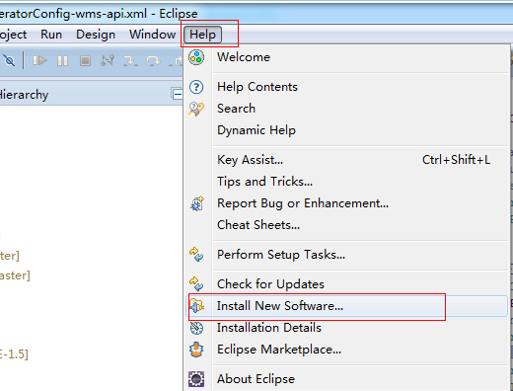

Eclipse -> Help -> Install New Software

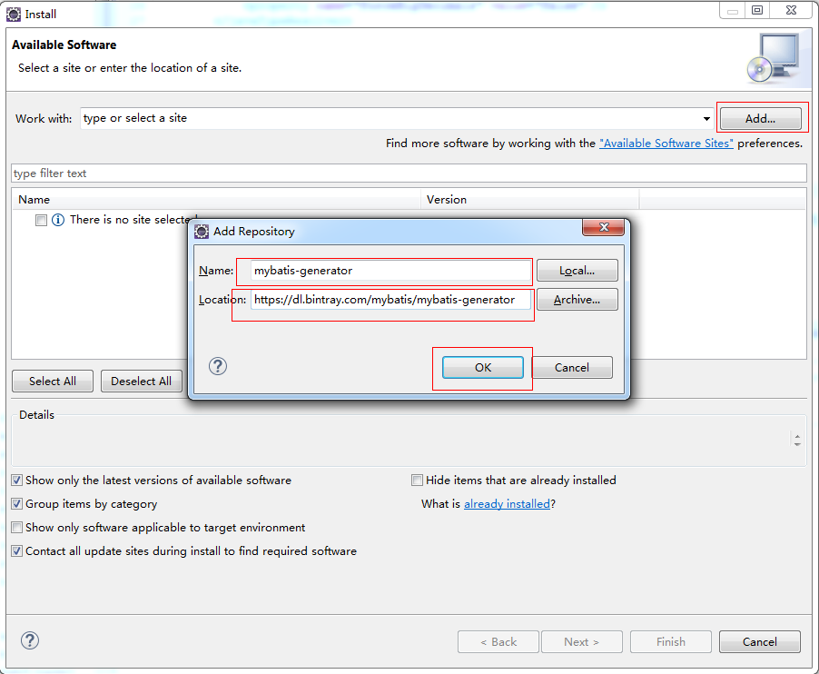

点击Add -> 输入Name和Location -> OK

name:mybatis-generator

location:https://dl.bintray.com/mybatis/mybatis-generator

在MybatisGenerator项目中,

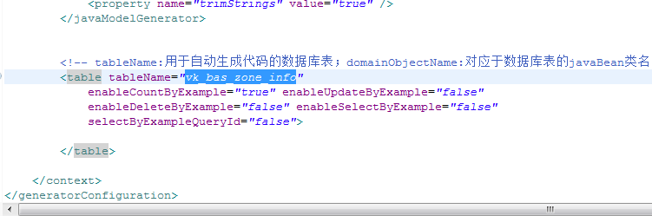

编辑generatorConfig-wms-api.xml

更改jar包路径

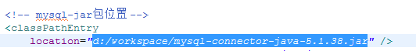

更改表名

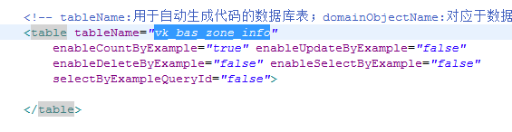

右键generatorConfig-wms-api.xml -> Generate MyBatis/IBATIS Artifacts

