# MANUAL FOR BACKGROUND NETWORK ANALYSIS TOOLBOX

## CONFIGURING ENVIRONMENT

For using this Background Network Analysis Toolbox, it need to configure the environment.

1. This toolbox is coded in MATLAB R2013a. (MATLAB is a [multi-paradigm](https://en.wikipedia.org/wiki/Multi-paradigm_programming_language) [numerical computing](https://en.wikipedia.org/wiki/Numerical_analysis) environment and [fourth-generation programming language](https://en.wikipedia.org/wiki/Fourth-generation_programming_language).) Without matlab environment or installing matlab which is MATLAB R2013a or above, it could not run successfully. In account of running successfully, please install MATLAB R2013a or above.
2. This toolbox is also using Statistical Parametric Mapping(**Statistical Parametric Mapping** refers to the construction and assessment of spatially extended statistical processes used to test hypotheses about functional imaging data). Because the first part, Residual Estimation, is using the function of SPM, the SPM12 or above is needed. SPM can be downloaded from this page: ‘<http://www.fil.ion.ucl.ac.uk/spm/software/spm12/>. SPM is in ZIP, it needs to be decompressed first. For example, if SPM is decompressed to this location, ‘D:\SPM’ in Fig1.1.

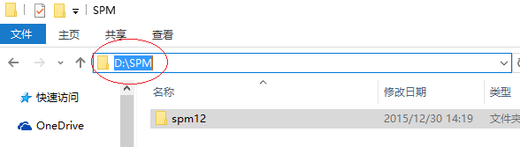

Fig1.1

There should be a new folder where there is the content of spm12 in the folder, ’D:\SPM’.

1. Next step is to set the search path of matlab. Click this ‘Set Path’ icon in the ‘ENVIRONMENT’ panel in Fig1.2.

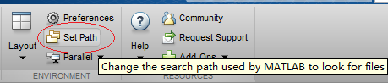

Fig 1.2

A ‘Set Path’ window will come out. Click the ‘Add Folder…’ button in this ‘Set Path’ window just like in Fig 1.3.

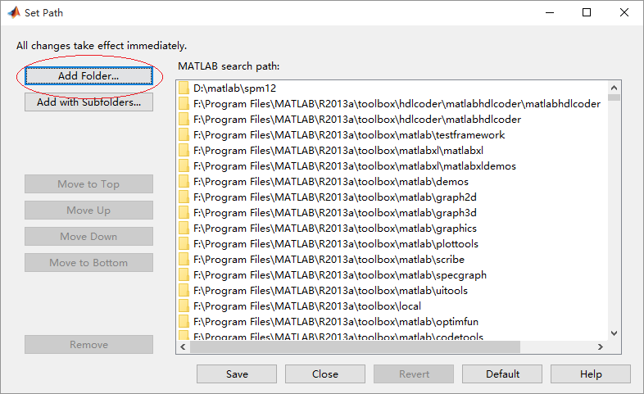

Fig 1.3

Another widow for selecting path will pop up. Selecting the ‘spm12’ folder in the folder where SPM was decompressed. If SPM was decompressed in ‘D: \SPM’, the ‘spm12’ folder should be selected in this location. Click ‘select’. As showed in Fig 1.4.

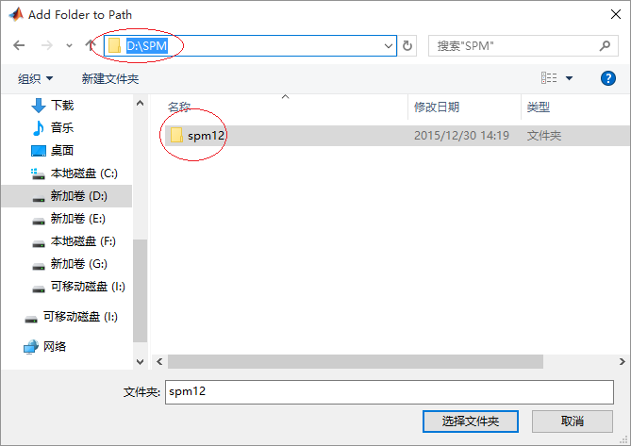

Fig 1.4

In this time, you can find out that the ‘spm12’ folder is added to the matlab search path. The selected folder appear in the table of ‘Set Path’ folder’s table. After that, please click ‘Save’ button and you can close this ‘Set Path’ window. As showed in Fig 1.5.

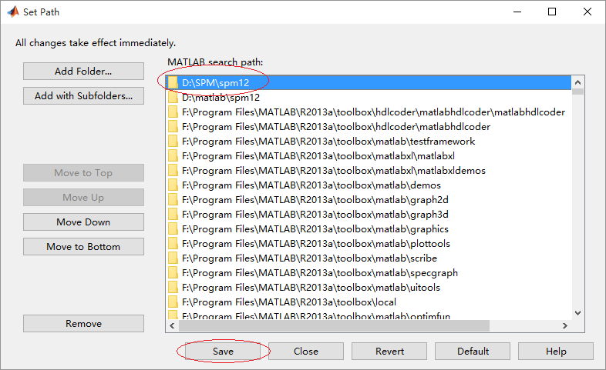

Fig 1.5

1. Now you can try to confirm whether your environment is set properly. Tap ‘spm’ in the ‘command’ window of matlab and Enter. A main menu of ‘SPM12’(Fig 1.6) should pop up.

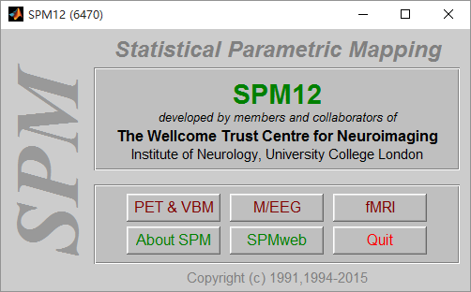

If a window like this appear, the environment was set properly and you can close the window. Otherwise, you should configure the environment following the process above.

## The main menu of BNAT

1. After configuring the environment, you can try to use this Background Network Analysis Toolbox(BNAT). The software should have been compressed, so it needs to be decompressed to an appropriate location. For example, you could decompressed it in ‘D:\matlab’. Then, there will be a ‘BNAT’ folder which contains all the files of BNAT. Showed in Fig 2.1.

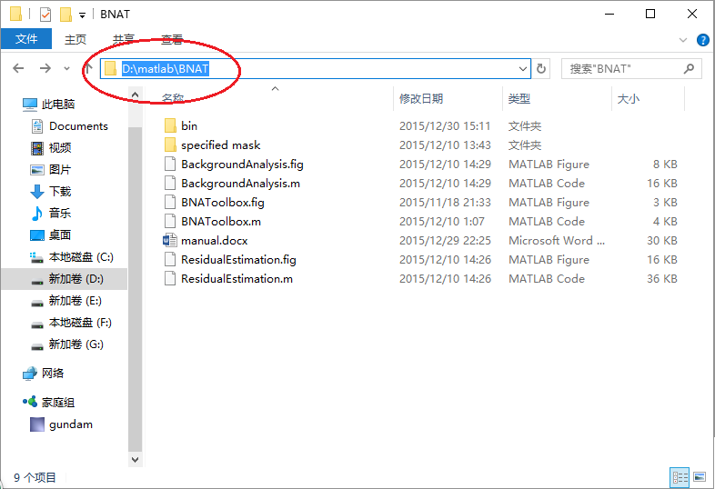

Fig 2.1

Copy the address in the address field, and paste it to the address field of matlab and enter. After then input ’BNAToolbox’ in the Command window of matlab and enter just like below Fig 2.2.

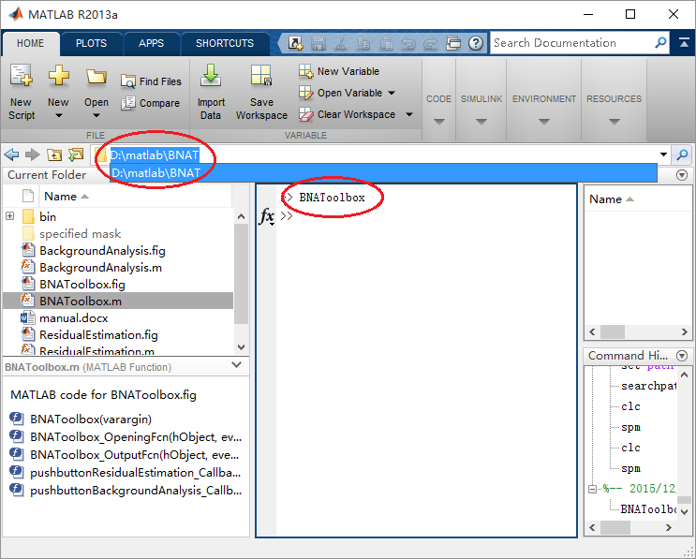

Fig 2.2

1. Maybe, it takes a few seconds, then the main menu of BNAT will pop up like below Fig 2.3.

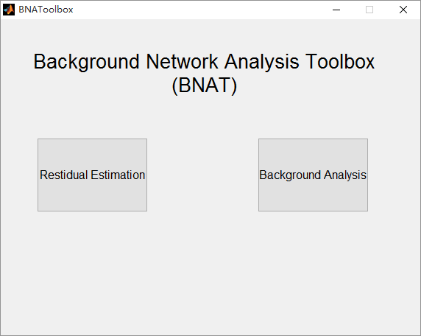

Fig 2.3

1. The whole menu(Fig 2.3) only contains 2 buttons, one is ‘Residual Estimation’, the other is ‘Background Analysis’. For doing every processing of Background Network Analysis, you should use ‘Residual Estimation’ first. After finishing Residual Estimation, use Background Analysis.

## Residual Estimation

1. Click the ‘Residual Estimation’ button, the ‘Residual Estimation’ window (Fig 3.1) will pop up.
2. In Fig 3.1, mark 1 to mark 3 are the Data & Design. They are used for selecting data sets or fMRI data in batch.

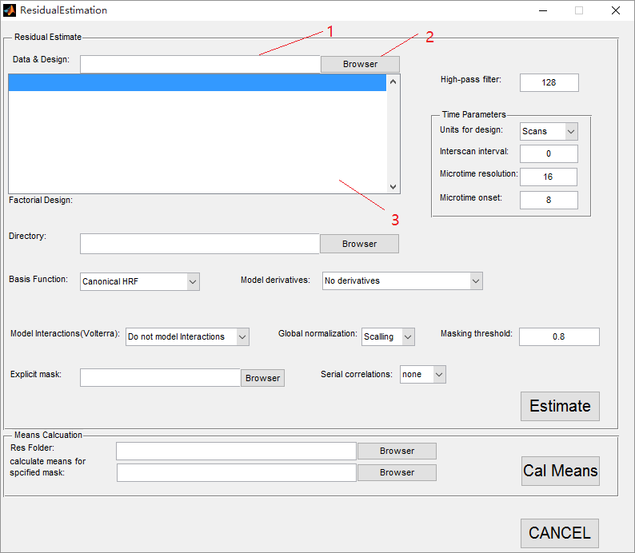

Fig 3.1

But before selecting data, the data have to be well prepared and saved in specified file structure. Saying that you have n subjects and mi is the number of fMRI scanning sessions of the ith subject. And kj is the number of the fMRI data sets of the jth session. Just like the Fig 3.2 below.

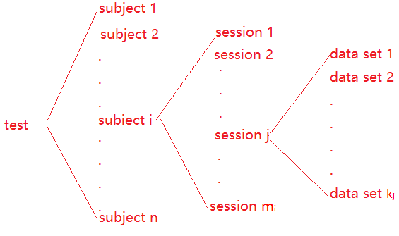

Fig 3.2

So for the batch processing, it need a similar file structure as Fig 3.2 for containing all this data sets. Data sets of the jth session should all be in a session folder. All session folders of the ith subject should be in a subject folder. All the subject folders of this single test should be in the same folder as well. This directory tree will be similar as Fig 3.2. Except for the directory structure, 2 extra configuration files should be added to every session folder. They must be named as ‘Cond*.mat’ and ‘Reg*.txt’ (‘*’ represents one or a few characters).

What is cond & Reg

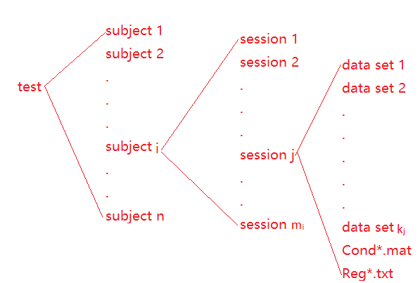

Fig 3.3

The fMRI data sets must be named in alphabetic sequence regarding to the time sequence. But all the folder names of subject folder or session folder and fMRI data sets’ names are not specified.

Here an example is showed how it woks. Saying that there are 2 subjects (p1, p2) here, every subject has 2 sessions (s1, s2) and every session has 175 data sets and 2 configuration files (Cond*.mat & Reg*.txt). As a result, the fMRI data sets should be in such a file structure showed in Fig 3.4. The files’ names and folders’ names are not specified but should be in alphabetic sequence.

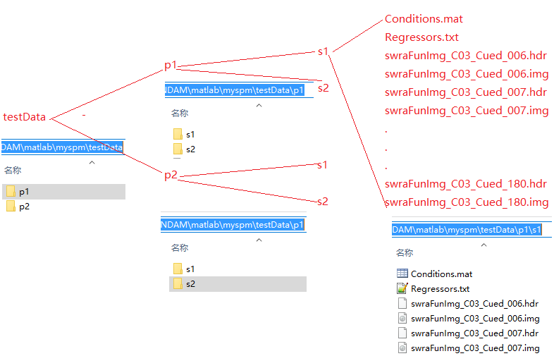

Fig 3.4

After that, you can use mark 1 or mark 2 in Fig 3.1 to select the data set. The folder you should select is the root of the directory tree. If in Fig 3.4, the folder should be selected is ‘testData’. Either directly input the URL address in mark 1 or select it in dialog box by clicking mark 2 is OK. So, Fig 3.5 show how to select the target folder, ‘testData’.

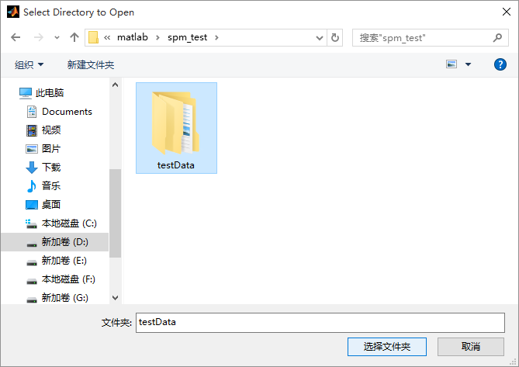

Fig 3.5

After selecting the folder, mark 3 of Fig 3.1 displays the fMRI data sets in the folder. As showed in Fig 3.6.

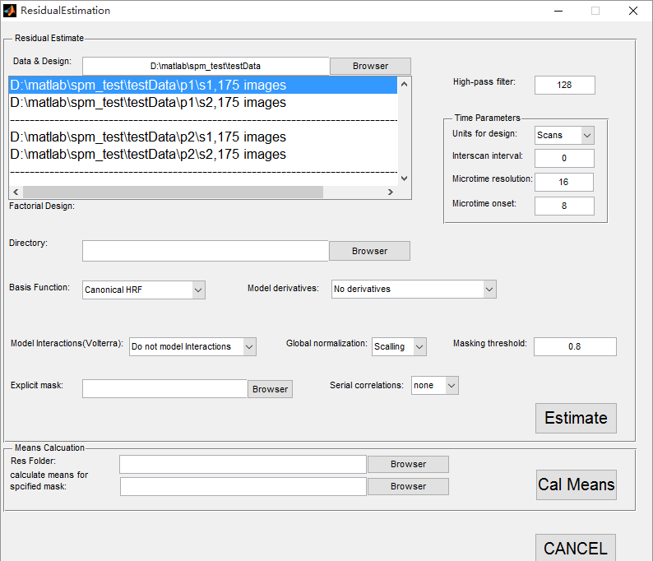

Fig 3.6

1. In Fig 3.7, you can fill an integer in the text field of mark 4 for high-pass filter cutoff.

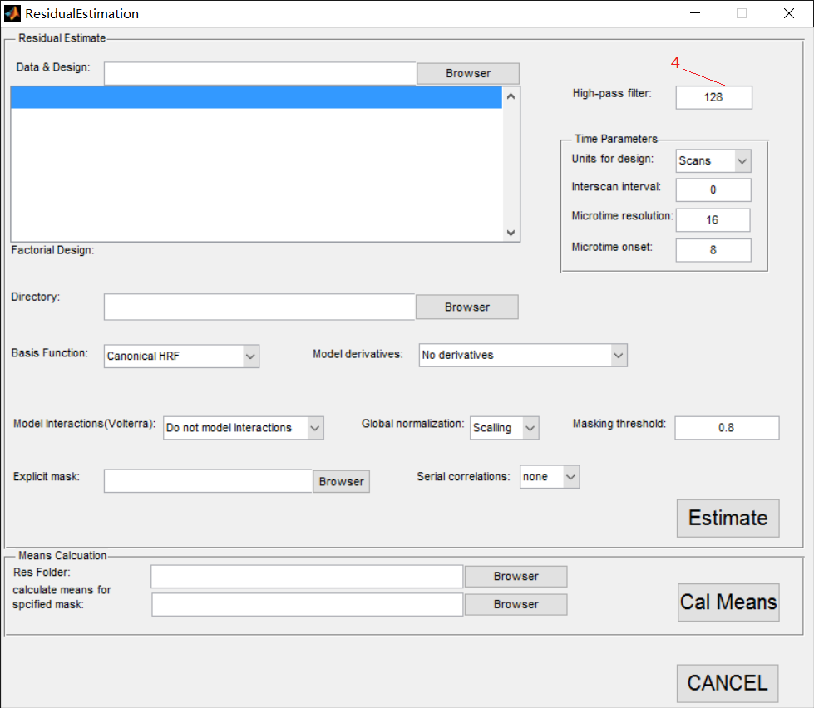

Fig3.7

High-pass filter:

The default high-pass filter cutoff is 128 seconds. Slow signal drifts with a period longer than this will be removed. High-pass filtering is implemented using a residual forming matrix (i.e. it is not a convolution) and is simply a way to remove confounds without estimating their parameters explicitly. The constant term is also incorporated into this filter matrix.

1. In Fig 3.8, mark 5 to mark 8 are for setting Time Parameters. 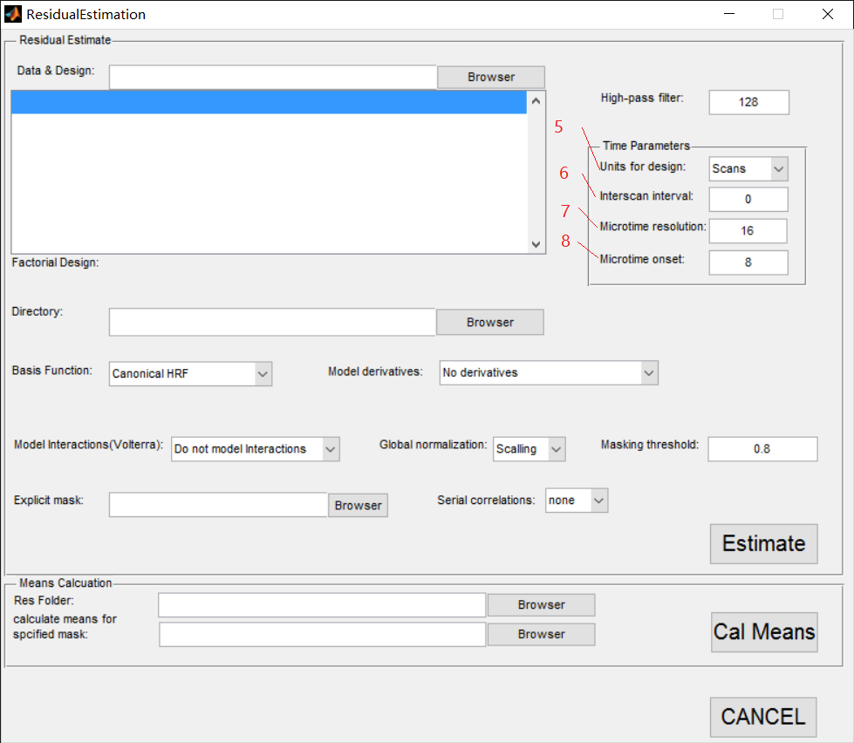

Fig 3.8

Units for design: You can choose a value through the popup menu through mark 5 in Fig 3.8 .

The onsets of events or blocks can be specified in either scans or seconds.

Interscan interval: You can fill in an integer in the text field of mark 6.

This is, TR, (specified in seconds), the time between acquiring a plane of one volume and the same plane in the next volume. It is assumed to be constant throughout.

Microtime resolution: You can fill in an integer in the text field of mark 7.

In Echo-Planar Imaging (EPI), data is acquired a plane at a time. To acquire a whole volume data takes at least a second or two.

It is possible, however, that experimental events may occur between scan (volume) acquisition times. This can be specified when building your design matrix either by (i) specifying your design in scans and using non-integer values or (ii) specifying your design in seconds at a resolution greater than the TR.

SPM takes these timing specifications and builds its regressors using a ‘microtime’ time-scale. The microtime resolution, t, is the number of time-bins per scan.

Do not change this parameter unless you have a long TR and wish to shift regressors so that they are aligned to a particular slice.

Microtime onset: You can fill in an integer in the text field of mark 8.

The microtime onset, t0, is the first time-bin at which the regressors are resampled to coincide with data acquisition. If t0 = 1 then the regressors will be appropriate for the first slice. If you want to temporally realign the regressors so that they match responses in the middle slice then make t0 = t/2 (assuming there is a negligible gap between volume acquisitions).

Do not change the default setting unless you have a long TR.

A typical use of the t and t0 parameters is to set them to correspond to the results of any slice timing correction you have made e. g. if you have 24 slices and have made slice 12 the reference slice you would set t=24, t0=12.

1. You can use mark 9 and mark 10 in Fig 3.9 for setting a URL path.

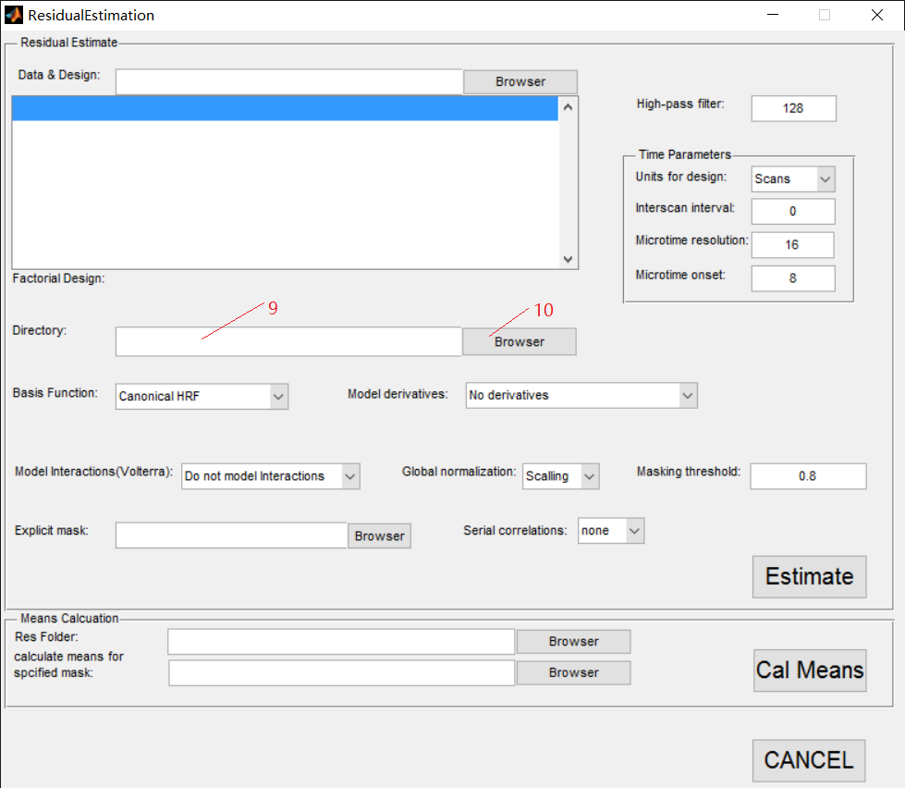

Fig 3.9

URL path can be inputted to the textfield of mark 9 or selected in GUI by clicking the button of mark 10.

The result of Residual Estimation will be save in the path you select.

1. You can use the popup menu of mark 11 in Fig 3.10 for choosing different Basis function. Choosing different Basis function, the parameters in the red circle of Fig 3.10 are different as well.

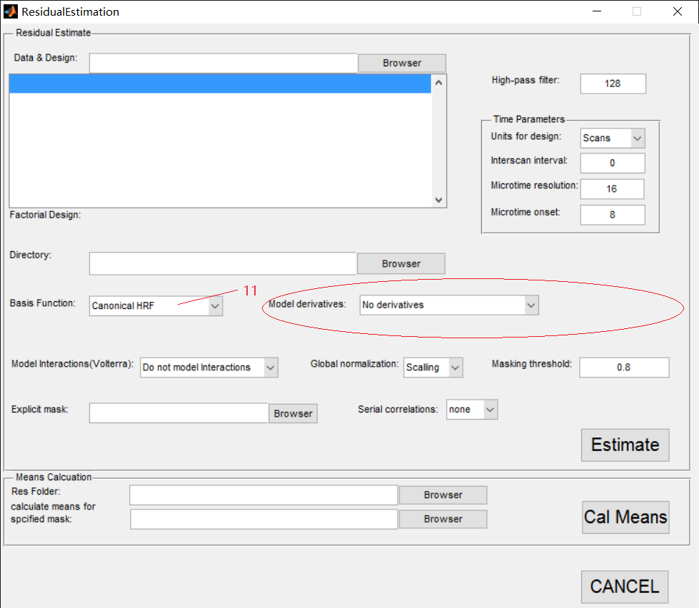

Canonical HRF: Canonical Hemodynamic Response Function (HRF). This is the default option. Contrasts of these effects have a physical interpretation and represent a parsimonious way of characterizing event-related responses. This option is also useful if you wish to look separately at activations and deactivations. This is implemented using a t-contrast with a +1 or -1 entry over the canonical regressor.

Model derivatives:

Model HRF Derivatives. The canonical HRF combined with time and dispersion derivatives comprise an ‘informed’ basis set, as the shape of the canonical response conforms to the hemodynamic response that is commonly observed. The incorporation of the derivative terms allow for variations in subject-to-subject and voxel-to-voxel responses. The time derivative allows the peak response to vary by plus or minus a second and the dispersion derivative allows the width of the response to vary by a similar amount.

A positive estimate of the time-derivative regression coefficient implies that the peak hemodynamic response occurs earlier than usual i.e. than would be expected using just the canonical regressor. A positive estimate for the dispersion derivative implies a less dispersed response than usual.

The informed basis set requires an SPMF for inference. T-contrasts over just the canonical are perfectly valid but assume constant delay/dispersion. The informed basis set compares favourably with e.g. FIR bases on many data sets.

Fourier Set, Fourier Set (Hanning), Gamma Functions, Finite Impulse Response (FIR): For each of these options you must also specify the window length which is the length in seconds of the post-stimulus time window that the basis functions span. You must also specify the order, that is, how many basis functions to use.

Usually, an informed basis set should be sufficient for most data sets. If this does not provide a good fit to the data it may be worthwhile re-considering how the neuronal events are modelled i.e. is the timing correct? Should events be split into subsets?

Alternatively, the gamma basis functions are an interesting choice as a particular linear combination of them is actually used to specify the canonical HRF. The FIR approach is of interest as it is equivalent to the method of ‘selective averaging’.

1. You can use these 3 popup menus of mark 12 to mark 14 in Fig 3.11 for setting Model interactions (Volterra), Global normalization, Masking threshold.

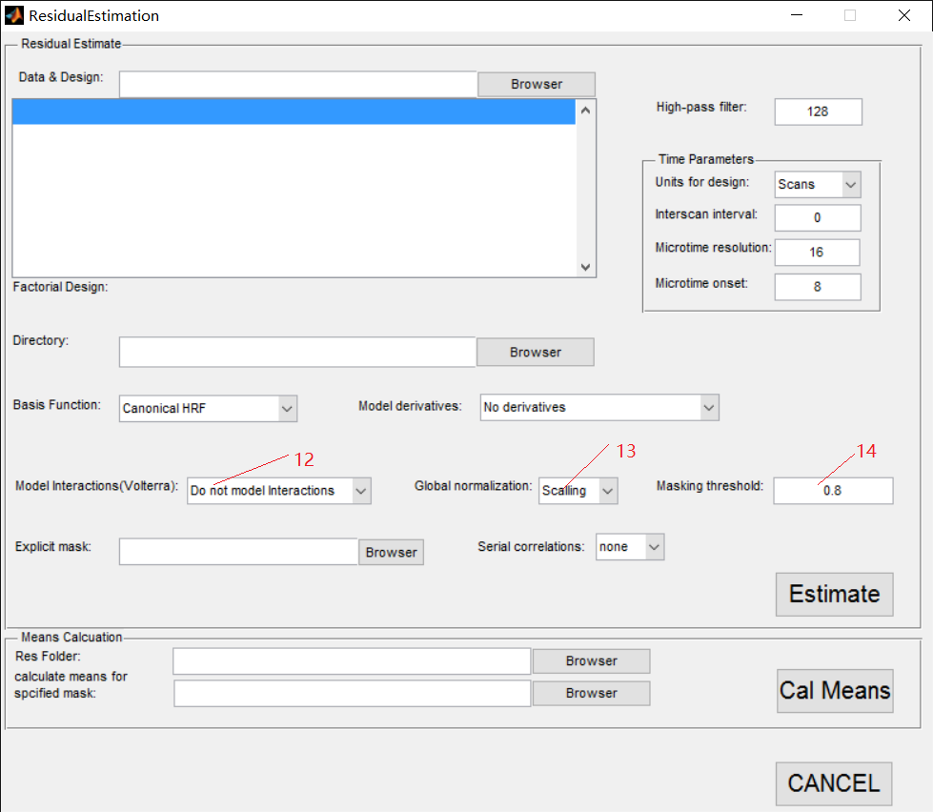

Fig 3.11

Model Interactions (Volterra):

The value can be set by the popup menu of mark 12.

Generalized convolution of inputs, U, with basis set, bf.

For first order expansions the causes are simply convolved (e.g. stick functions) in U by the basis functions in bf to create a design matrix X. For second order expansions new entries appear that correspond to the interaction among the original causes. The basis functions for these effects are two dimensional and are used to assemble the second order kernel.

Interactions or response modulations can enter at two levels. Firstly the stick function itself can be modulated by some parametric variate. This can be time or some trial-specific variate like reaction time modeling the interaction between the trial and the variate. Secondly interactions among the trials themselves can be modeled using a Volterra series formulation that accommodates interactions over time (and therefore within and between trial types).

This last option is useful for accommodating nonlinearities in the hemodynamic response. For example, if two events occur within a second or so of each other then the hemodynamic response to the pair may be less than the sum of the responses to each event when occuring in isolation. This type of ‘sub-linear’ response can be modelled using Volterra kernels. See [36] for further details.

Global normalization:

The value can be set by the popup menu of mark 13.

SPM can normalise fMRI data in one of two ways. These are selected using the options ‘None’ (the default) and ‘Scaling’.

Both methods are based on first estimating the average within-brain fMRI signal, gns, where n denotes scan and s denotes session. If you select ‘Scaling’, SPM will multiply each fMRI value in scan n and session s by 100=gns.

If you select “None” then SPM computes the grand mean value, gs =PNn=1 gns N where N is the number of scans in that session. This is the fMRI signal averaged over all voxels within the brain and all time points within session s. SPM then implements “Session-specific grand mean scaling” by multiplying each fMRI data point in session s by 100=gs.

Masking threshold:

You can input a number in the textfield of mark 14.

1. You can use mark 15 or mark 16 in Fig 3.12 for selecting your mask file. The URL path can be directly input in the textfield of mark 15 or selected in GUI by clicking the button of mark 16.

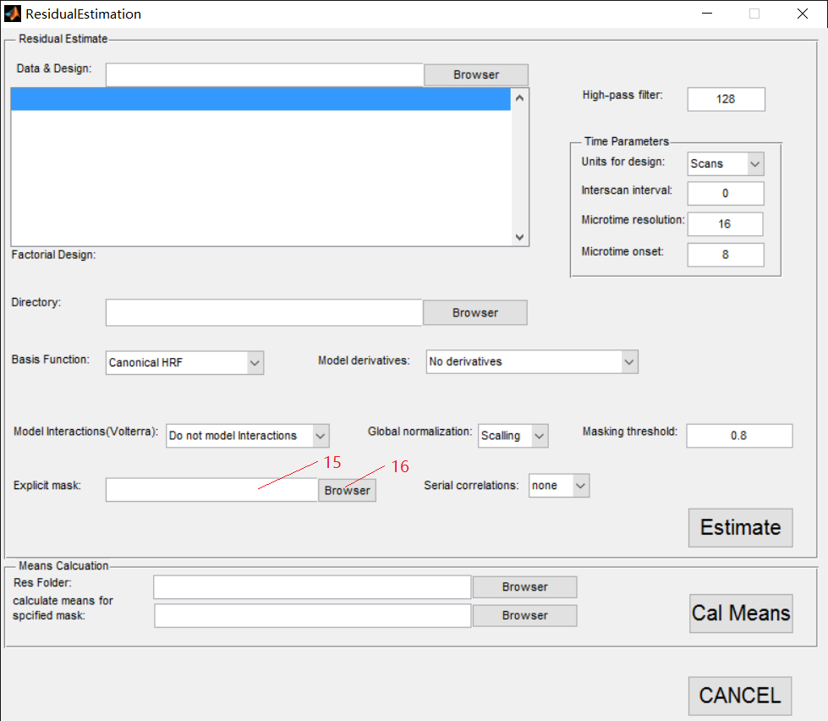

Fig 3.12

Explicit mask:

Specify an image for explicitly masking the analysis. A sensible option here is to use a segmentation of structural images to specify a within-brain mask. If you select that image as an explicit mask then only those voxels in the brain will be analyzed. This both speeds the estimation and restricts SPMs/PPMs to within-brain voxels. Alternatively, if such structural images are unavailable or no masking is required, then leave this field empty.

1. You can use the popup menu of mark 17 in Fig 3.13 to choose a value of Serial correlations.

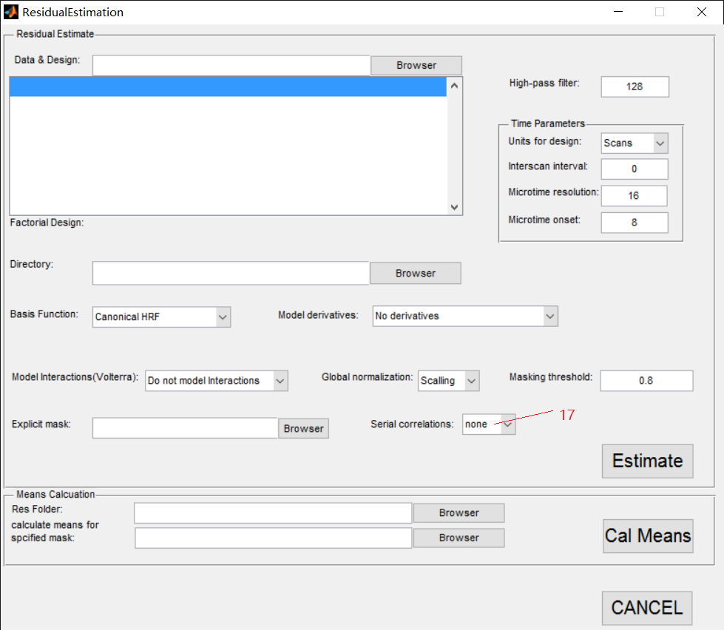

Fig 3.13

Serial correlation:

Serial correlations in fMRI time series due to aliased biorhythms and unmodelled neuronal activity can be accounted for using an autoregressive AR(1) model during Classical (ReML) parameter estimation.

This estimate assumes the same correlation structure for each voxel, within each session. ReML estimates are then used to correct for non-sphericity during inference by adjusting the statistics and degrees of freedom appropriately. The discrepancy between estimated and actual correlations are greatest at low frequencies. Therefore specification of the high-pass filter is particularly important.

Serial correlation can be ignored if you choose the “none” option. Note that the above options only apply if you later specify that your model will be estimated using the Classical (ReML) approach. If you choose Bayesian estimation these options will be ignored. For Bayesian estimation, the choice of noise model (AR model order) is made under the estimation options.

1. After all these procedures, you can click the button ‘Estimate’ of mark 18 in Fig 3.14. The program will be running. A word, ‘Running’, will exist on the bottom of the widow as in the red circle of Fig 3.14 during procedure running. Not until the ‘Running’ disappears, are using matlab and the program permitted.

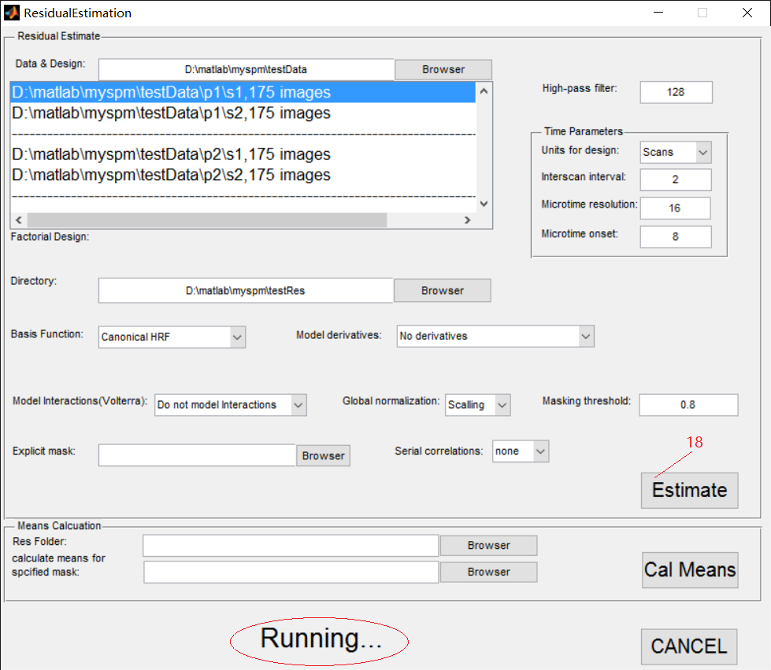

Fig 3.14

1. After the word, ‘Running’, disappears, the procedure of ‘Estimate’ is finish, as showed in Fig 3.15.

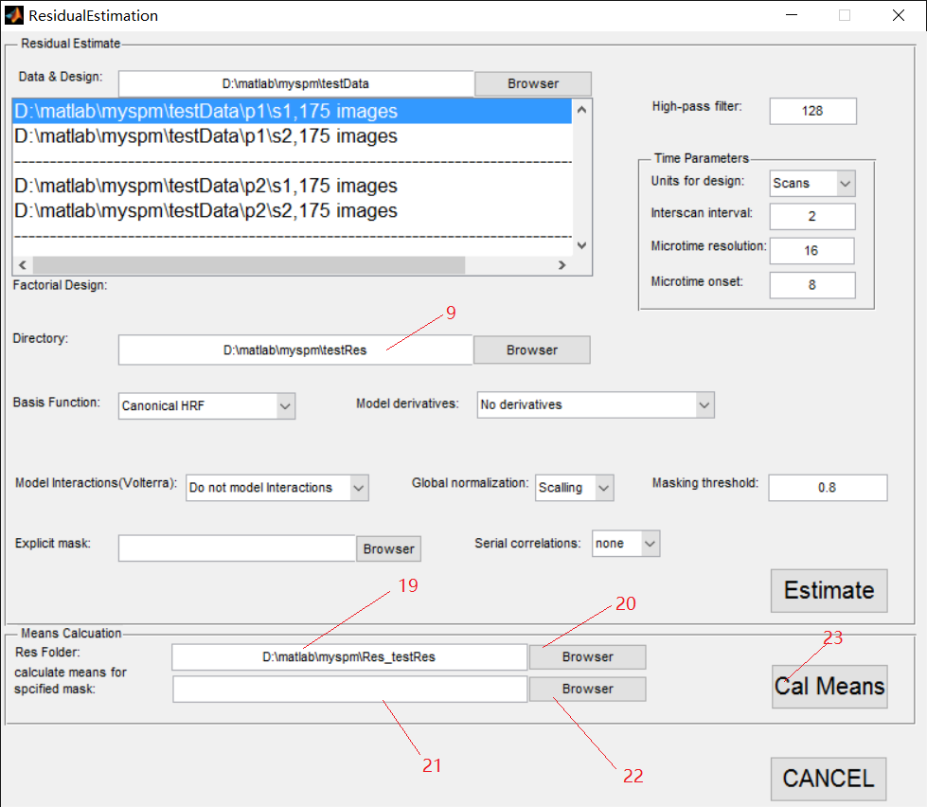

Fig 3.15

Res Folder:

It is the folder where you save your estimated date. The URL path can be directly input in the textfield of mark 19 or selected in GUI by clicking the button of mark 20. If you just finish the ‘Estimate’ procedure, the value of mark 9 will be directly pasted in the textfield of mark 19.

Calculate means for specified mask:

It is the mask file for calculating means. The URL path can be directly input in the thexfield of mark 21 or selected in GUI by clicking the button of mark 22.

1. By clicking the button ’Cal Means’ of mark 23, the program will be running. A word, ‘Running’, will exist on the bottom of the widow as in the red circle of Fig 3.14 during procedure running. Not until the ‘Running’ disappears, are using matlab and the program permitted. The result will save in the same folder as the value in mark 19 in Fig 3.15. After the word, ‘Running’, disappears, the procedure of Residual Estimate is all finished. You can click the button ‘CANCEL’ to exit this window.

Adsf