# MANUAL FOR BACKGROUND NETWORK ANALYSIS TOOLBOX

## Installation

* 1. This toolbox is coded in MATLAB R2013a. Please install MATLAB R2013a or above. This toolbox is also using Statistical Parametric Mapping. Residual Estimation actually is directly using API function of SPM. So SPM12 or above is needed. SPM can be downloaded from this page: ‘<http://www.fil.ion.ucl.ac.uk/spm/software/spm12/>.
  2. Both BNAT and SPM are needed to add to Matlab search path. For example, if SPM and BNAT are unzipped to this location, ‘D:\myfolder’ in Fig1.1. There should be these folders in ’D:\myfolder’.

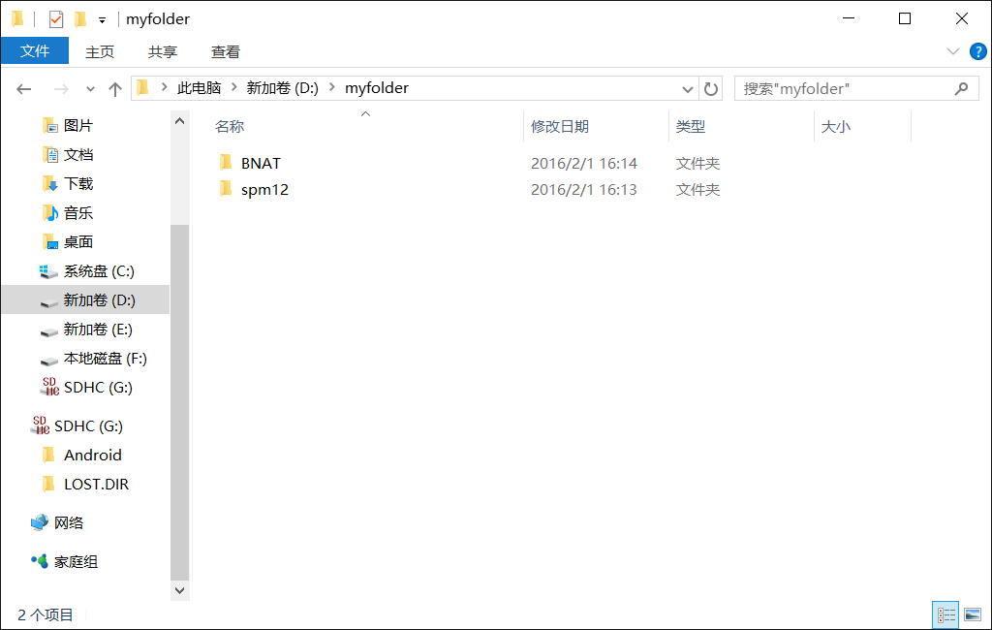

Fig1.1

* 1. Click this ‘Set Path’ icon in the ‘ENVIRONMENT’ panel (Fig1.2). Click the ‘Add Folder…’ button in the ‘Set Path’ window (Fig 1.3). Select the folder ‘spm12’ from where it was just unzipped. In this example, it is in ‘D:\myfolder’. And click ‘select’ (Fig1.4). Again, repeat the same procedure to add ‘BNAT’. Finally click ‘save’ button to save the setting (Fig1.5).

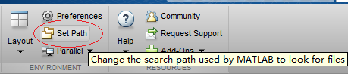

Fig 1.2

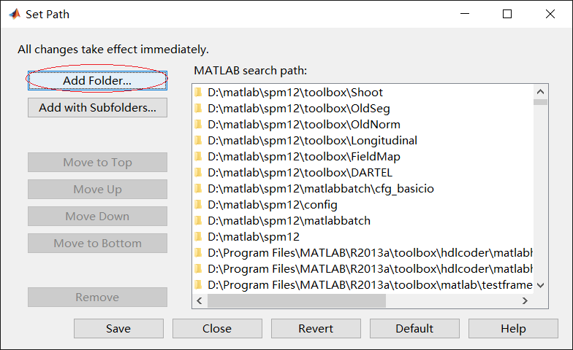

Fig 1.3

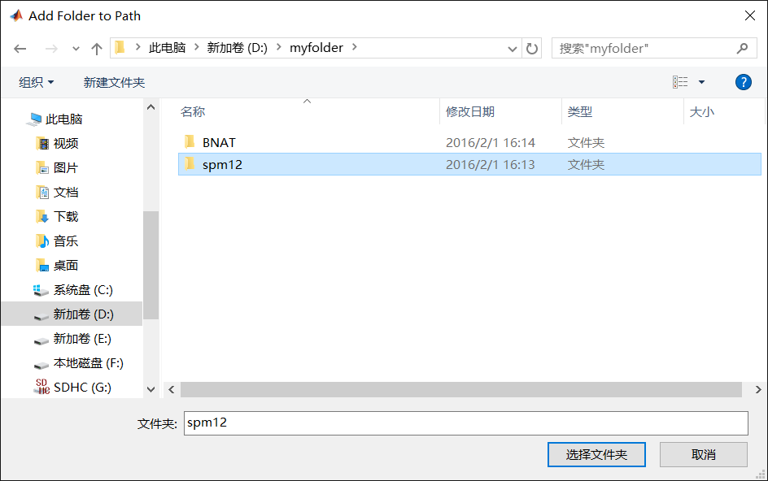

Fig 1.4

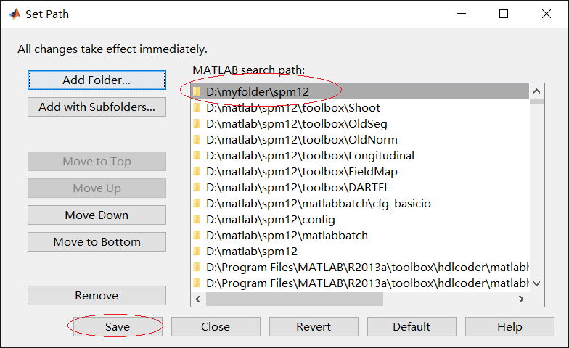

Fig 1.5

* 1. Now you can try to confirm whether your setting is correct. Type ‘BNAT’ in the ‘command window’ of Matlab. A main menu of ‘BNAT’ (Fig 1.6) should pop up. If a window like this appear, you can close the window. Otherwise, you should try above setting again.

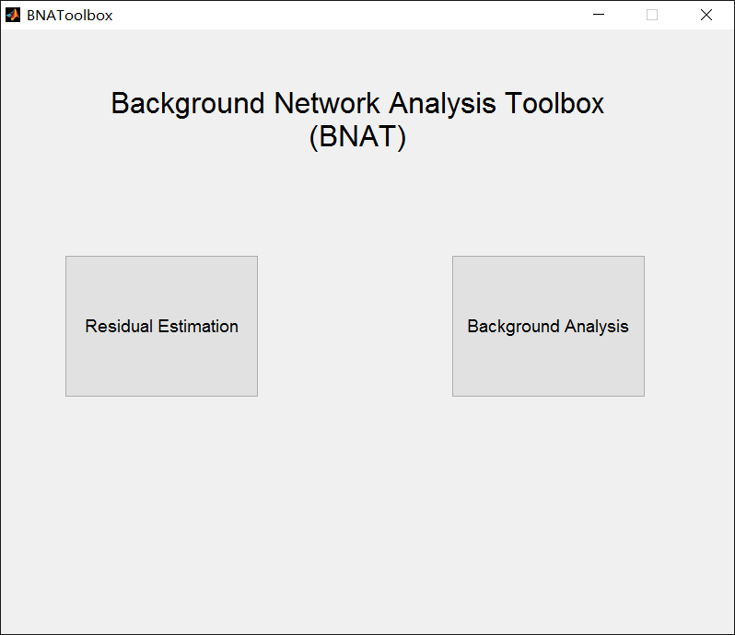

Fig 1.6

## Begin to use

* 1. After installation, you can now use this Background Network Analysis Toolbox (BNAT). Run your Matlab, type ‘BNAT’ in the ‘command window’. Wait a second, the main window of BNAT will pop up (Fig1.6).
  2. The whole menu only contains 2 buttons, one is ‘Residual Estimation’, the other is ‘Background Analysis’. For doing every processing of Background Network Analysis, you should use ‘Residual Estimation’ first. After finishing Residual Estimation, use Background Analysis.

## Residual Estimation

* 1. Click the ‘Residual Estimation’ button, the ‘Residual Estimation’ window (Fig 3.1) will pop up.
  2. In Fig 3.1, mark 1 to mark 3 are the Data & Design. They are used for selecting data sets or fMRI data. Our program here is designed for batching, which means it can deal with plenty of data in a time.

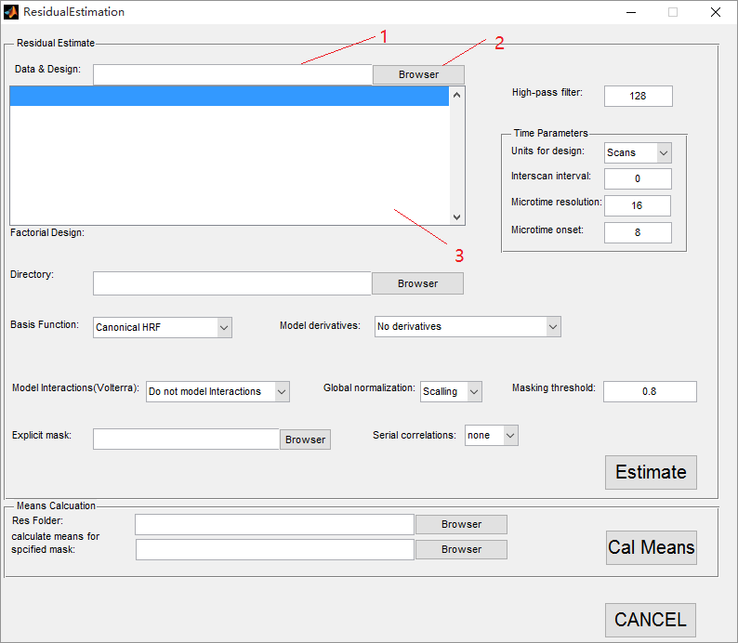

Fig 3.1

* 1. But before selecting data, the data have to be saved in specified file structure for batch. Saying that you data sets are in the structure below (Fig 3.2). Your test has n subjects and mi is the number of fMRI scanning sessions of the ith subject. And kj is the number of the fMRI data sets of the jth session.

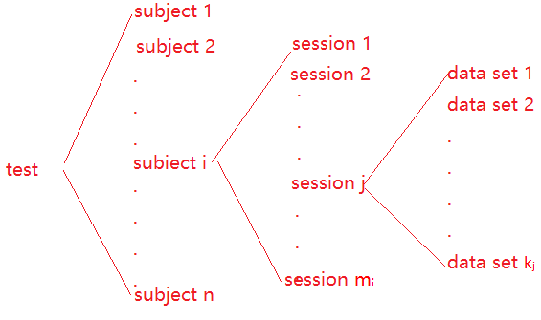

Fig 3.2

So for batch, your data set should be in a similar file structure (Fig 3.2). All data sets (data set 1-kj) of the jth session should be in a session folders (session j). All session folders (session 1-mi) of the ith subject should be in a subject folder (subject i). All the subject folders (subject 1-n) of this single test should be in the same folder as well. The directory tree will be like below (Fig 3.3). Moreover, 2 extra configuration files should be added to every session folder. They must be named as ‘Cond*.mat’ and ‘Reg*.txt’ (‘*’ represents one or a few characters). The first four and three characters must be the same.

What is cond & Reg

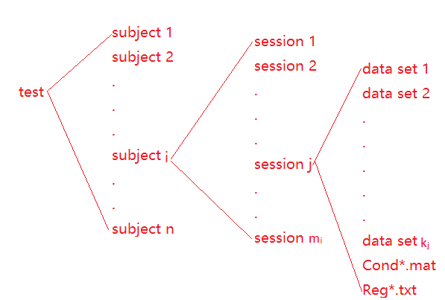

Fig 3.3

So, what is ‘Cond*.mat’ & ‘Reg*.txt’ ?

‘Cond*.mat’: The file contains the same parameters of SPM-> fmri-> Specifiy 1st –level-> ‘Conditions’, you can read SPM’s manual as reference. But here a more direct way is used to generate these parameters. Open the function, ‘CondGenerator.m’ in the ‘BNAT’ (e.g. ‘D:\myfolder\BNAT’) folder. It is a script for generating the ‘Conditions’ parameters. Following the instruction in the comment of the script, you can use it to generate your own ‘Conditions’ parameters. After that please move your ‘Cond*.mat’ files to every targeted ‘session’ folder.

‘Reg*.txt’: The file actually the same as the one of SPM-> fmri-> Specifiy 1st –level-> ‘Multiple regressors’. You can read the SPM’s manual as reference. The file can be save in either ‘.txt’ or ‘.mat’. But ‘.txt’ is easier to deal with. First, create a txt file named ‘Reg*.txt’ (e.g. ‘Regressors.txt’, ‘Reg_p1s1’). Then you can type or copy your parameters in the file. The number of rows in the file should be the same as the number of data sets in the same session file. Every parameter of the same data set is separated by a ‘white space’. After inputting all parameters, you can move your ‘Reg*.txt’ files to every targeted ‘session’ folder. E.g. if there are 11 data sets in a session folder and every data sets has 8 parameters, you can type it in the file like this below.

1.4210855e-014 0.0000000e+000 -1.4210855e-014 -3.9756933e-016 1.9878467e-016 0.0000000e+000 2.1257083e+003 1.5688188e+003

-6.5474681e-003 4.8472000 2.2144085 1.7655743 1.5122401e-003 3.5208670e-003 2.1259743e+003 1.5887805e+003

-2.2839011 1.0110099e-001 7.4376742e-003 1.8069802 2.9684026 1.4888901e-003 2.1860330e+003 1.5913342e+003

-3.3106699 4.6506663 2.3787610 -2.4753019 3.2547137e-003 -4.4745733e-003 2.1006496e+003 1.6016406e+003

-3.7850820 9.7056363 5.3364837 5.7405948e-004 3.4929847 -3.5634731 2.1229025e+003 1.5723337e+003

-7.0994337 5.1831287 -6.1578773 3.9491474 9.6412342 -6.2418005 2.1519764e+003 1.5802083e+003

-7.3500312 1.0069912e-001 -1.3454679e-001 1.5799031 8.7571889 -7.6585120 2.1170006e+003 1.5824428e+003

1.1413707e-003 7.2508389 -4.2548884 2.0794977 5.6052800 -5.8359665 2.1764546e+003 1.5846971e+003

2.2102072 4.4198944 -1.3461109e-003 -9.3829454e-003 7.2368065 -4.7754450 2.1630544e+003 1.5928819e+003

3.4195371 6.5715514 -3.6044054e-003 6.1710471 8.5706665 -6.8156326 2.1130822e+003 1.5769911e+003

-5.5226208 2.0913915 3.6387632 1.6030506 8.5413162 -8.1242757 2.1876778e+003 1.5882102e+003

All the folder names of subject folder and session folder, and fMRI data sets are not specified. You can named it whatever you want. But please attention! The fMRI data sets must be named in alphabetic order regarding to the time sequence. So it is the best to use a number to order the data sets in time sequence.

Here is an example showing how it works. Saying that there are 2 subjects (p1, p2) here, every subject has 2 sessions (s1, s2) and every session has 175 data sets and 2 configuration files (Conditions.mat & Regressors.txt). As a result, the fMRI data sets should be in such a file structure showed below (Fig 3.4). The files’ names and folders’ names are not specified. But the data sets’ names must be in alphabetic order.

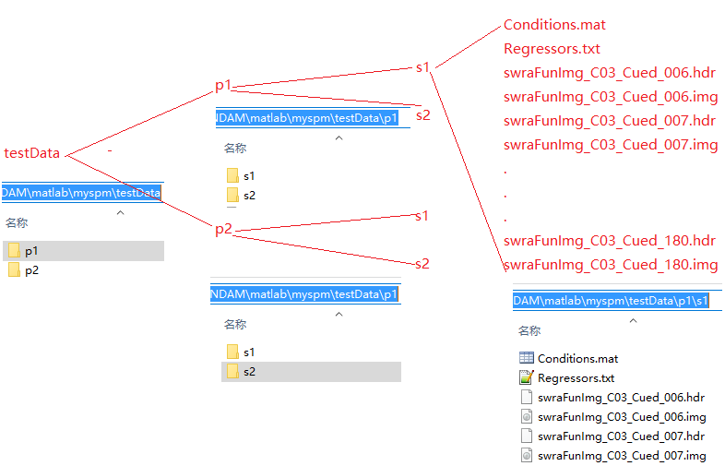

Fig 3.4

After that, you can use mark 1 or mark 2 in Fig 3.1 to select the data set. The folder you should select is the root of the directory tree. If in this example (Fig 3.4), the folder should be selected is ‘testData’. Either directly input the URL address in mark 1 or select it in dialog box by clicking mark 2 is OK. So, Fig 3.5 show how to select the target folder, ‘testData’.

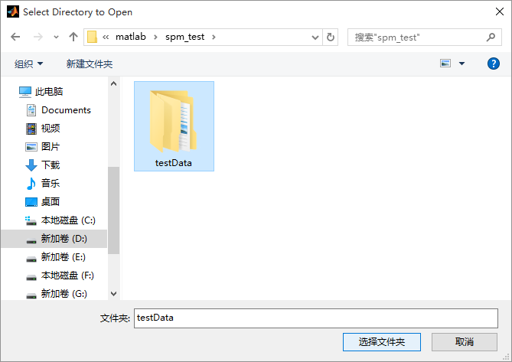

Fig 3.5

After selecting the folder, mark 3 (Fig 3.1) displays the fMRI data sets in the folder. As showed below (Fig 3.6).

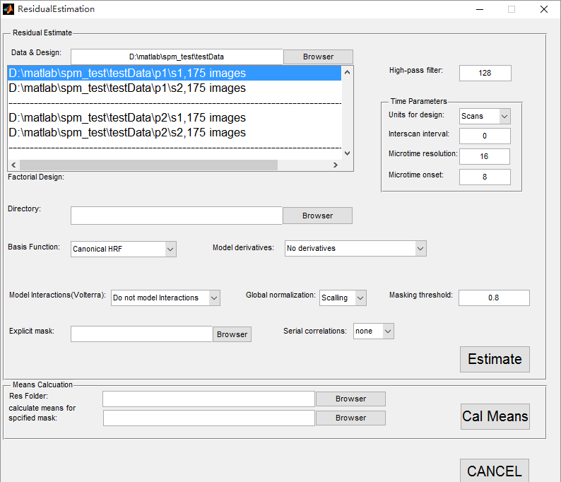

Fig 3.6

* 1. You can fill an integer in the text field of mark 4 (Fig 3.7) for high-pass filter cutoff. (The parameters here are the same as the ones in SPM-> fmri-> Specifiy 1st –level. Because the window here are using the SPM’s api function. You can read the SPM’s manual as reference. )

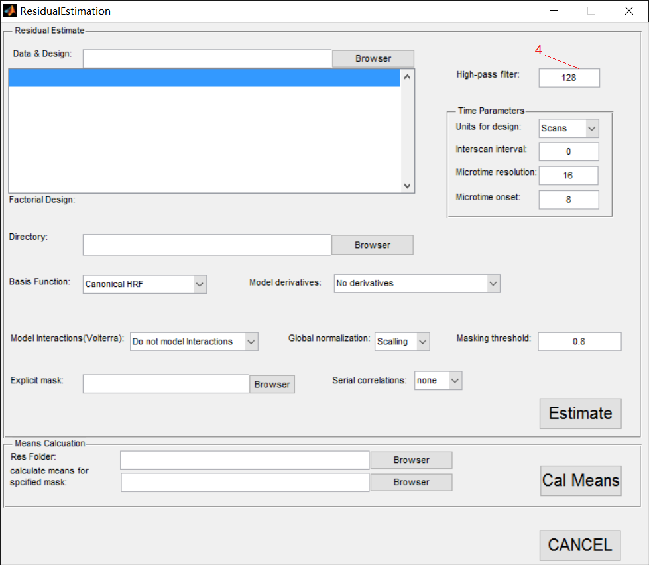

Fig 3.7

* 1. Mark 5 to mark 8 (Fig 3.8) are for setting Time Parameters. (The parameters here are the same as the ones in SPM-> fmri-> Specifiy 1st –level. Because the window here are using the SPM’s api function. You can read the SPM’s manual as reference.)

Units for design: You can choose ‘Scans’ or ‘Seconds’ as a unit through the popup menu through mark 5.

Interscan interval: You can fill in an integer in the text field of mark 6.

Microtime resolution: You can fill in an integer in the text field of mark 7.

Microtime onset: You can fill in an integer in the text field of mark 8.

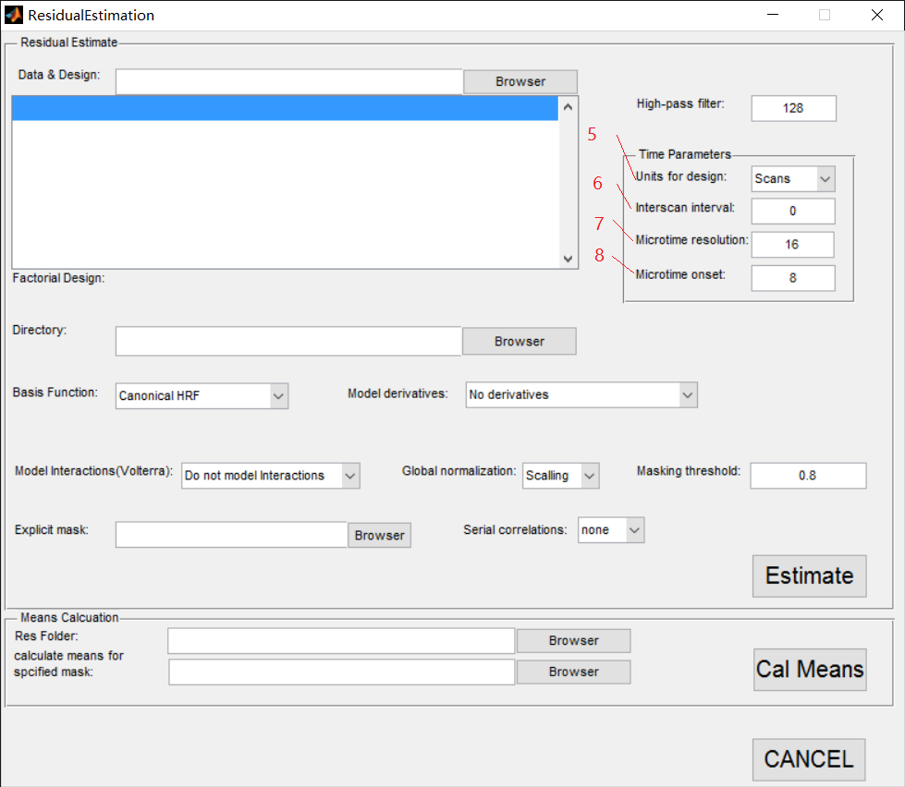

Fig 3.8

* 1. You can use mark 9 and mark 10 (Fig 3.9) for setting a URL path. URL path can be inputted to the textfield of mark 9 or selected in GUI by clicking the button of mark 10. The result of Residual Estimation will be save in the path you select. (The parameters here are the same as the ones in SPM-> fmri-> Specifiy 1st –level. Because the window here are using the SPM’s api function. You can read the SPM’s manual as reference.)

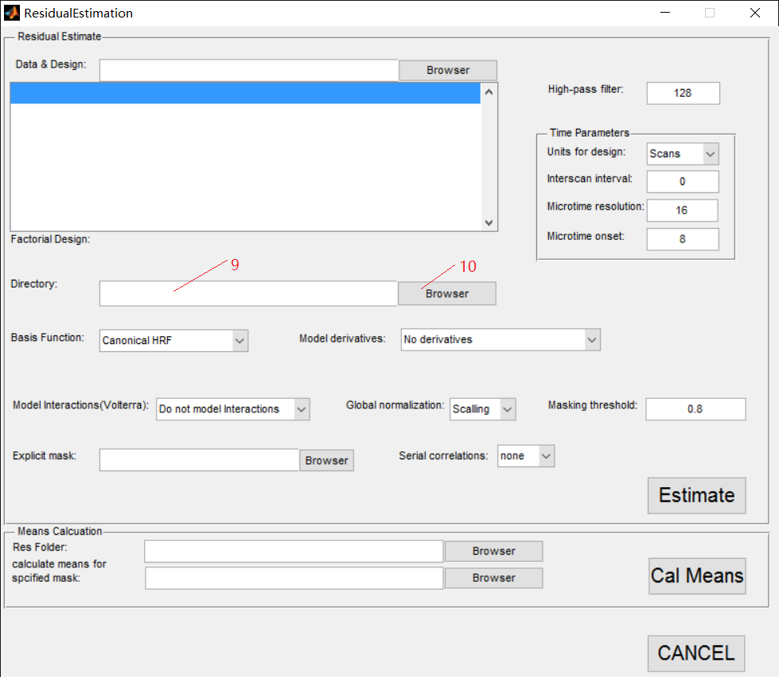

Fig 3.9

* 1. You can use the popup menu of mark 11(Fig 3.10) for choosing different Basis function. Choosing different Basis function, the parameters in the red circle of Fig 3.10 are different as well. And it has following selection: Canonical HRF, Fourier Set, Fourier Set (Hanning), Gamma Functions, Finite Impulse Response (FIR), none. (The parameters here are the same as the ones in SPM-> fmri-> Specifiy 1st –level. Because the window here are using the SPM’s api function. You can read the SPM’s manual as reference.)

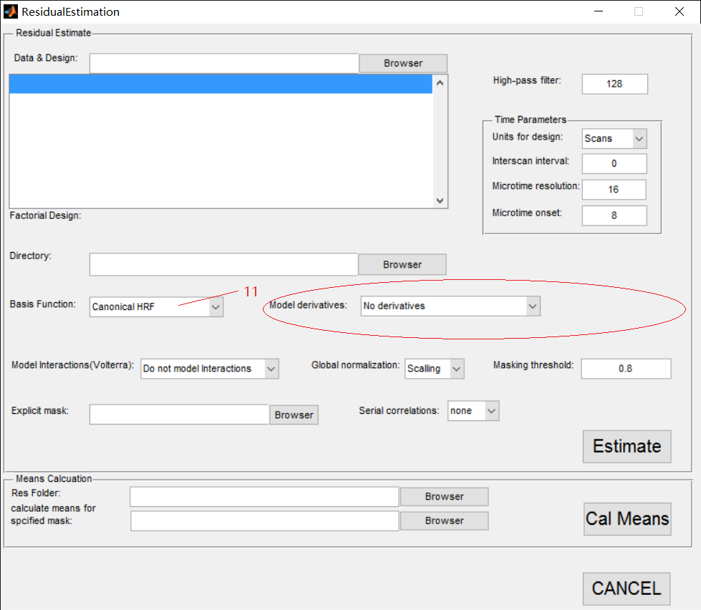

Fig 3.10

* 1. You can use these 3 popup menus of mark 12 to mark 14 (Fig 3.11) for setting Model interactions (Volterra), Global normalization, Masking threshold. (The parameters here are the same as the ones in SPM-> fmri-> Specifiy 1st –level. Because the window here are using the SPM’s api function. You can read the SPM’s manual as reference.)

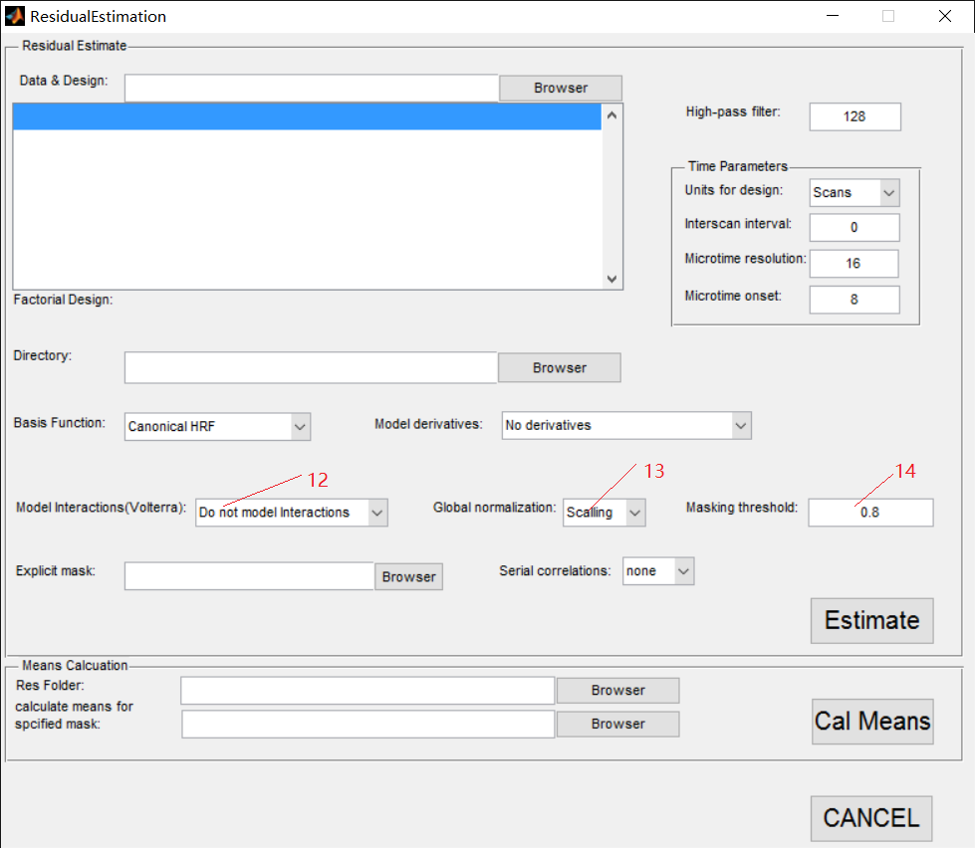

Fig 3.11

* 1. You can use mark 15 or mark 16 (Fig 3.12) for selecting your mask file. The URL path can be directly input in the textfield of mark 15 or selected in GUI by clicking the button of mark 16. (The parameters here are the same as the ones in SPM-> fmri-> Specifiy 1st –level. Because the window here are using the SPM’s api function. You can read the SPM’s manual as reference.)

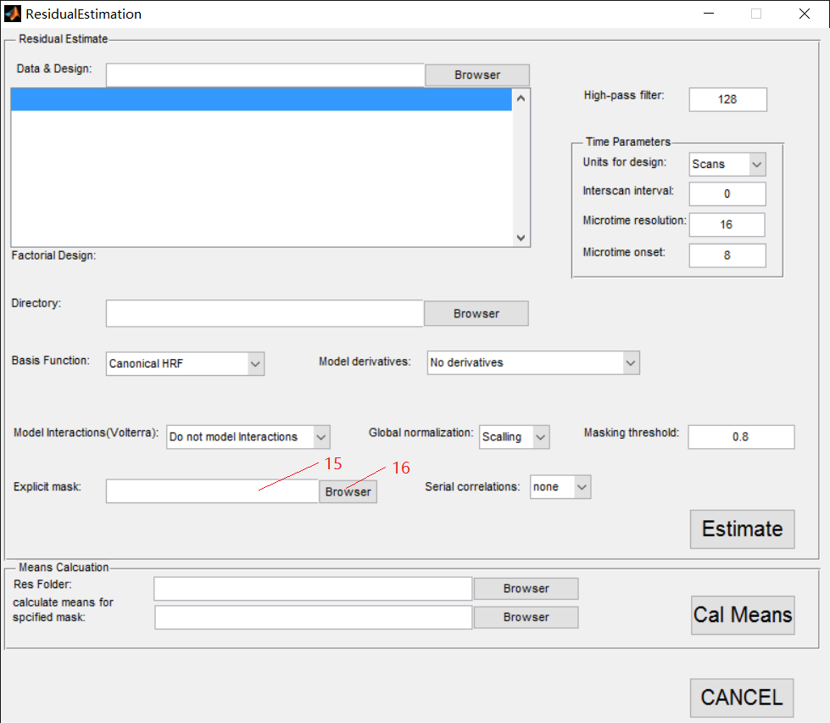

Fig 3.12

* 1. You can use the popup menu of mark 17 (Fig 3.13) to choose a value of Serial correlations. (The parameters here are the same as the ones in SPM-> fmri-> Specifiy 1st –level. Because the window here are using the SPM’s api function. You can read the SPM’s manual as reference.)

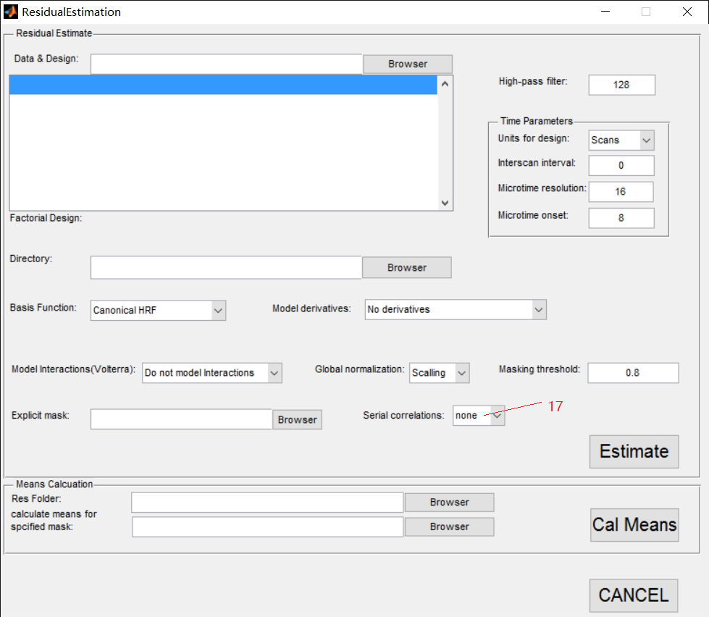

Fig 3.13

* 1. After all these procedures, you can click the button ‘Estimate’ of mark 18 (Fig 3.14) to run the calculation. A word, ‘Running’, will exist on the bottom of the widow as in the red circle (Fig 3.14). Not until the ‘Running’ disappears, are using Matlab and the program permitted.

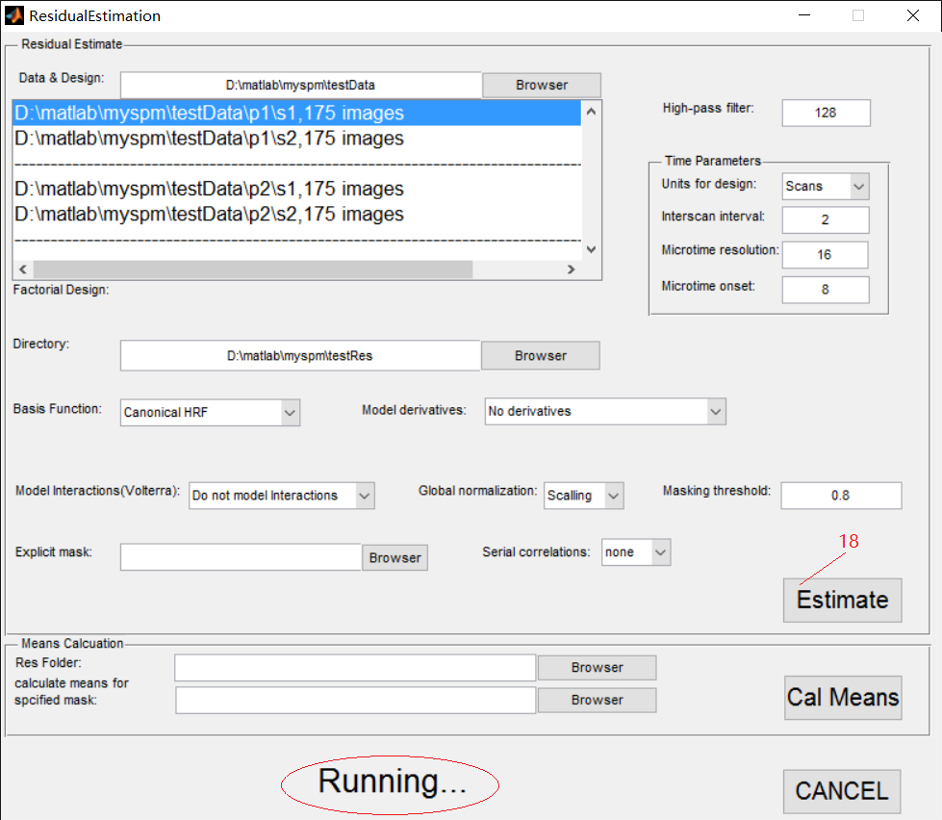

Fig 3.14

After the word, ‘Running’, disappears, the procedure of ‘Estimate’ is finish, as below (Fig 3.15).

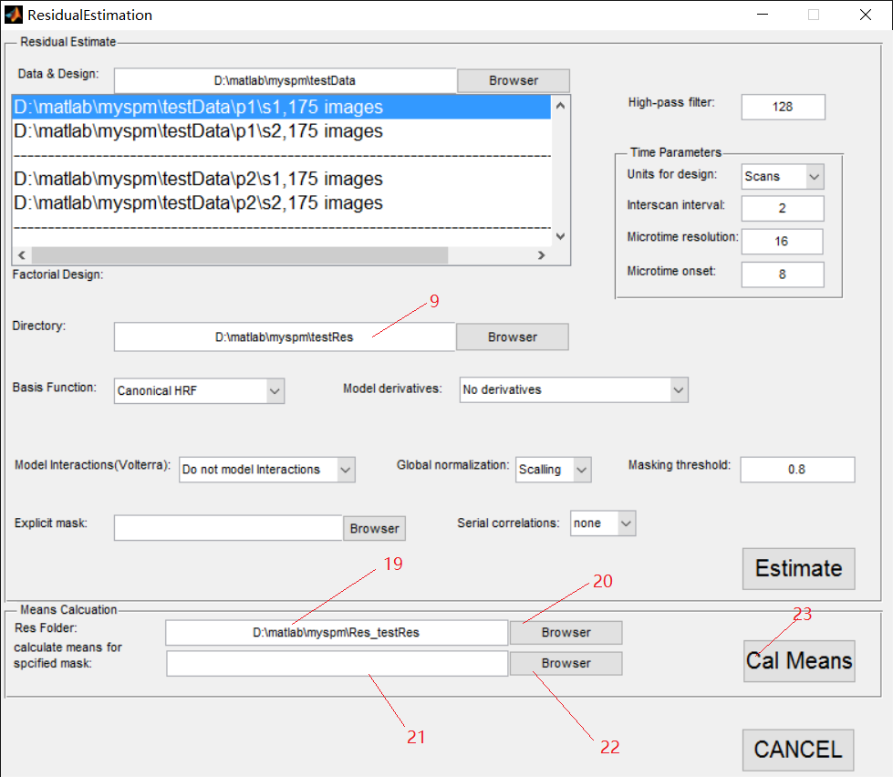

Fig 3.15

* 1. After finishing above procedure, you can input value to ‘Res Folder’ and ‘Calculate means for specified mask’ through mark 19 to 22 (Fig 3.15).

Res Folder: It is the folder where you save your estimated date. The URL path can be directly input in the textfield of mark 19 or selected in GUI by clicking the button of mark 20. If you just finish the ‘Estimate’ procedure, the value of mark 9 will be directly pasted in the textfield of mark 19.

Calculate means for specified mask: It is the mask file for calculating means. The URL path can be directly input in the thexfield of mark 21 or selected in GUI by clicking the button of mark 22.

* 1. By clicking the button ’Cal Means’ of mark 23 (Fig 3.15), the program will be running. A word, ‘Running’, will exist on the bottom of the widow as in the red circle (Fig 3.14) during procedure running. Not until the ‘Running’ disappears, are using matlab and the program permitted. The result will save in the same folder as the value in mark 19 (Fig 3.15). After the word, ‘Running’, disappears, the procedure of Residual Estimate is all finished. You can click the button ‘CANCEL’ to exit this window.

Adsf