# 

# PlaqueQuant – Blood Vessel Stenosis Quantification Software User Manual Version 2.0 FOR BETA VERSION ONLY

**Table of Contents**

1 Introduction 3

1.1 Purpose 3

1.2 Highlighted Features 3

2 Installation 4

3 Usage 5

3.1 Workflow pipeline 5

3.2 Overall 6

3.3 Image Loading and Registration 10

3.4 Image View 12

3.5 Image Examining 13

3.6 Image Editing 14

3.7 2D & 3D Numerical Measurements 18

3.8 Generate Report 22

3.9 Saving & Opening Segmentation 23

4 Known Issues 24

5 Credits 25

## Introduction

### Purpose

PlaqueQuant is a software with various algorithms, which facilitates user to perform accurate segmentation of blood vessels. Quantitative analysis is performed to help user to quantify blood vessel stenosis

### Highlighted Features

The PlaqueQuant highlights the following features:

1. All-in-one pipeline system architecture.
2. Easy-to-use and intuitive interface.
3. DICOM image data well compatible.
4. Smart automatic segmentation algorithm.
5. 2D and 3D numerical analysis.
6. Automatic clinical report generator.

## Installation

Follow the instruction to install the software:

1. Unpack the zip/rar file.
2. Double click the installer file “Setup”.
3. Press “Install” when prompted with installation of Microsoft Visual C++ redistributable. Finish the rest of the installation as instructed.
4. Press “Run” when prompted with system security message.
5. Click “Finish” to finish installation.

## Usage

### Workflow pipeline

The PlaqueQuant adopt a pipeline fashion for each case as shown in **Error! Reference source not found.**.

Figure 1 Workflow Diagram

### Overall

The following figure is the overall of the software. The software basically contains 5 parts: Menu Bar, Tool Bar, Widget Window, Measurement Window, Viewers.

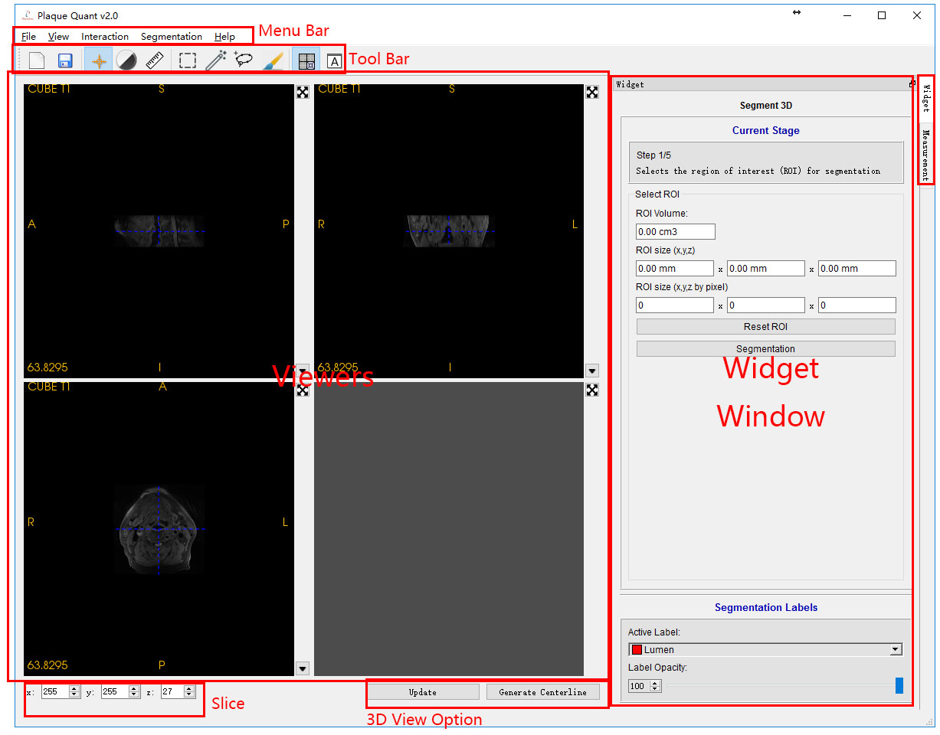

Figure 2 Main Window

#### Viewers:

There are 4 viewers in total. The lower right one is the 3D viewer; others are 2D viewers.

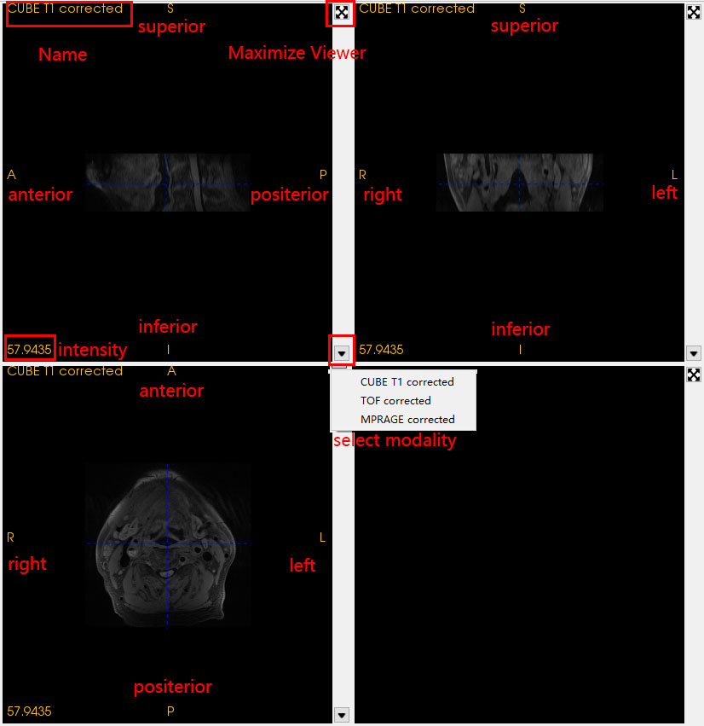

Figure 3 Image viewers

Every 2D viewer has a capital letter to represent its directions, (S: superior, I: interior, A: anterior, P: posterior, R: right, L: left) and a few interaction ways (be introduced in tool bar).

Upper left is the modality name.

Lower left is the voxel intensity of the cursor.

Upper right is a button which can maximize the current viewer. (This button will change to return normal size when the viewer is maximized)

Lower right is a button “▼” for changing modality.

3D viewer is a passive viewer for the performance consideration which means this viewer cannot render without clicking the “update” button during doing the segmentation. If the user wants to check their segmentation result, click the “update” button. And it only has one interaction way.

|  |  |
| --- | --- |
| Holding left click | * Rotation |
| Moving wheel and holding right click | * Zoom-in and zoom-out |
| Holding middle button | * Translating |
| Keyboard “r” | * Resetting position |

#### Tool bar:

In the tool bar, the software consists of 3 examining modes, 3 editing modes, 2 view models and the 2 basic function (open and save) for 2D viewers.

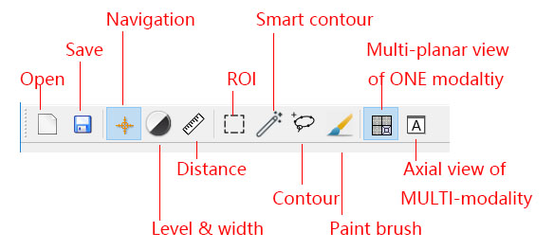

Figure 4 Toolbar tooltips

|  |  |  |
| --- | --- | --- |
| **Functions** | | **Operations** |
| Open | * Open the registration wizard for loading images | |
| Save | * Open the saving wizard for saving the segmentation image | |
| **Views** | **Operations** | |
| Multi-planar view of one modality | * Display 3 different views (axial view, sagittal view, coronal view) in 3 viewers which are from the same MRI modality image. | |
| Axial view of multi-modality | * Display 3 views in 3 viewers of 3 different MRI modalities images all in axial view | |

|  |  |
| --- | --- |
| **Modes** | **Operations** |
| All | * Move middle wheel to change slice |
| Navigation | * Left click to select slices location * Hold right click to zoom * Hold middle click to move camera |
| Level & width | * Hold left click to control the window level and widow width of images. |
| Distance | * Left click to place a point and measure the distance between 2 points |
| ROI | * Left click to the border and drag it, 3 ROI frames will move synchronously * All voxels in the extent of 3 frames will be extracted for doing segmentation |
| Smart Contour | * Left click to place a seed point * Left click to place a point on contour * Hold left click to drag a point on contour |
| Contour | * Left click to place a contour point * Hold left click to keep placing contour points * Right click to extract lumen wall (when auto lumen segmentation enabled) * Double left clicks to draw the contour with specified label |
| Paint brush | * Hold left click to draw with specified label. * Hold right click to erase label as an eraser |

#### Menu bar:

The operation of menu bar is almost the same as the tool bar. Except for the following:

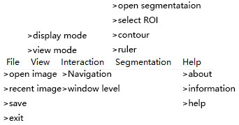

|  |  |
| --- | --- |
| File->recent image->… | Open recent image in history |
| Segmentation->open segmentation | Open a segmentation result saved before |

#### Widget Window:

On the upper part of the widget window can be change on different mode. The first 3 stages are the configurations of 4 editing modes (ROI, smart contour, contour, paint brush).

On the lower part, it is the setting of active label and its opacity. When the opacity of the label is changed, the relevant label of the viewers will be change synchronal.

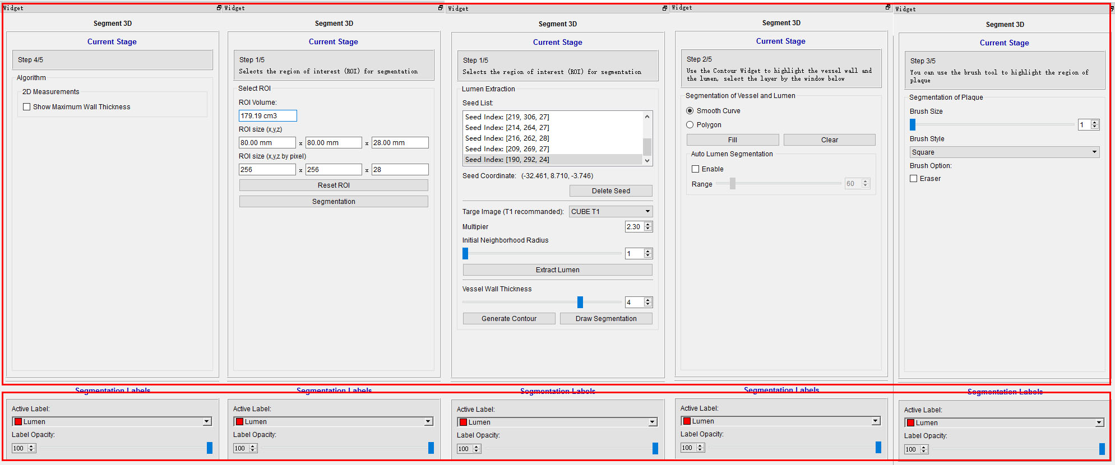

Figure 5 Widget Window

#### Measurement Window:

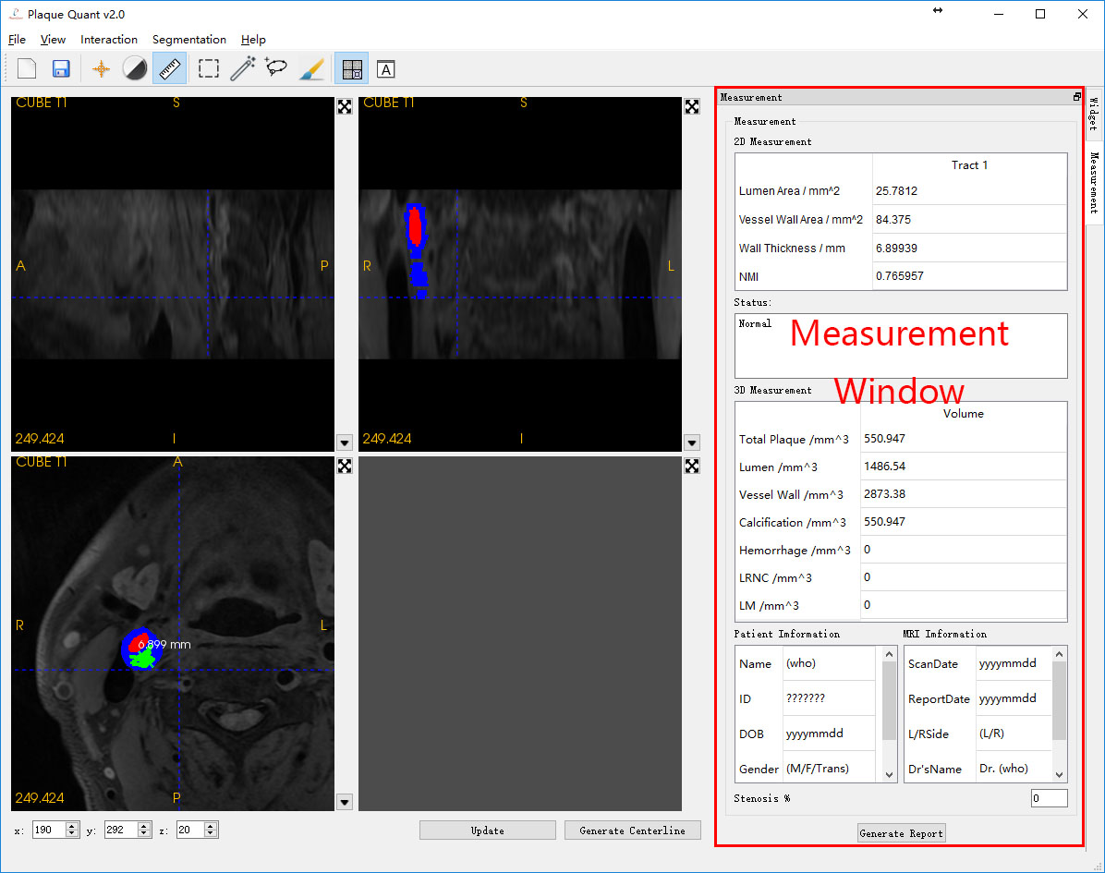

Figure 7 Measurement Window

The Measurement Window are using for 2D and 3D numerical measurement and automatic report generating. The 2D and 3D numerical measurements will be updated in real time by modifying the segmentation.

### Image Loading and Registration

Medical image loading can be performed by clicking “File” -> “Open Image” OR “Recent Image” in menu bar. Then the “File loader” will pop up. The software is able to load multi-modality MRI image in DICOM or NIFTI format. Other formats are still not yet supported. By clicking “Open Image”, user is supposed to select accurate folder which contains images to be loaded. By clicking “Recent Image”, user can select the recent folder in history.

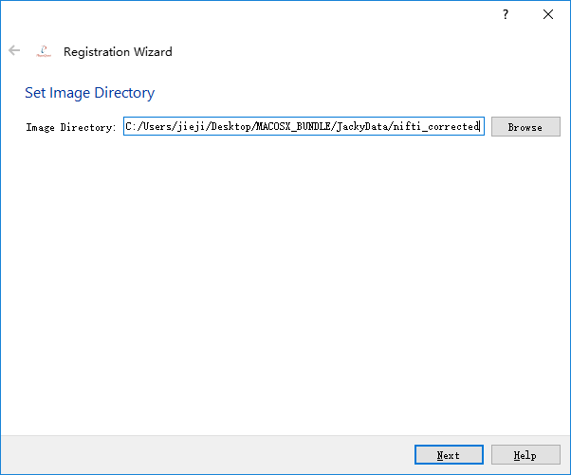

Figure 6 File loader

In the next, all supported image data are loaded into the upper table, user should follow hints of the wizard and select relevant images. By clicking “<<” the highlighted image will insert to the corresponding slot. While clicking “X”, the image in the corresponding slot will be removed. The software is capable to load 5 different modalities MRI image (CUBE T1 image，CUBE T2 image，CUBE T1 + Contrast, 2D Double Inversion Recovery(DIR)/Quadruple inversion recovery(QIR), MPRAGE).

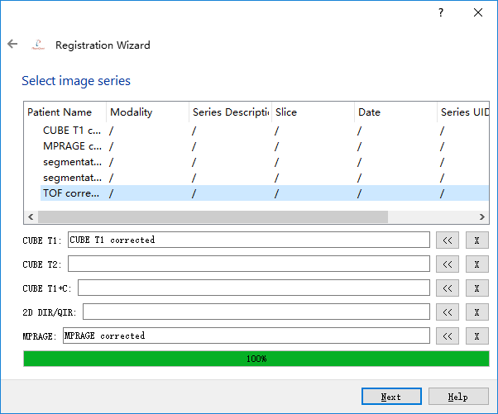

Figure 7 Image selection

In the next, properties of the selected images are displayed and user can do the final confirm whether they are the correct image to be loaded (Only for DICOM, NIFTI do not have these properties). If not, user is capable to click the “<-” in the upper left to return previous wizards. If nothing goes wrong, user can click the “finish” and the software begins to load image and do the registration, which should be taken a few seconds. Please don’t be panic if the software is not responding.

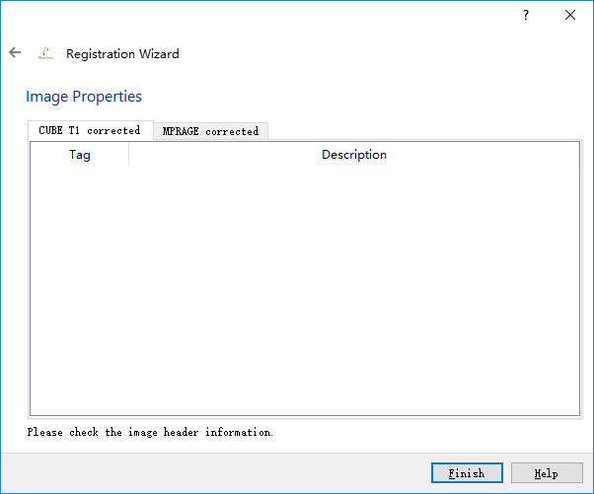

Figure 8 Function tab options - Image Preprocessing

### Image View

As it has already been written in 3.1, Multi-planar view of one modality and Axial view of multi-modality are 2 views for user to browse their images.

#### Multi-planar view of one modality

On upper right it is a sagittal view. On upper left it is a coronal view. On lower left it is an axial view. All three 2D viewers are displaying the same modality image.



Figure 9 Multi-planar view

#### Axial view of multi-modality

Three 2D viewers are displaying different modalities and all of them are in axial view. Normally, vessel wall and lumen are easily recognizable in axial view.

### Image Examining

As it has already been written in 3.1, Navigation mode, level & width mode and distance mode are 3 modes for user to examine their images.

#### Navigation

Holding left click: drag the blue cursor and the intensity in the lower left will update synchronously.

Middle button: drag the image position.

Holding right click: up to zoom-in, down to zoom-out.

Keyboard “r”: reset the image position.

#### Level & Width

Holding left click: change the 2D viewer’s window level and window width. While moving vertically, the window level will change. While moving horizontally, the window width will change.

#### Distance Measurement

The first left clicks: place a begin point of the distance widget.

The second left click: place an end point of the distance widget.

Both points have been placed: left click to drag one of those point to alter points’ positions.

By checking “Show Maximum Wall Thickness” checkbox, the distance widgets will automatically pair to the current position where maximum wall thickness locates.

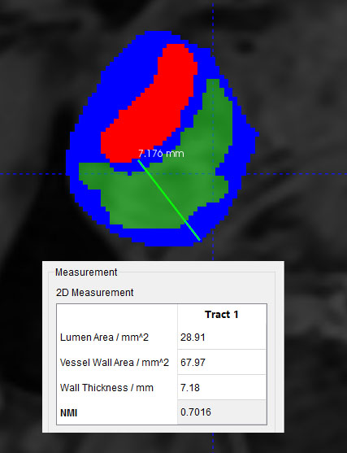

Figure 10 Show Maximum Wall Thickness

### Image Editing

As it has already been written in 3.1, ROI mode, contour mode and paint brush mode are 3 modes for user to do segmentation. User is supposed to follow the hint on the right. Extracting ROI(Optional) -> Using contour widget for doing segmentation -> Using paint brush for optimizing segmentation

#### ROI(Optional)

In this mode, user is supposed to select their region of interesting for segmentation, but this is not compulsory.

In every view, the frame has borders which are used as change its sizes. Anytime the size of the frame is changed, its configuration will be updated on the right.

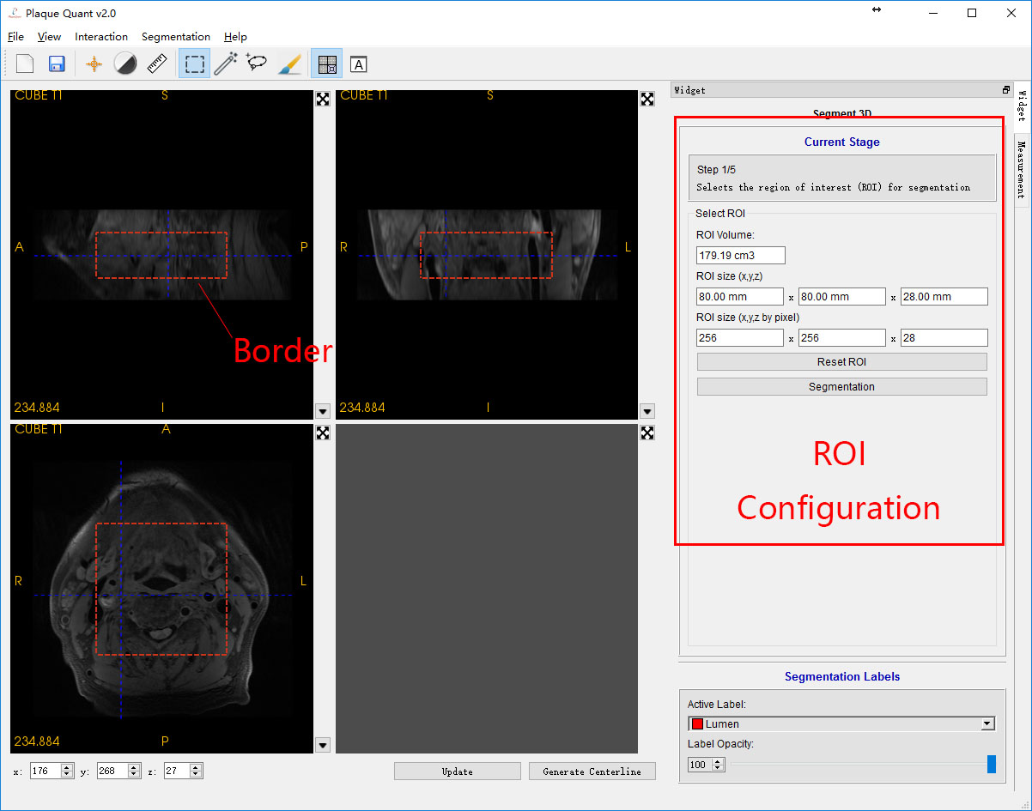

Figure 11 ROI selection

After finishing changing the frame, user can click segmentation to extract the ROI.

If user is not satisfied, please click Reset ROI again and redo the upper procedures.

#### Smart Contour

In this mode, user is supposed to use contour to extract the draft of lumen and vessel wall. Here an algorithm using region grow method for rapid lumen and vessel wall segmentation. User just need to place a seed for growing on lumen volume.

#### Contour

In this mode, user is supposed to use contour to do the lumen and vessel wall segmentation.

Normally the vessel wall and lumen are easily recognizable in axial view. So user is suggested to only using contour in axial-view 2D viewer or change to axial view of multi-modality. User is also suggested to maximize the working 2D viewer for better performance (3.1 viewer).

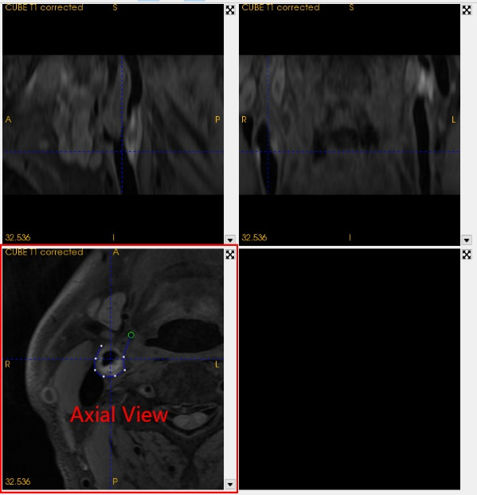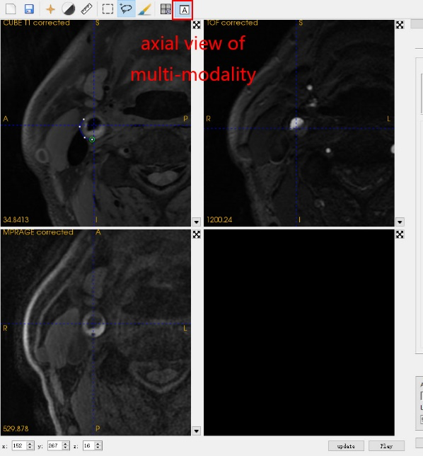

Figure 12 Axial view

One the right is the configuration of contour mode. User can select using polyline contour or smooth curve contour to do segmentation. The software also purposes an algorithm for doing lumen segmentation. User just need enabled it and provide the vessel wall contour with appropriate threshold rage, the software will automatically find the lumen contour. The lower part is for selecting segmentation labels. While auto lumen segmentation is enabled, the labels will be automatically selected for user.

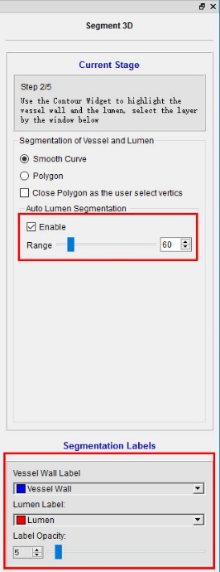

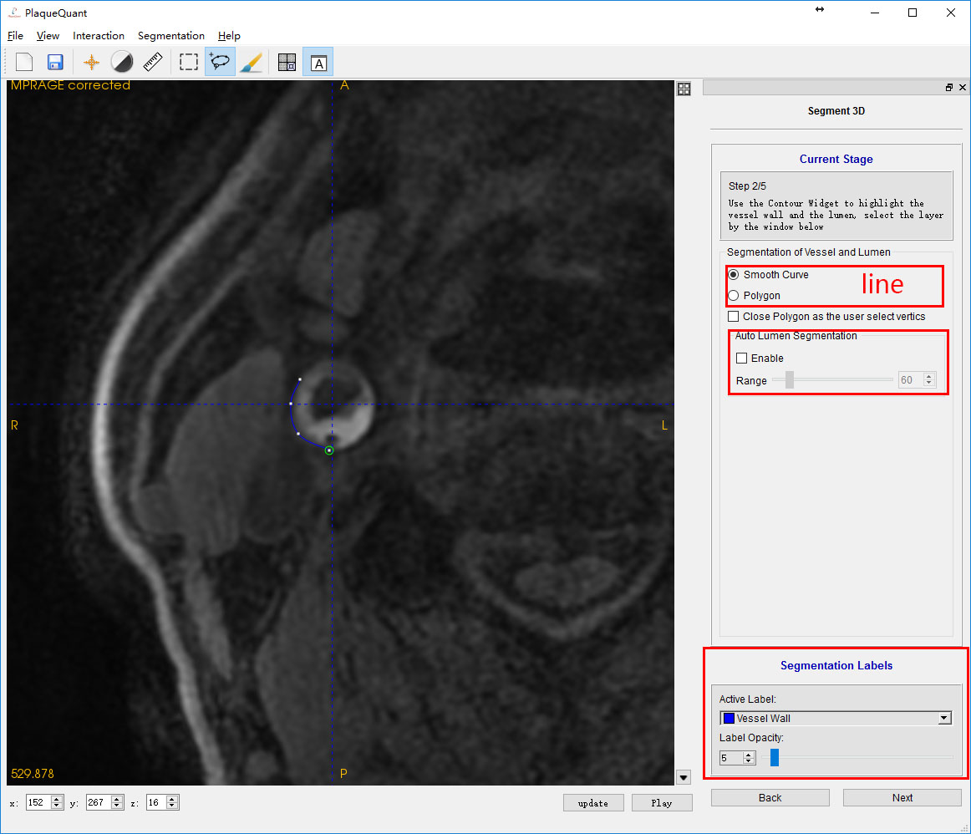

Figure Lumen segmentation

**Anytime:**

Keyboard “Enter”: close loop and do segmentation with active label

Keyboard “Esc”: delete the whole contour widget

**Before closing loop:**

Left click: Placing a contour node. When the cursor is close to the first node, it close loop.

Holding left click: Continuously placing contour nodes.

Right double clicks: Close loop.

Keyboard “Delete”: Delete last contour node.

**After closing loop:**

left click: When the cursor is close to the contour line instead of node, add a new node. When it is close to a node, holding left click can alter a node’s position.

Left double clicks: Do segmentation with active label.

Keyboard “Delete”: Delete the node which is close to the cursor

**Auto lumen segmentation enabled:**

The same as above instead of the following:

Before closing loop:

Right double clicks: Close loop and generate lumen contour (If no lumen is found, user can define their own lumen).

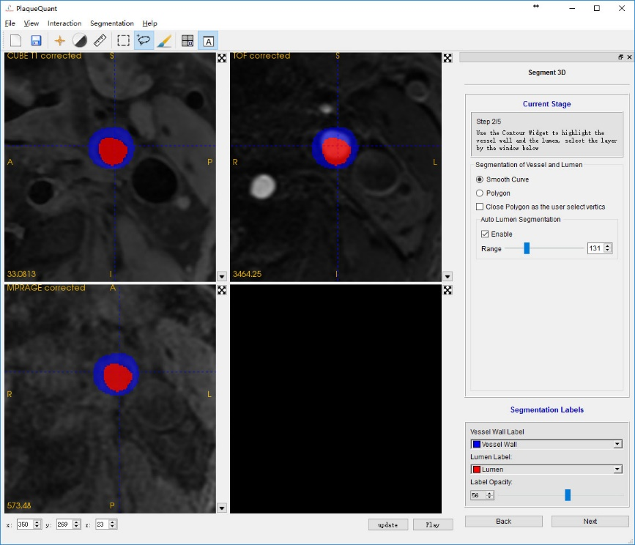

Figure 13 Segmentation result

In axial view of multi-modality mode, user can compare the segmentation result in different modality.

#### Paint brush

In this mode, user is supposed to use paint brush to optimize their segmentation result.

Paint brush is a quite straight forward widget for user to do segmentation. However, it is too time consuming to do all segmentation manually. Using contour should be the best option. But user can still use paint brush to optimize their segmentation and add other label, such as calcification, hemorrhage.

On the right side is the paint brush configuration. User can change the brush size and brush shape. The lower part is for selecting paint brush label.

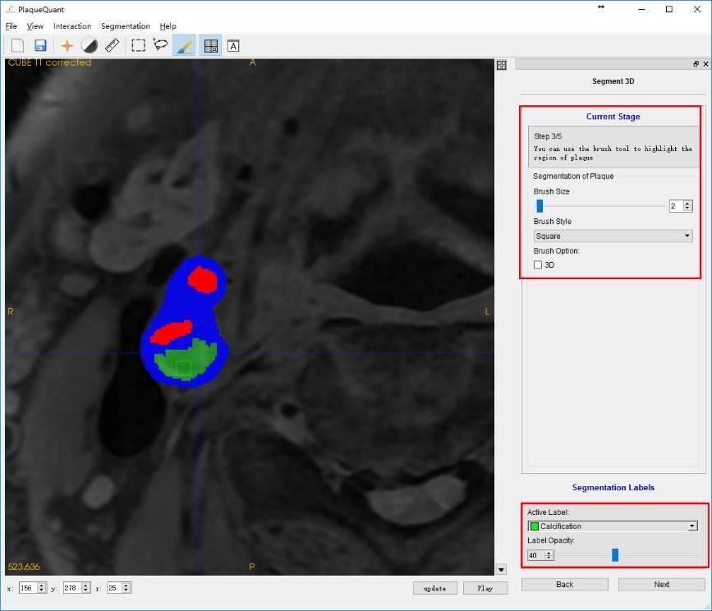

Figure 14 Paint brush

Holding left click: Draw with the active label.

Holding right click: erase the label and replace with nothing.

### 2D & 3D Numerical Measurements

After finishing editing segmentation, user can get 2D & 3D numerical measurements from the software. All the measurements can be updated in real time when user changes the current slice.

#### Maximum Wall Thickness

By clicking “Next” of the segmentation window to move to “Step 4/5”, user can enable the algorithm, maximum wall thickness, which is the maximum distance between the lumen wall and vessel wall.

By setting checked of the “show maximum wall thickness”, the software can automatically find out the maximum wall thickness of the current slice show its trajectory in the 2D viewers. And the status text frame can tell the user whether the software can find the distance.

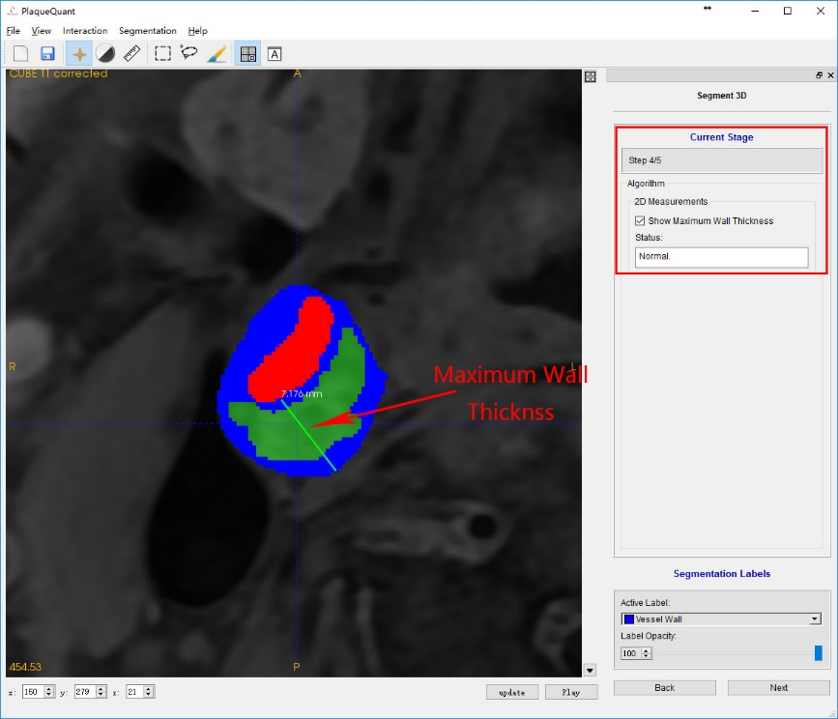

Figure 15 Maximum Wall Thickness

However, because of the ambiguity of vessel segmentation, the algorithm cannot guarantee that maximum wall thickness can always be found and the precision. User should judge the result on their own opinions and use distance mode instead.

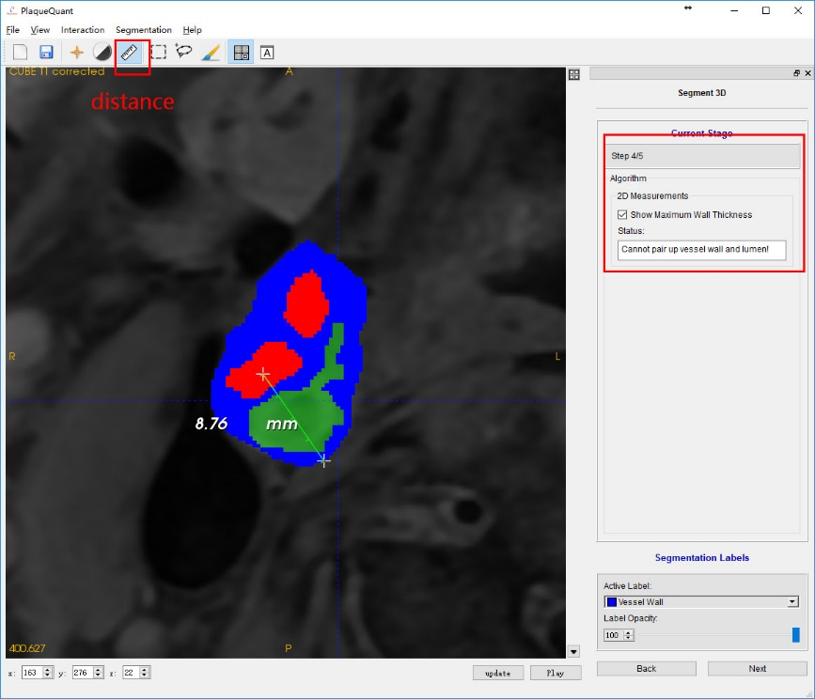

Figure 16 Manual measurements

#### 2D Numerical Measurements

2D numerical measurements provide following straight forward data of current slice:



Figure Maximum Wall Thickness

|  |  |
| --- | --- |
| Quantity | Details |
| Lumen area (mm2) | the area of label “lumen” of current slice |
| Vessel wall area (mm2) | the area of label “vessel wall” of current slice |
| Wall thickness (mm) | the maximum distance between the lumen wall and vessel wall |
| Normalized Wall Index (1) |  |

#### 3D Numerical Measurements

3D numerical measurements provide following straight forward data of the segmentation results:

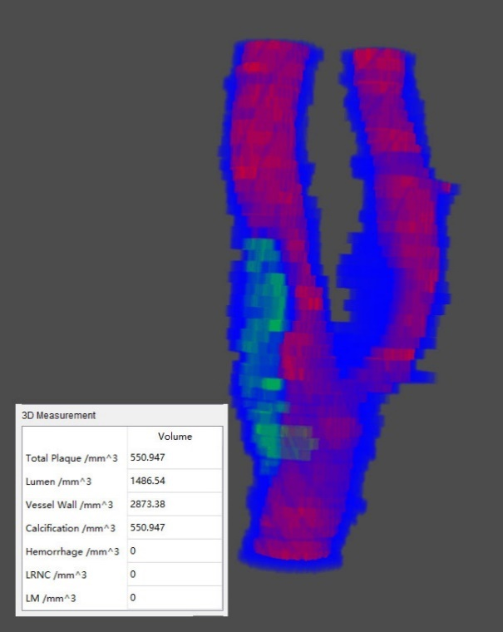

Figure 18 3D Measurements

|  |  |
| --- | --- |
| Quantity | Details |
| Total plaque (mm3) | calcification + hemorrhage + LRNC + LM |
| Lumen (mm3) | lumen volume |
| Vessel wall | vessel wall volume |
| Calcification | calcification volume |
| Hemorrhage | hemorrhage volume |
| LRNC | LRNC volume |
| LM | LM volume |

#### Stenosis

The software also provides an intuitive quantity named “Normalized Wall Index” (NMI) for user to measure severity of stenosis:

The user is supposed to use ROI mode to remove redundancy (the bottom part and the top part of the segmentation should be removed). By selecting ROI and click “segmentation” on the segmentation window. Then changing the opacity of every label (such as 5) in case of blocking the sight

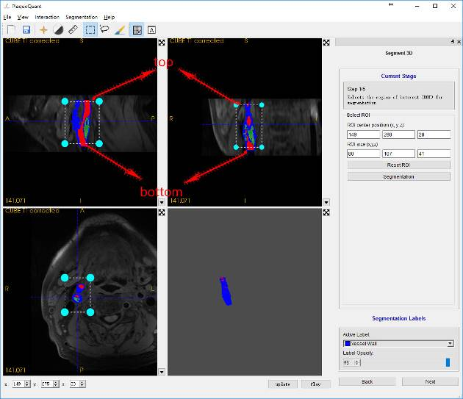

Figure 19 ROI selection

After that user is supposed to click “update” to render their segmentation. This time the center line of the vessel can be seen clearly in the 3D viewer.

User should select 2 points on the center line by pressing keyboard “Enter”, a sphere on the center line will label the selected location and keyboard “Delete” will clear all spheres. User should define their own 2 spheres location. After 2 spheres have been specified, the stenosis will be automatically filled for the user.

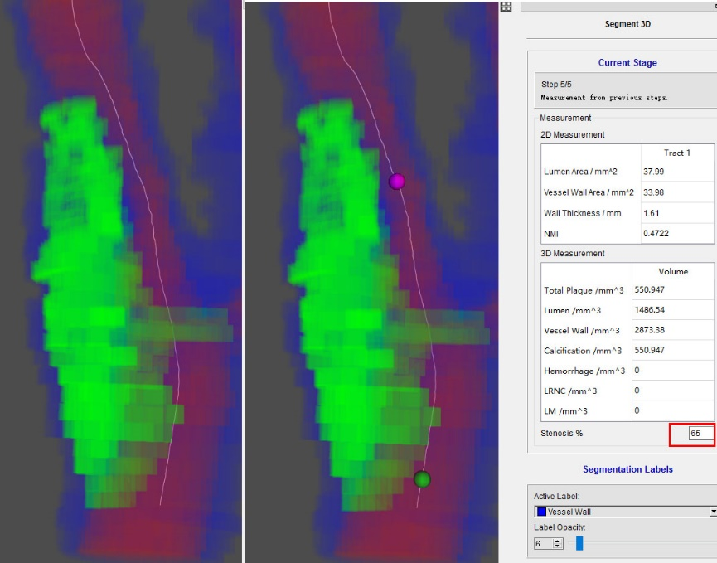

Figure 20 Reference & Stenosis point selection

### Generate Report

After finishing all segmentation, user can generate their own report for their particular images. The report generated by the software have all most important data from the segmentation.

The user is supposed to change the slice of lower left 2D viewer and view angle of 3D viewer which they are interested in. The report generator will generate a report which is based on these 2 viewers, the 2D & 3D numerical measurements and information from DICOM images.

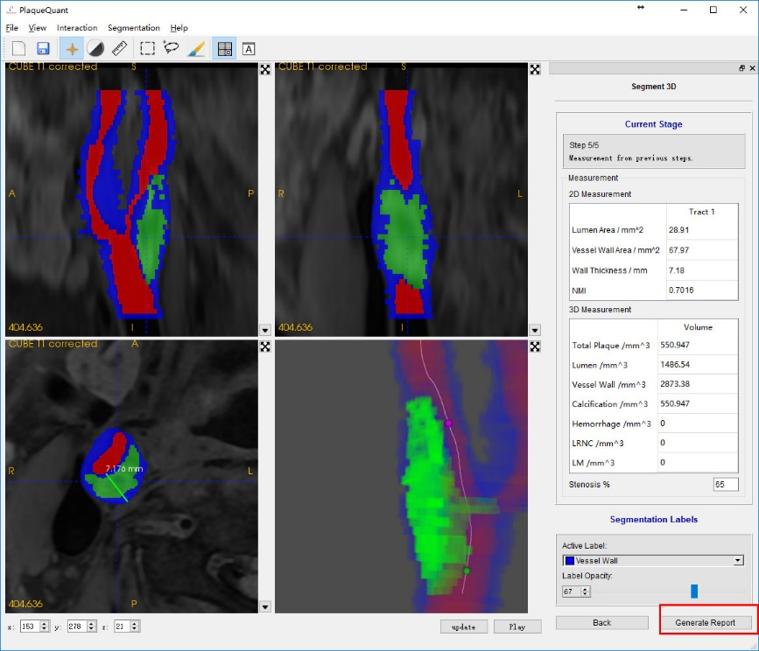

Figure 21 Generate report

### Saving & Opening Segmentation

Users are advice to save their segmentation from time to time since the auto recovery function is yet to be implemented.

User can click “File->save” on the menu bar or “save” on the tool bar to save their segmentation result. The segmentation will be saved in NIFTI format.

User can also open their segmentation again after open their original image, by clicking “segmentation->open segmentation” on the menu bar.

## Known Issues

1. Discontinuous segmentation results in several functions failures.
2. Opacity cannot be updated real time for 3D volume rendering.
3. Centerline extraction might fail if there are outliners, such as miss drawn point outside of the vessel or a hole inside the lumen, in the segmentation.