# C:\Users\lwong\AppData\Local\Microsoft\Windows\INetCache\Content.Word\iFusion.png

# iFusion – User Manual v1.0 FOR BETA VERSION ONLY

**Table of Contents**

1 Introduction 4

1.1 Purpose 4

1.2 Highlighted Features 4

2 Installation 4

3 Usage 5

Workflow pipeline 5

3.1 Basic Controls 6

3.2 Image Fusion 7

**Table of Figures**

Figure 1 Workflow Diagram 5

Figure 2 Toolbar tooltips 1 6

Figure 3 Toolbar tooltips 2 6

Figure 4 Function tab options - Image Preprocessing 7

Figure 5 Registration properties 7

Figure 6 Image fusion properties 8

Figure 7 Image fusion describe 8

Figure 8 Export images 8

## Introduction

### Purpose

The purpose of this document is to instruct user to use the application iFusion in details. This application allows user to register two images to the same space and fuse these images together with specified weighting.

### Highlighted Features

The software highlights the following features:

1. Register images to same space
2. Fuse two images together and create a new image
3. Export the image in DICOM or NIFTI.

## Installation

Follow the instruction to install the software:

1. Unpack the zip/rar file.
2. Place your “license.dat” in the same directory as the file “Setup.vbs”.
3. Double click the script file “Setup.vbs”.
4. Press “Install” when prompted with installation of Microsoft Visual C++ redistributable. Finish the rest of the installation as instructed.
5. Press “Run” when prompted with system security message.
6. Installation is completed when you see “iFusion.lnk” short cut appears at the root directory of installation.

## Usage

### Workflow pipeline

The BTPNS adopt a pipeline fashion for each patient cases as shown in Figure 1.

Figure Workflow Diagram

### Basic Controls

BTPNS consist of an Image view with traditional controls grouped in four modes, namely “View”, “Image Level”, “Move” and “Draw” modes.

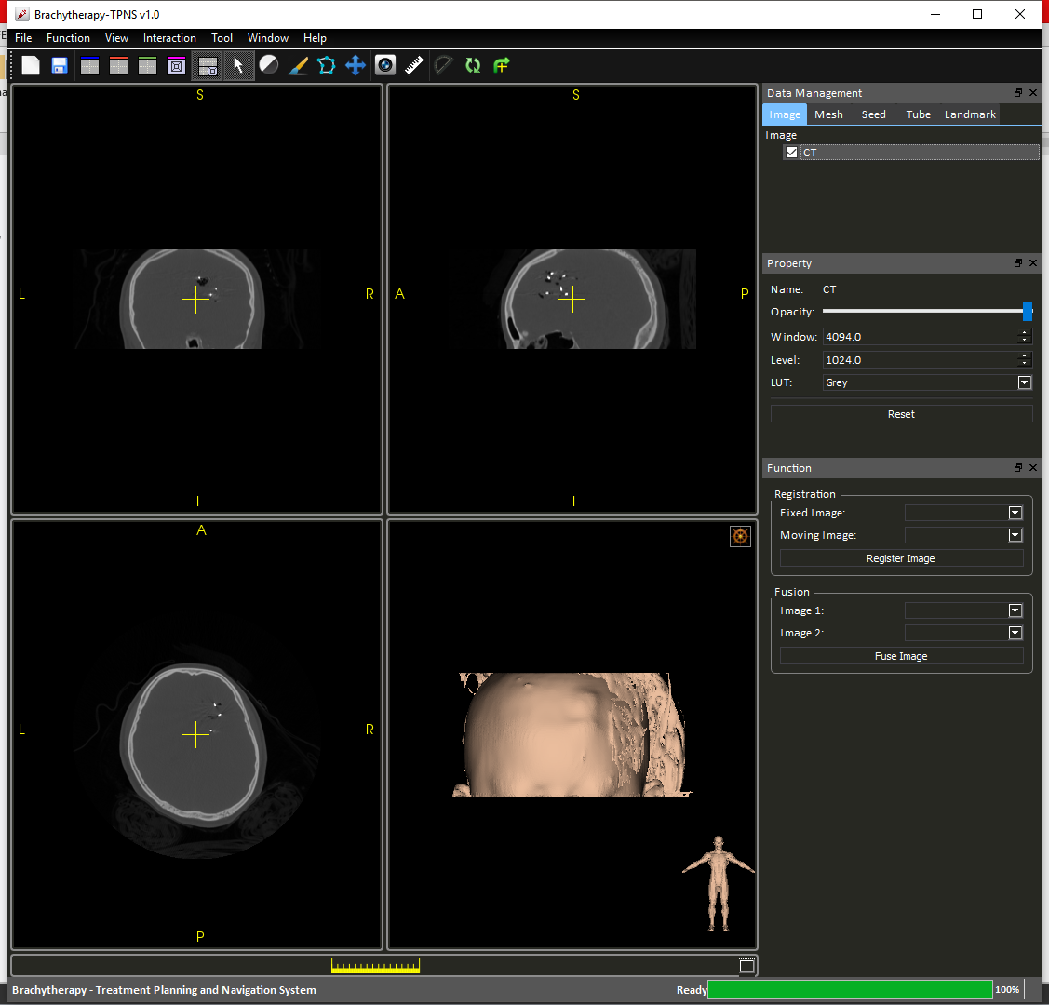

View

Image Level

Move

UI Layout

Figure Toolbar tooltips 1

|  |  |
| --- | --- |
| **Modes** | **Operations** |
| View | * Left click to select slices location * Hold right click to zoom * Hold middle click to move camera |
| Image Level | * Hold left click to control the contrast and brightness of images. |
| Move | * Hold left click to rotate selected image. * Hold middle click to translate selected image. |

The UI Layout buttons changes the layout to Sagittal/Coronal/Axial/3D/4-up respectively.

There are also additional widgets for user’s convinience.



Screen Capture

Reset View Plane

Ruler

Protractor

Center Camera

Figure Toolbar tooltips 2

WL

|  |  |
| --- | --- |
| **Widgets** | **Functions** |
| Screen Capture | Capture the scene on screen. |
| Ruler | Measuring distance. |
| Protractor | Measure angles. |
| Center Camera | Resets the camera and center the camera with respect to all the loaded images. |
| Reset View Plane | Resets the view plane normal to follow Cartesian x, y and z. |

### Image Fusion

The image preprocessing step can be performed by selecting “Image Fusion” option under the “Function” tab (Figure 4).

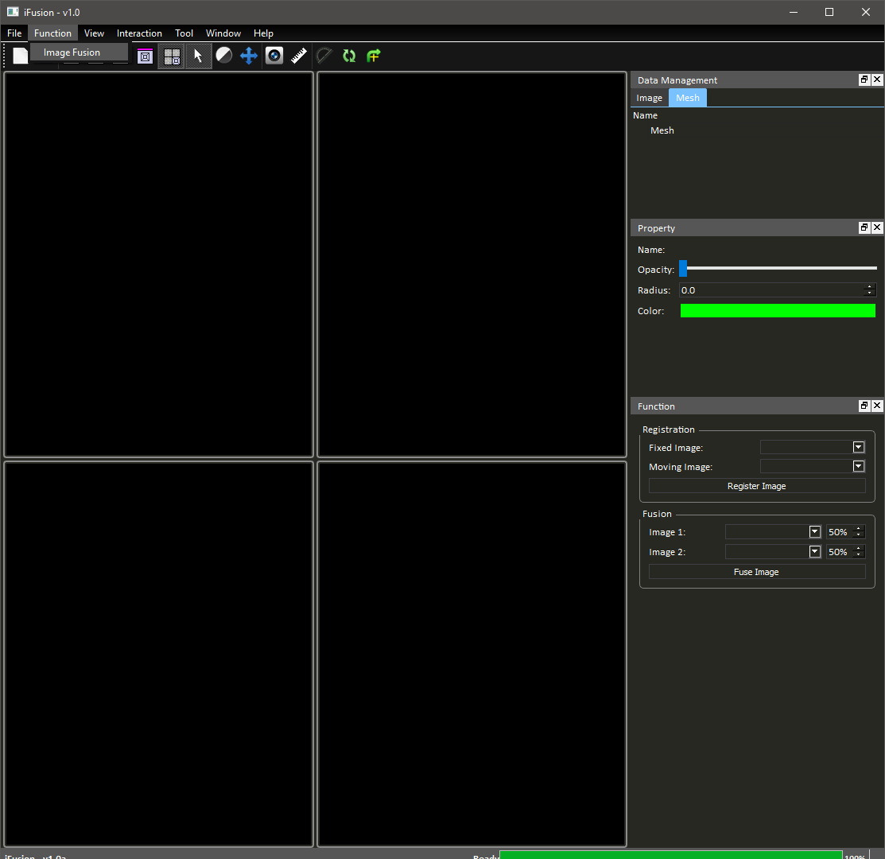

Figure Function tab options - Image Preprocessing

During this step, registration and image fusion can be performed optionally.

#### Registration

To register the image, user can follow these steps:

1. Manually align the images roughly.
2. Choose fix image and moving image in the panel at the right-hand-side (Figure 5).

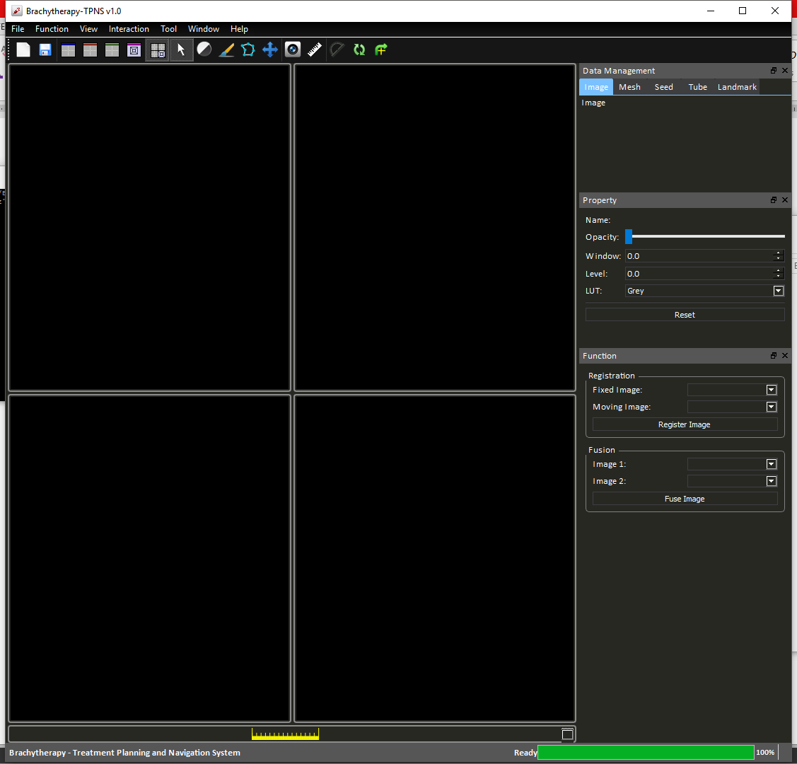

Figure Registration properties

1. Press “Register Image”.

This process may take 5-20 seconds depend on the quality of the initial alignment. If the result is not satisfactory, user can perform a series of registrations by repeating the upper steps.

#### Image Fusion and Exporting Images

To fuse two images into one weight sum image, user can follow these steps:

1. Select images to be fused.

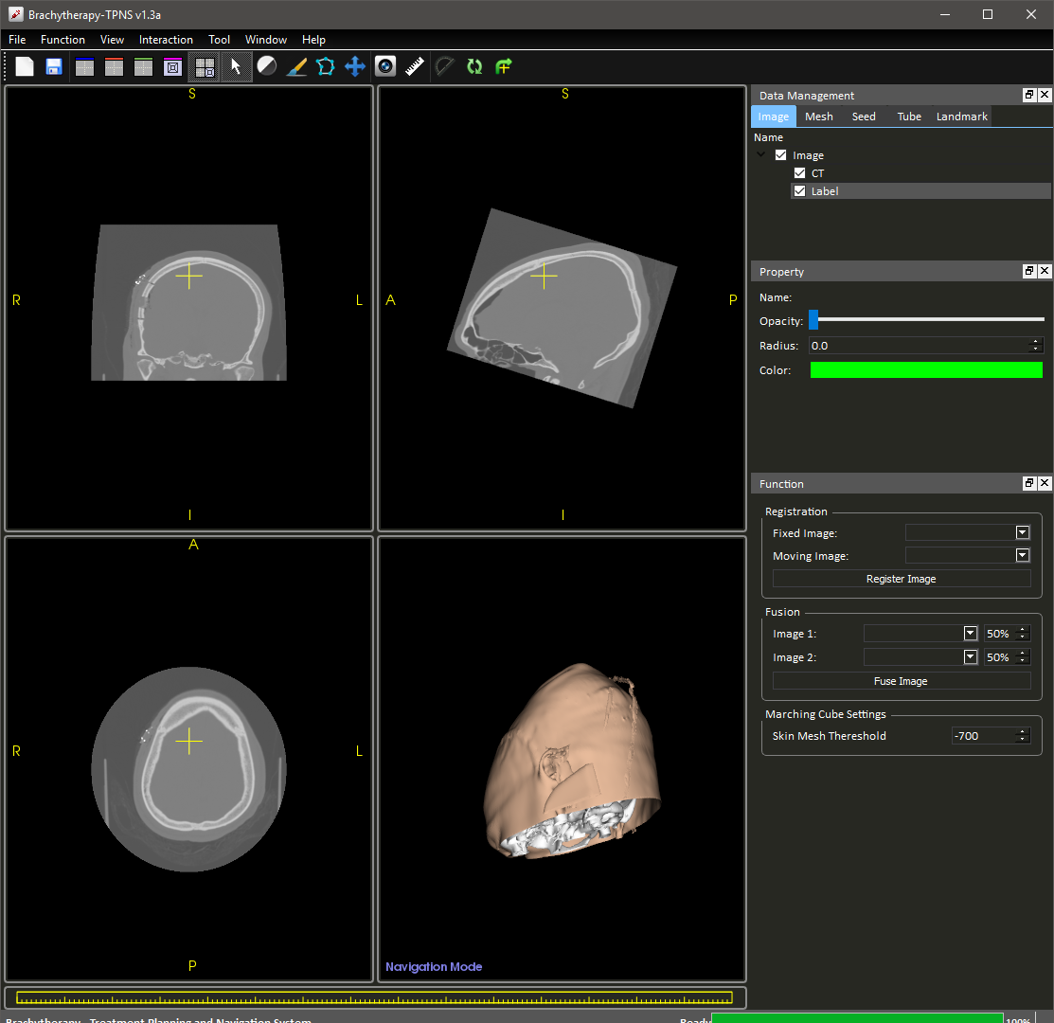

Figure Image fusion properties

1. Press “Fuse Image”

A new image data will be created as the 50-50 weighted sum of the two selected images (Figure 7). The weight constant can be adjusted by changing the percentage value at the right hand side.

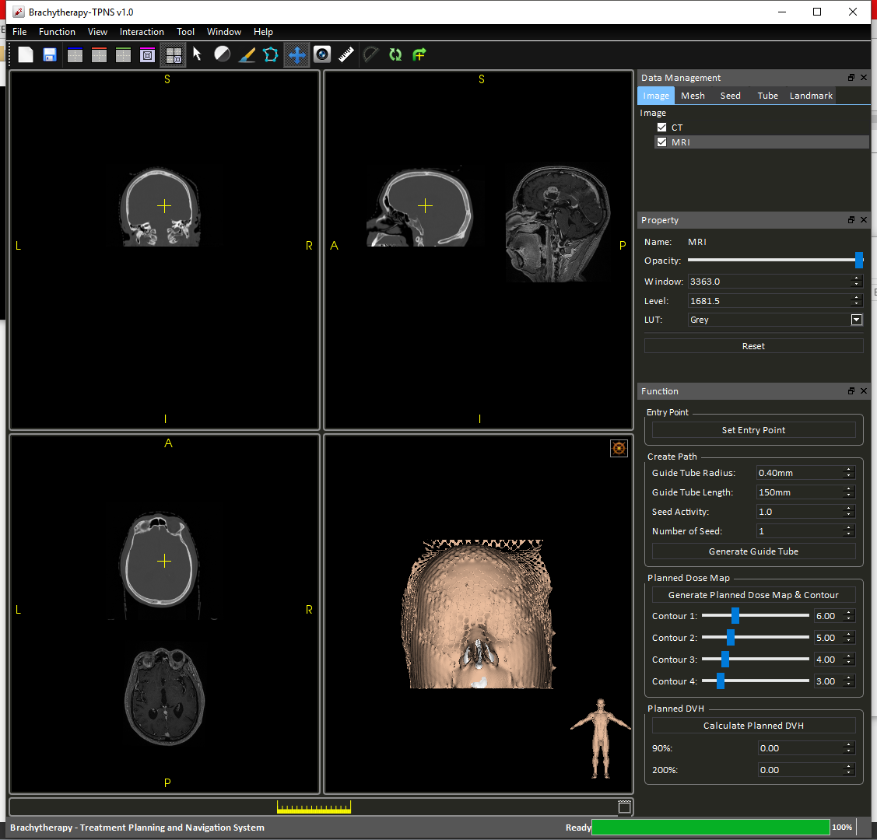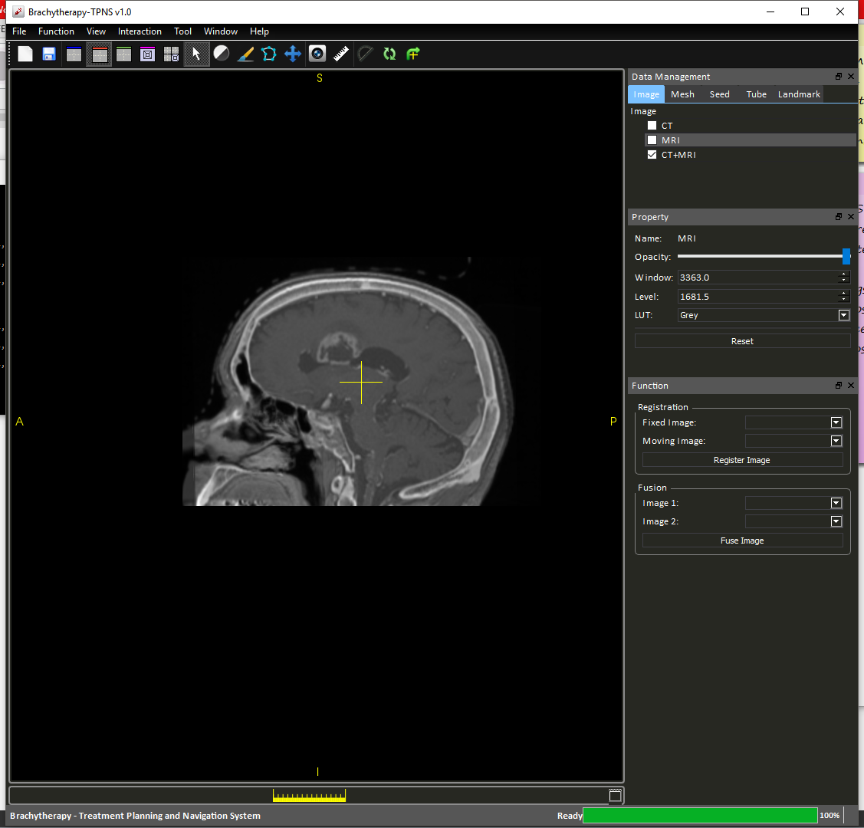

Figure Image fusion describe

To export the fused image, right click on the image “CT+MRI” on the “Data Management Panel” and select “Export as DICOM/NIFTI”.

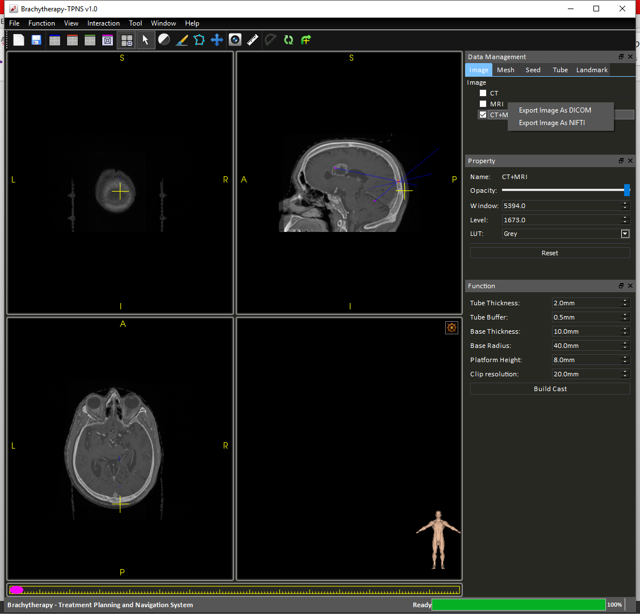

Figure Export images